FOSM Report of Bucking Wood at the Hazmat Building That
Was Hauled from Forest Road 462 Earlier, Wednesday, December 10, 2025

Sam Beard
On Wednesday, December 10, seven FOSM volunteers bucked (cut into short pieces) the approximately 1 cord of donation wood hauled from Forest Road 462 and the 462DC1 dispersed camping area last Wednesday. All the wood was from pinon trees, except a few pieces of Rocky Mountain juniper. The bucked wood was piled along the fence at the hazmat building behind the ranger station. The Mountain Christian Church Wood Ministry volunteers will eventually donate the wood to East Mountain families who heat their homes with wood.
The volunteers were Eric Russell, Steve Roholt, Dan Benton, Sim Cook, Jerry Carroll, Cliff Giles, and Sam Beard.
Project photos are presented below.

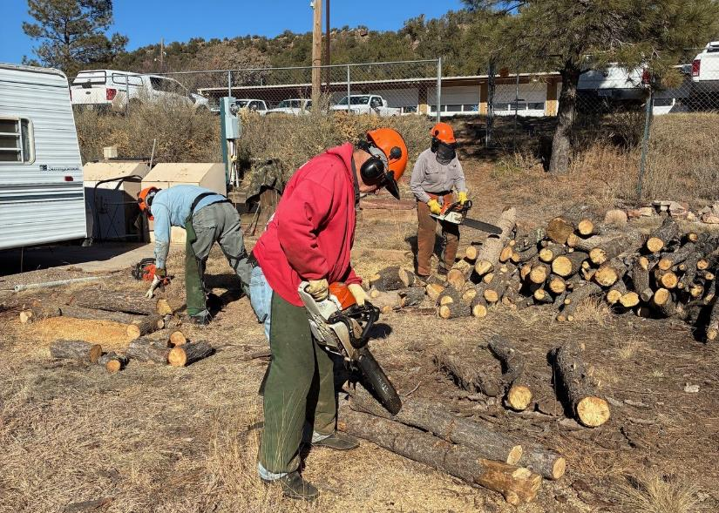
L to R: Eric Russell, Jerry Carroll, and Dan Benton beginning to buck the pile of wood hauled from Forest Road 462
and the 462DC1 dispersed camping area south of the Ranger Station. All photos by Cliff Giles
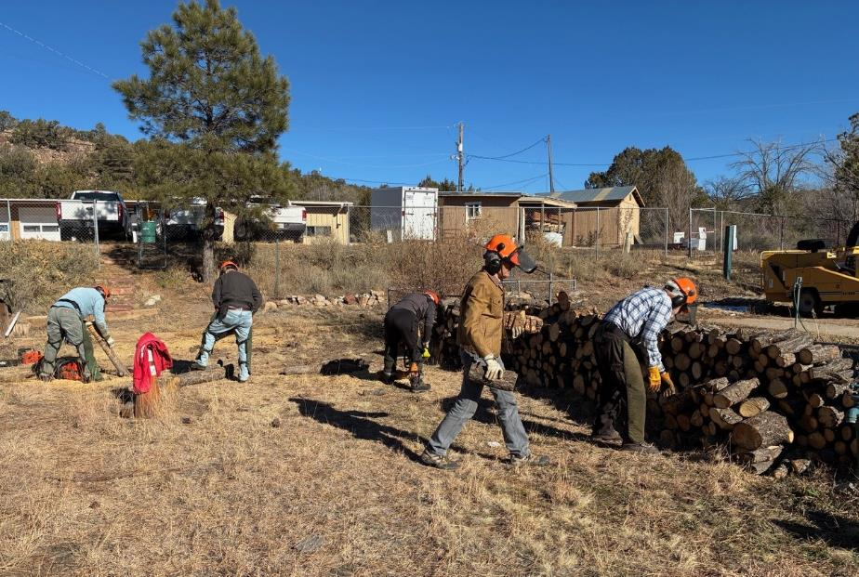
Sim Cook and Sam Beard are stacking the bucked pieces of wood along the fence behind the hazmat building.
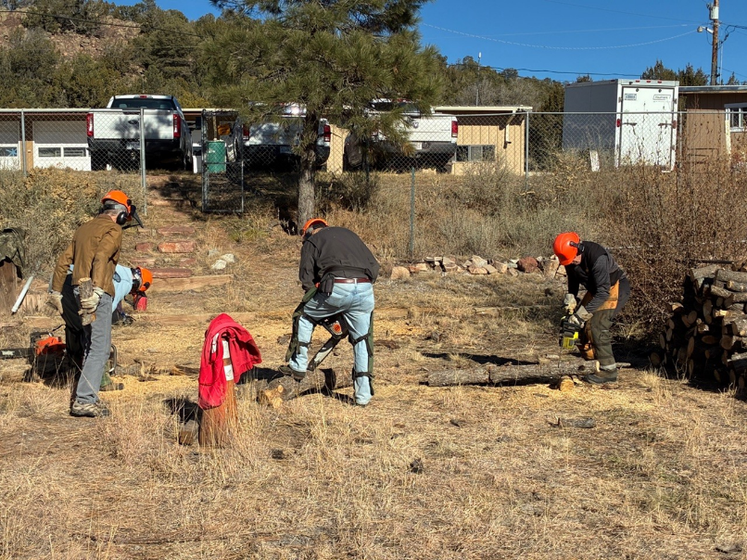
L to R: Eric Russell, Jerry Carroll, and Steve Roholt are completing the project by bucking the last logs.
Sim Cook is carrying a piece of wood to the pile.

