Thursday, 12/11/25- La Luz: It’s December, but after a cool, 1.5 mile hike the day turned into a gorgeous, almost hot, 60-degree day of work. Twelve volunteers and Jen (SRD) hiked up La Luz Trail to do a bit of work on areas with erosion problems. There are several areas where the trail is getting minimally washed out but we split into two groups and worked on three main areas, using mostly rock work to shore up the trail. We finished at 2PM, just as everyone was getting tired of lugging rocks of every shape and size!

Volunteers: Rich Fagioli, Claudia Bergsohn, Eric Russell, Dorothy Hendrix,
Luis Cuadros, Don Fisher, Roland Stumpf, Tony Pachelli, Jim Houle, Kerry Jones, John McNett and Laura Leon

Pictures: Luis Cuadros, Rich Fagioli and Laura Leon

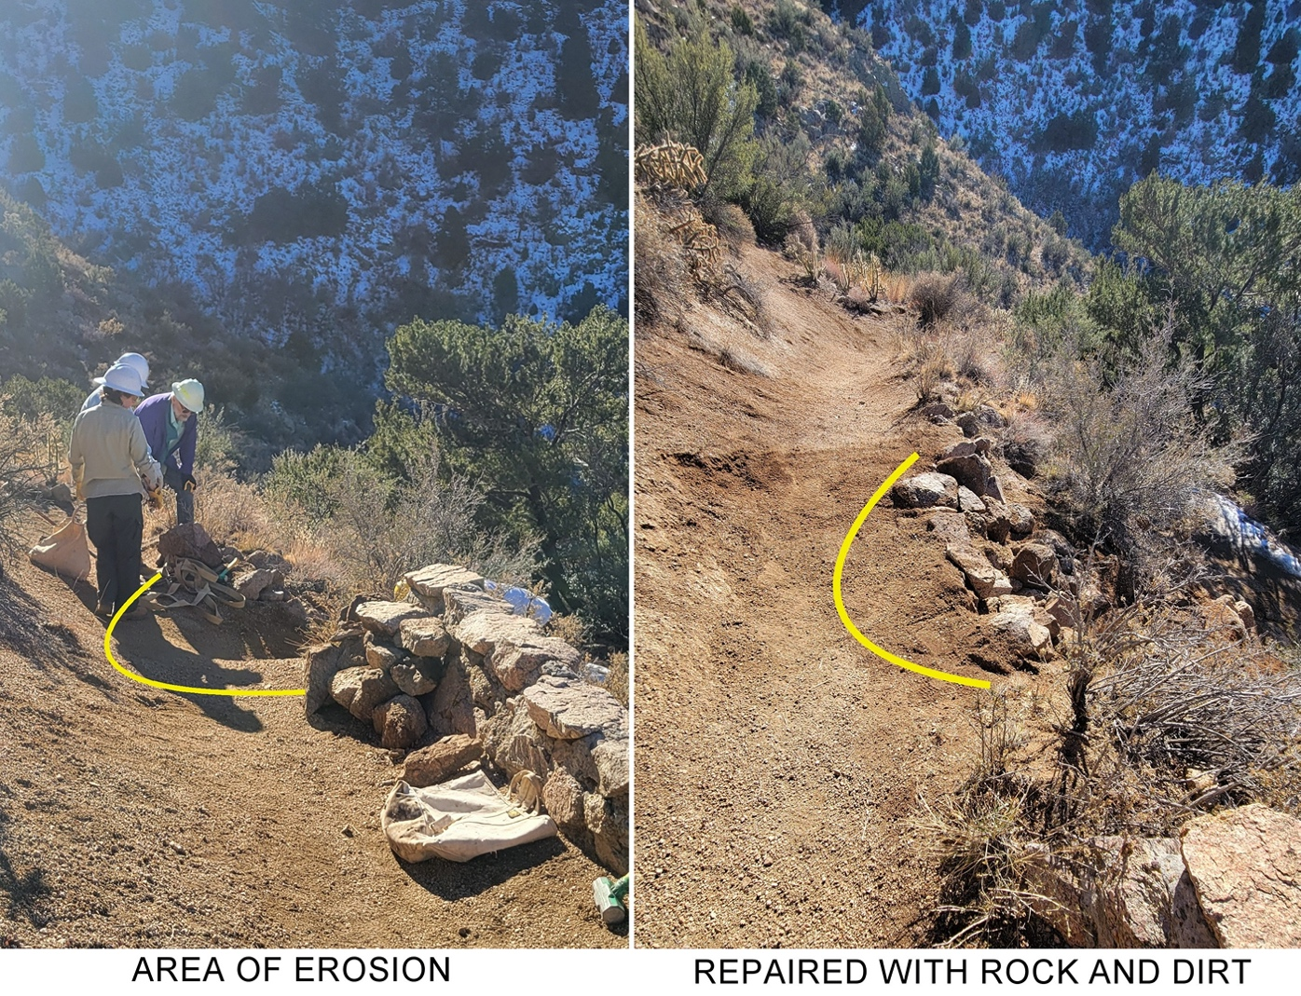

One group moved up the trail about 1.7 miles and worked on this area fitting pieces together like a jigsaw puzzle.
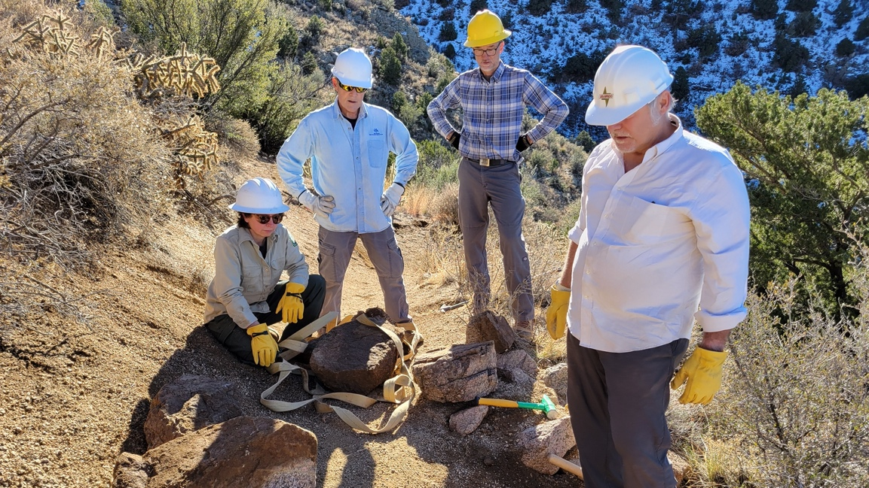

First you start making a collection and then you look them over really, really carefully. Jen, Tony, Roland and Rich are thinking hard, wondering when it will be time for lunch.
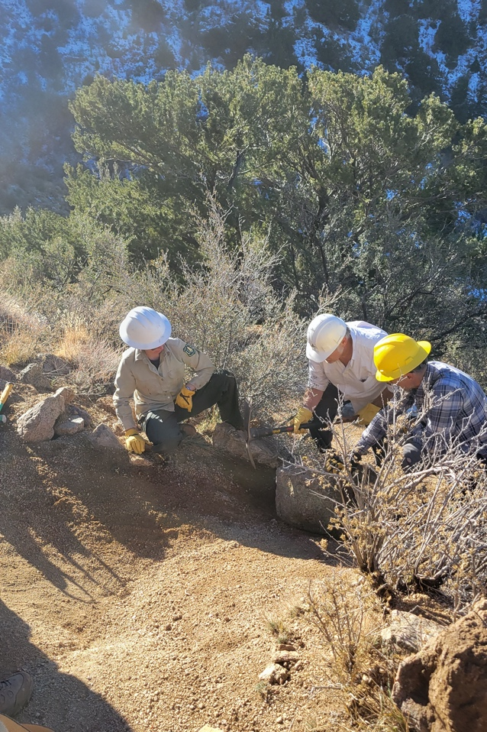

Jen, Rich and Roland make sure the rocks are touching each other, fitting in snuggly.
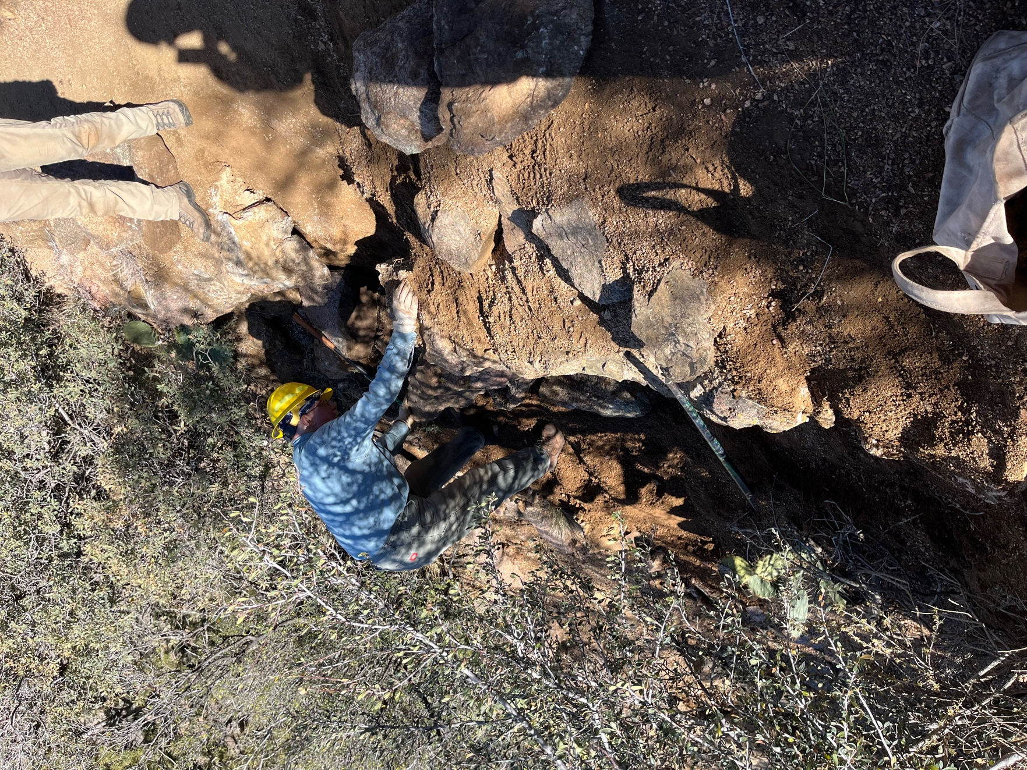

The other group worked on this area of concrete and rock that had split into 2 parts. Eric’s hand is on the section that had dropped down and the other section had really hallowed out underneath the existing rock. The area was fairly steep.
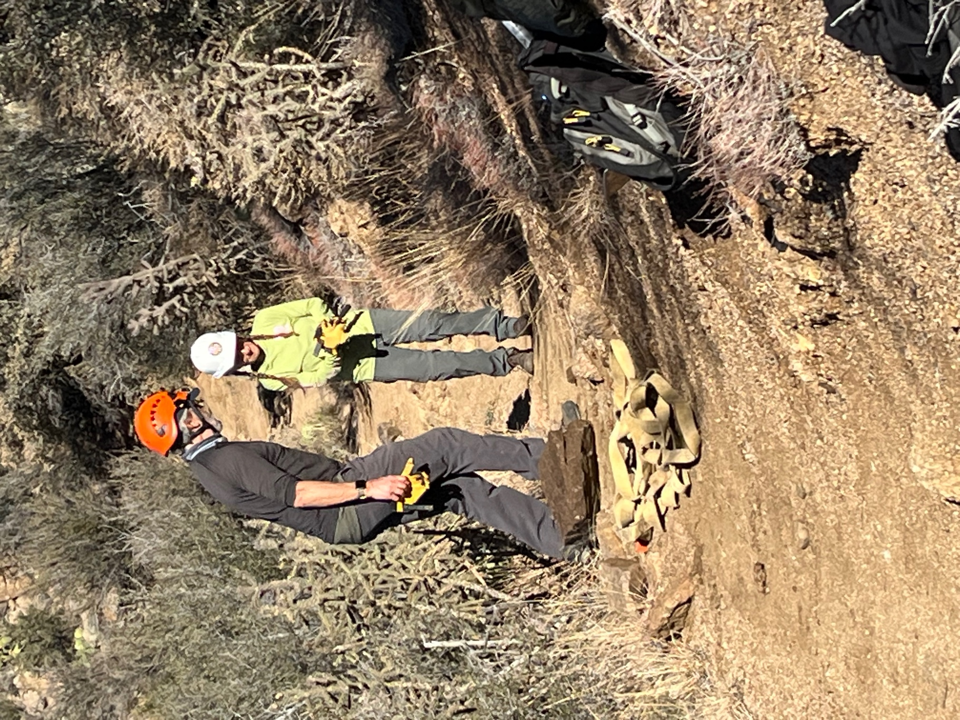

Claudia and Don out shopping for rocks.

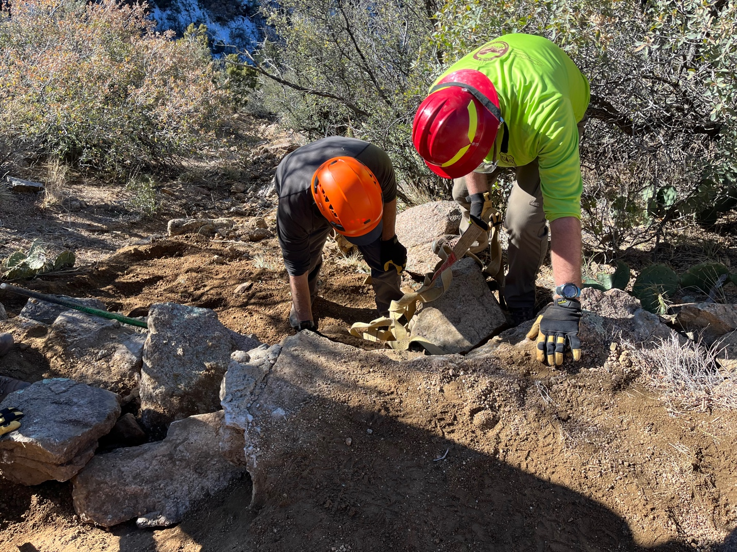

Kerry and Don try to set a large rock without anyone or anything falling down the slope.

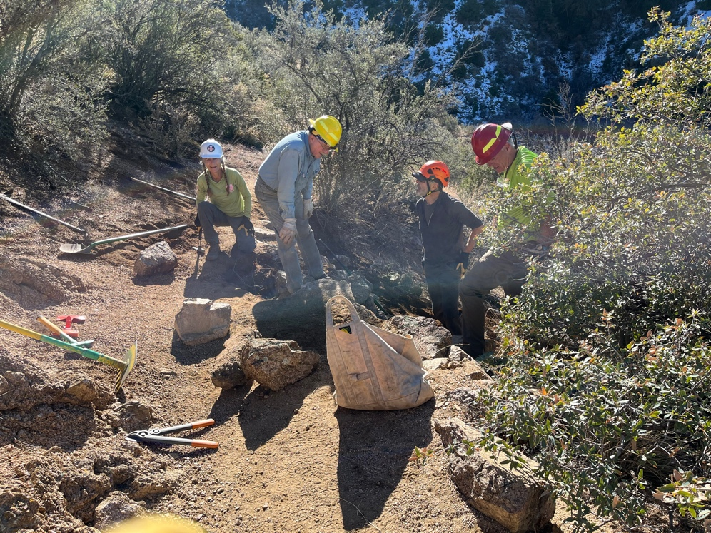

Claudia, Eric, Don and Kerry try to fit it all together. Laura gathered lots of rocks to make crush.
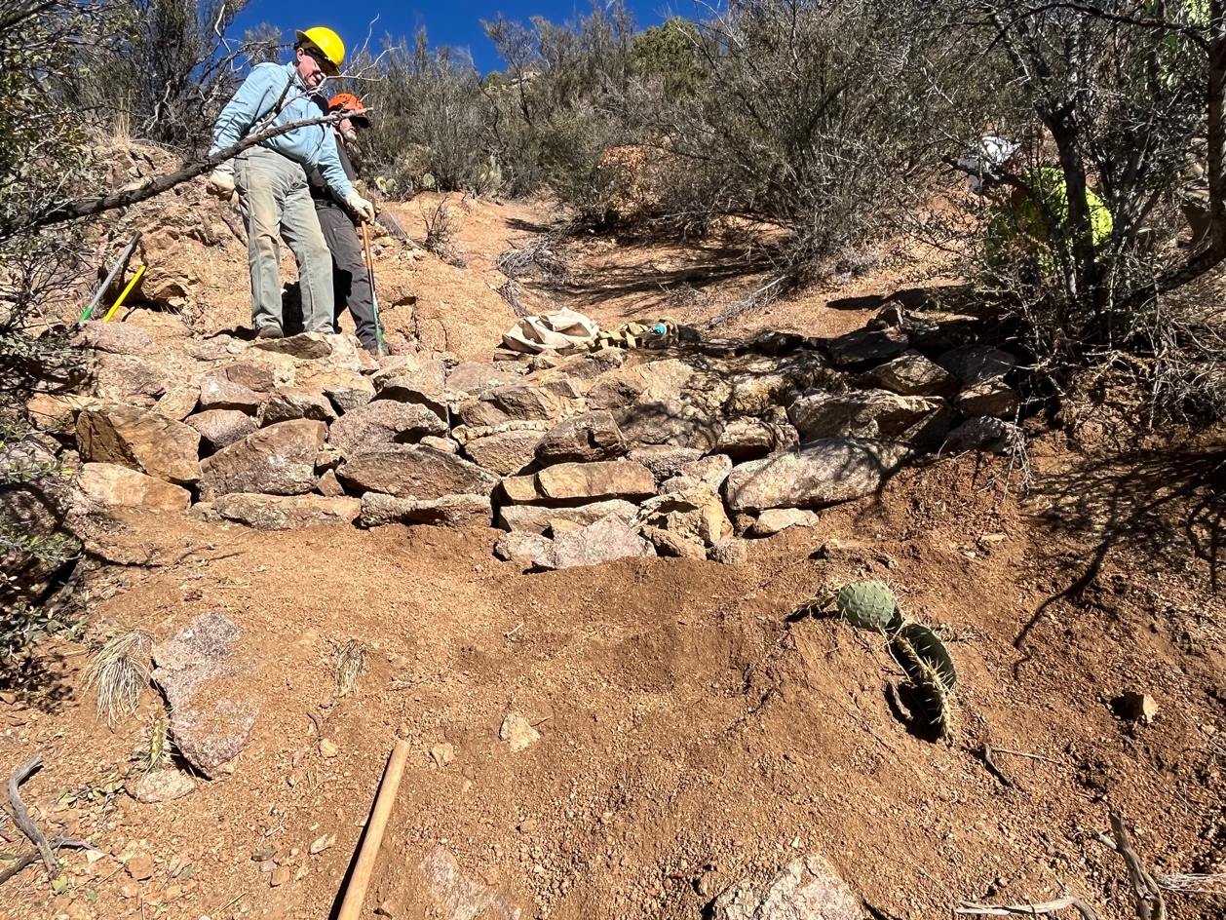

Almost finished.

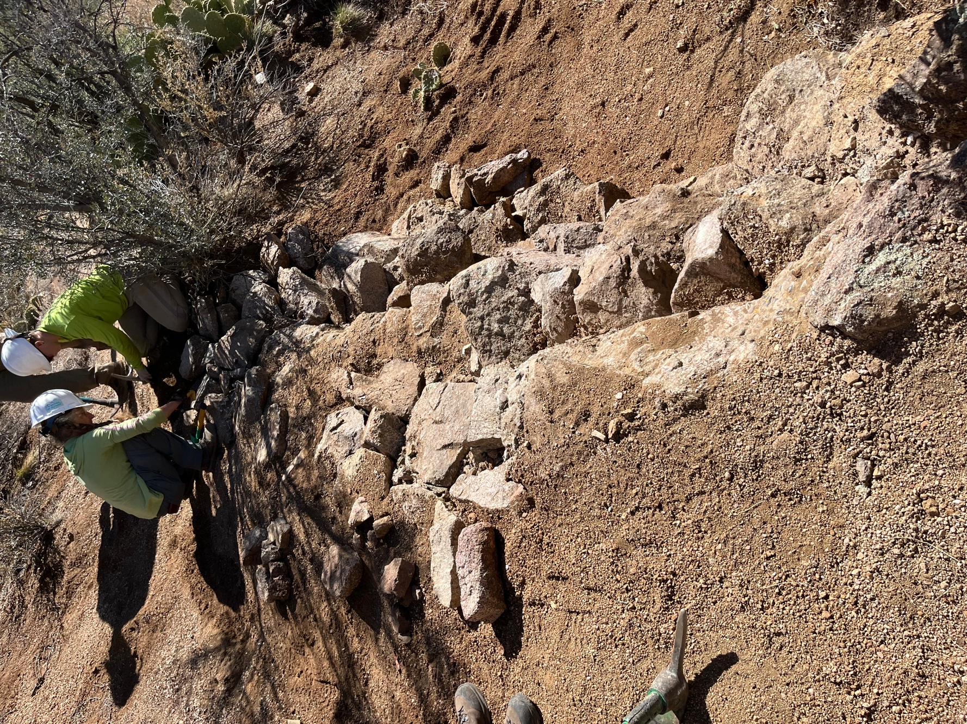

Claudia and Dorothy finish up the final corner rocks.

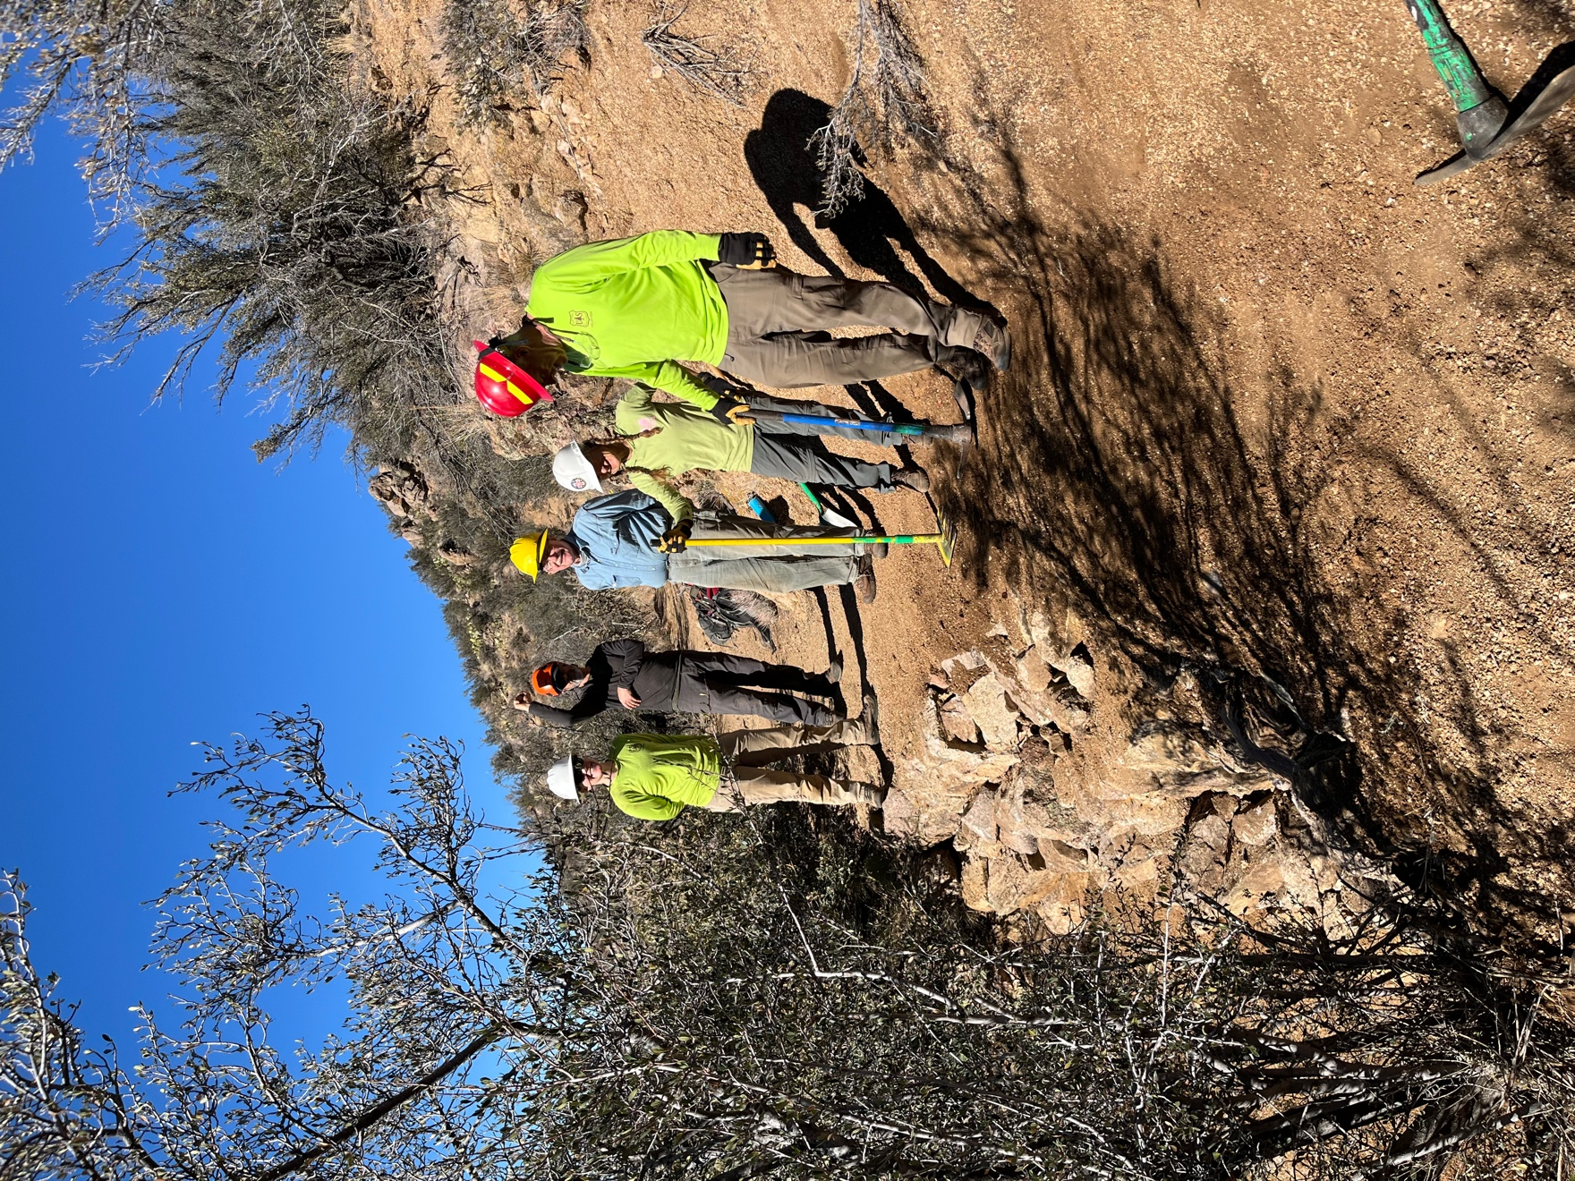

It took all day but it was a success.
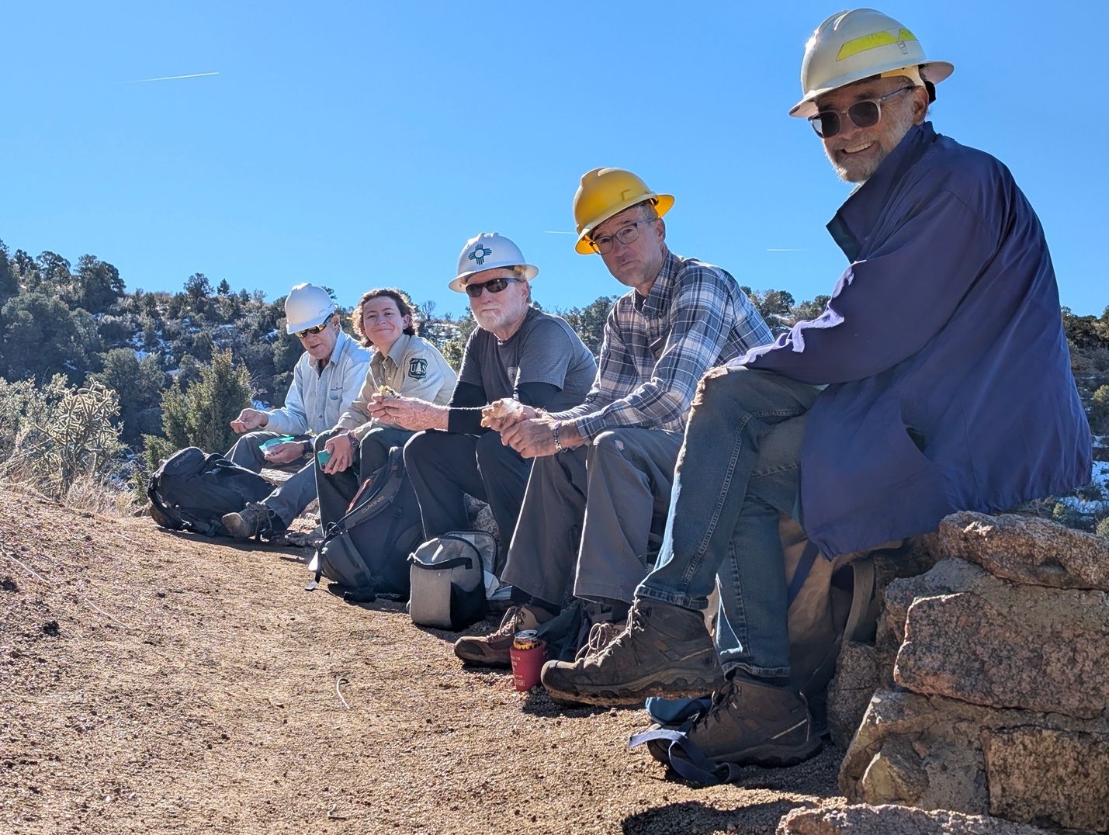

Meanwhile the other crew moved onto another eroded area and made the decision to have that lunch. L to r: Tony, Jen, John, Roland and Jim.

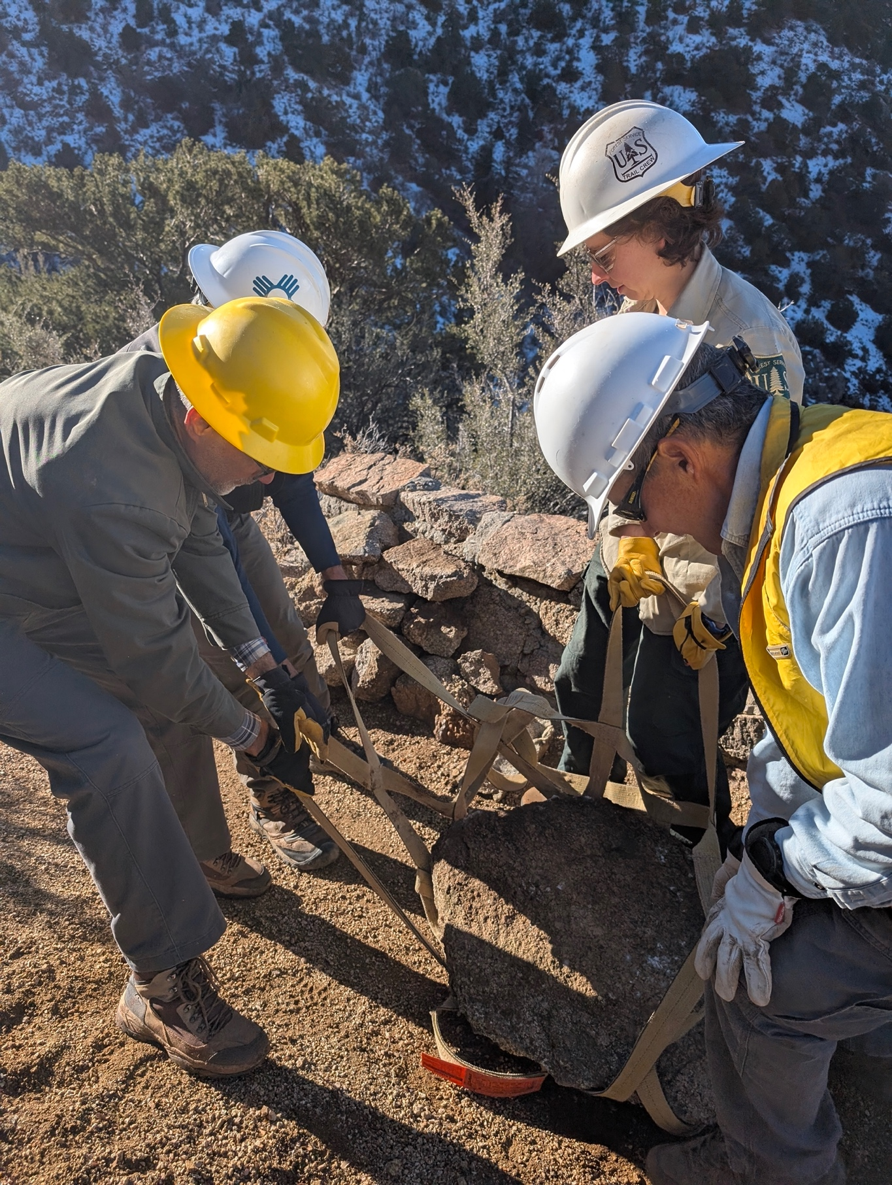

I think everyone got the chance to move some boulders.

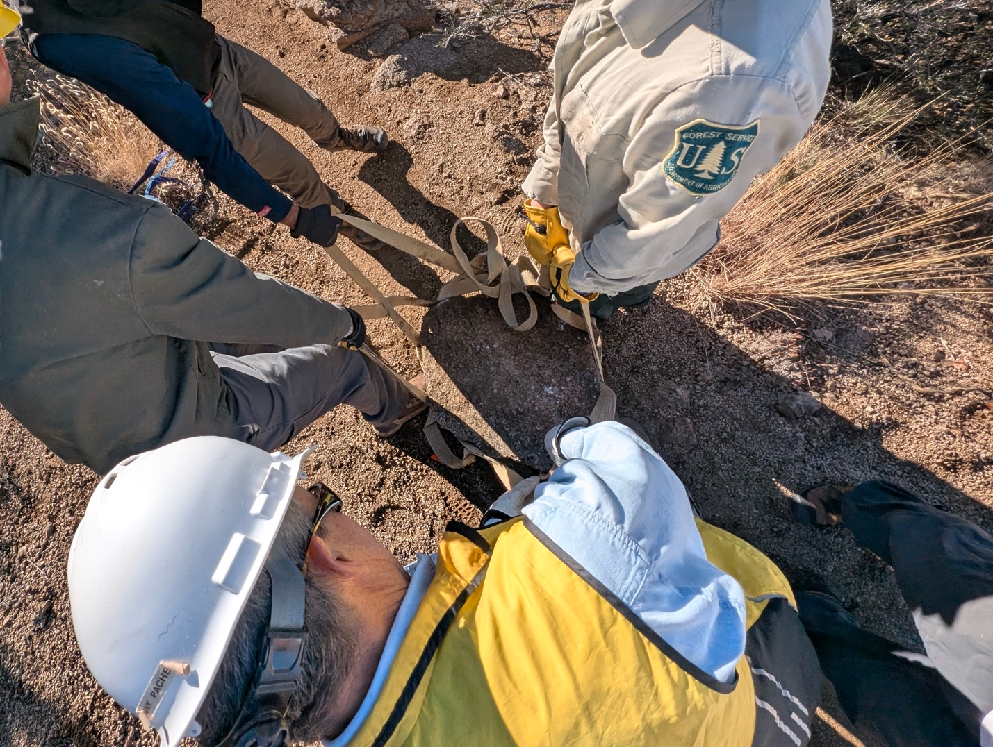

Bird’s eye view.

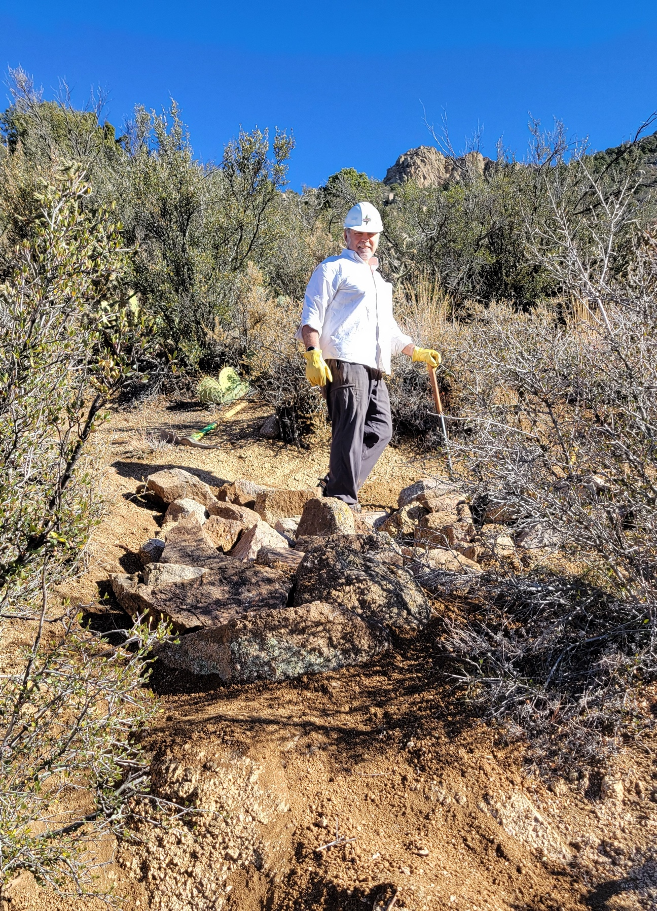

Rich had some fun today!

