Report of Several Graffiti Tags on Boulders near the Small Parking Lot across Forest Road 333E from the Upper Restroom
in Juan Tabo Picnic Area, Sunday, January 4, 2026

Sam Beard
On Sunday morning, January 4, I hiked the relatively new trail from the upper Juan Tabo Picnic Area restroom to La Luz Trailhead. During my return hike, I went to a group of boulders located north of the trail I hiked up on. In an area where I had removed tags in the past, I found one very large tag and about a half-dozen smaller tags that are shown in the photos below.
In an email I will announce an outing to remove these tags on Tuesday, January 6.

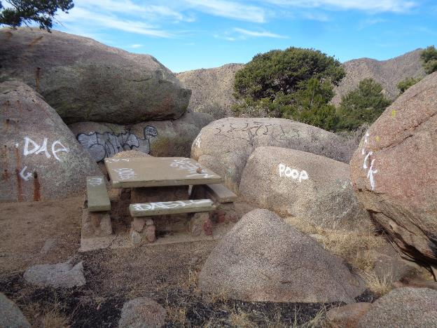
Graffiti tags on boulders and picnic table east of the small parking lot that is across Forest Road 333E from upper restroom in Juan Tabo Picnic Aea. All photos by Sam Beard

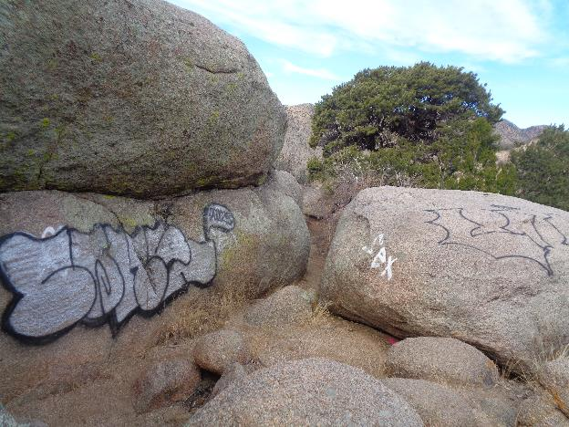
The largest tag near the picnic table in the above photograph.

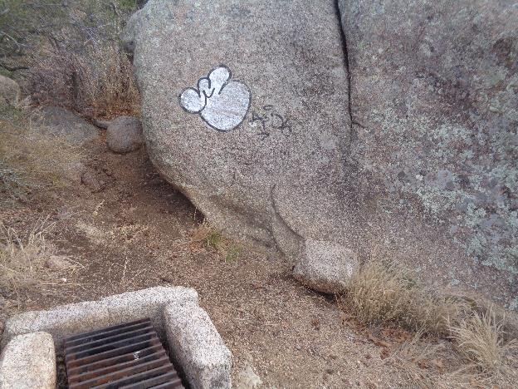
Small tag on boulder near the large tag above.

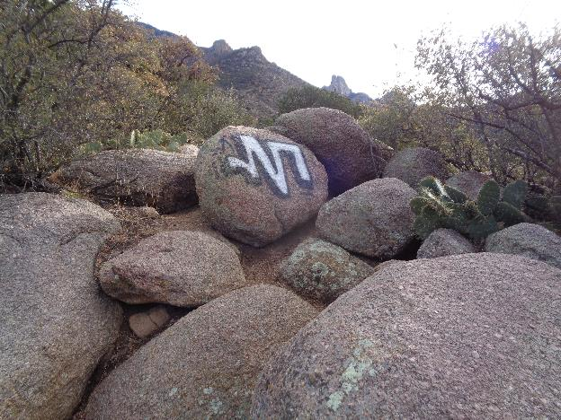
Graffiti tag on boulder that is located just north of the lower part of the relatively new trail
from the upper Juan Tabo Picnic Area restroom to La Luz Trailhead. Photo was taken standing
in the small parking lot across FR-333E from the upper Juan Tabo PA restroom.

