Report of Graffiti Removal from Boulders in Juan Tabo Picnic Area, Tuesday, January 6, 2025
Sam Beard
On Tuesday, January 6, FOSM volunteers Pauline Ho, Rick Buss, Sim Cook and Sam Beard removed graffiti tags from boulders northeast of the upper Juan Tabo Picnic Area restroom. Black, white, and silver tags were removed with a chemical for removing tags from brick, stone, and mortar sold by the World’s Best Graffiti Removal System Company in California. Some of the white paint was thick and not all of it was removed. These were old tags, because very small patches of a low-growing lichen-type of plant was found on top of the paint. Three coats of the chemical were applied to most of the tags. The FOSM low pressure (550 psi) battery-powered washer was used to remove the gray residue of paint and chemical. In addition to working on the large group boulders, we removed two tags on smaller boulders near the small parking lot where we parked.
Project photos are presented below.]

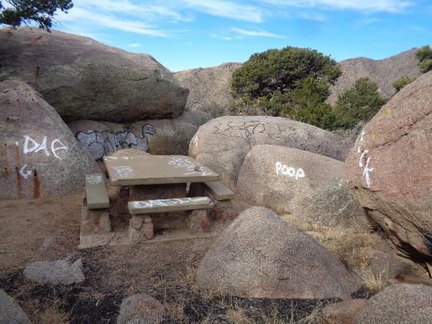
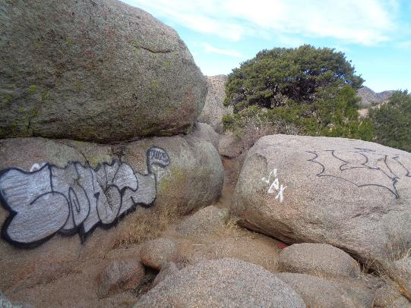
One large graffiti tag and about a dozen smaller tags on boulders and the table located
near the small parking lot across Forest Road 333E from the upper Juan Tabo restroom.
All photos by Sam Beard

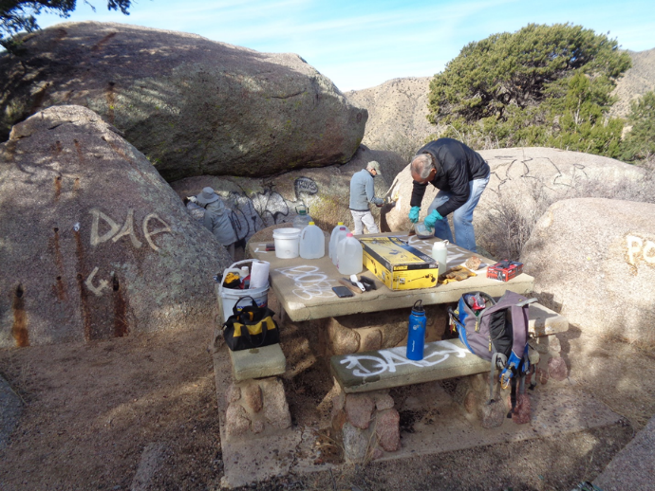
FOSM crew removing tags from the boulders with a chemical for removing tags
from brick, stone, and mortar from the World’s Best Graffiti Removal System Company.

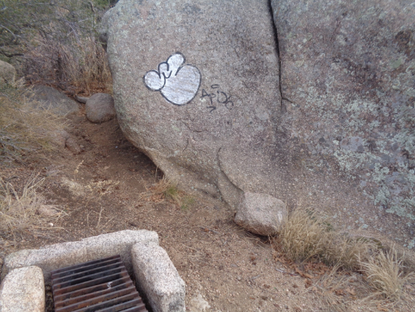
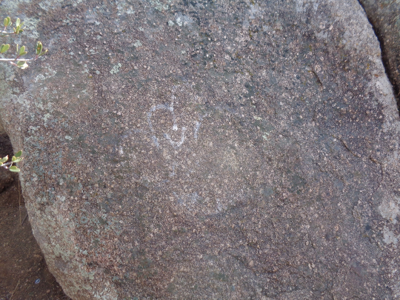
Top – Small tag on the other side of the largest boulder.
Bottom – Most of this tag was removed.

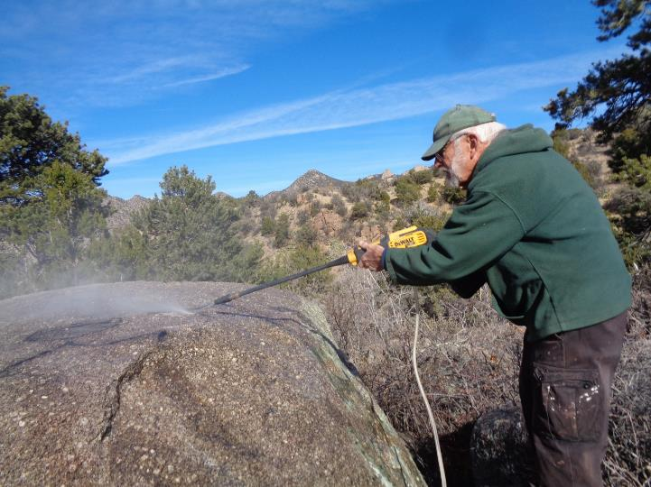
Sam Beard using the FOSM low pressure washer to remove the paint and chemical residue
from the top of this boulder. Only one application of the chemical was required
to dissolve this black paint.
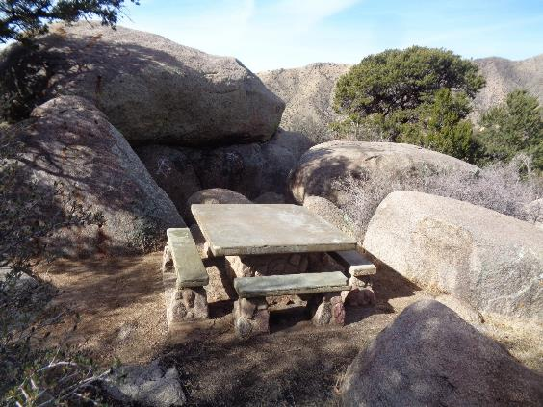
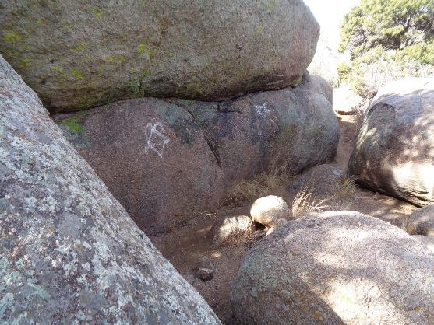
The boulders after most of the tags had been removed. The silver and black tags were
completely removed. The white paint was thicker and not all of it was removed.

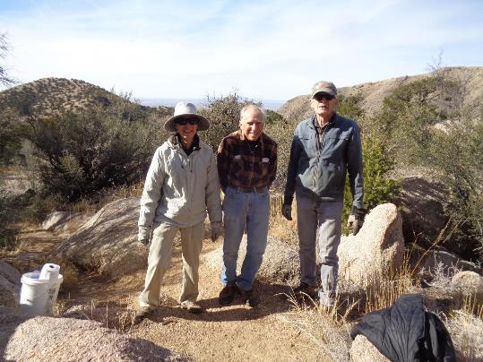
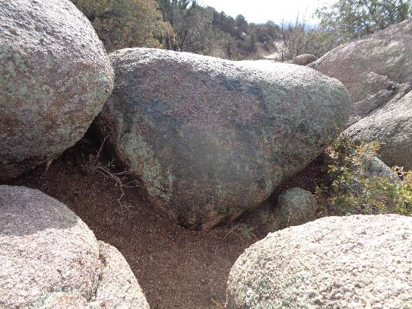
Top - The graffiti tag removal crew. L to R: Pauline Ho, Rick Buss, and Sim Cook.
Bottom – A small blue tag was removed from the center boulder.
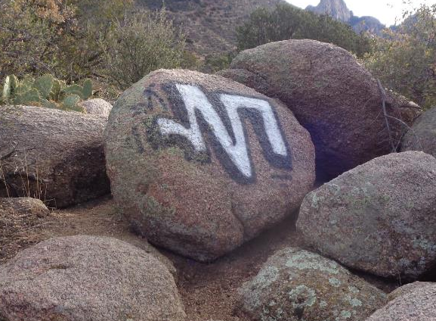
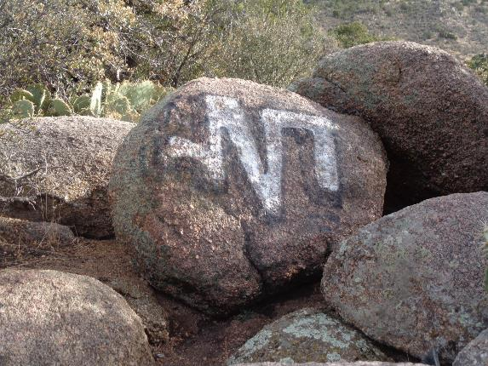
Most of the black and some of the white paint on this tag was removed.

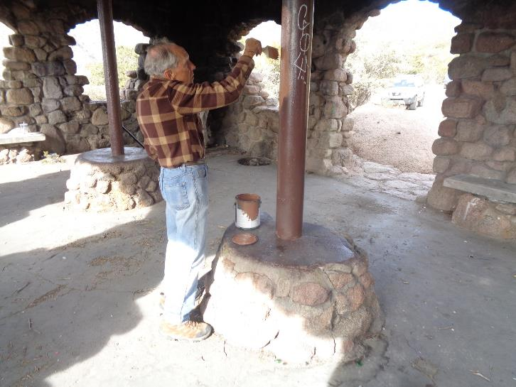
After we completed working on the boulders, we moved down to the Juan Tabo CCC picnic shelter.
This shelter is a favorite site for tags, but on Tuesday, the only tag was a small white one on this steel post.
Rick is painting over this tag. We also swept the floor after we had lunch here.

