Report of New NMDOT Gate on Crest Highway just Past Sandia Peak Ski Area,
Wednesday, January 7, 2026

Sam Beard
The New Mexico Department of Transportation (NMDOT) has completed construction of a gate on the Crest Highway just past the Sandia Peak Ski Area. The gate will be closed after storms to allow the DOT to plow the upper highway without vehicles being on the road. I got an email stating that the gate had been closed today after the recent storm. Note that the color of the gate matches the color of the Doc Long Picnic Area main gate.
Photos of the gate are presented below.

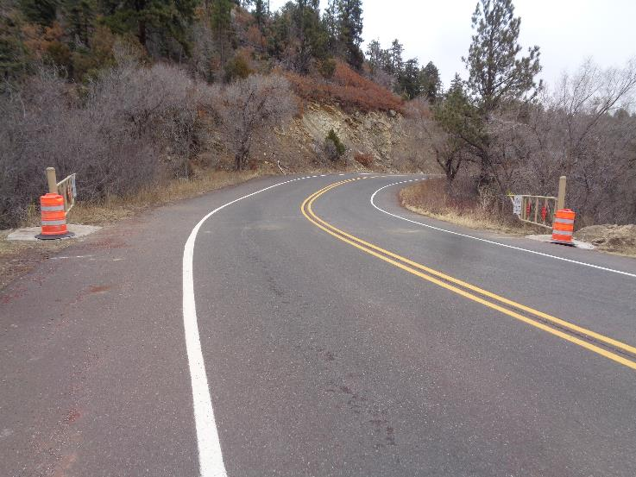
View of the gate going up the highway just past the Sandia Peak Ski Area.
All photos by Sam Beard

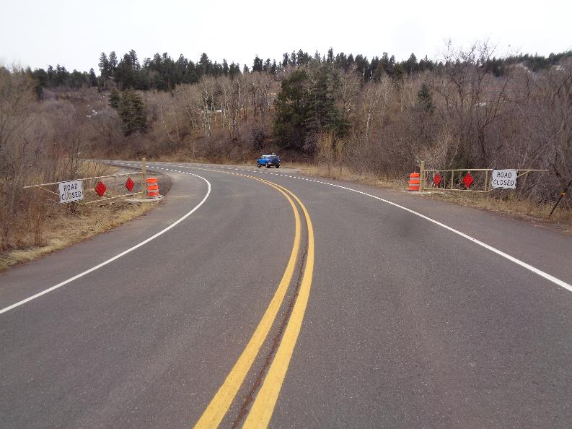
View of the gate going down the highway.
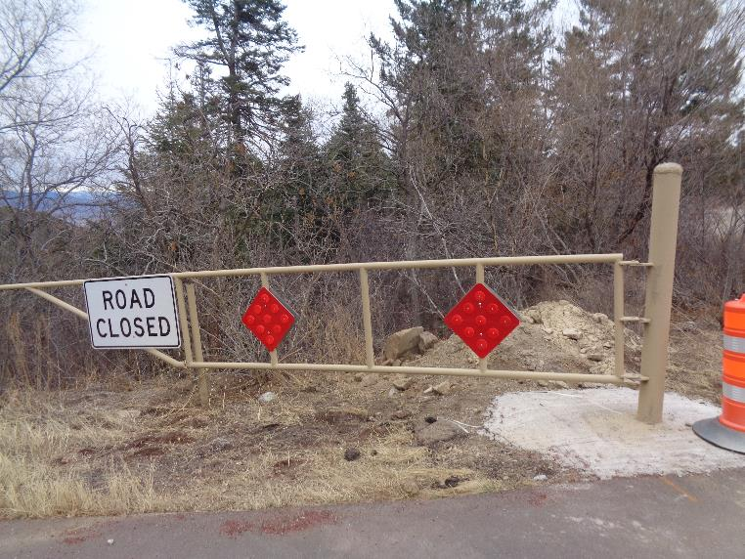
East gate.

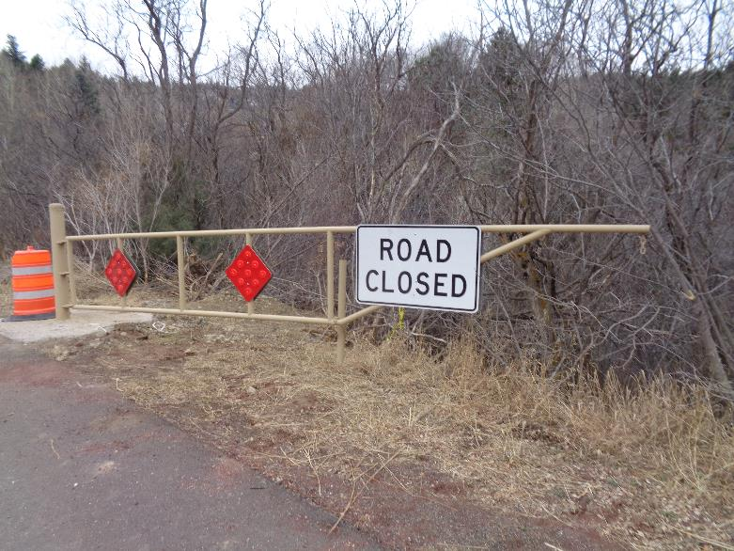
West gate.

