Report of Removal of Graffiti from Sandia Crest Plaza on Wednesday, January 7, 2026
Sam Beard
At the request of Julie Padilla, Sandia Ranger District Recreation Staff Officer, Sam Beard and his grandson, Garrett, removed three graffiti tags from the Sandia Crest Plaza on Wednesday. This area is located between the upper parking lot and the front of the Crest House. The air temperature was 29F. Tags on the Crest House front wall and door were painted over with brown paint. The blue paint on the restroom wall was partially removed with the World’s Best Graffiti Removal System chemical for brick, stone, and mortar.
Project photographs are presented below.

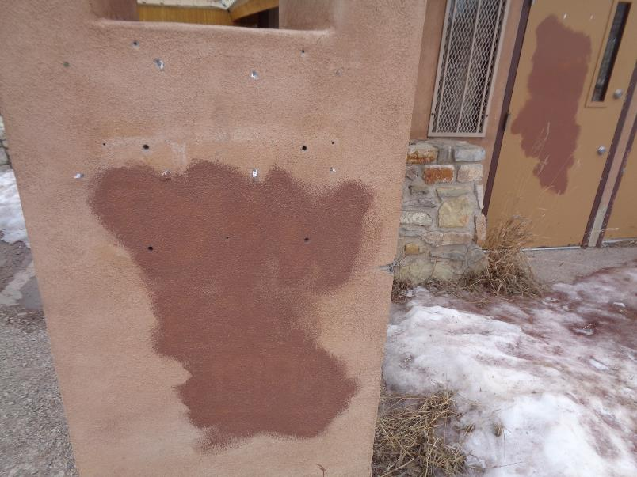
Tags on the front of the Crest House wall and a door were covered with brown paint.
All photos by Sam Beard
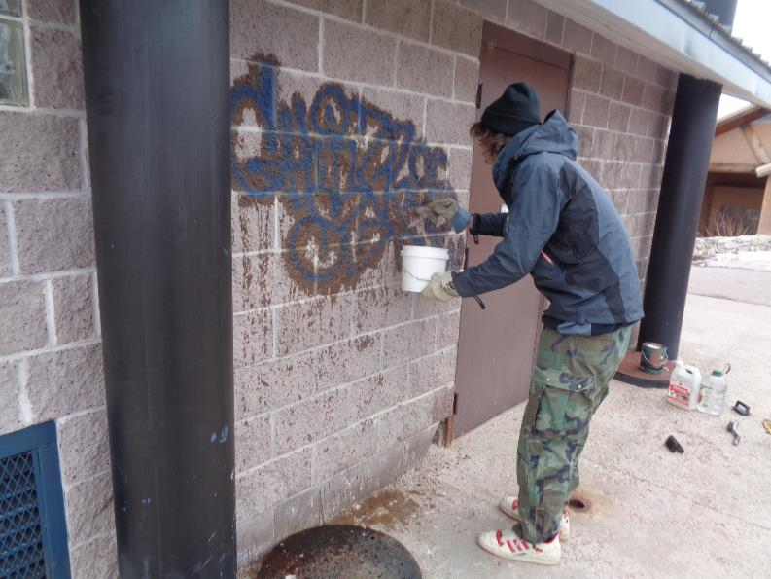
Garrett applying the chemical for removing tags from mortar, brick, and stone by the World’s Best Graffiti Removal System
in California. Note how blue the paint was. Garrett also painted over small tags inside one of the restrooms.
All photos by Sam Beard
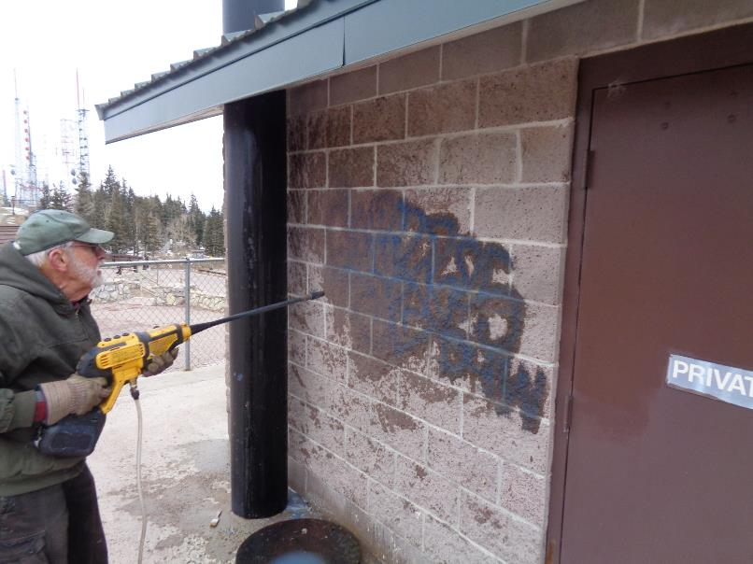
Three coats of chemical were applied to the paint. Sam is removing the paint and chemical residue
with the FOSM battery-powered low-pressure washer.
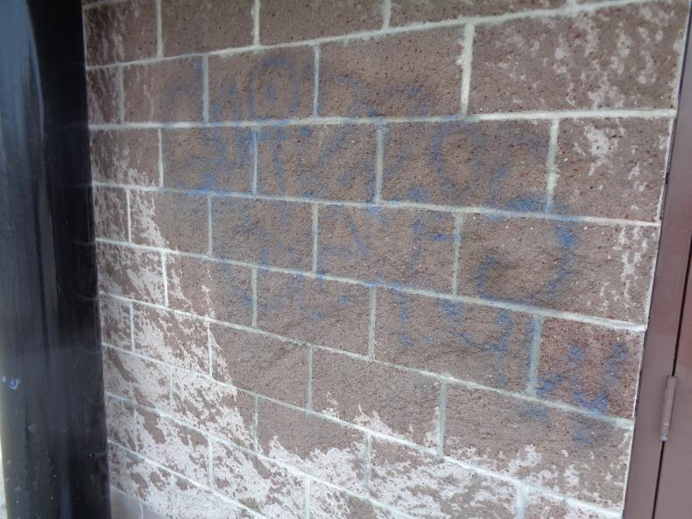
Much of the blue paint has been removed. The temperature was 29F, and we did not have time to repeat
the tag removal procedure. We can try to remove more of the blue paint when the weather is warmer.
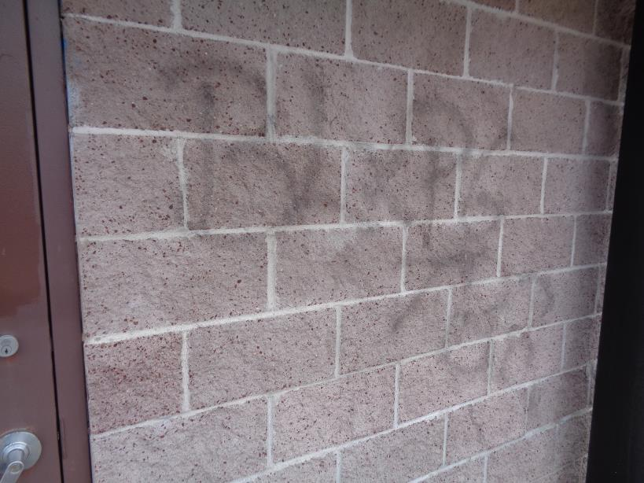
Several months ago, we removed most of this black tag from the adjacent wall. The concrete blocks are very porous,
the paint is absorbed, and it is very difficult to remove all of the paint.

