Thursday, 01/15/26- Piedra Lisa: Our group of 8 volunteers joined Jen (SRD) and spent Thursday up on Piedra Lisa doing some brushing. It was a chilly start but as soon as the sun hit us, the jackets came off. We hiked and brushed starting at the wilderness area sign and worked our way through pockets of ice, snow and mud but conditions were not too bad. We made it to the top of the trail where the snow became too deep to do any brushing on the north side of the trail. Hikers appeared around lunchtime. We took down some cholla on the low end of the trail as we hiked out. Great view and great company! It was nice to be back out working.

Volunteers: Byron Garner, Jim Houle, Larry Larrichio, Roland Stumpf, Rich Fagioli,
Kerry Jones, Bill Perkins and Laura Leon

Pictures: Laura Leon

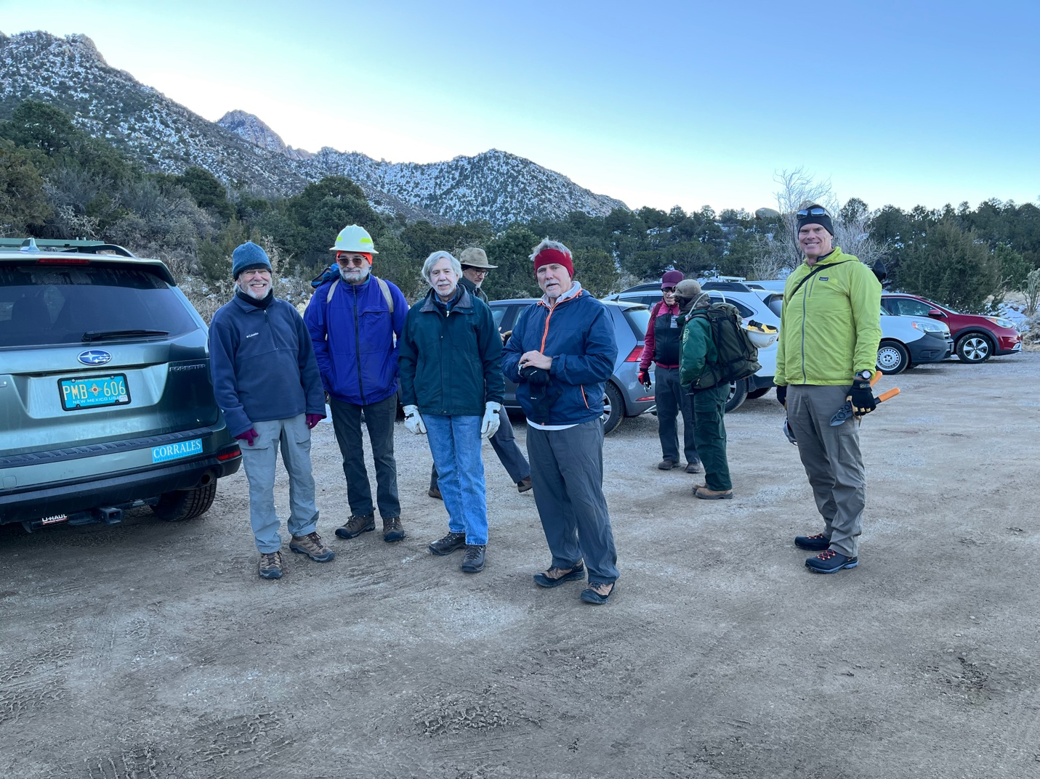

What an enthusiastic crew!! We love brushing- well some of us…
It was chilly until the sun managed to find us.

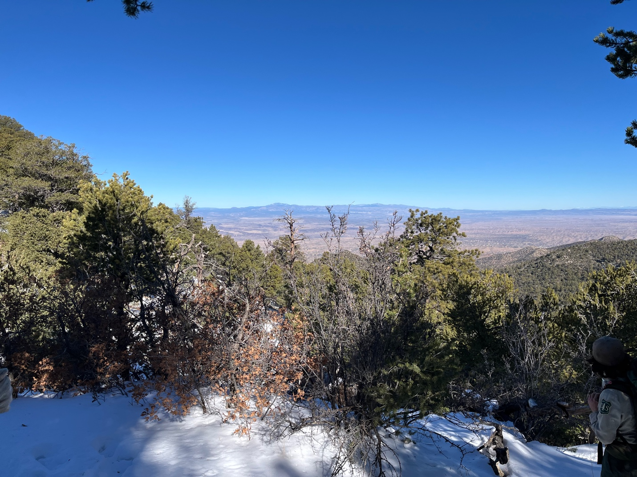

Up at the top there was plenty of snow. In fact too much to allow us to brush down the north slope.

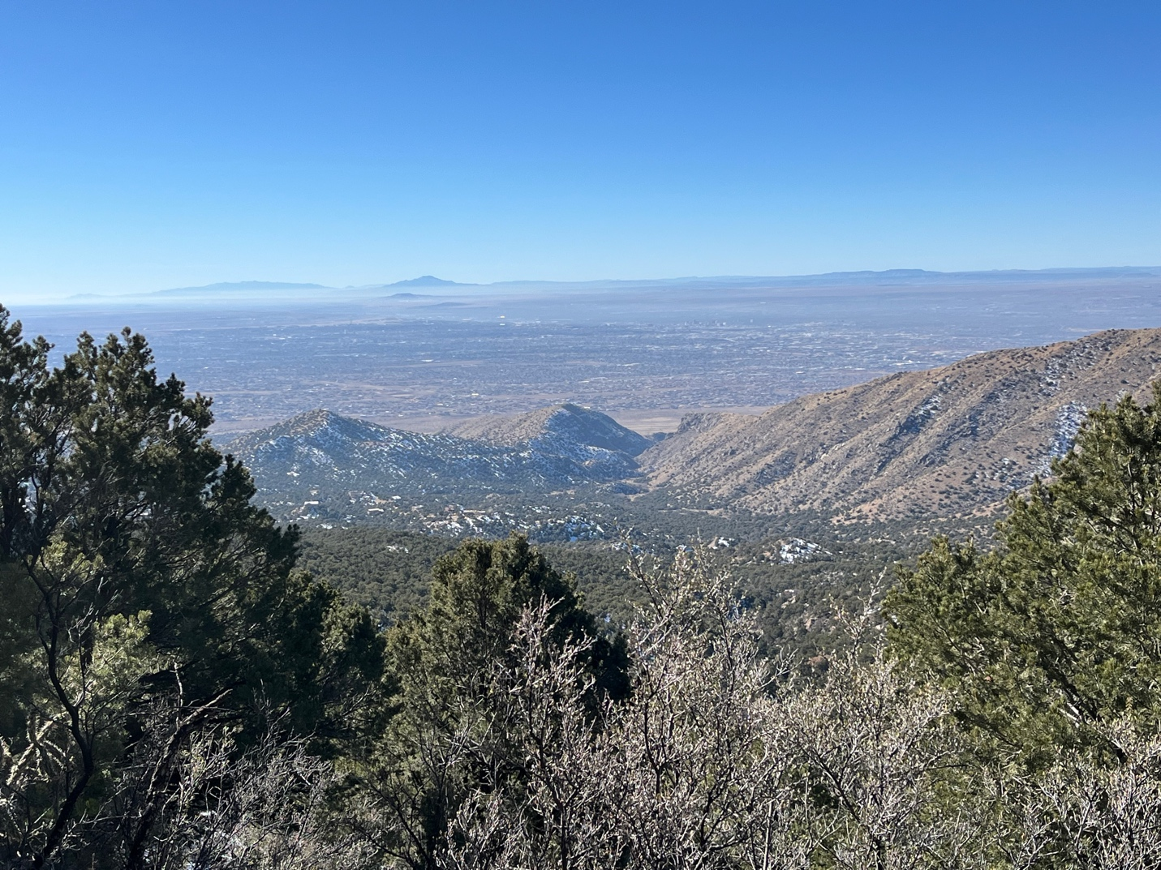

Great views along the way.

