Report of a Project to Begin Construction of Tool Racks and Hangers
in the New FOSM Container, Wednesday, January 21, 2026

Sam Beard
On Wednesday, five FOSM volunteers began construction of racks and hangers in the new 8-foot by 20-foot container south of the FOSM Guard Station. Vertical 2x4s were installed on ten steel tiedowns along the sides of the container so that there would be wooden supports to which tool racks and hooks could be attached. At the west end of the container high on the north wall hooks for long handle loppers were screwed into a 2x6 attached between two vertical 2x4s. Below the loppers, a tool rack was installed to hold Pulaskis, pick mattocks, and sledge hammers. Hangers for shovels were installed high on the south side of the container. The tool rack will be extended to hold more digging tools, and spaces for McLeods and rock bars will be constructed on the south wall.
The volunteers working on this project were Dan Benton, Cliff Giles, Don Carnicom, Joelle Hertel, and Sam Beard.
Projects photos are presented below.

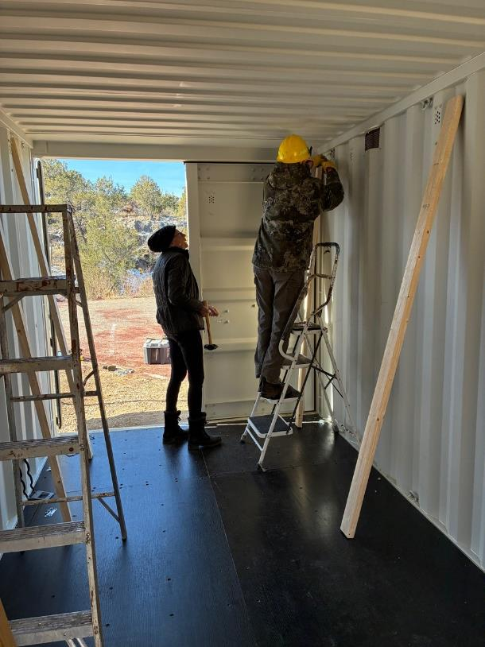
Joelle Hertel observing Dan Benton attaching a 2x4 to an upper tie down with a U-bolt. Five 2x4s were
attached to steel tiedown loops along each side of the container. The tool rack and shovel hangers
were attached to the vertical 2x4s. All photos by Cliff Giles unless stated otherwise.
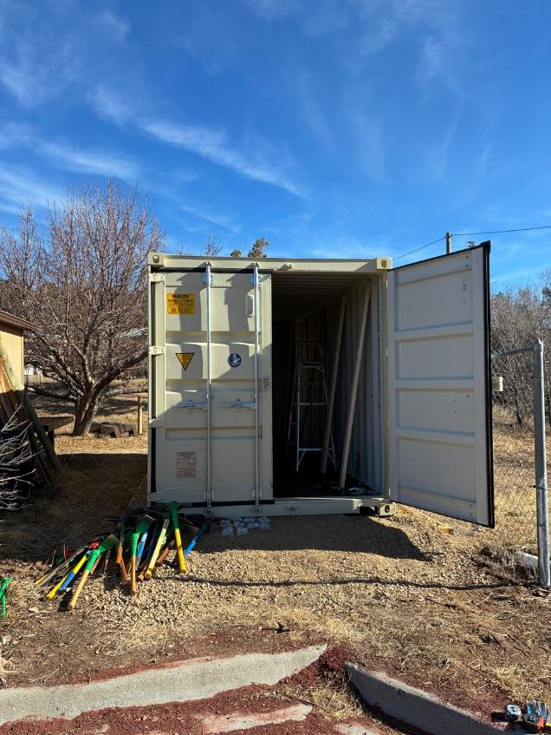
These tools were moved from the FOSM Guard Station and put in the tool rack
when it was finished.
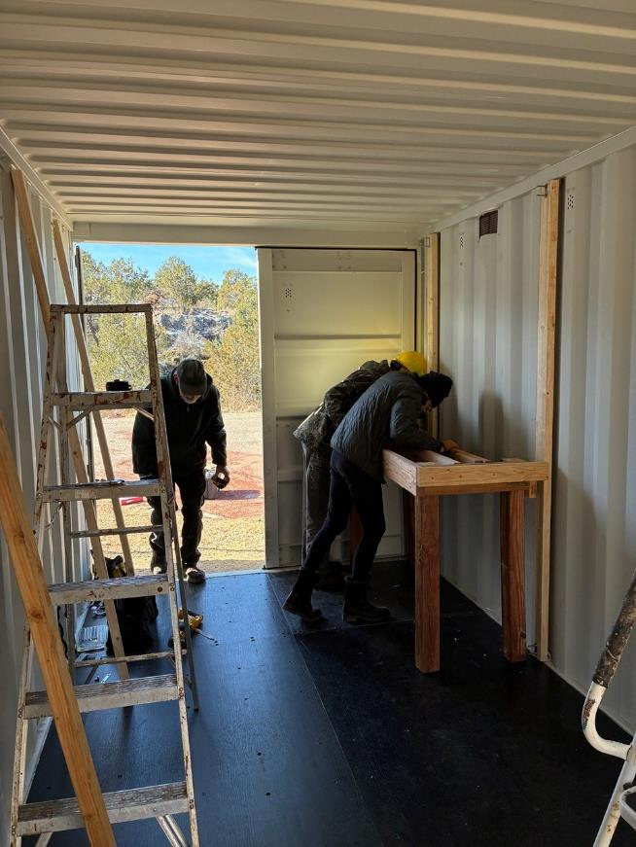
Dan and Joelle are attaching the tool rack to the vertical 2x4 while Sam is entering the container.
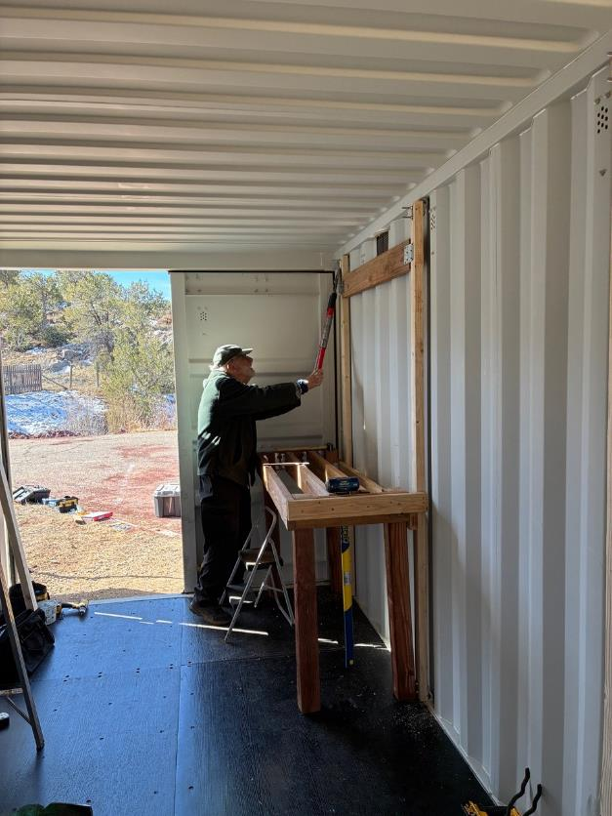
The 2x6 was installed between the vertical 2x4s so that long hooks could be screwed into it.
As part of the planning for the hooks, Sam is holding up a long handle lopper to decide
where to place a hook.
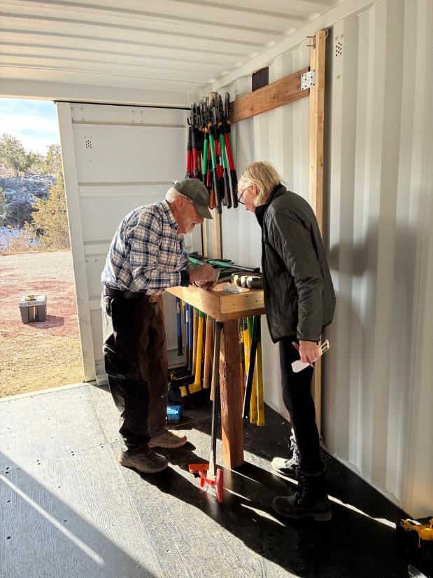
Sam and Joelle planning the extension on the tool rack where Joelle is standing.
Pick mattocks and Pulaskis will be stored in the extension that will include space for
tools purchased in the future.

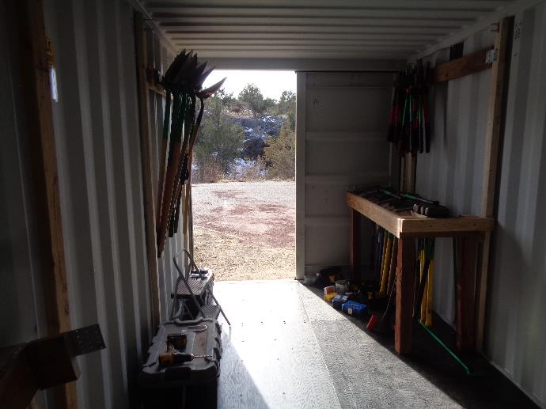
Shovels were hung on the upper left hooks, long-handle loppers were hung on hooks on the
upper right, and pick mattocks and sledge hammers were placed in the lower tool rack.
Additional racks will be constructed to accommodate more digging tools, McLeods, and rock bars.
Photo by Sam Beard

