Trail maintenance Project: Monday, February 2, 2026
Byron Garner

On February 2, the Monday tail crew began a 2.5 mile trek up Embudo trail to the lower switchbacks and continuing work begun by Jen and her crew a few weeks ago. None of us could recall the 1000 foot elevation gain this required and could not figure out how the gradient had changed so much without making headlines. Our efforts were divided between those who tackled the cactus and the remainder going for the abundant overgrowth of apache plum, mountain mahogany, live oak, cedar and pinon pine. Our initial ambition included the quixotic notion that we were going to knock this thing out with one day's effort. One hour later that was revised to include another three more + work days. The shady areas of the upper trail still have stretches of ice and snow which were easily managed with a little caution. The return hike was by way of the Horse Bypass which in the upper area definitely required traction gear. The overgrowth here was also beyond expectations and will require a day or two of good effort. We would also like to very much welcome new member Andrew Chavez to the crew. The crew included Rav Nicholson, Ken Wilson, Susan Gregory, Jamey Browning, John Cooper, Sim Cook, Dave McCreery, Phil Cromer, Steve Roholt, Andrew Chavez and Byron Garner.

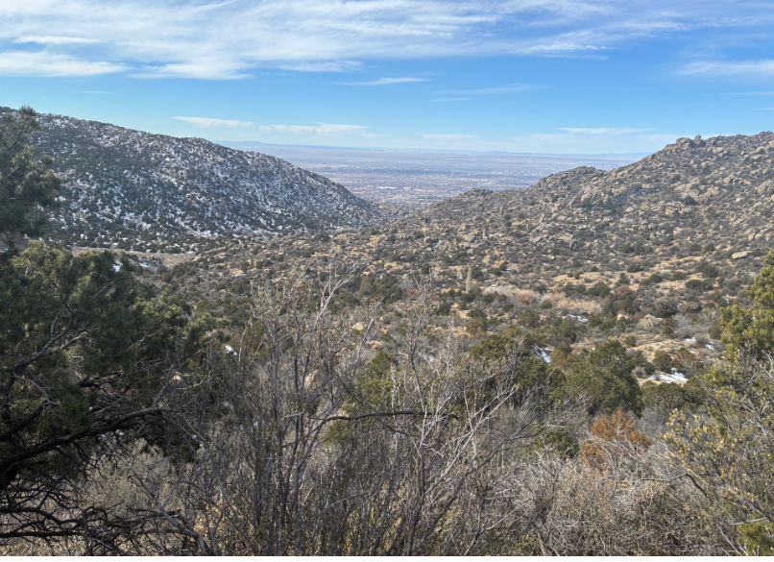John Cooper
A bid hazy but still a great view we all enjoyed

