Report of FOSM Project to Construct Additional Tool Racks in the Storage Container, Wednesday, February 4, 2026
Sam Beard
On Wednesday, February 4, seven FOSM volunteers completed the following tasks in the container and in the FOSM Guard Station:
- Adding a second nut on the U-bolts securing the vertical 2x4s to the lower tie-downs
- Cutting off the excess part of the 5/16-inch bolts in the lower U-bolts
- Installing the wooden frame securing the McLeods.
- Installing 2x8 wooden frames on the floor securing the lower parts of the steel rock bars
- Installing 2x8 wooden frames on the floor securing the lower parts of tools such as two post hole diggers, several hoes used in trail construction, and two tools used to remove old shingles from roofs that are being replaced.
- In the Guard Station, four 2x4 vertical supports were installed from the rafters to the horizontal 2x4s supporting crosscut saws and long pole saws to prevent sagging of the horizontal 2x4s.
The volunteers working on Wednesday were Dan Benton, Cliff Giles, Jerry Carroll, Eric Russell, Don Carnicom, Chuck Logan, and Sam Beard.
Project photos are presented below.

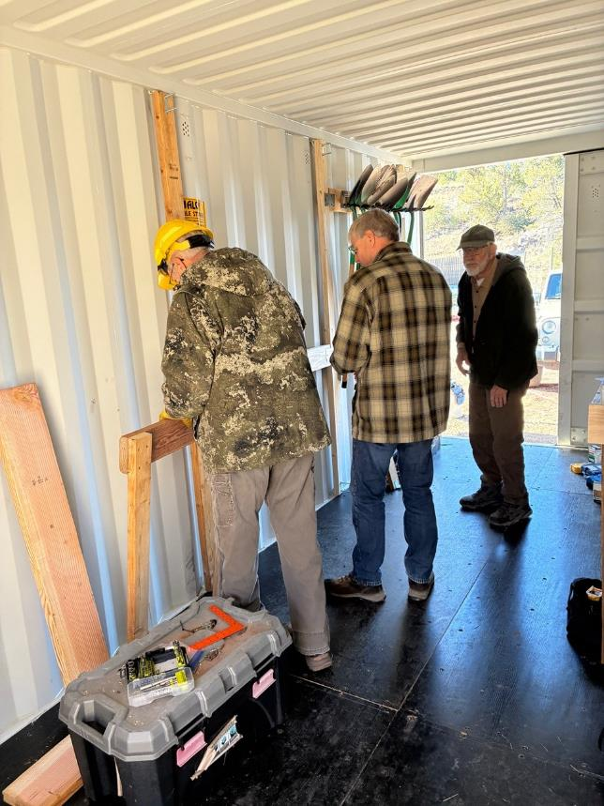
Dan Benton, Chuck Logan and Sam Beard beginning to work on additional tool racks in FOSM storage container. All photos by Cliff Gile, unless noted otherwise.
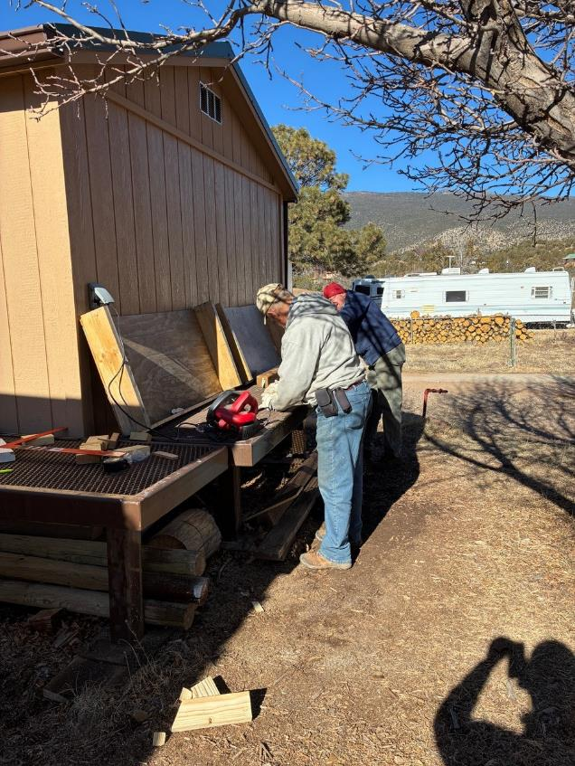
Jerry Carroll and Eric Russel cutting 2x6 lumber to install in container as part of a tool rack.

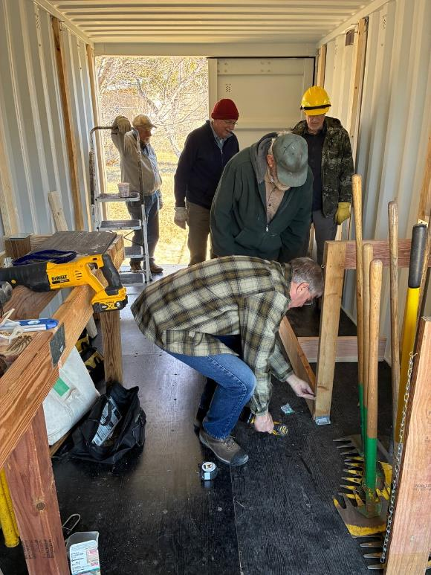
Chuck Logan preparing to install a metal plate between the 2x8 frame for other long handle tools and one leg of the McLeod rack.

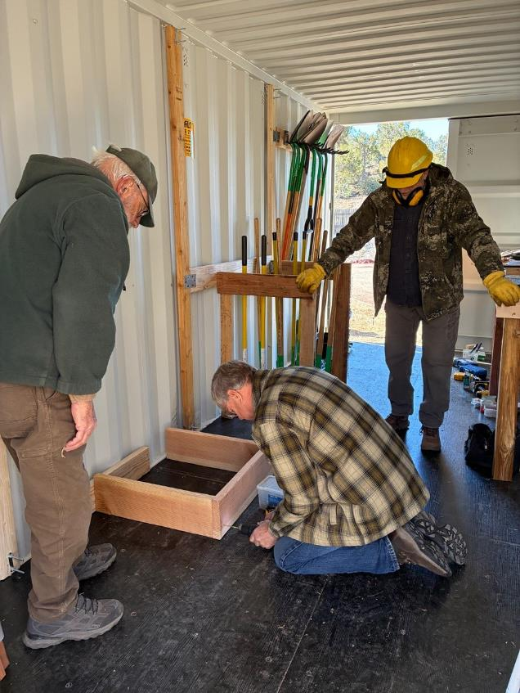
Chuck installing a screw in one joint of the fame for other long handle tools.
Sam and Dan are observing.
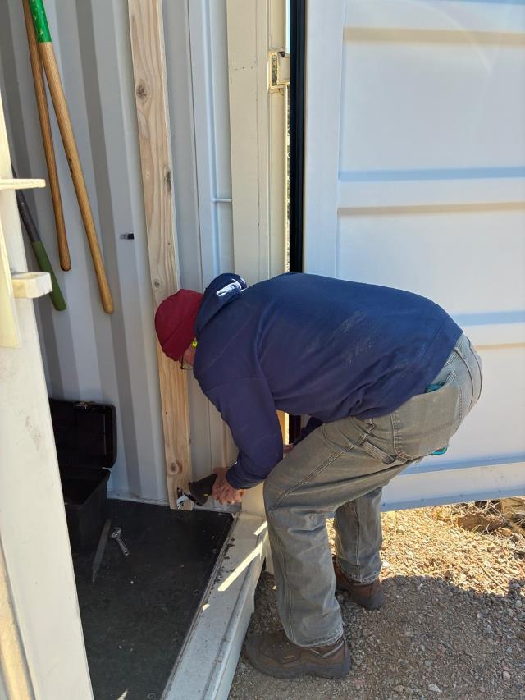
Eric Russell using the FOSM battery-powered saw to cut off the protruding bolt on a U-bolt
securing a 2x4 to the tie-downs.

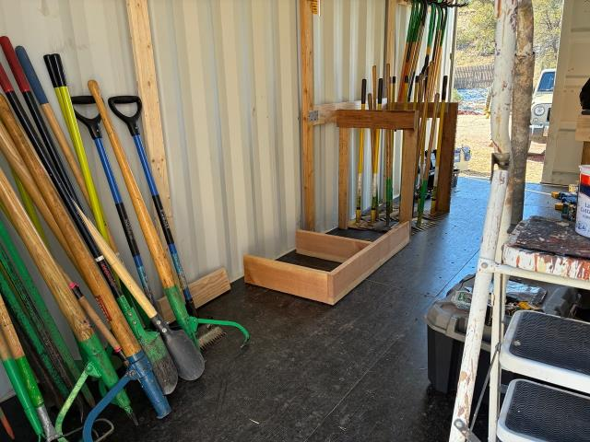
The completed tool racks on the south side of the container.

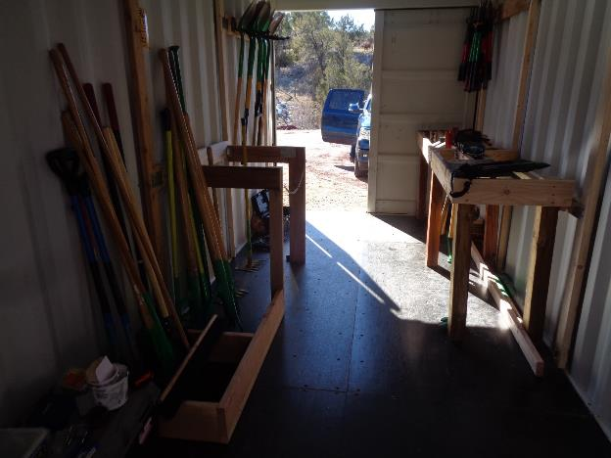
Completed tool racks in the container with some tools in the racks. Laura Leon removed
some tools to use on the FOSM trail construction project on Thursday, Feb. 5. (The long tan-colored
object on the long-handle tool rack in the foreground is the edge of the wide push broom.)
Photo by Sam Beard

