Report of Work on the FOSM Guard Station
and New Storage Container, Wed., Feb. 11, 2026

Sam Beard

On Wednesday, February 11, seven FOSM volunteers worked in the Guard Station and new storage container. In the container, volunteers assembled a steel 4-shelf storage rack, built a shelf to store hard hat on, and began to store boxes of equipment on the shelves. In the Guard Station, volunteers installed a large 2.5-foot by 8-foot steel picnic table on the north side of the building. The bins holding screws, bolts, nuts, and nails was moved from the work bench on the south side of the room to the north side and placed on the new table. A battery charging station will be put on the wall at the west end of the table. Joelle Hertel has ordered several smaller bins to hold many different screws and bolts.

The volunteers were Tim Kirkpatrick, Eri Russell, Cliff Giles, Chuck Logan, Joelle Hertel, Dan Benton, and Sam Beard.

Photos of the project are presented below.

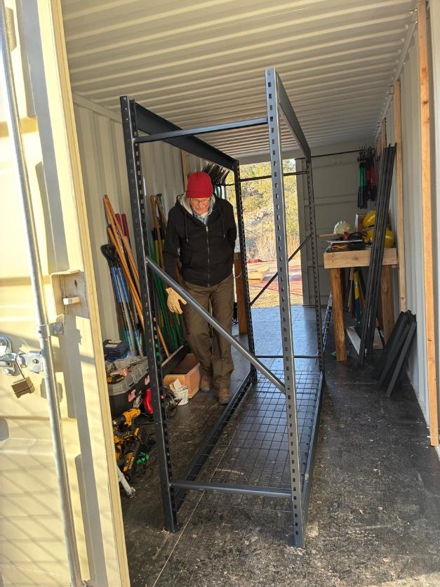
Eric Russell walking beside the new shelf unit. All photos by Cliff Giles

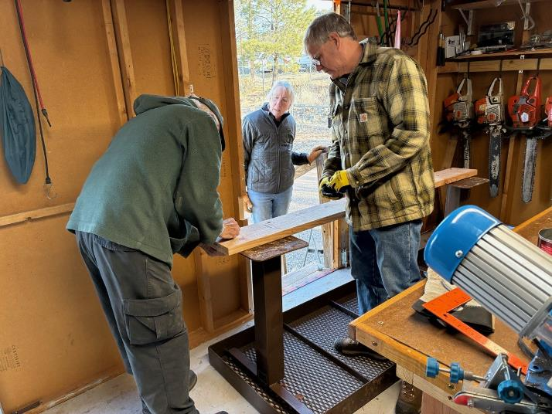
Sam Beard, Joelle Hertel, and Chuck Logan installing the old steel picnic
table in the Guard Station. The 2x8 will be attached to the table base for stability.

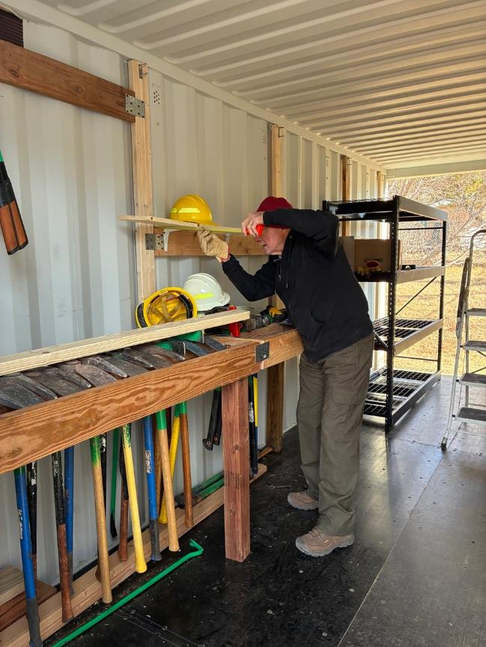
Eric working on the shelf where hard hats will be stored.
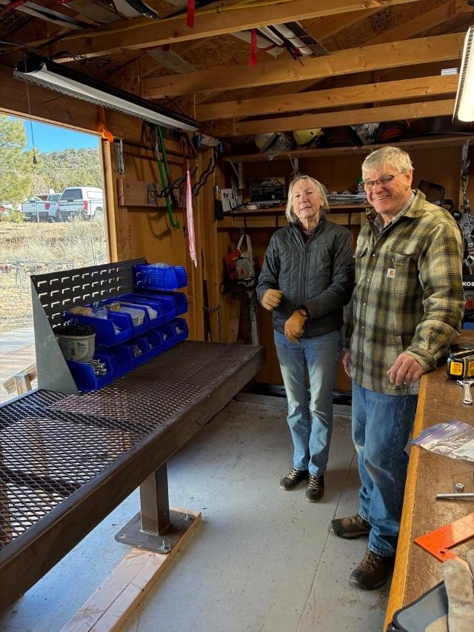
Joelle and Chuck beside the table that has been installed in the Guard Station.
Bins holding bolts, nuts, washers, and screws have been moved to the new table.
The east door can be opened for better ventilation.

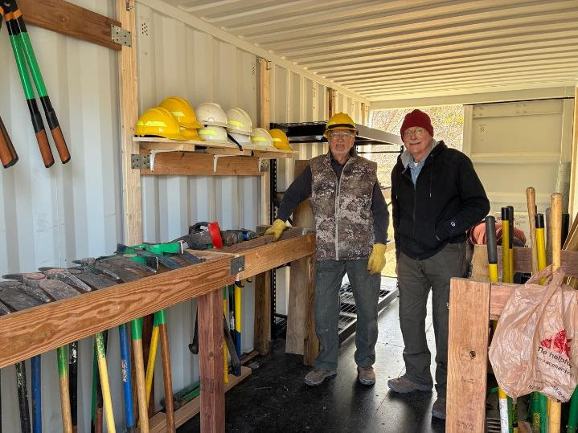
Dan Benton and Eric Russell in the new storage container with a shelf for hard
hats and three racks for tools. Note the new 4-shelf rack for storing equipment behind Dan.

