Thursday, 02/05/26- High Voltage: What a beautiful day! Fourteen FOSM volunteers (!!) joined Chris Casey from PATA and Jen (SRD) for an amazing day in Placitas. The sun was out and the temps were great- fantastic, except it’s all wrong for February. We broke up into groups and worked on several areas. One group spent the day reworking a technical area for mountain bikes that had a jump. The rest of the crew wandered along doing some reroutes, widening the trail in spots, building a small retaining wall to shore up an eroding section of trail and digging out roots so the trail could be smoothed and widened. We were quite spread out so pictures were tricky to get. Lots of tasks and lots of hands made for an enjoyable day.

Volunteers: Tony Pachelli, Roland Stumpf, Bill Perkins, Steve Roholt, Jim Houle,
Eric Russell, Byron Garner, Steve Forrest (a new digger!), Rich Fagioli, Sim Cook, Luis Cuadros, John Braly, Claudia Bergsohn and Laura Leon

Pictures: Luis Cuadros and Rich Fagioli

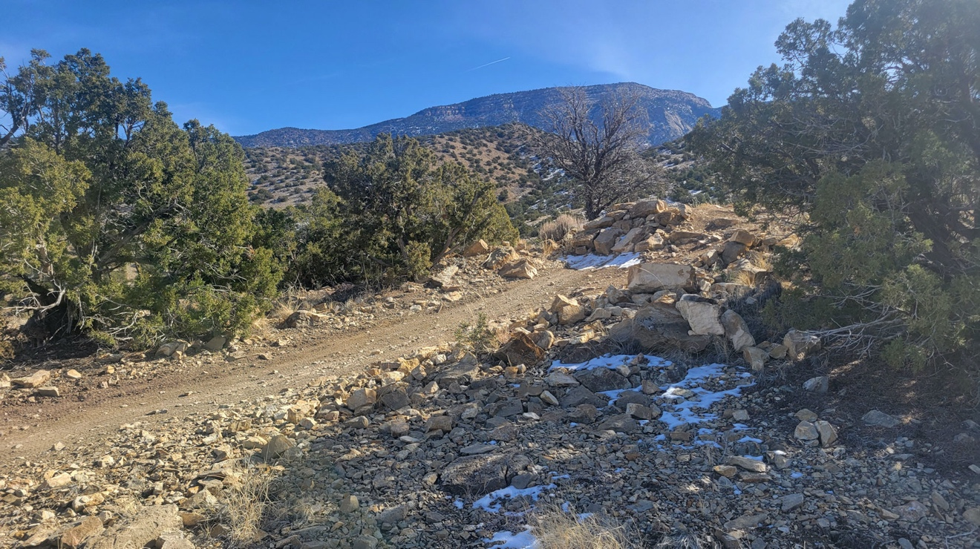

A great start to the day.
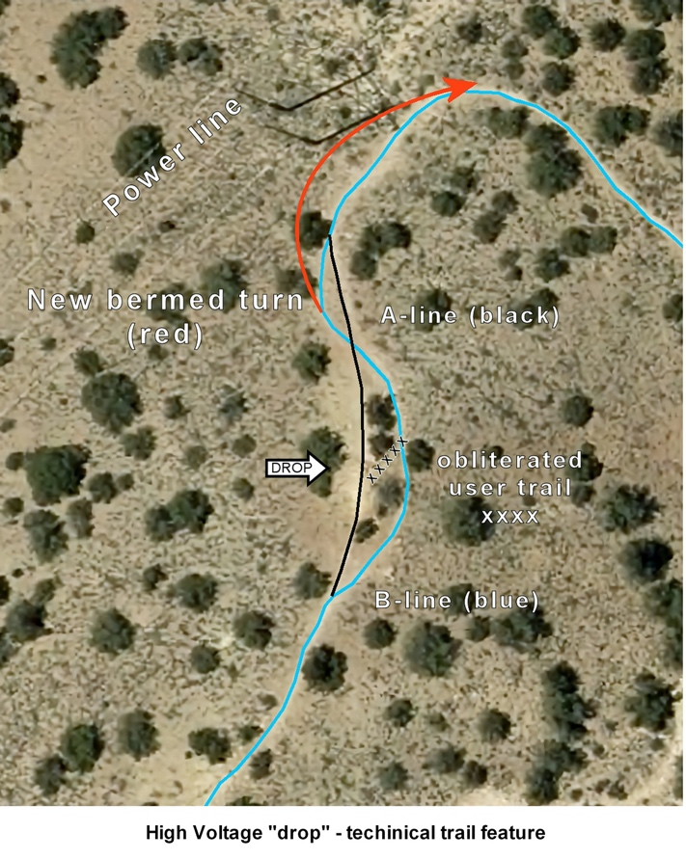
One group worked all day on this project (The red line on the map).
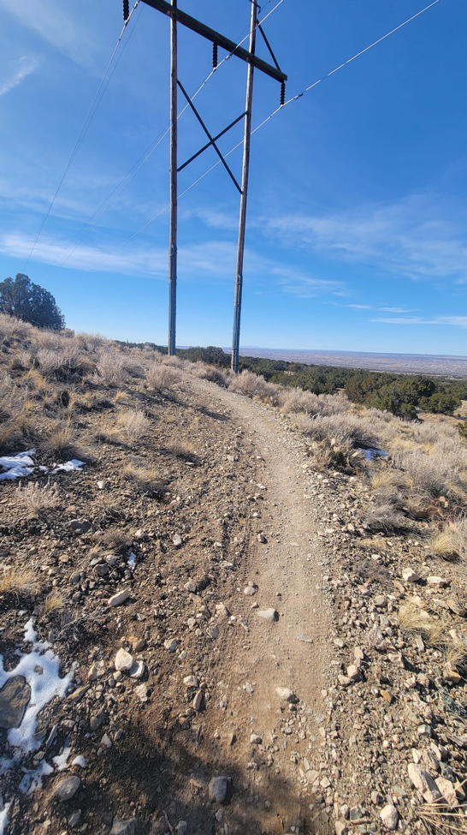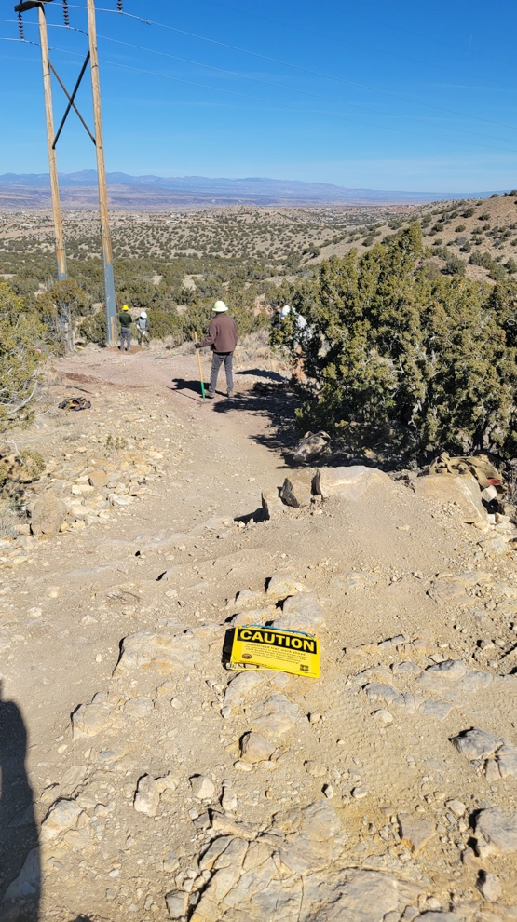

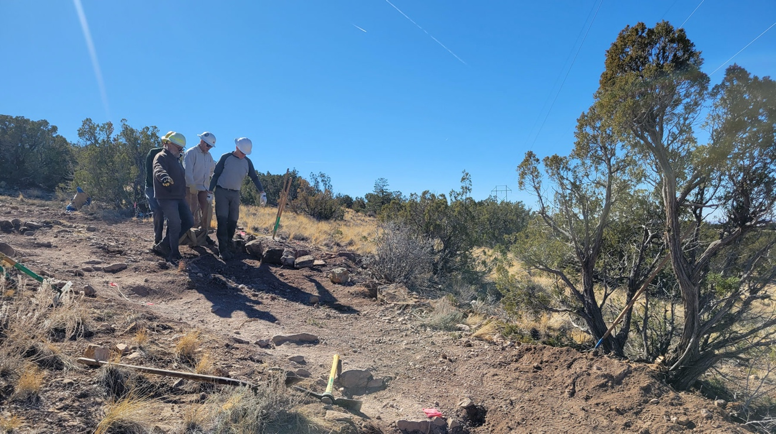

After Steve R. trimmed and cut out some juniper, rocks were transported and set into place. The tread was reworked.

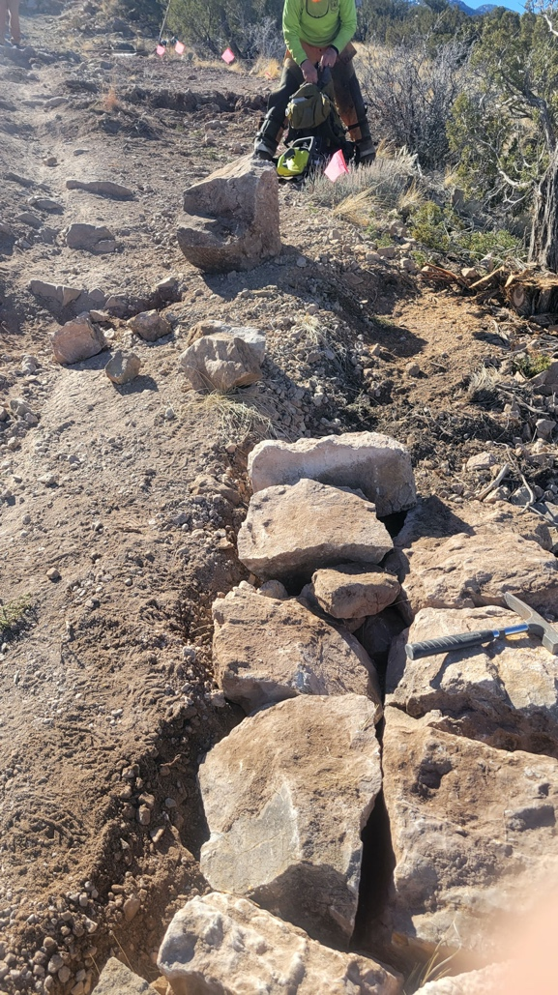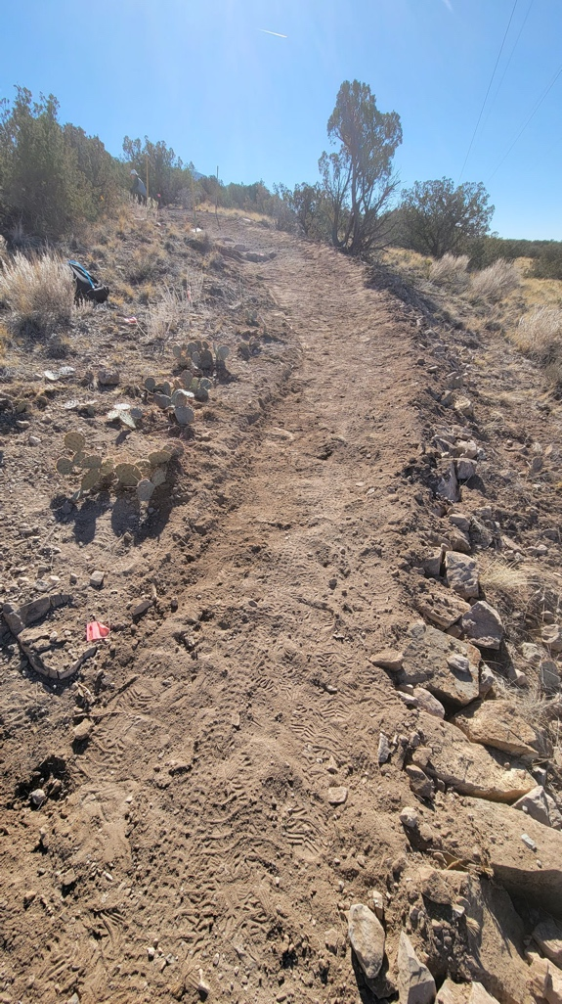

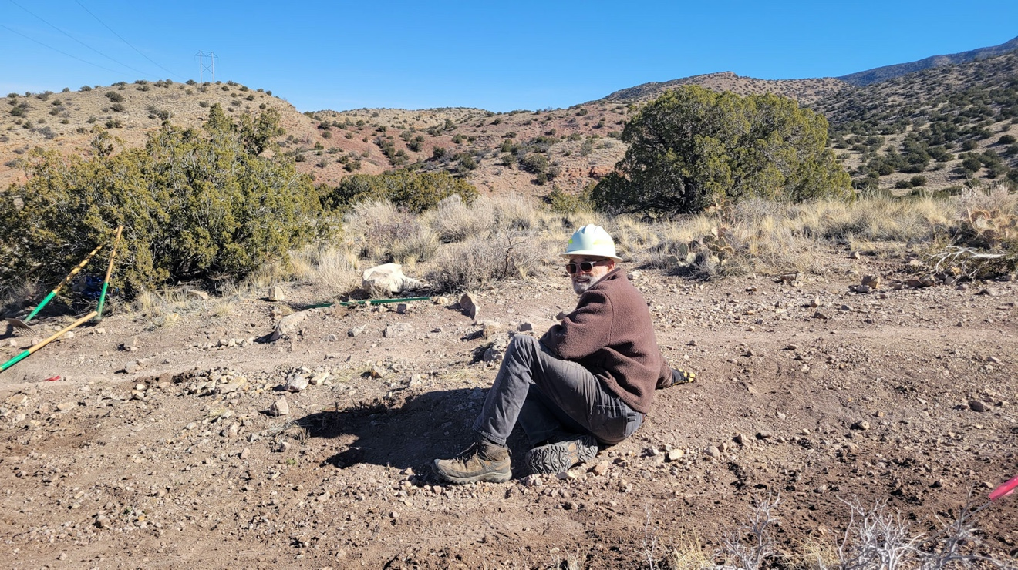

Rest was taken! Jim enjoys the day.

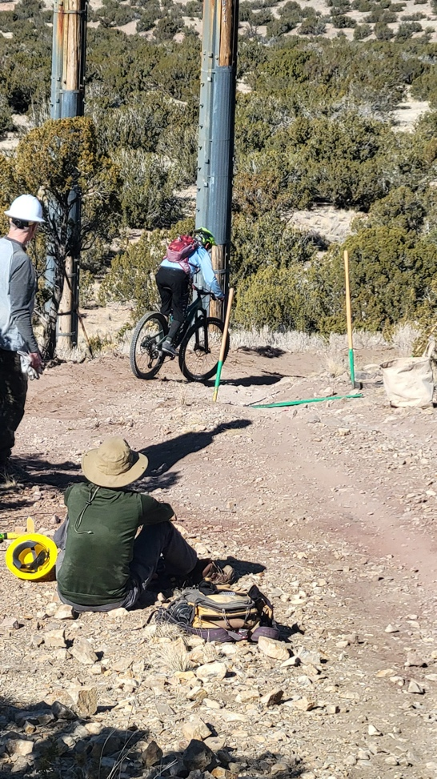 A test run.

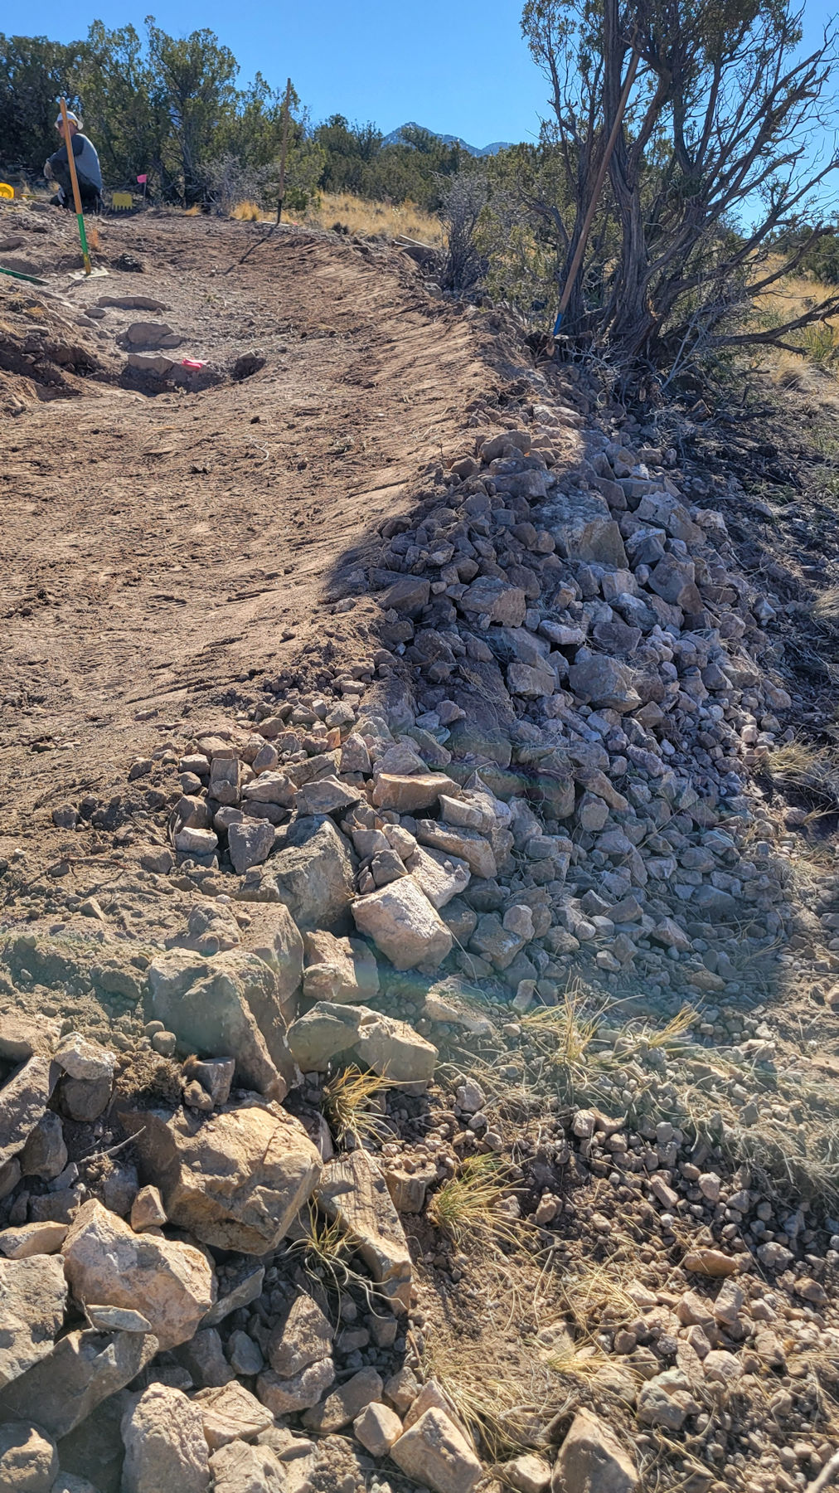

We don’t usually make berms but this one was a much-needed doozy. Beautiful work!

Meanwhile, everyone else was working on trail repairs.
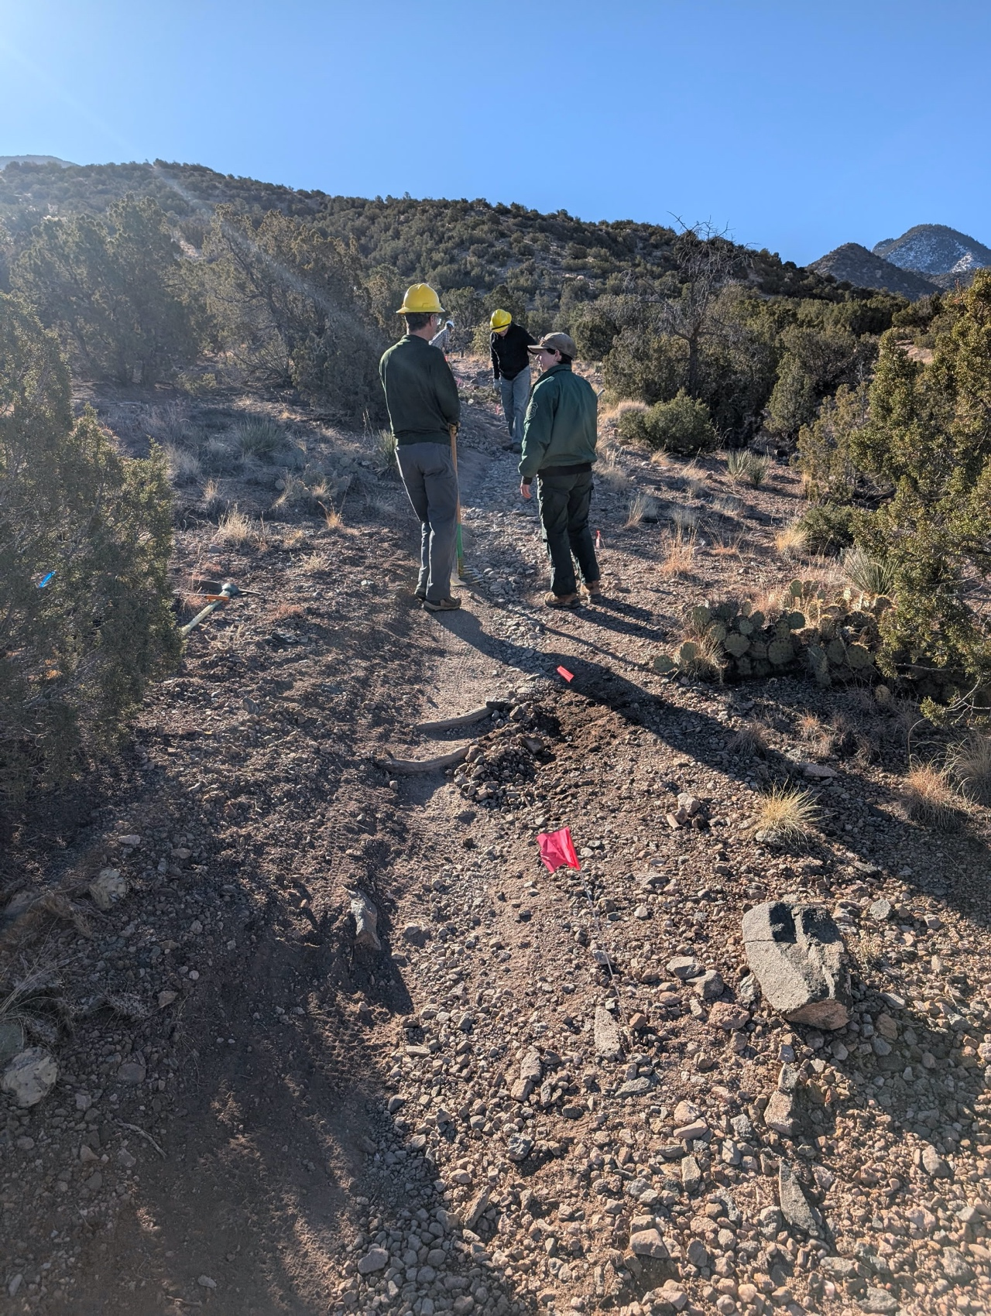

Jen and Roland are talking about who knows what while Eric gets to work.

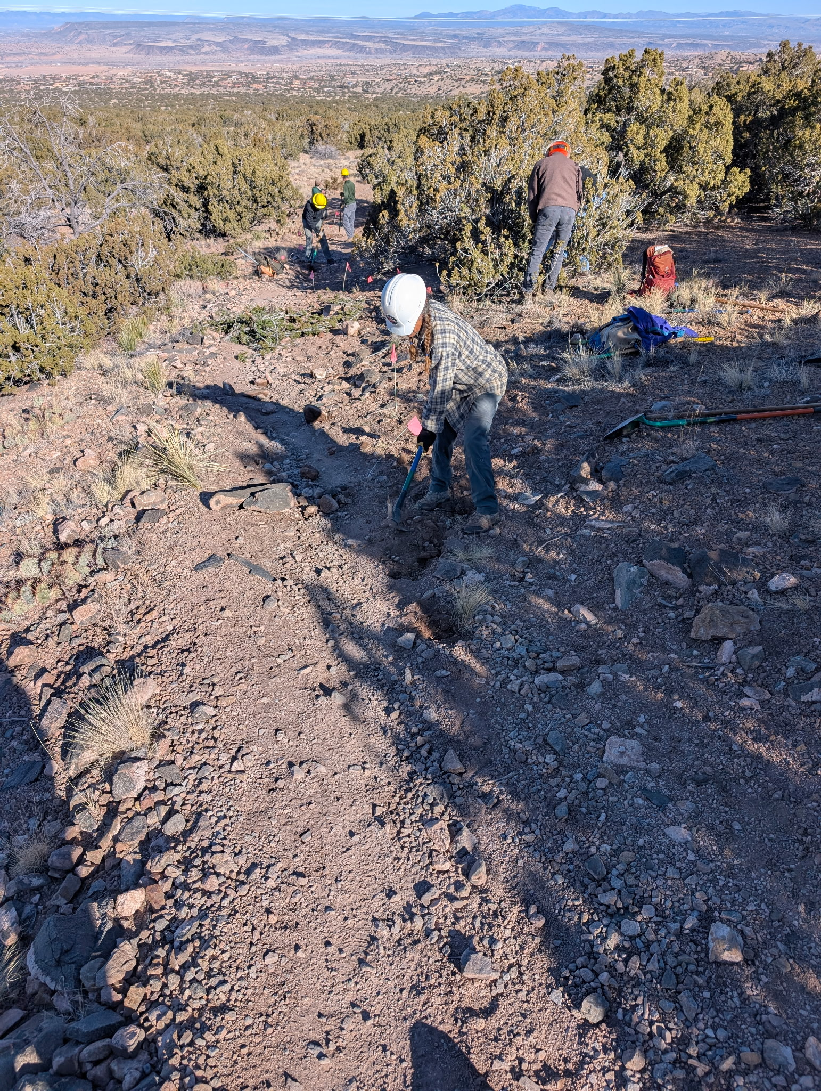

Claudia the digger, although she does enjoy variety in her work day. This reroute made some s curves to stop erosion.
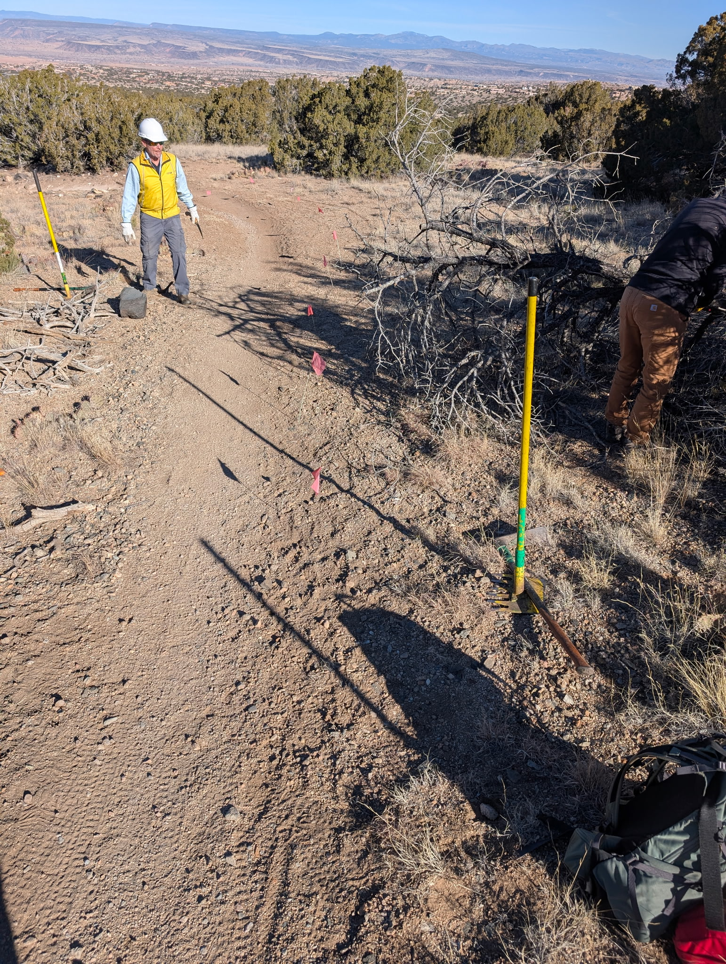

Tony and Laura prepare to remove a dead tree in the area where a reroute will go.
The old section was rutted and eroding especially leading into the turn.

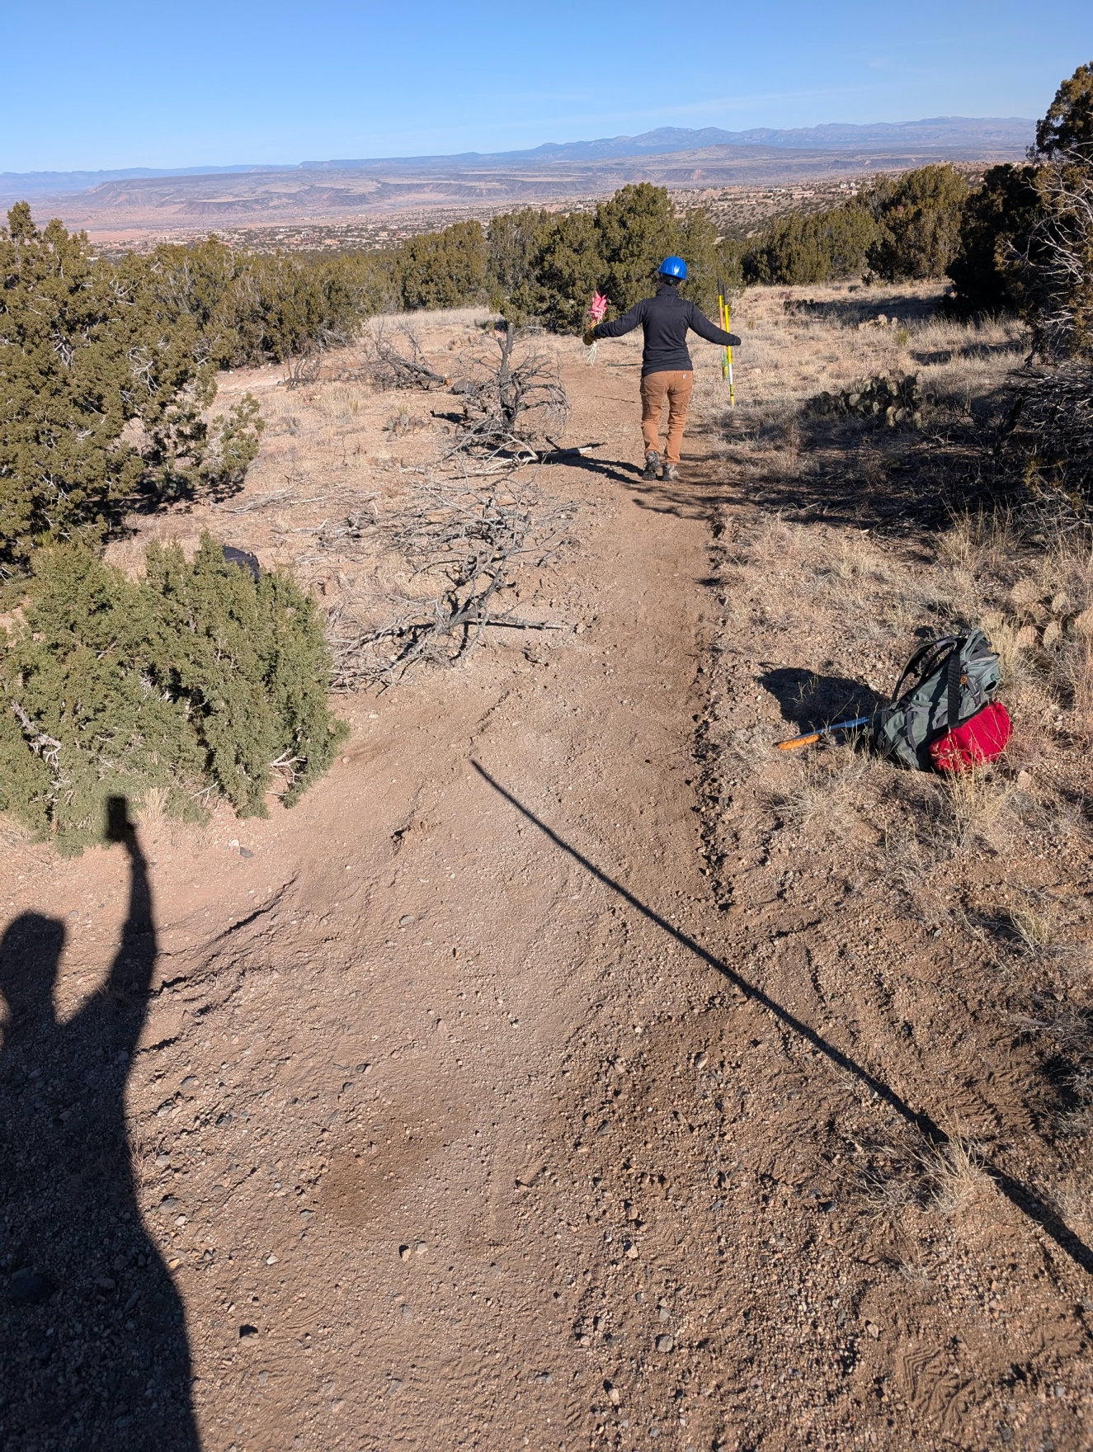

The new reroute runs parallel to the old rutted path hiding under the obliteration.
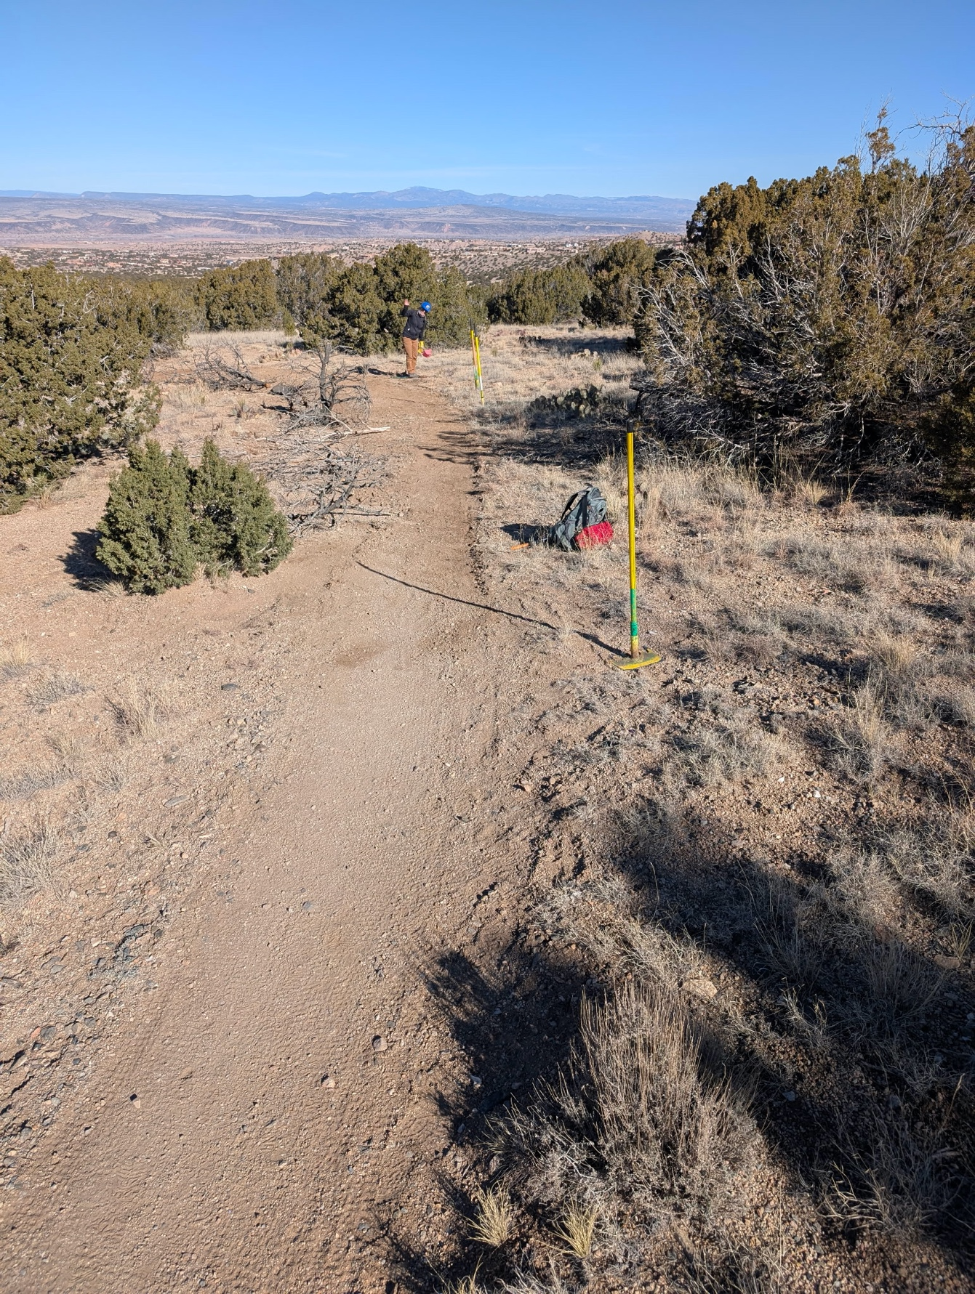

Tony, Rich and Laura’s beautiful work.

