Thursday, 02/12/26- High Voltage area: It was a warm day in Placitas on Thursday. Eleven volunteers met Jen (SRD) for a day of trail fixes, reroutes and an additional job of rock wall building. Some trees were downed, some trail benched and some back slopes were reworked. The sun was out and the temps were warm. Another terrific day of work!
Volunteers: Byron Garner, Steve Forrest, Rich Fagioli, John McNett, Tony Pachelli, Luis Cuadros, Bill Perkins, Laura Leon, John Braly, Cleve Sharp and Roland Stumpf

Pictures: Laura Leon and Jen Medina-Gray

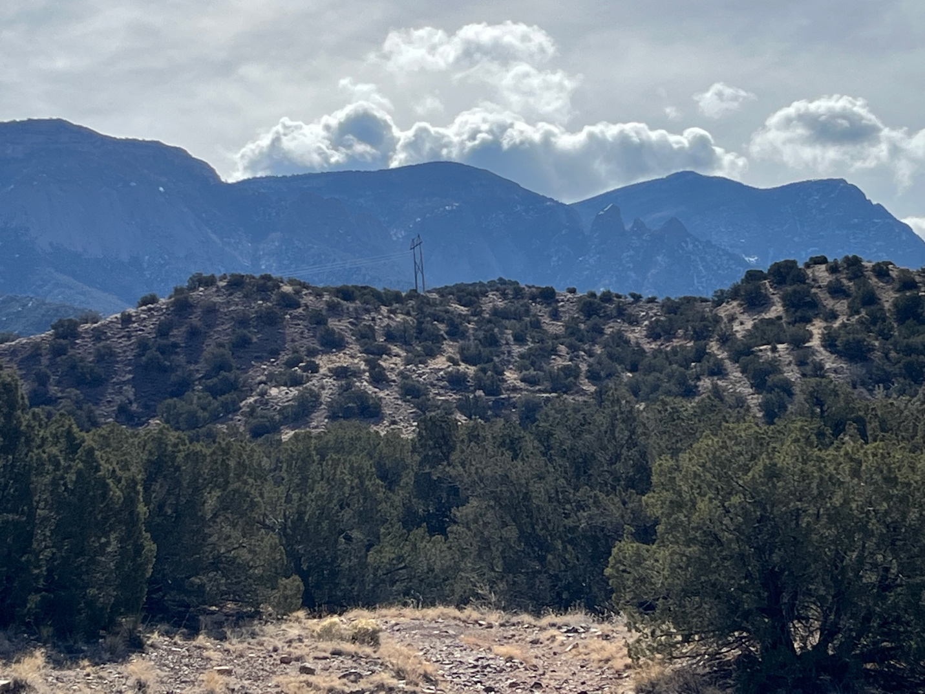

Lots of sun and some nice puffy clouds! A great start to the day.

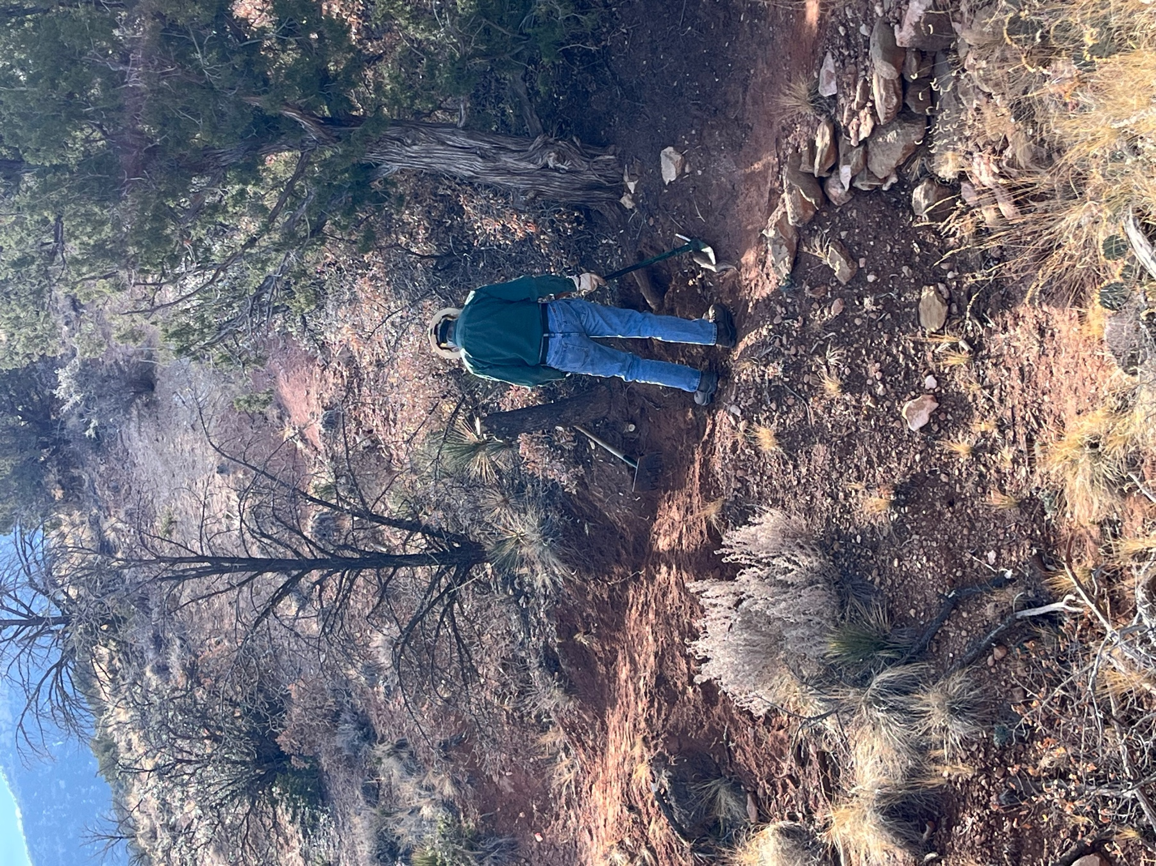

Byron took out a dead pine and juniper roots that were pushing trail users toward the outside edge of the trail. With a little benching, the area was back in use.

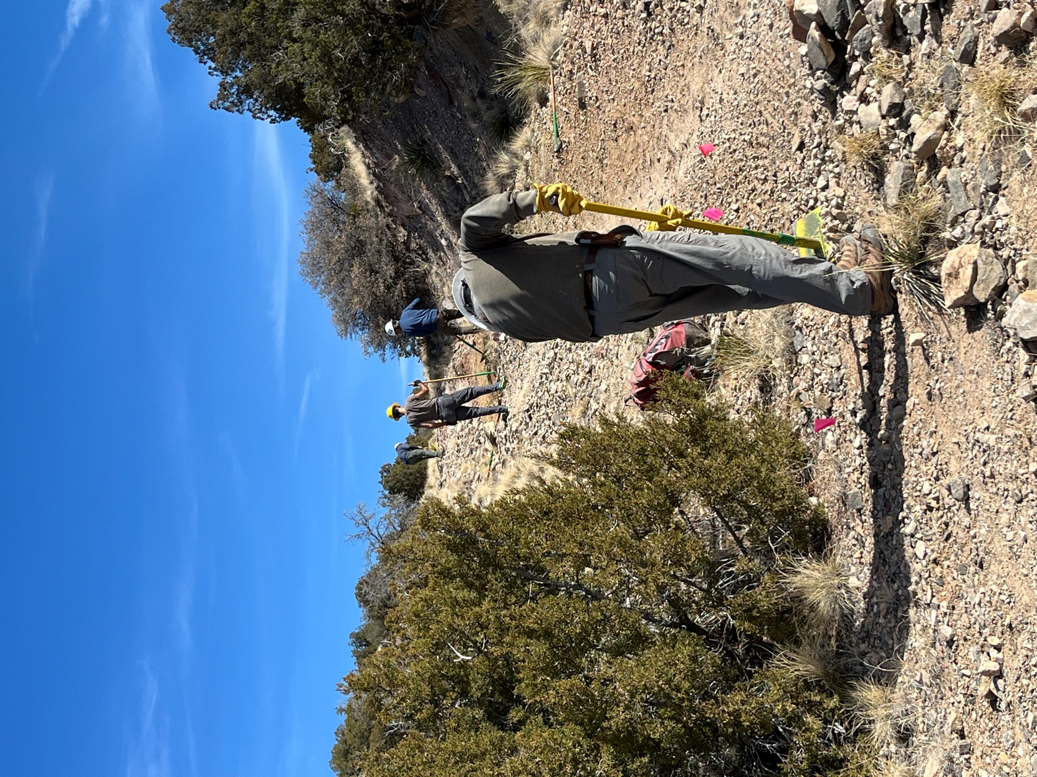

Bill, Roland, Luis and John M. raked some of the loose gravel to the edges of the slope. The juniper next to Bill was trimmed back so that visibility was increased on this three-way intersection.
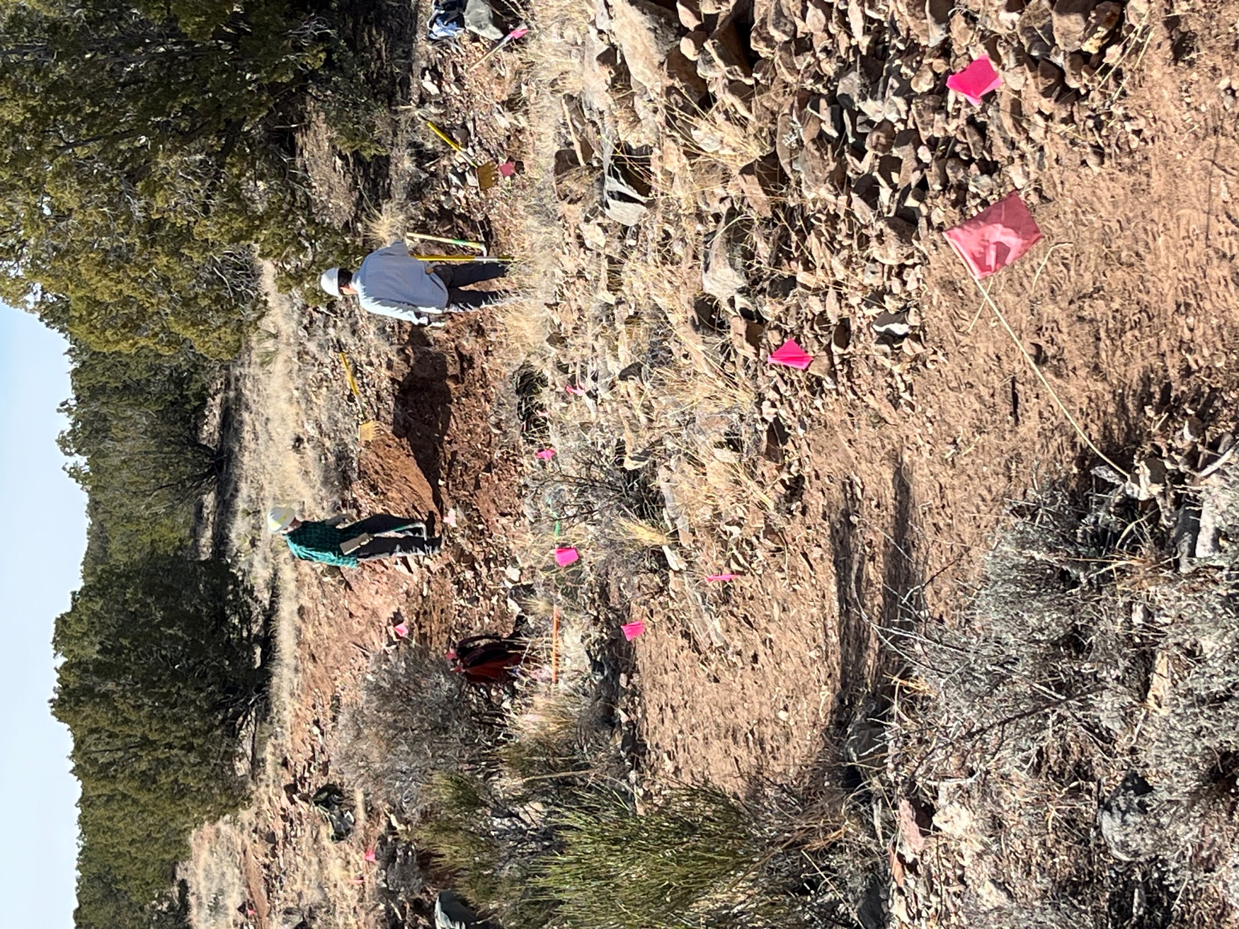

This reroute added some curves to slow erosion. Tony and Cleve are standing in a dry arroyo that the trail crossed at a 90-degree angle and now crosses at a 45-degree angle.

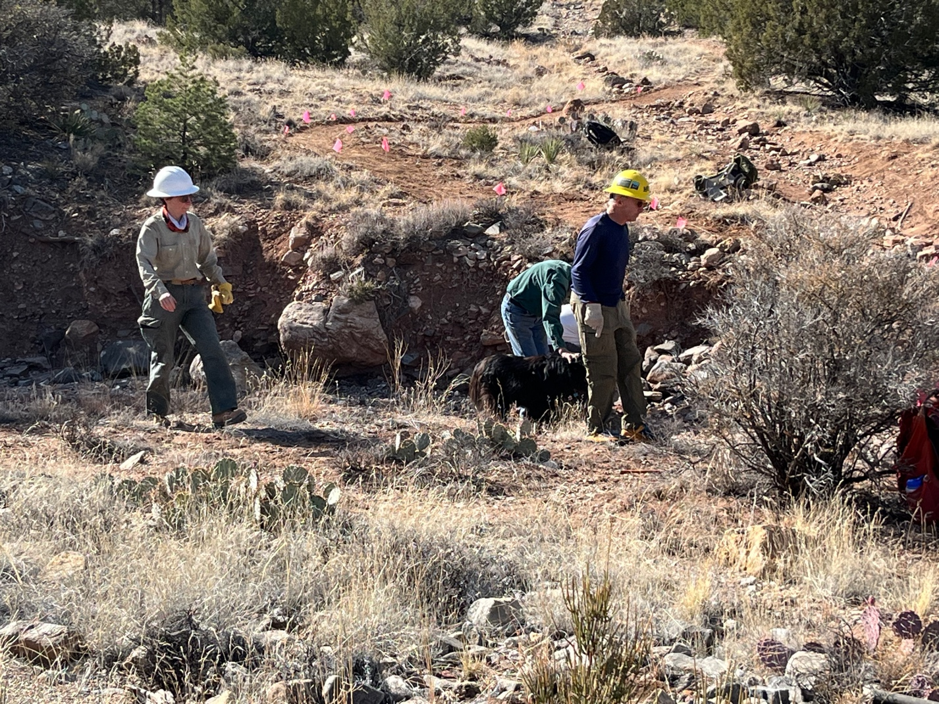

Jen and John B. hunt for rocks to shore up the hillside. Initially we just needed a few rocks. Byron is petting a visiting dog.
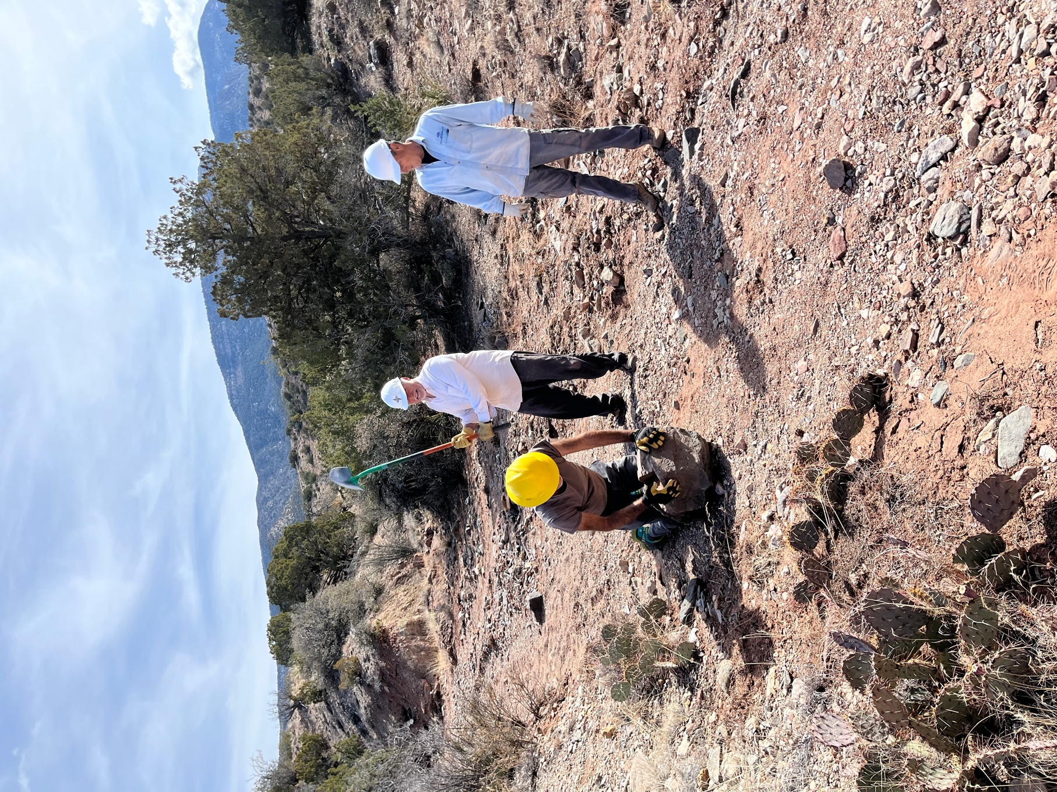

More, and bigger rocks were needed and some crew members needed to be motivated. Roland works, Rich plays and Tony oversees.

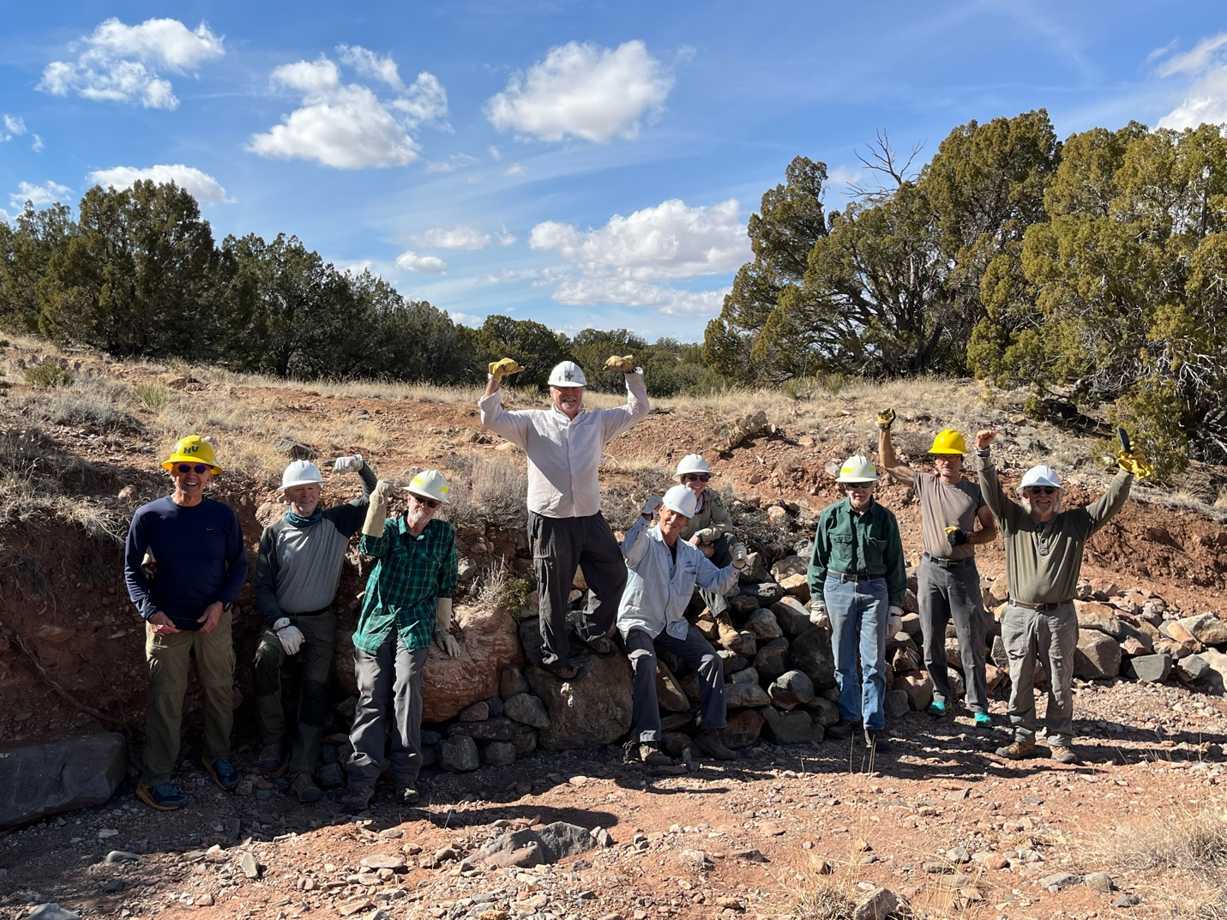

Muscles make the job happen! John B., Steve, Cleve, Rich (on the biggest rock we moved today), Tony, Jen, Byron, Roland and Bill. What a group….

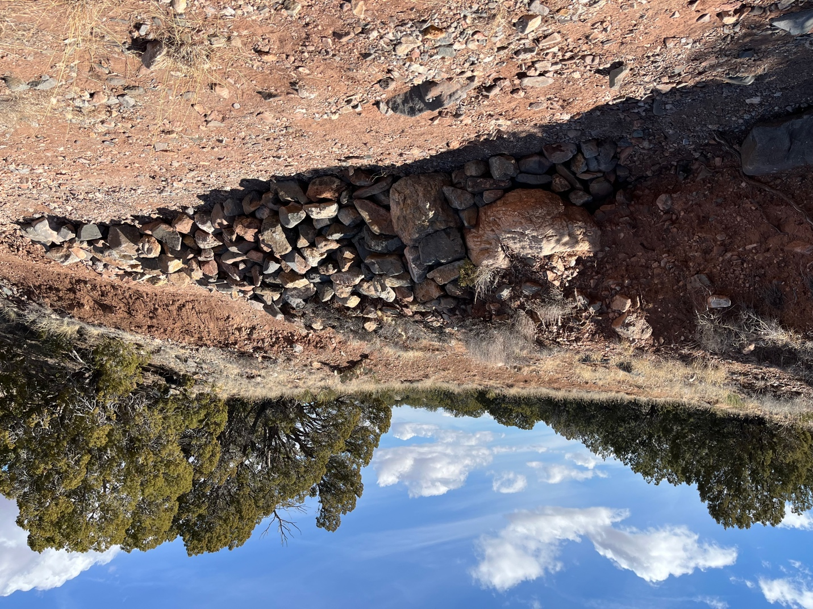

This is what the wall looks like without the riffraff.

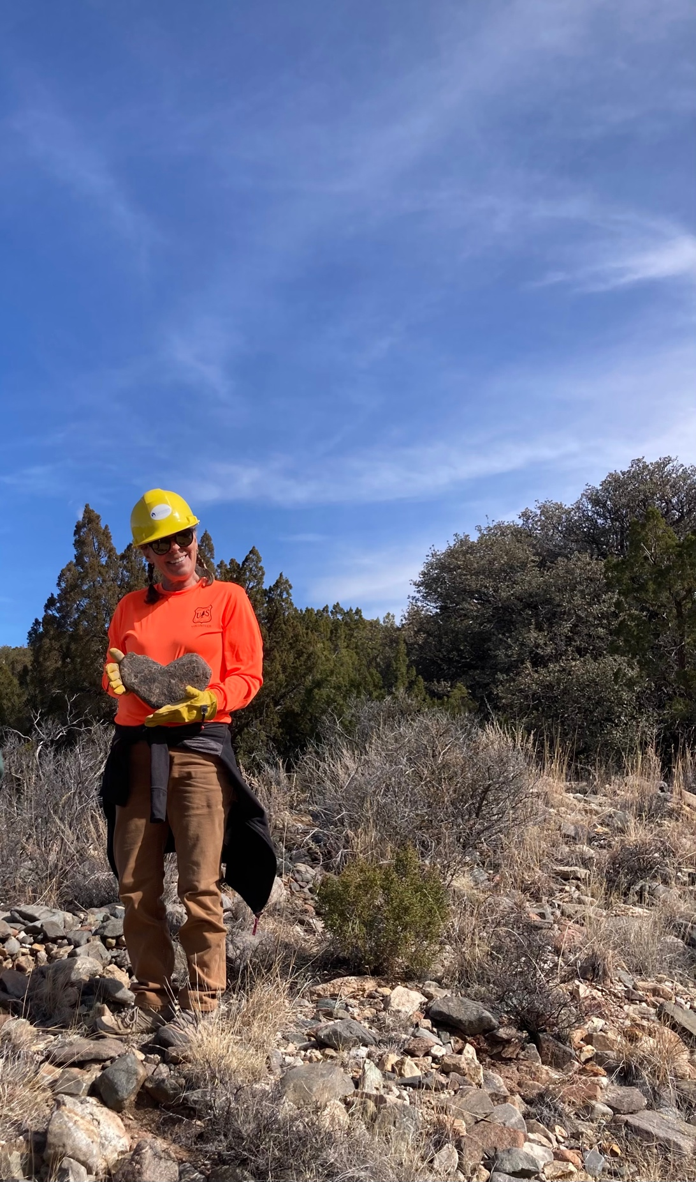

And just in time for Valentine’s Day…..

