Three Gun Kiosk Repairs

On Tuesday 2/17/26, 3 very patient and diligent FOSM volunteers joined SRD trails foreman Jen Medina-Gray on a journey to fix the wilderness Kiosk at Three Gun Springs. We replaced the bottom horizontal piece of the kiosk, reattached the back panel, added a new hasp for the yale lock, cleaned the plexiglass, and put a new map in the kiosk. Thank you all for your dedication and hard work on this project!

Volunteers: Pauline Ho, Rick Buss, and John Cooper

Photos: Jen Medina-Gray

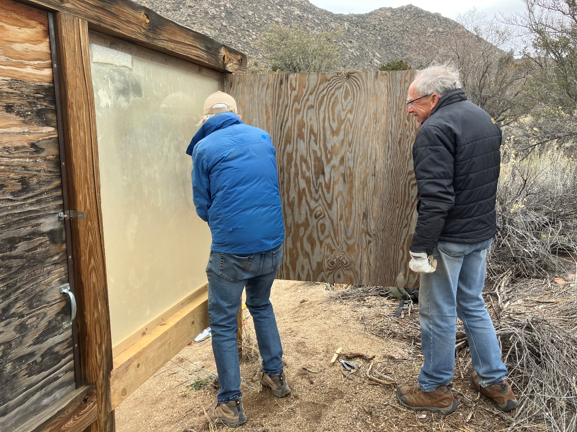

John and Rick reattach the pack panel of the kiosk with a new piano hinge
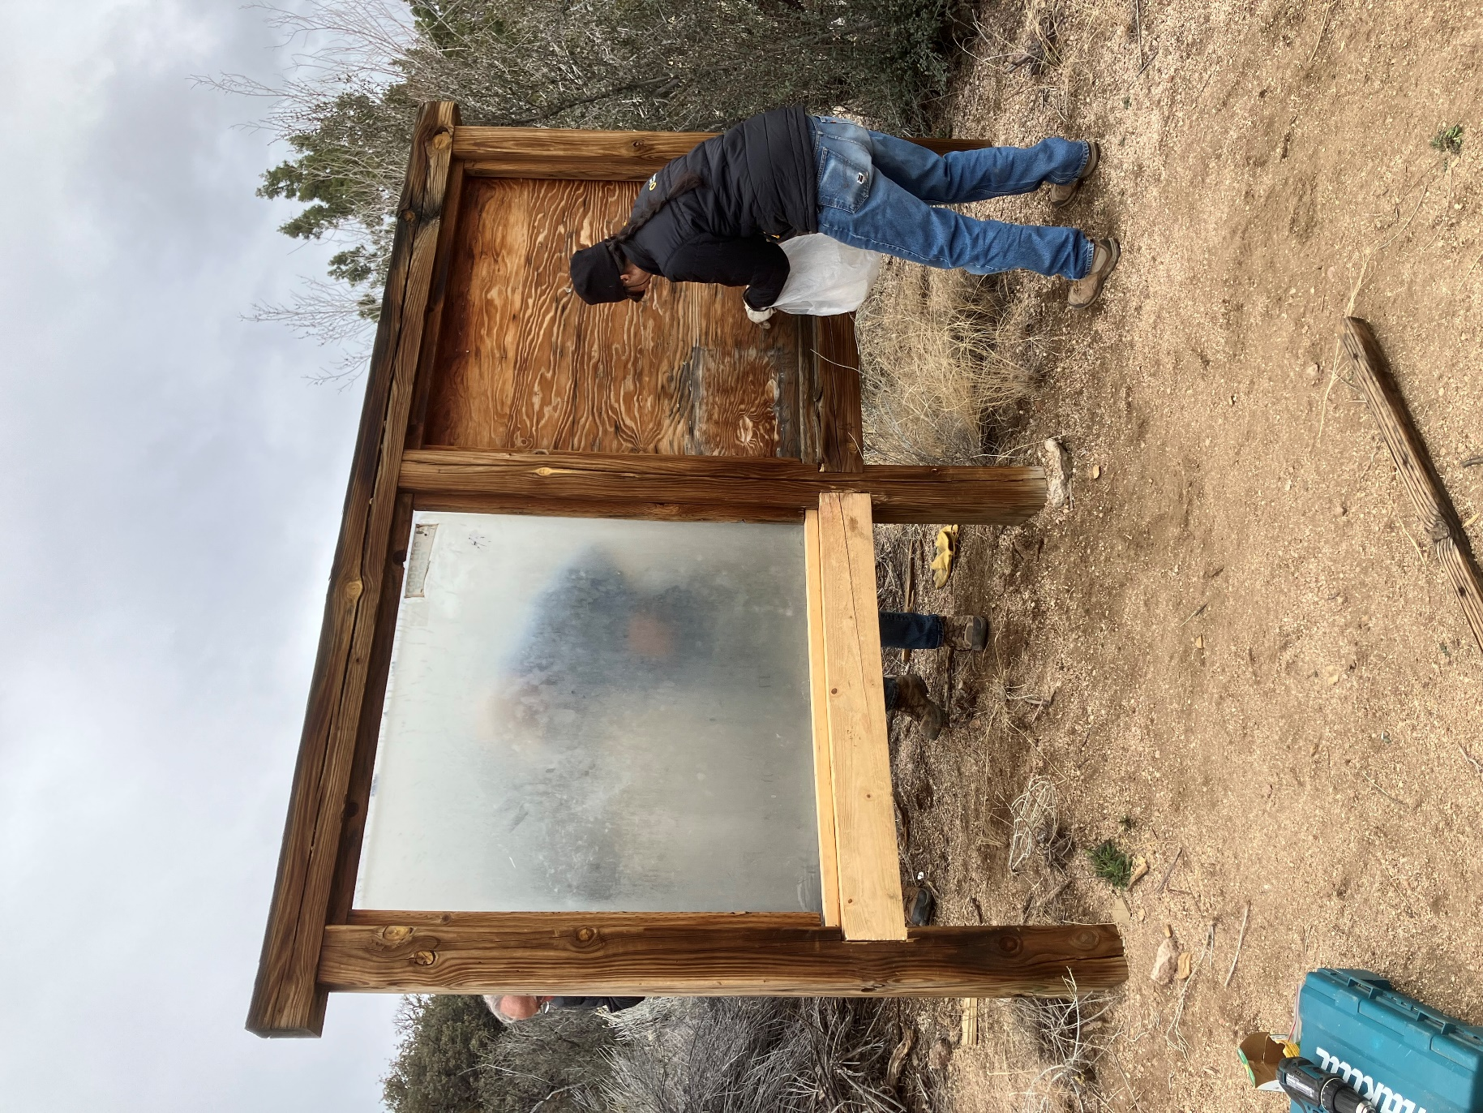

Pauline removes old staples from the kiosk
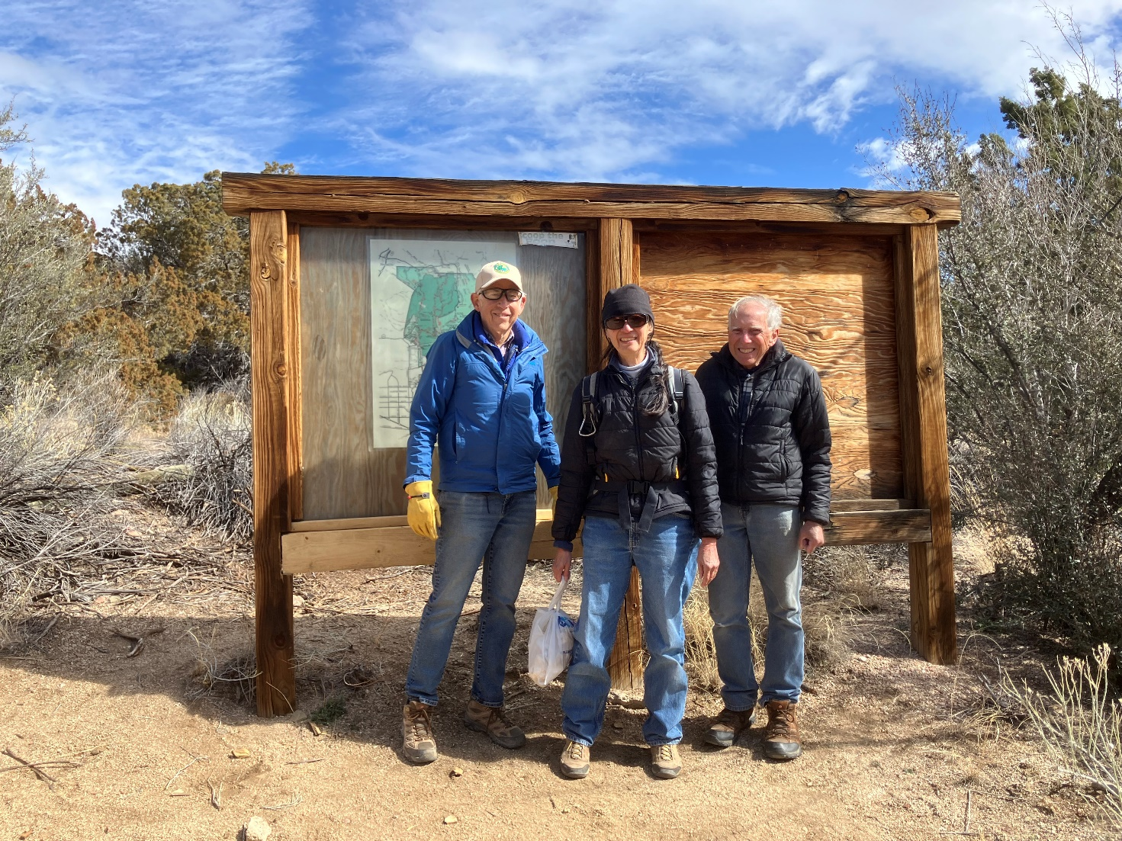

The crew stands with the newly repaired kiosk. The sun finally came out just as we finished working!

