Thursday, 02/19/26- 3 Guns: Thursday Crew set out to do some brushing on 3 Guns. ABORT. ABORT.ABORT. The15 volunteers and Jen (SRD) headed up the trail to where we left off a couple of weeks ago and made a valent attempt do what we could but the temp never got over 35 degrees and the wind was steadily picking up so after about 3 hours of toughing it out we just gave up and took our frosty fingers and toes down and out to defrost. Progress was made but there is still work to be done. Winter weather in February! Who would have thought! Are we spoiled or what?

Volunteers: Larry Larrichio, Bruce Hansche, Claudia Bergsohn, Kerry Jones,
Roland Stumpf, Cleve Sharp, Byron Garner, Steve Roholt, Laura Leon, Eric Russell,
Rich Fagioli, John McNett, Bill Perkins, Luis Cuadros, and Tony Pachelli

Pictures: Laura Leon- not many because I didn’t want to take my gloves off.

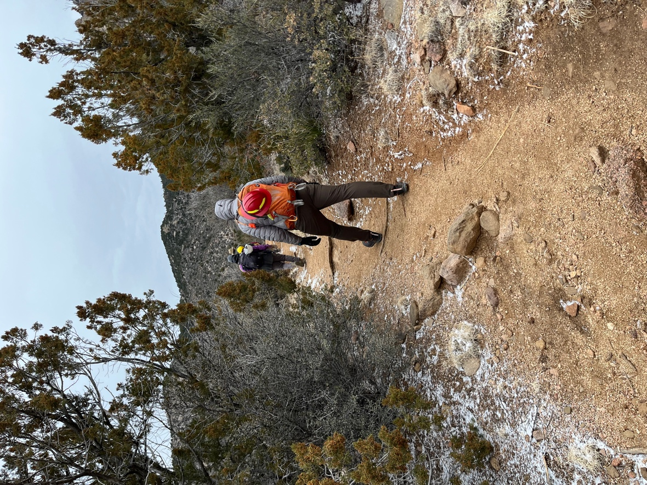 Bundled up and heading out.

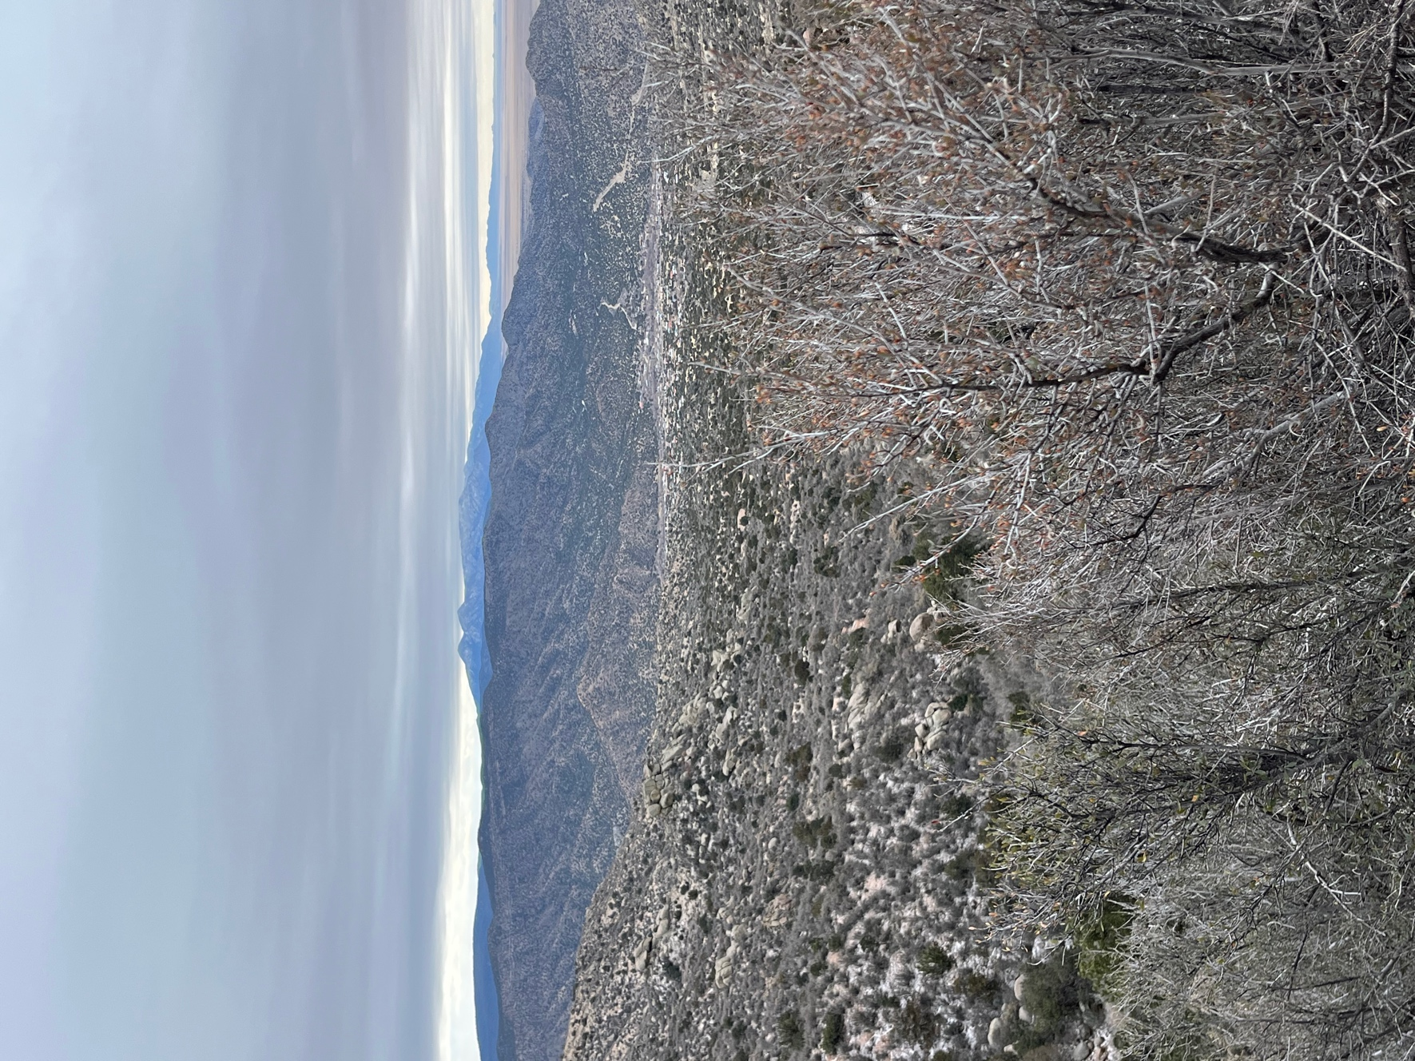

Not quite Caradhras (Lord of the Rings), but almost as foreboding. I still have wind whistling in my ears.

