Report of Painting Large Scenic Byway Sign at Roundabout on NM-14, Tuesday, March 3, 2026
Sam Beard
On Tuesday, March 3, Rick Buss, Pauline Ho, and Sam Beard painted the red background of the large scenic byway sign that was built by Ross Ward (Tinker Town founder) a few decades ago. The south side of the sign was in pour condition with paint missing on many parts of the surface. We painted the red background with Behr semigloss Red Brick paint. We painted a few letters with Behr semigloss Linen White paint, and the remaining white letters, the turquoise letters, and the turquoise arrowhead will be painted later.
Loose paint chips were removed with scrapers and wire brushes, and several holes and other damaged areas were filled with System Three epoxy paste. The paste became somewhat firm later in the afternoon, and we were able to paint over it. The top 2x8 board on the east side of the sign is in very pour condition, and it will be replaced later before the paint project is completed.
Project photos are presented below.

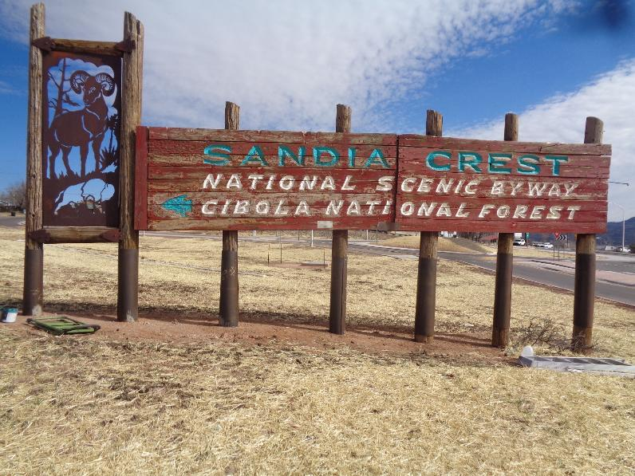
The south side of the Scenic Byway sign at the roundabout on NM-14 that has not been painted in several years.
All photos by Sam Beard
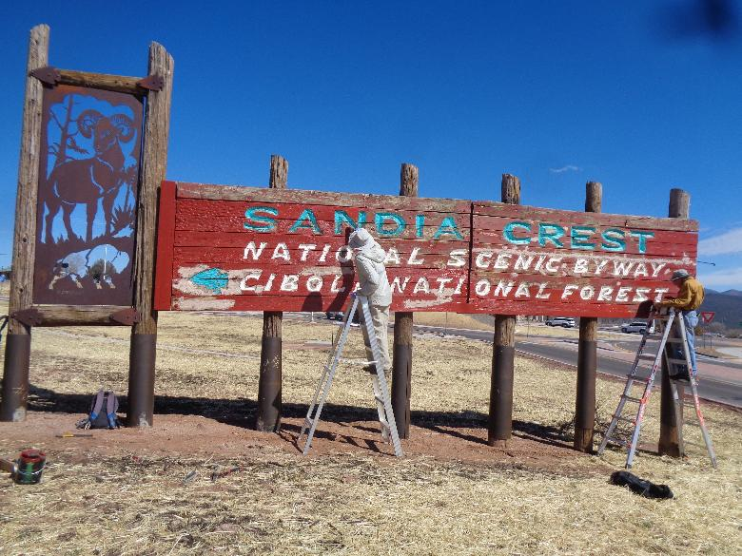
L to R: FOSM paint crew members Pauline Ho and Rick Buss painting the red background of the sign.
The gray areas are locations that were in especially pour condition. They have been filled with
System Three epoxy paste. Later in the day, the epoxy paste was firm enough that it could be painted.
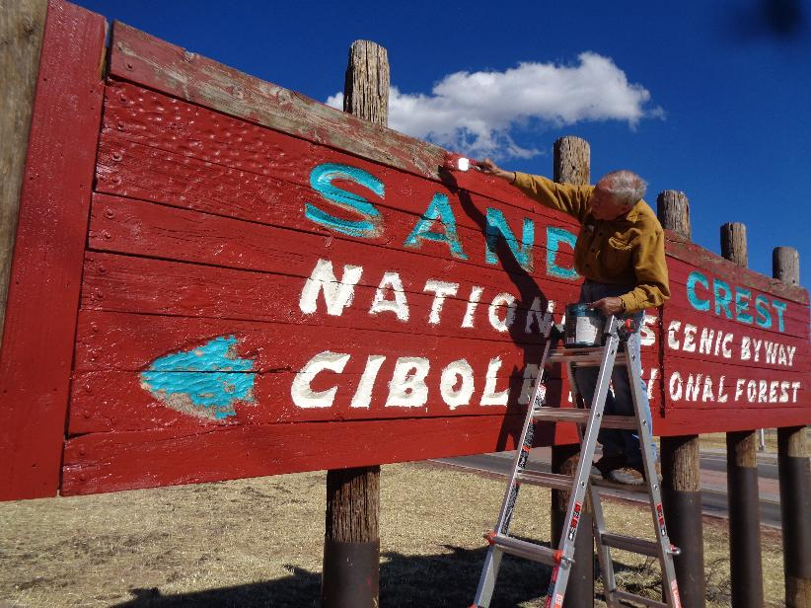
Rick is painting the top board of the west half of the sign. The top board on the east side is broken
and will be replaced with a new 12-foot long 2x8 board. The sign is 24 feet in length and approximately 5 feet wide.
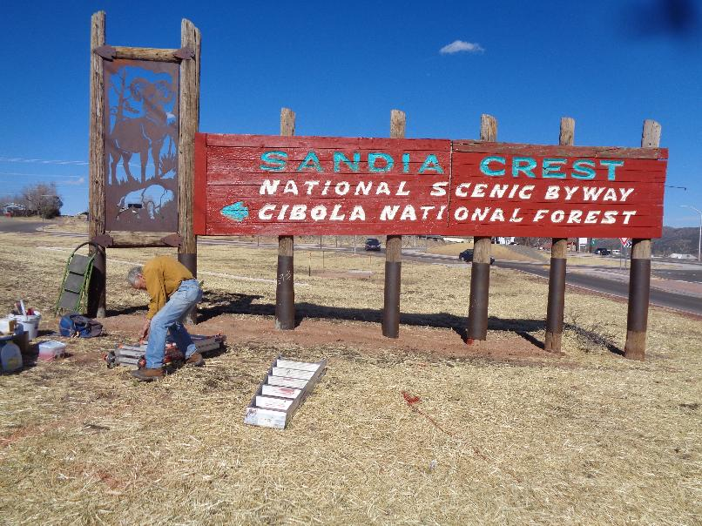
The south side of the sign after the red background has been painted. The white letters
and the turquoise letters and arrowhead will be painted later. Rick is preparing to carry the ladder to his vehicle.
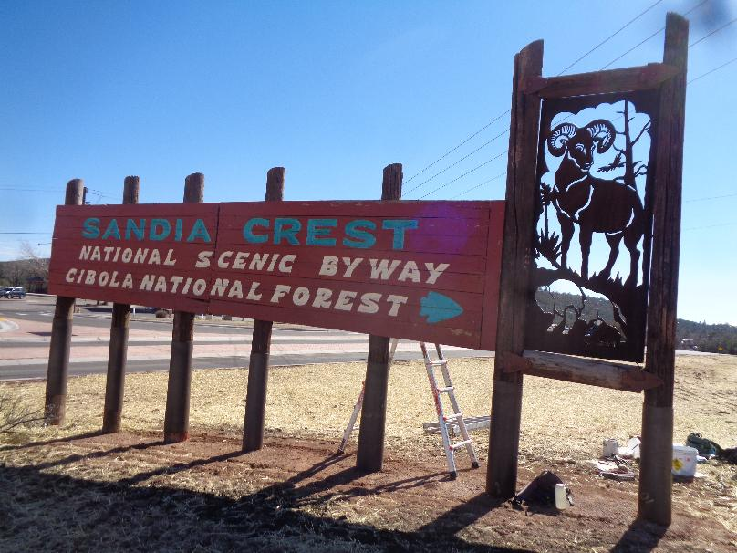
The north side of the sign is in very good condition, and some touchup painting will be done later.
The big horn sheep and bison were cut in the steel panel with a cutting torch by Ross Ward in 1991.

