Thursday, 03/05/26- Armijo: It was a cool day Thursday, but we were low enough to be out of the wind. Eight volunteers headed out to Armijo and continued benching and reworking spots from last week. It always seems to help to locate the meh spots after looking away for a week. There are plenty of stumps and lots and lots of tree fall to deal with in this reroute. We will need another week or two to finish up. At least we didn’t lose any crew members on the way out this week.

Volunteers: Bill Perkins, Bruce Hansche, Steve Forrest, Don Fisher, Kerry Jones,
Claudia Bergsohn, Luis Cuadros and Laura Leon

Pictures: Laura Leon

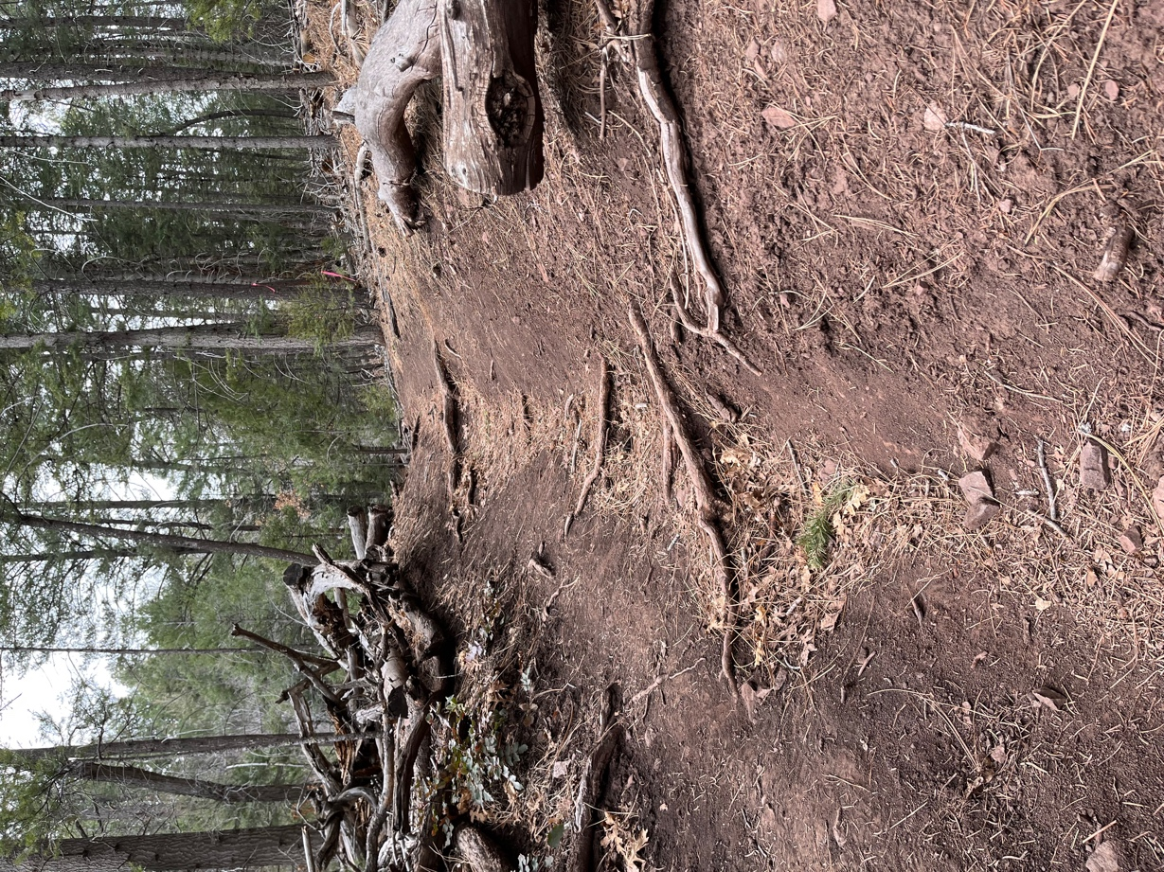

Existing trail is very eroded.

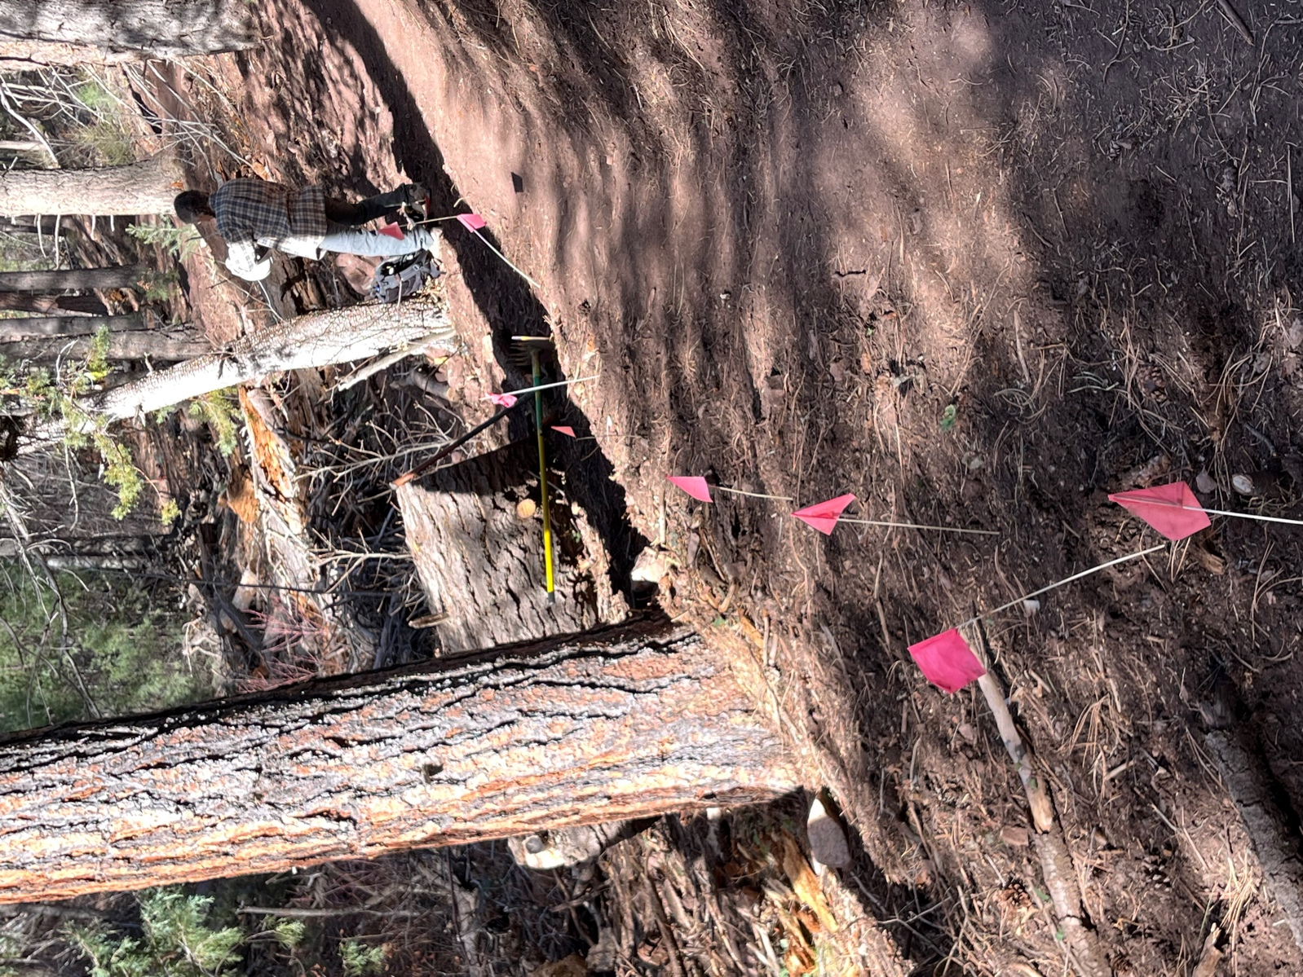

Claudia gets ready to work on a stretch of trail that we benched back in Nov. It still needed some TLC.
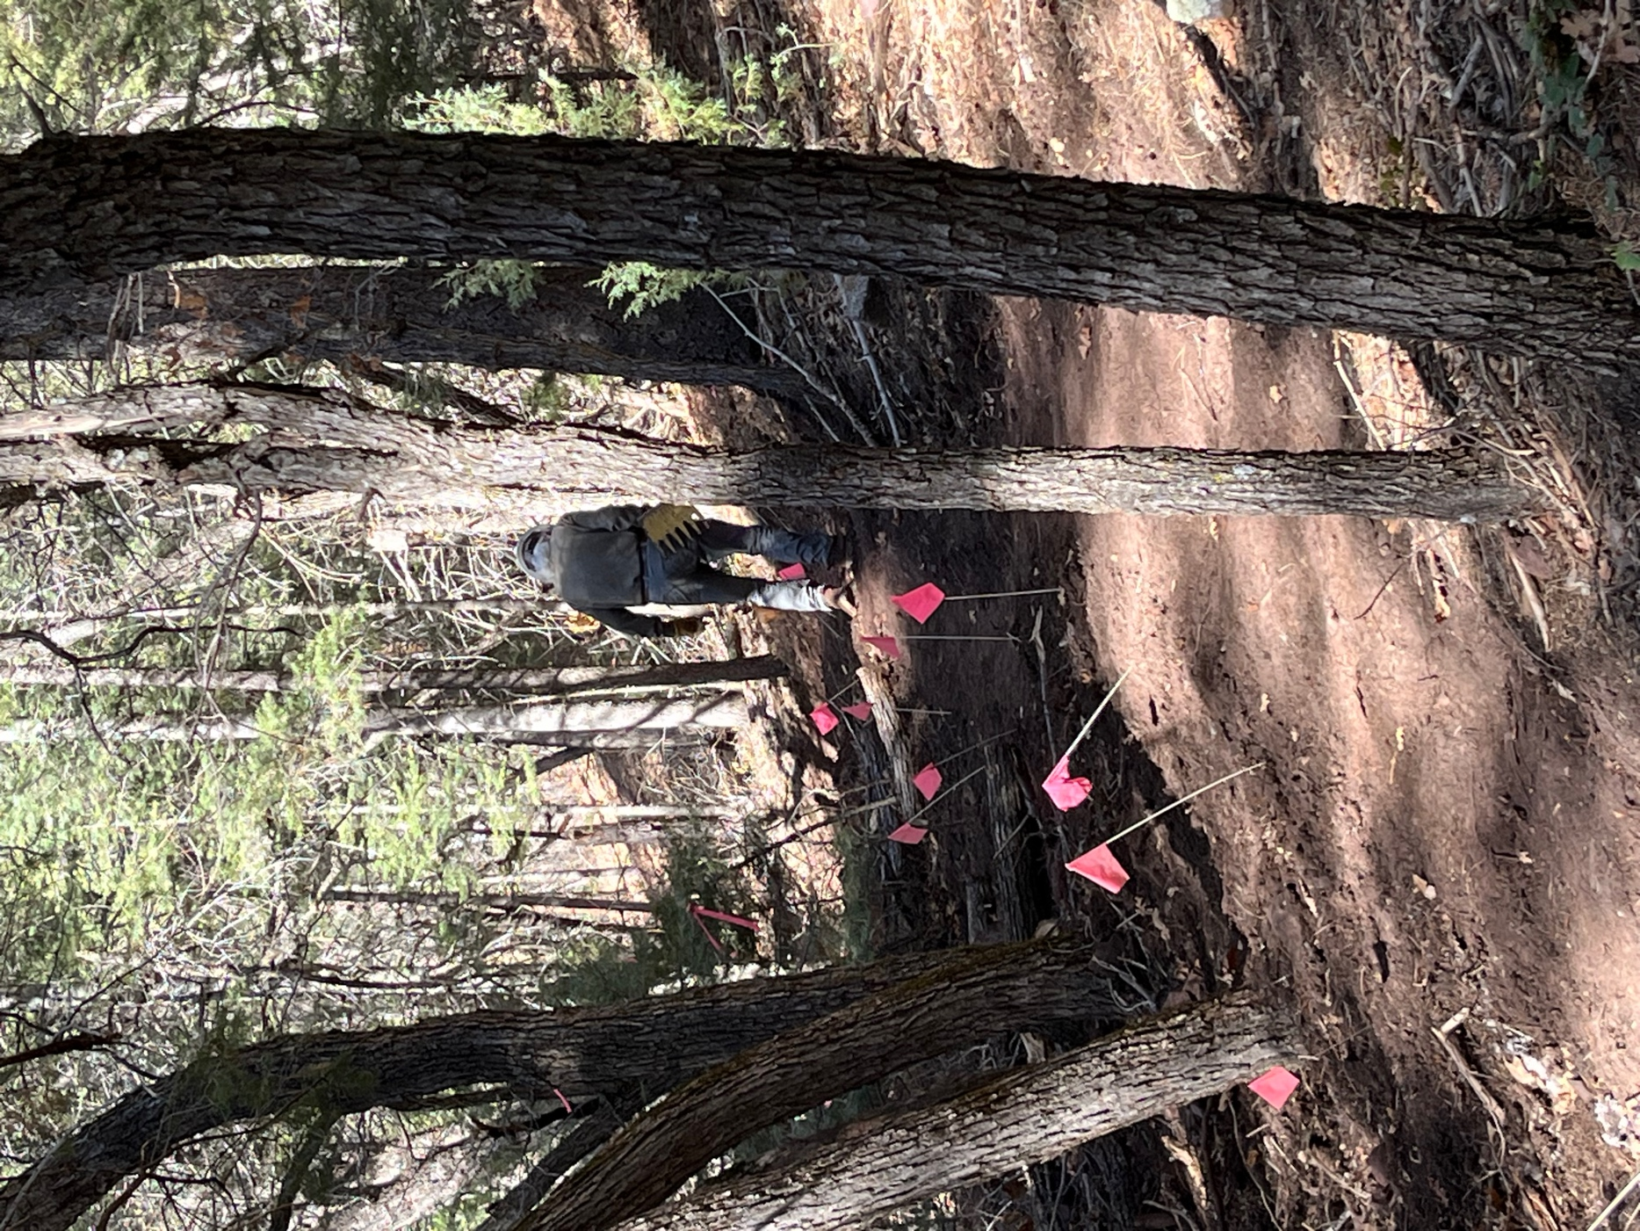

Bill gets to work on finishing a stretch of trail from last week.
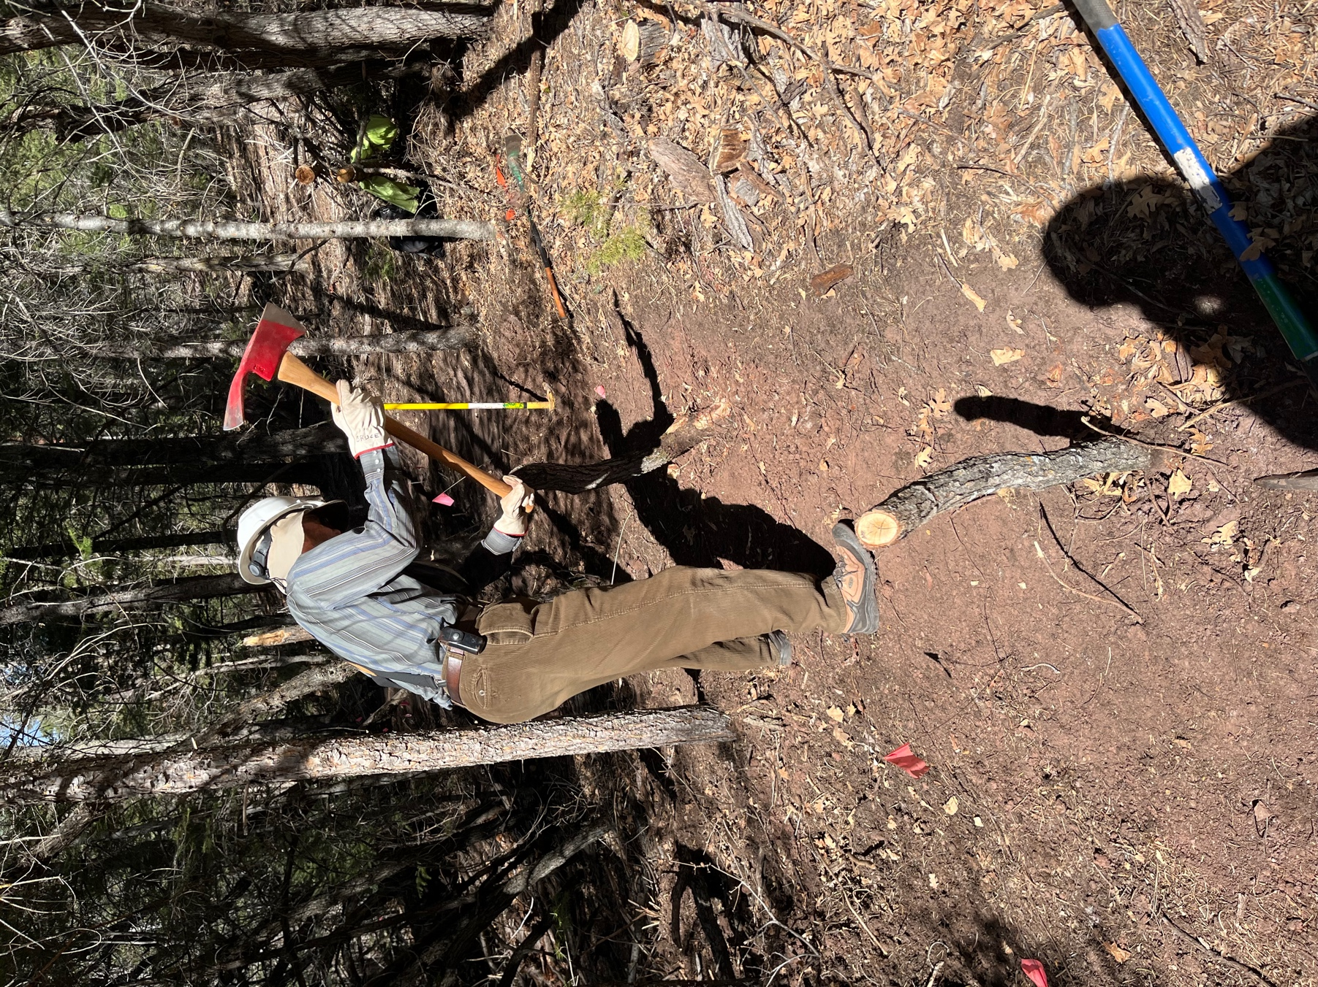

Bruce continues work to remove 3 stumps that he and Eric started work on last week.
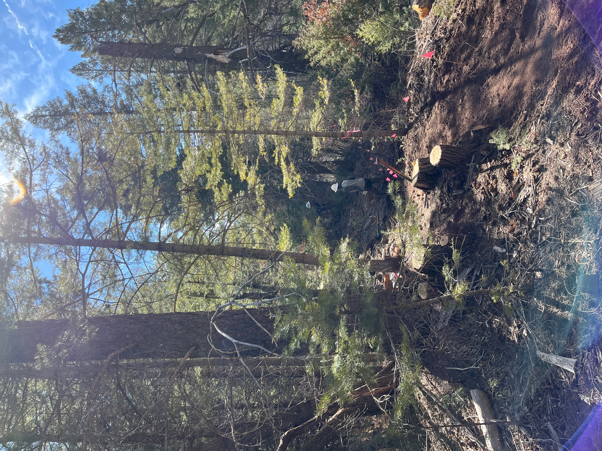

Luis used the pole saw on some high branches while Steve started digging. The sky started out sunny but clouded up as we worked.
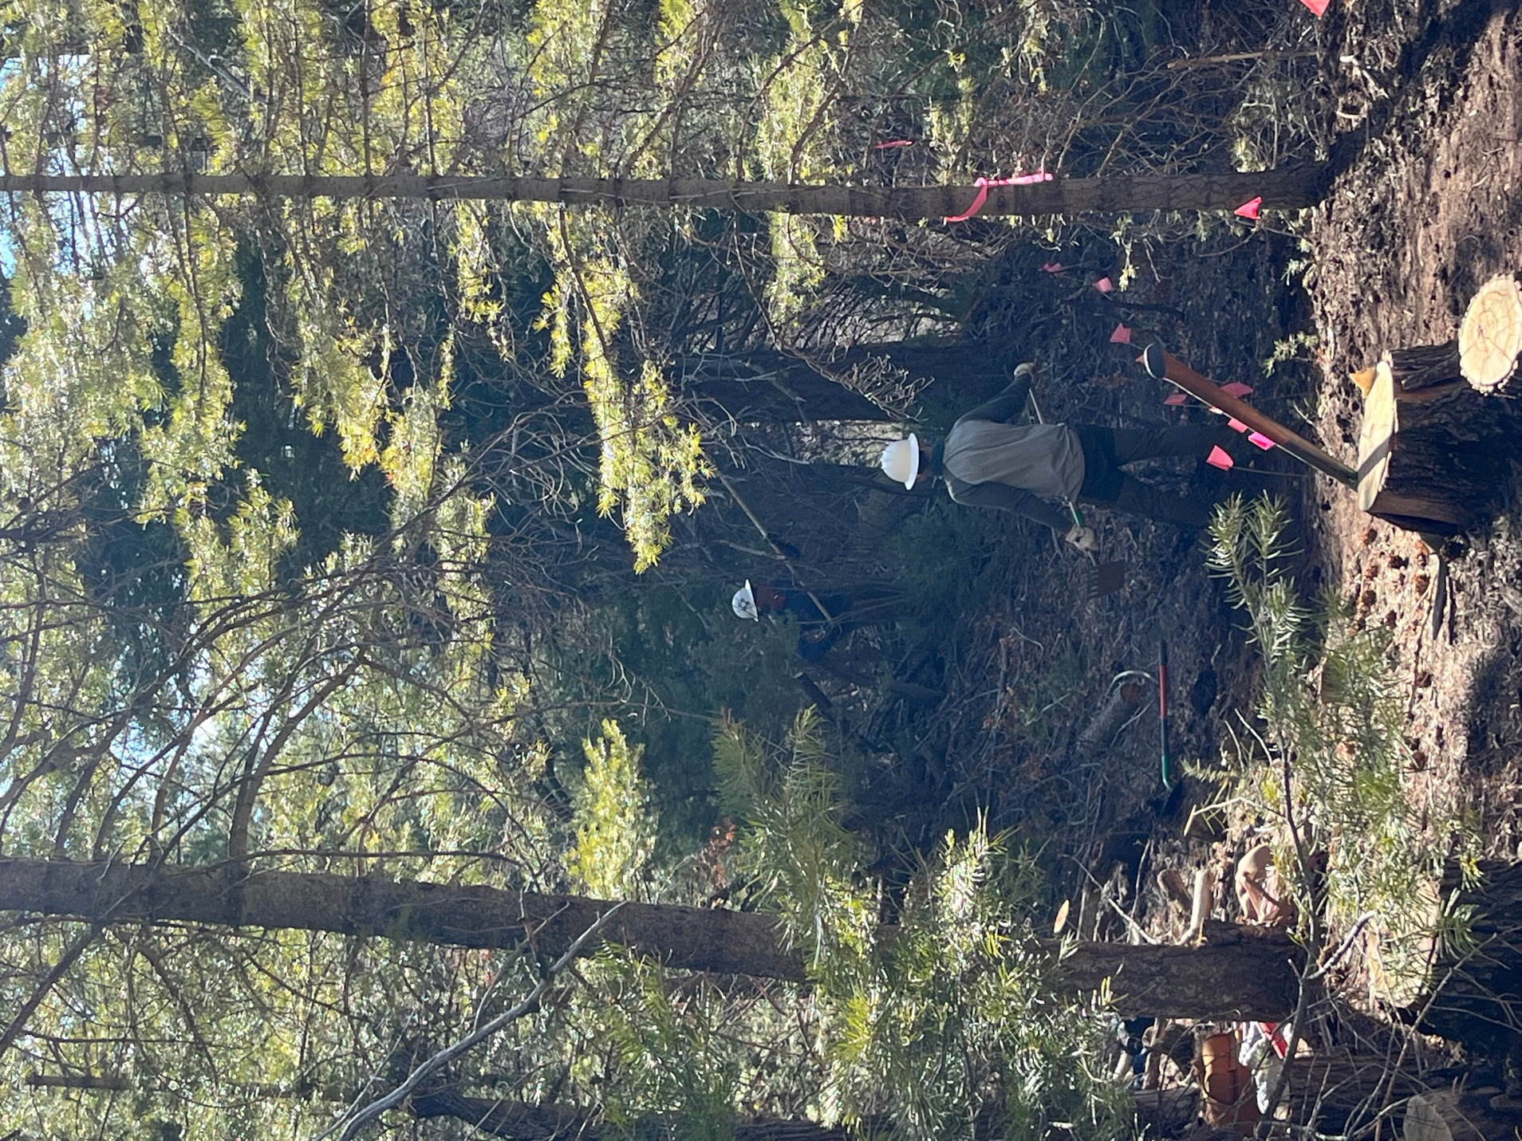

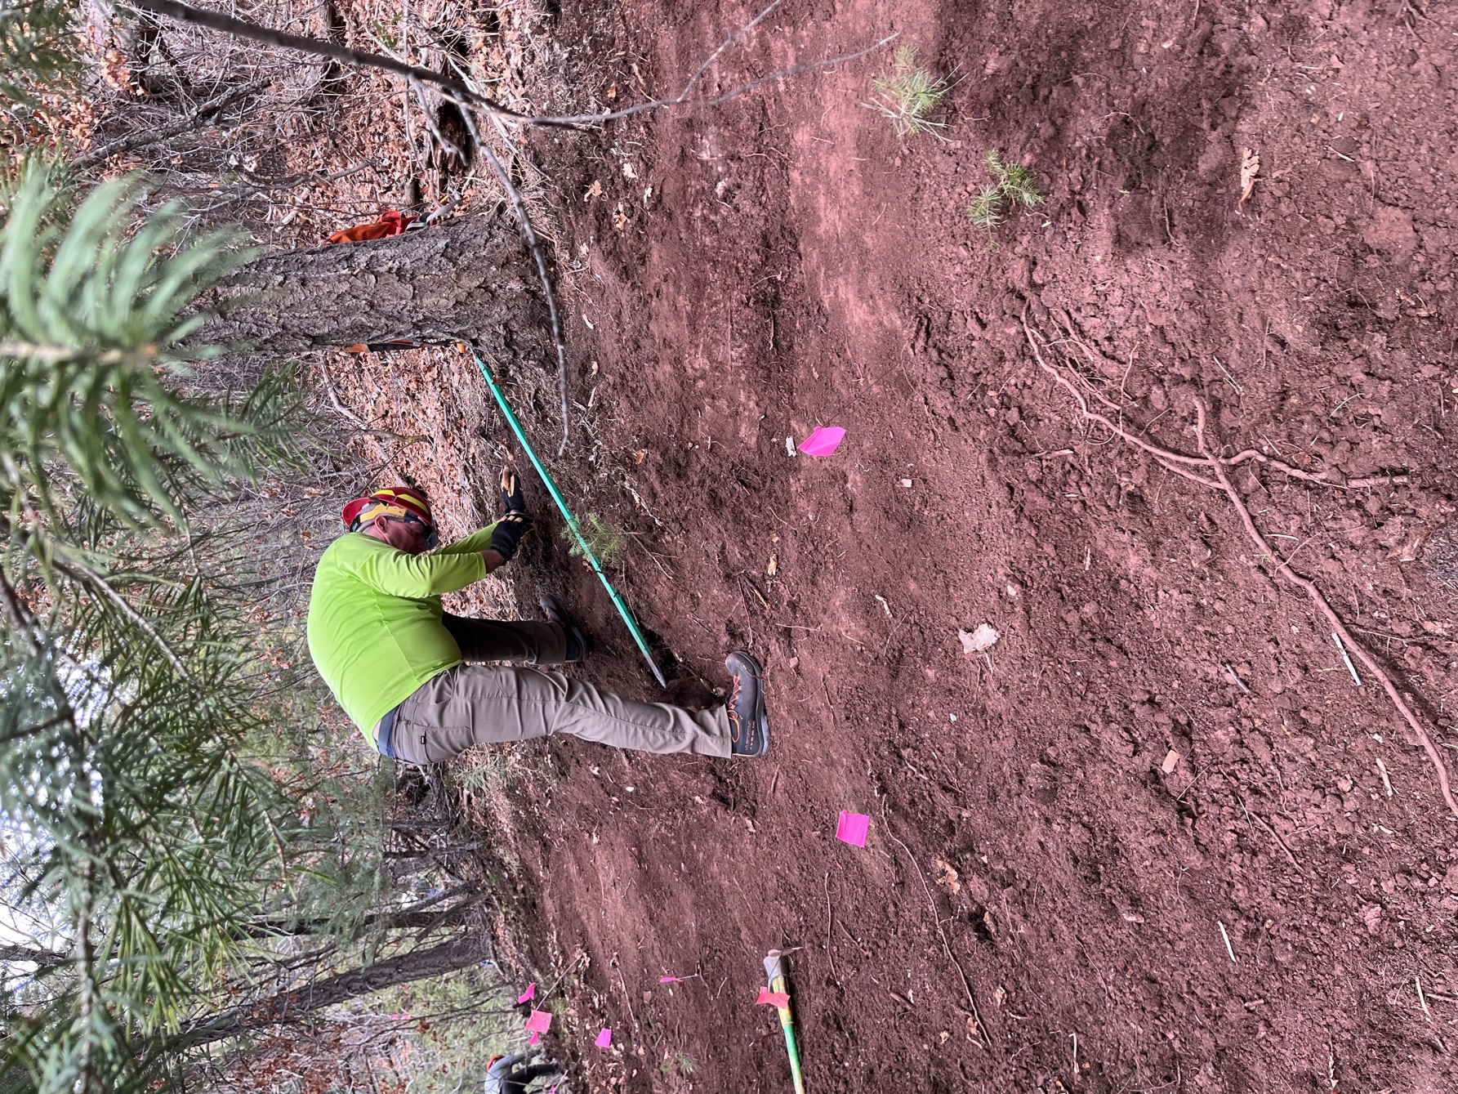

Kerry works at digging out a rock. The soil has a lot of clay in some area and it doesn’t like to release treasures.
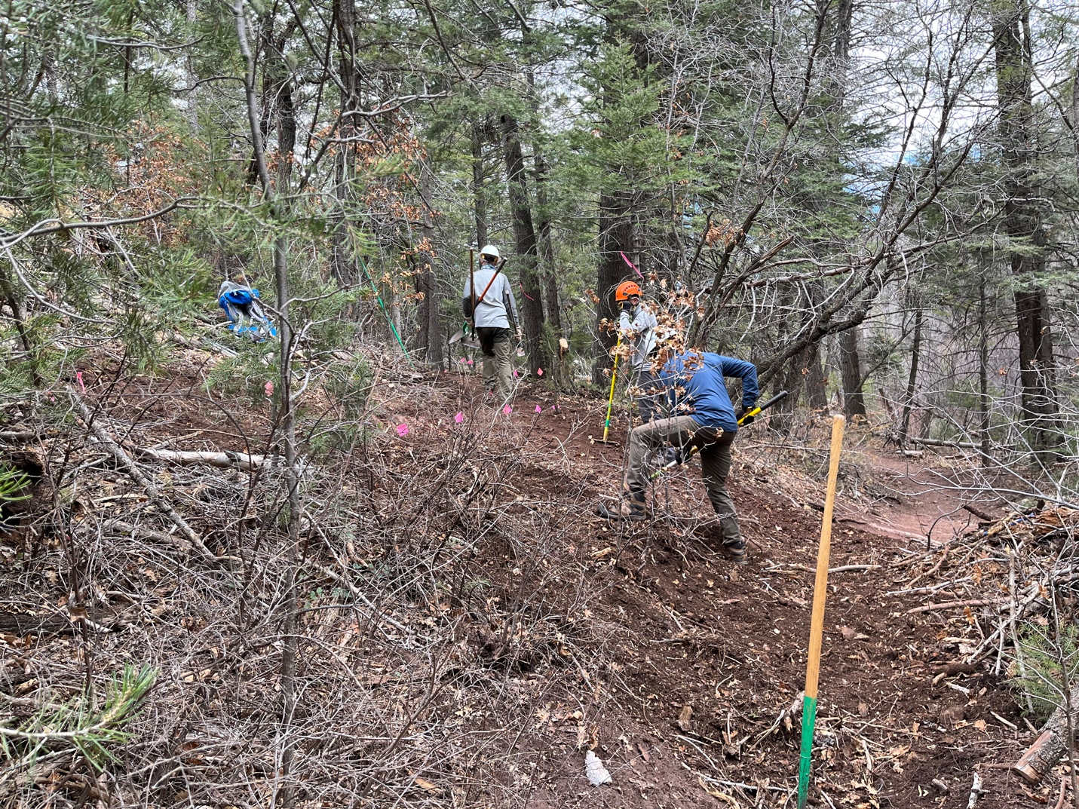

Luis and Don work on a section that cuts close to the existing trail. There is lots of debris to move.

