Report of Completion of Painting of Letters on Roundabout National Scenic Byway Sign, Saturday, March 7, 2026
Sam Beard and Karen Greif
On Saturday, March 7, Karen Greif and Sam Beard completed painting the white and turquoise letters and the arrowhead on the south side of the Roundabout Scenic Byway sign. On Wednesday, March 11, the FOSM crew will replace the broken 2x8 top board on the east side of the sign and cover the crack between the east and west sides of the sign with 5-inch-wide strip of sheet steel.

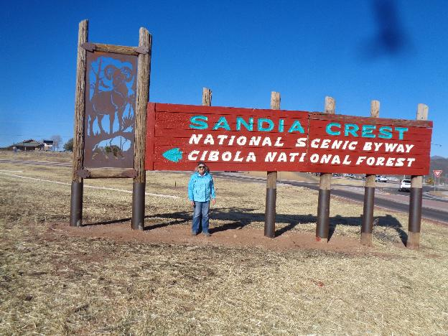
Karen Greif standing in front of the Roundabout Sign on which all the letters have been painted.

