Report of FOSM Bucking, Splitting, and Hauling 0.8 Cord of Wood from Felled Hazard Tree
in Oak Flat Picnic Area, Wednesday, March 4, 2026
Sam Beard
On Wednesday, March 4, FOSM volunteers bucked, manually split, and hauled wood from a hazard tree in Oak Flat Reservation Picnic Area felled earlier by Canyon Young, SRD (Sandia Ranger District) Trails and Wilderness Manager. Over half of the wood from the 24-inch diameter tree had been stolen before FOSM processed the wood which had been behind a locked gate. The 0.8 cord of wood was hauled to the Ranger Station and stacked at the hazmat building. The wood will be hauled to a Mountain Christian Church woodlot, and the wood ministry volunteers will distribute it to East Mountain families who need it to heat their homes.
The FOSM volunteers working on this project were Jerry Carroll, Tim Kirkpatrick, Sim Cook, Chuck Logan, Cliff Giles, and Sam Beard.
Project photos are presented below.

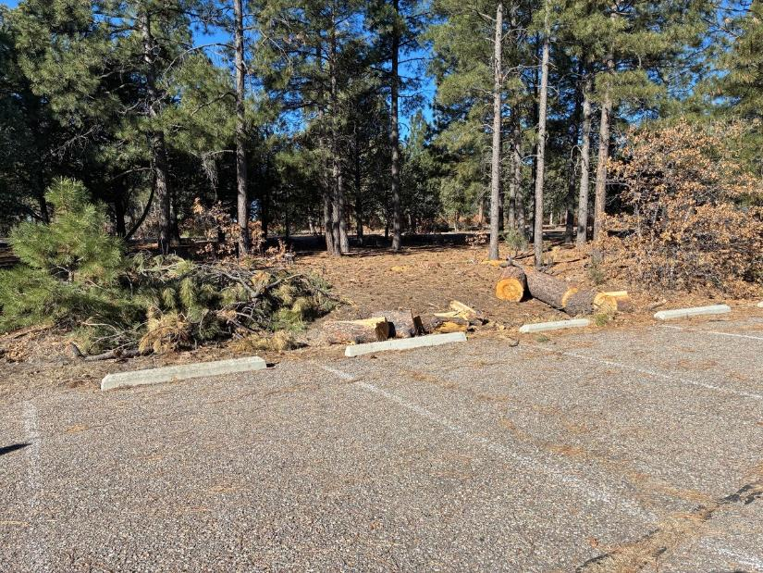
Rounds and slash from the hazard tree felled by Canyon Young, SRD Trails and Wilderness Program Manager, in at the Oak
Site in Oak Flat Reservation Picnic Area. All photos by Cliff Giles unless noted otherwise
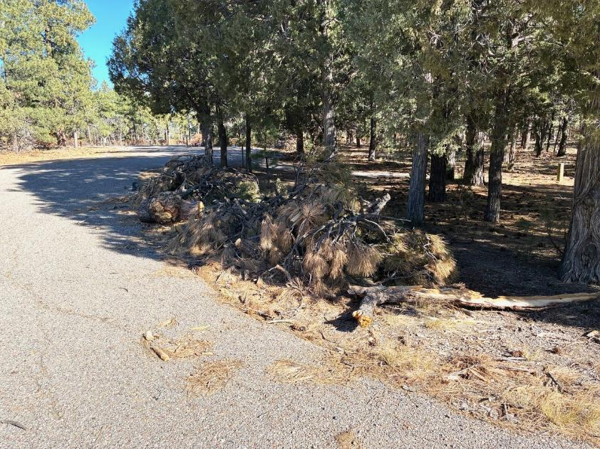
Slash pile and rounds on the other side of the parking lot.
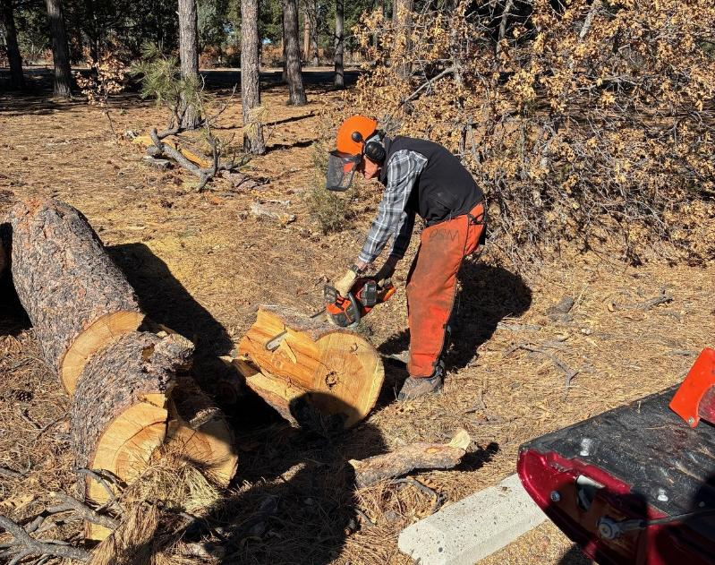
Sim Cook bucking a large round.
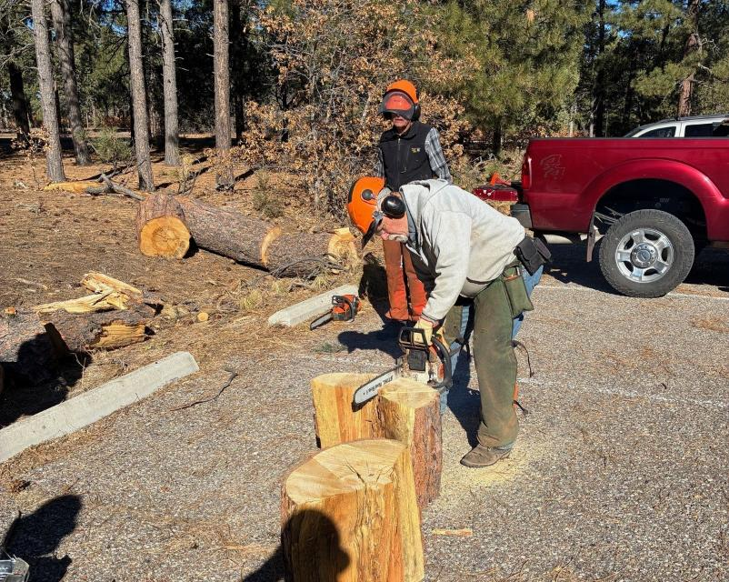
Jerry Carroll scoring a round to make manually splitting easier.
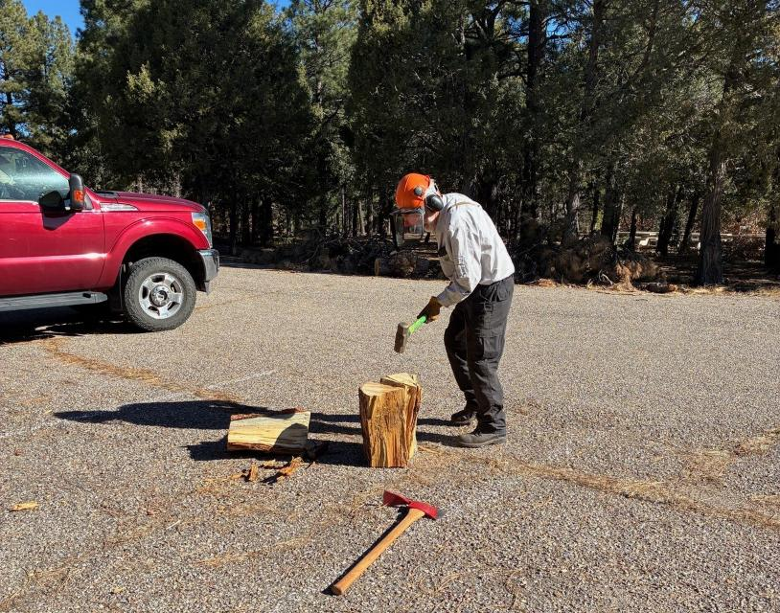
Sam Beard splitting a round with a sledge hammer and wedges.
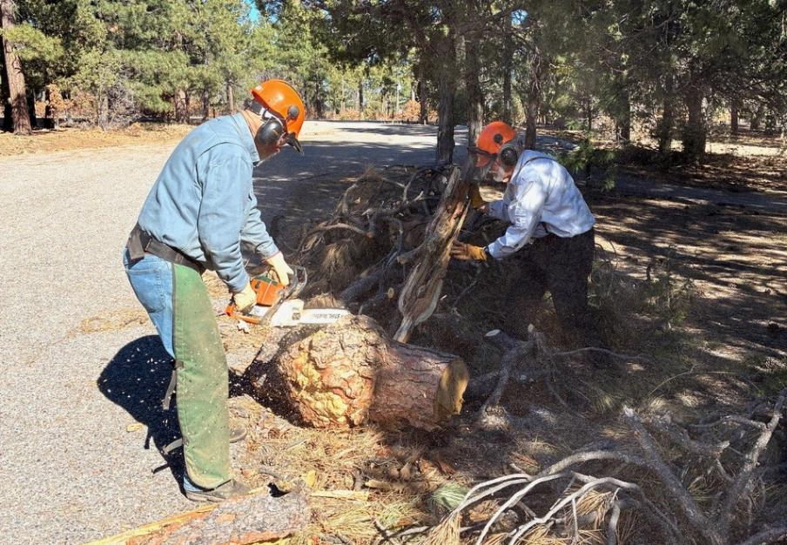
Jerry Carroll cutting a burl off of piece of pine trunk. Sam is moving slash to make cutting easier.
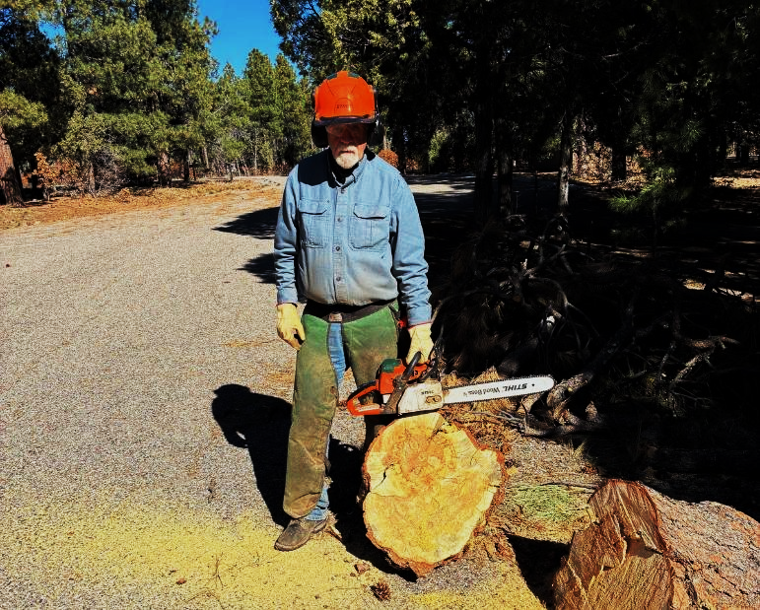
Jerry has completed cutting the burl from the trunk. The grain in the burl is very irregular.
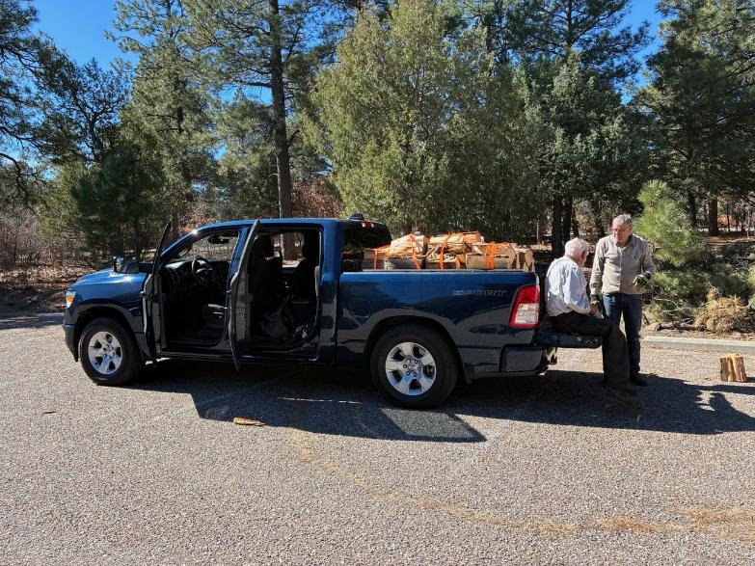
Sam and Chuck having lunch on the tail gate of Chuck’s truck. After loading the split wood
on the truck and securing it with tiedowns, the load is ready to haul to the SRD hazmat building.
Some wood was also hauled in Jerry Carroll’s truck.

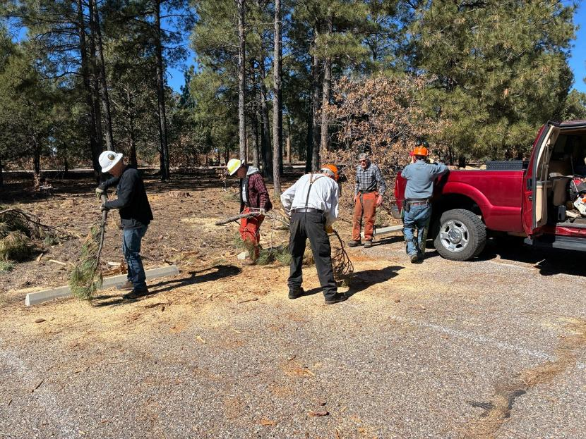
Chuck Logan, Tim Kirkpatrick, and Sam Beard are using branches to sweep the parking lot.
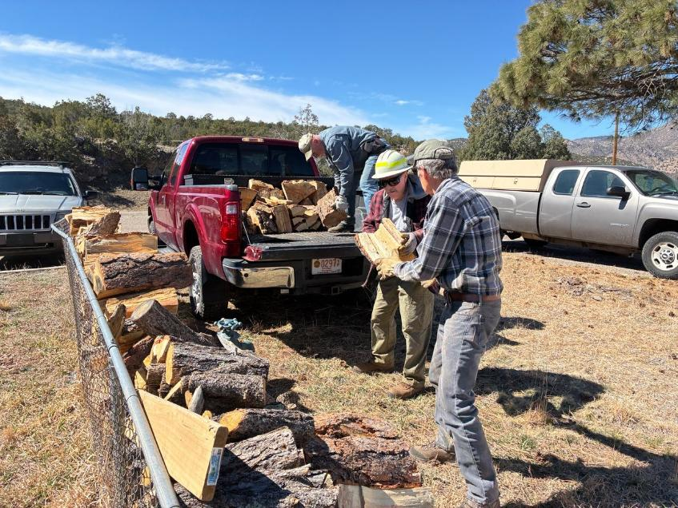
Unloading and stacking the wood at the hazmat building.
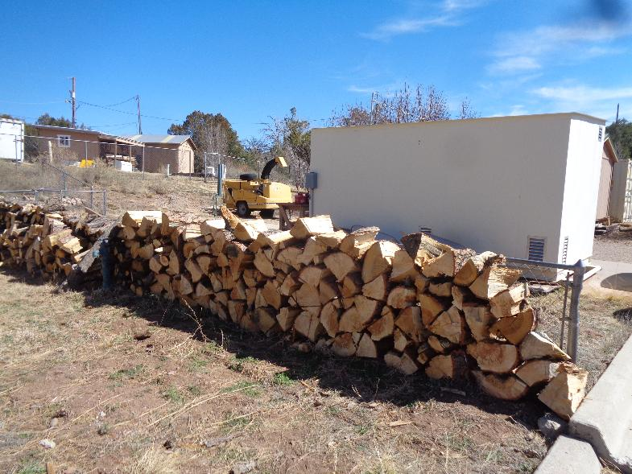
Stacked split wood at the hazmat building. The wood will be hauled to a Mountain Christian
Church woodlot, and the church wood ministry will distribute it to East Mountain families
who heat their homes with wood.

