Thursday, 03/12/26- Armijo: Still working on Armijo. It was a windy and cool start to the day so we hustled down to the reroute. We had thirteen volunteers and Jen (SRD) working this week and we still have another week of work left on the reroute. It’s looking great but there’s tons of debris, mostly branches and old fallen trees to clear and we have a lot of duff to move. Unfortunately, the current trail is very close to the reroute so we are having to pile up debris to move down later when we obliterate the old trail. We’ll get there, and we have been going over our work at the start of each week to make sure the finished trail is up to our standards!

Volunteers: Bruce Hansche, Steve Roholt, Tony Pachelli, Jim Houle, John McNett, Eric Russell, Bill Perkins, Steve Forrest, Luis Cuadros, Don Fisher, Claudia Bergsohn, Kerry Jones and Laura Leon

Pictures: Laura Leon and Luis Cuadros

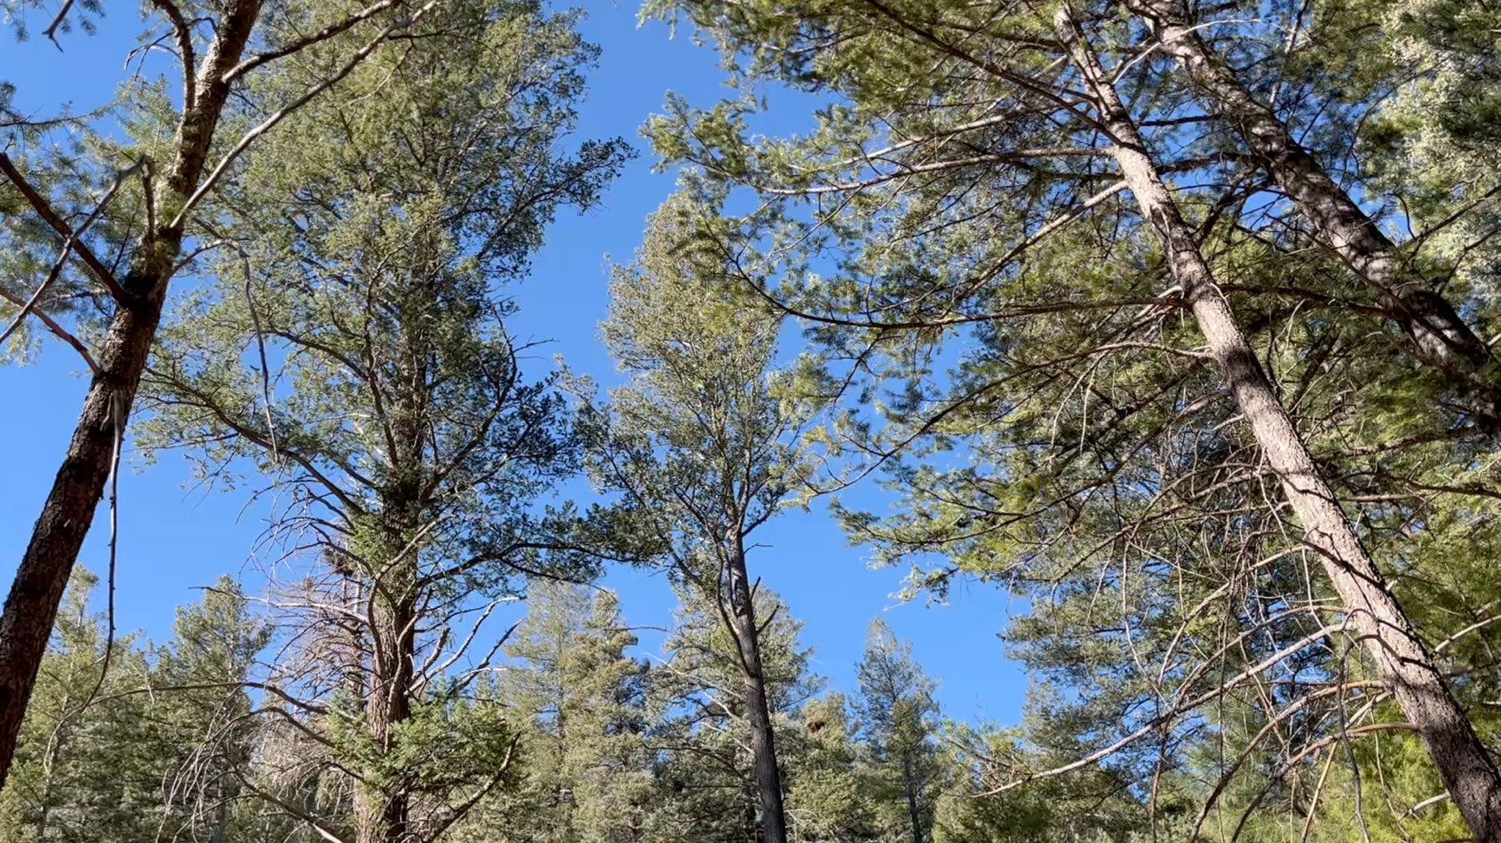

If you click on the picture, you should be able to hit play and listen to the wind!
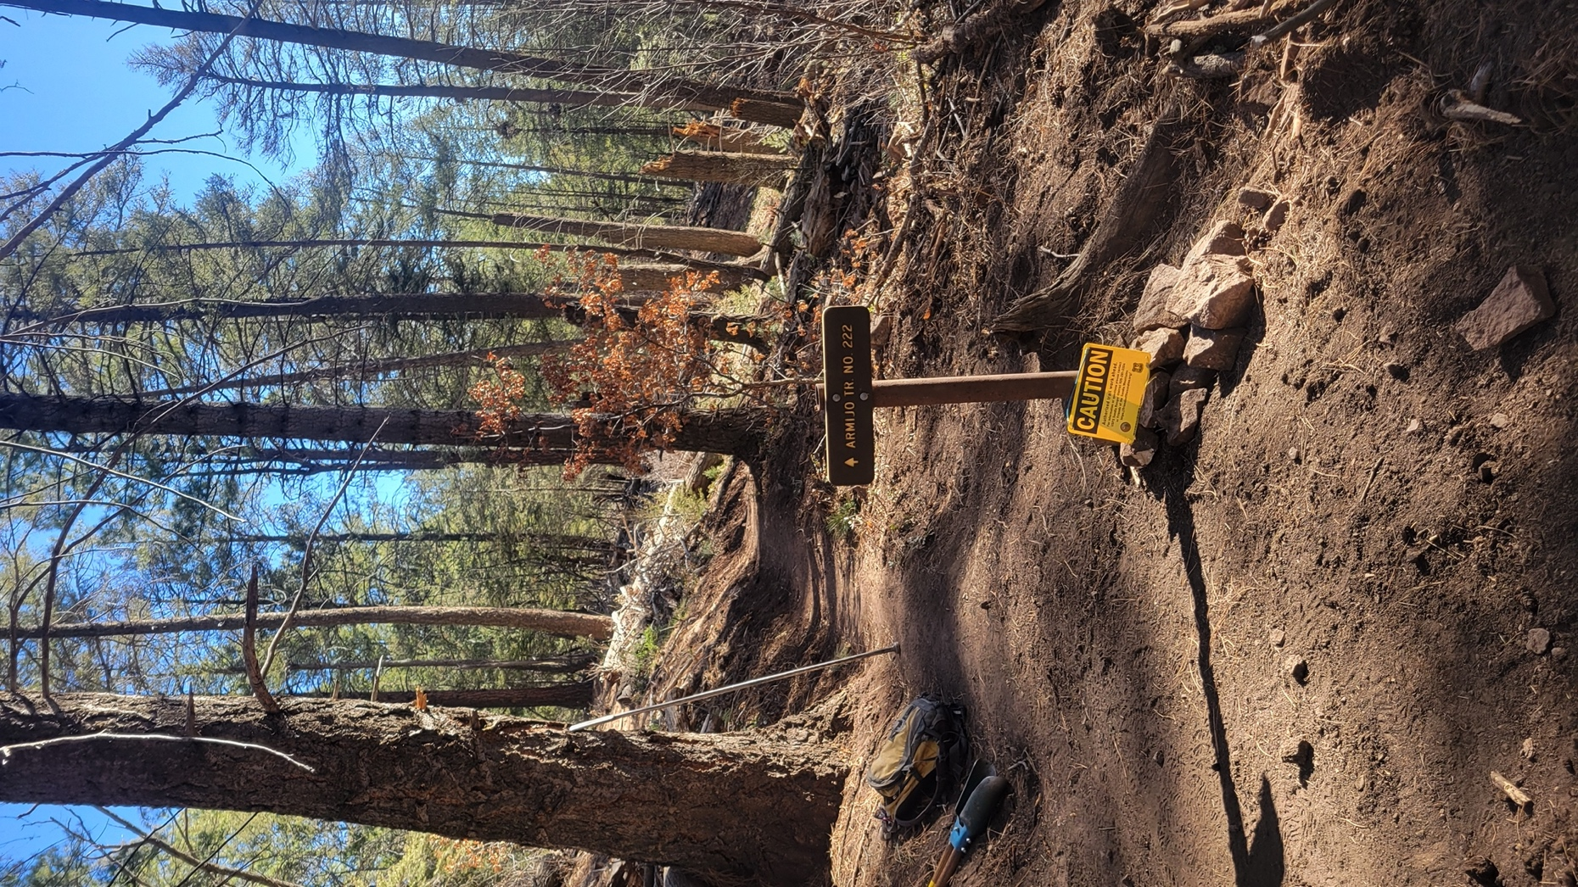

Lots of hands worked on installing the new sign where Armijo and Faulty meet.
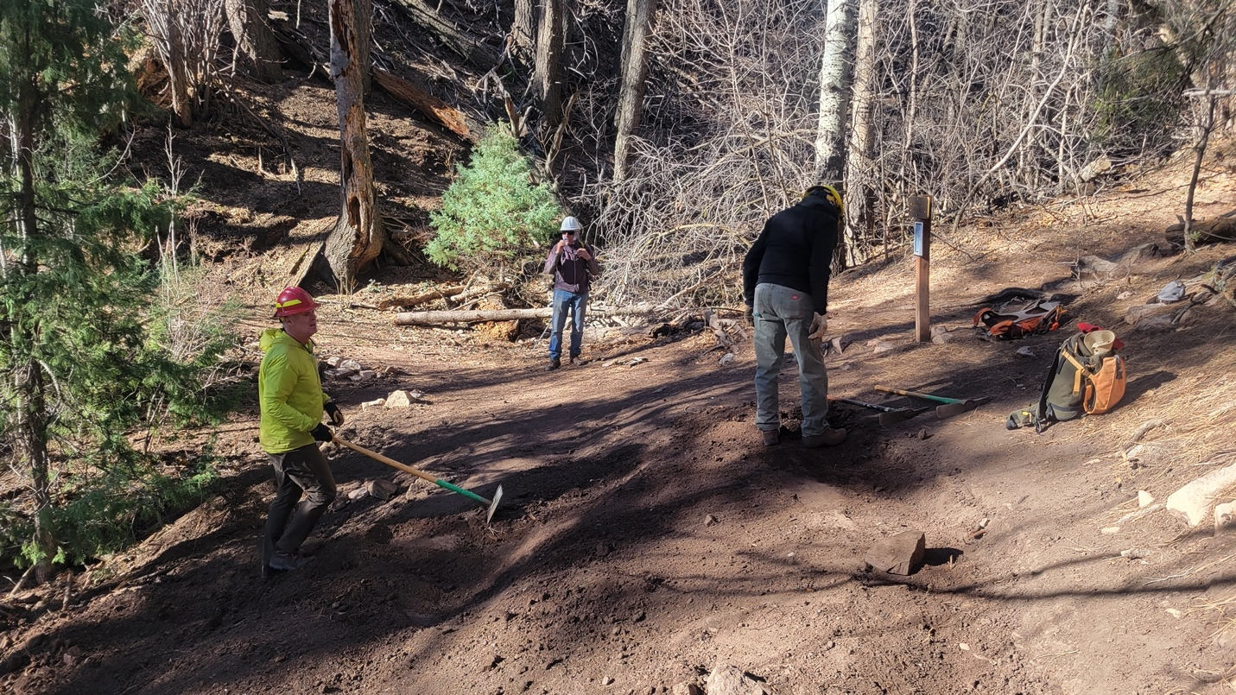

Kerry, Eric and Steve R. do some clean up around the new sign installation.

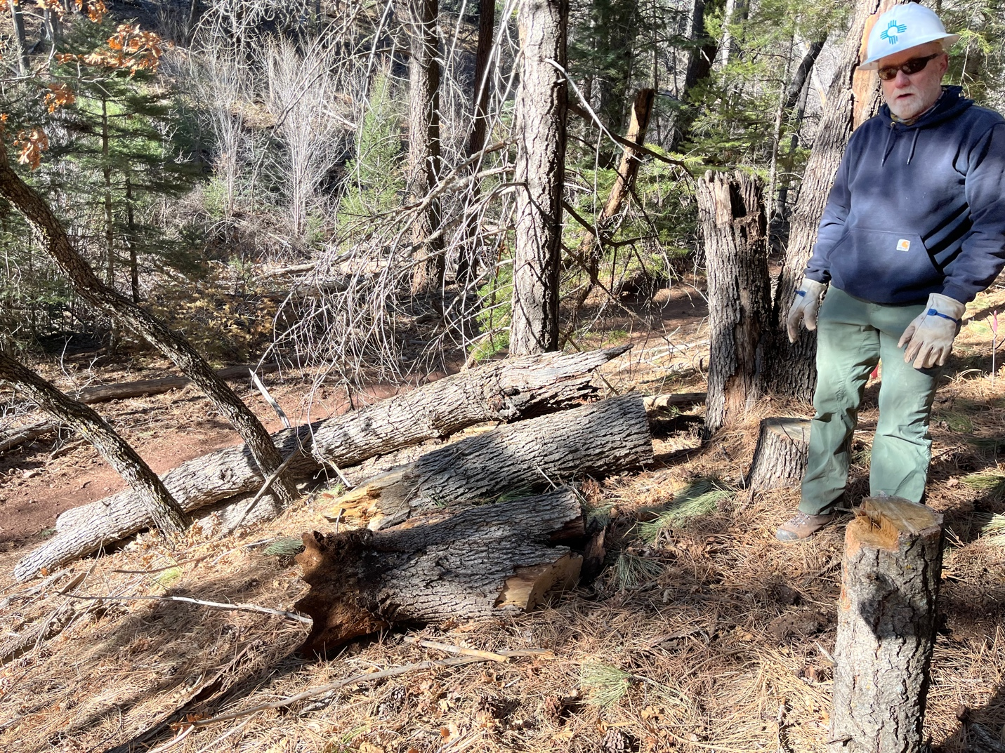

So many stumps and so much dead wood! John is excited to get started. The new trail is where he is standing and the old trail is below to the right in the picture.
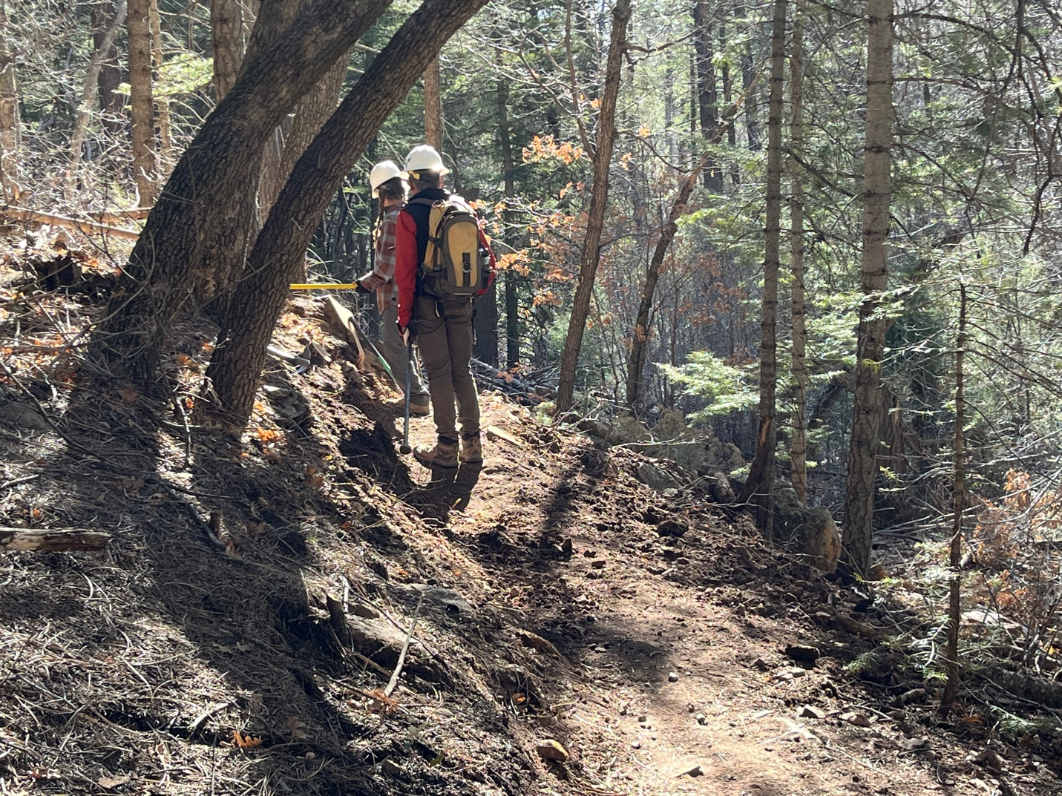

Claudia and Luis discuss a troublesome spot that we have returned to many times. There’re these two stumps….

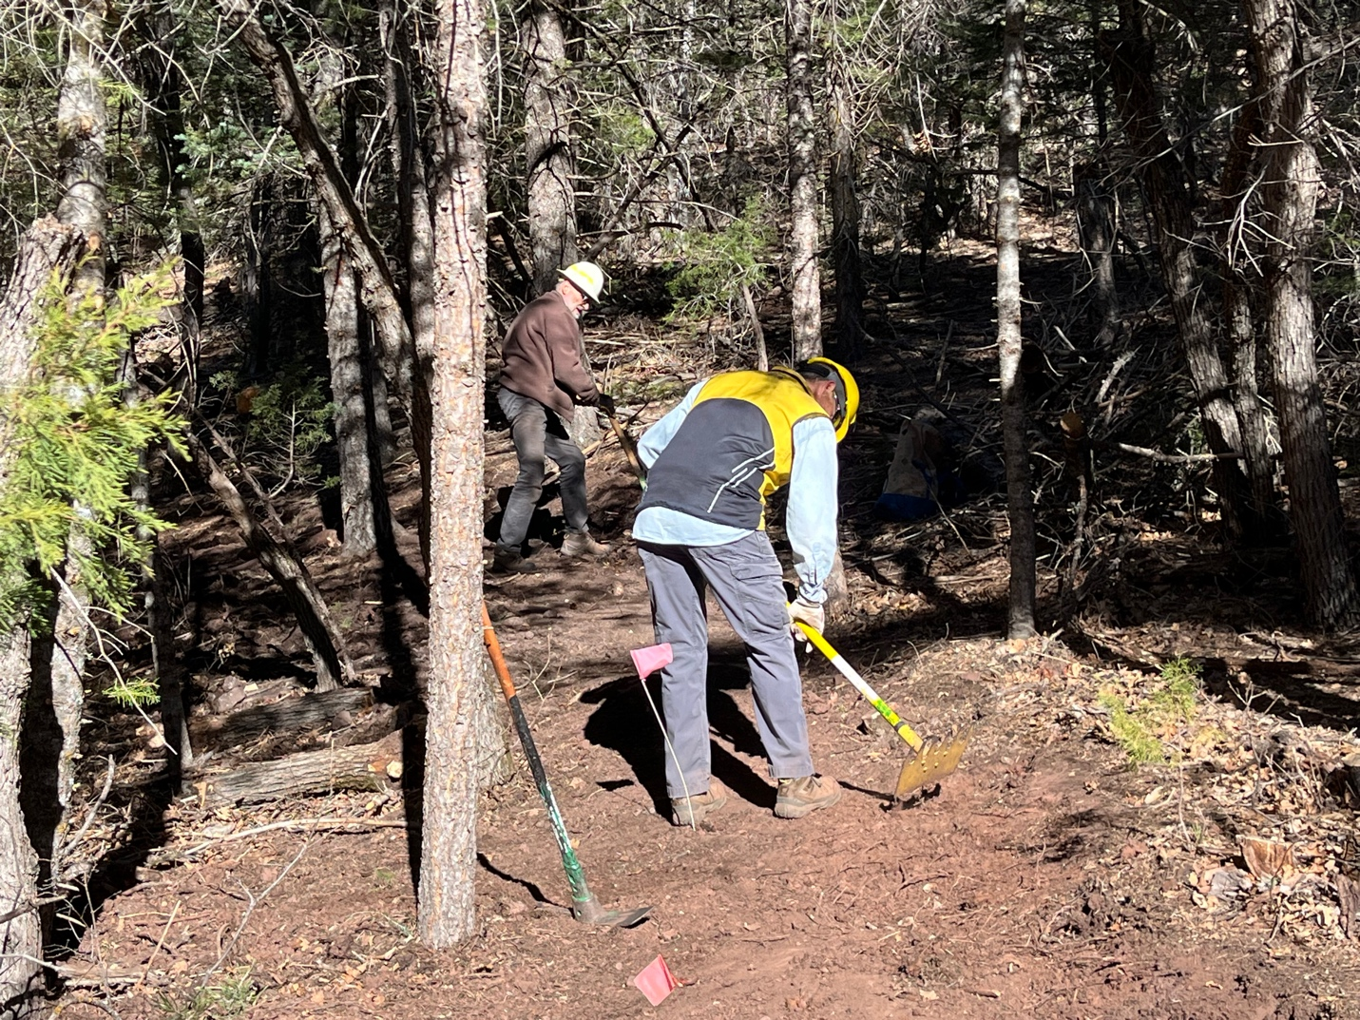

Jim and Tony rework a section.

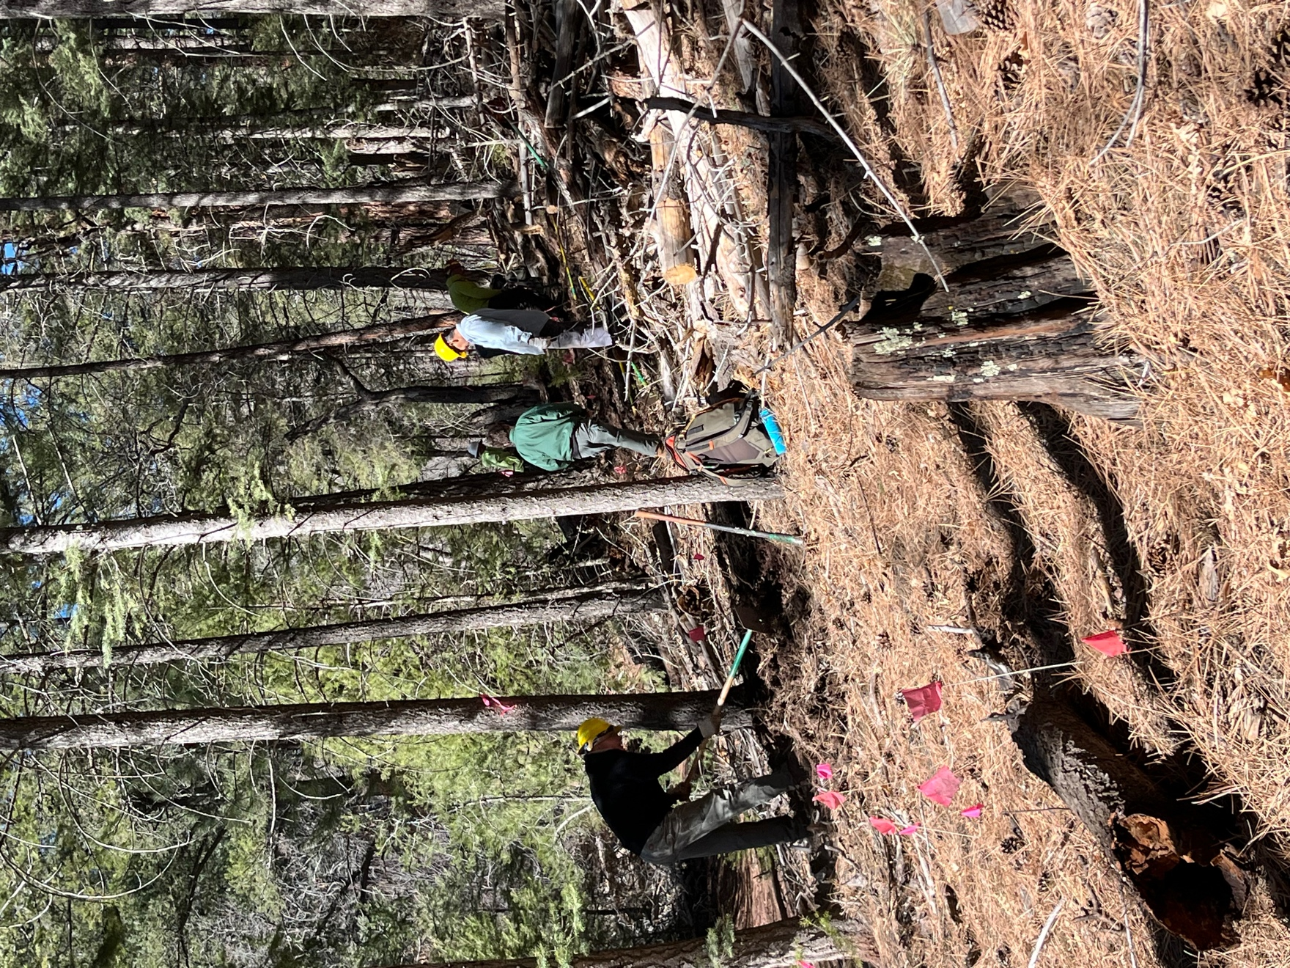

The crew works along the last sections. The duff is about a foot thick and did I mention there are a lot of branches and dead wood?

