Trail Maintenance Project: Monday, March 16,2026
Byron Garner

On a chilly overcast morning, the Monday trail crew trekked two and seven-tenths miles out the newly rerouted North Faulty trail to tackle a challenging ponderosa noted from a much appreciated report by Susan Gregory. This trophy size ponderosa and associated debris completely obliterated about ten-twelve feet of trail for which a reroute had been built. The entire crew of eleven pitched in to clear debris, limb and provide escape routes before forming a strategy and selecting crosscut points. With Jamey's forethought, we had the perfect saw for the job and began the long process, with many two person shift changes, of making the two cuts on this 29" dia. forest veteran. After finishing the cuts and some strenuous heaving with two Kant hooks, the trail was declared clear, the reroute obliterated, and the celebratory lunch and rest began.
On our return, a previously noted and poorly supported leaner was also removed with rope and minor cutting.
The team included Rav Nicholson, Paul Karas, Rene Archer, Jamey Browning, Ken Wilson, Susan Gregory, Dana Price, John Cooper, Dave McCreery, Larry Larichio and Byron Garner. Photos: Rene Archer, Paul Karas and John Cooper.

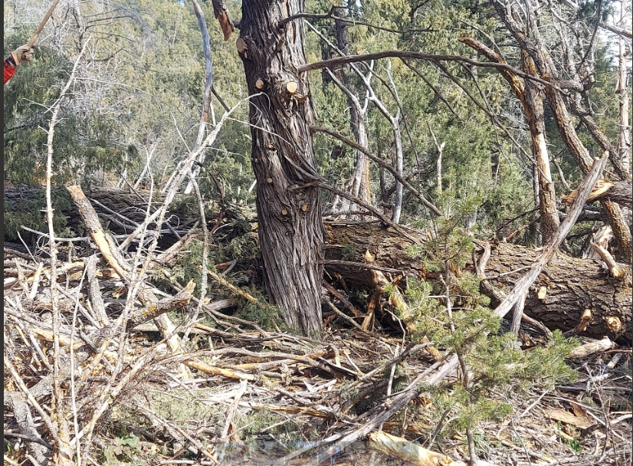 Archer
Yes Virginia there is a trail

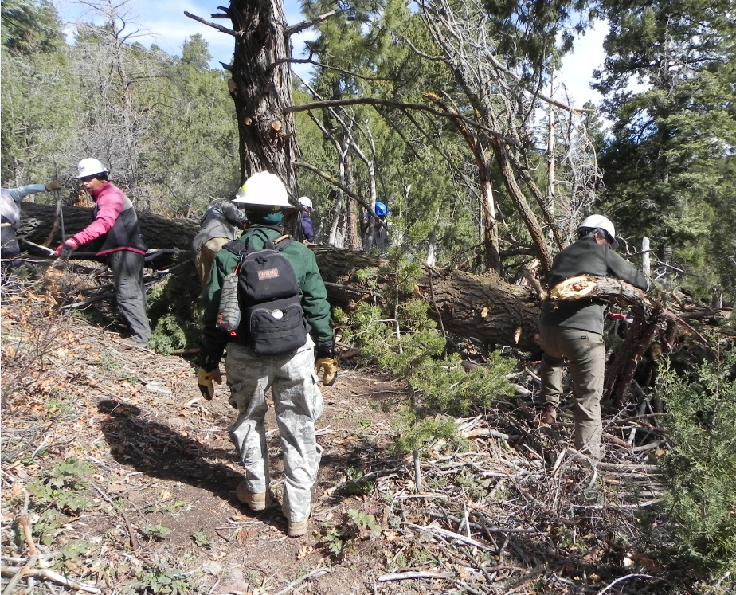

Larry, Rav and Paul tackle the debris field

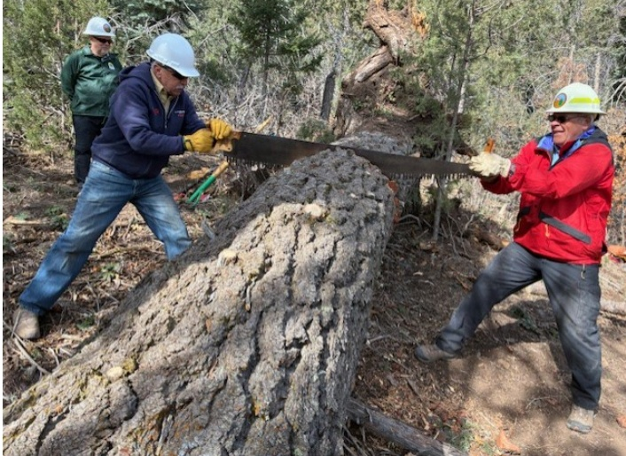Cooper
Ken and Dave start the show

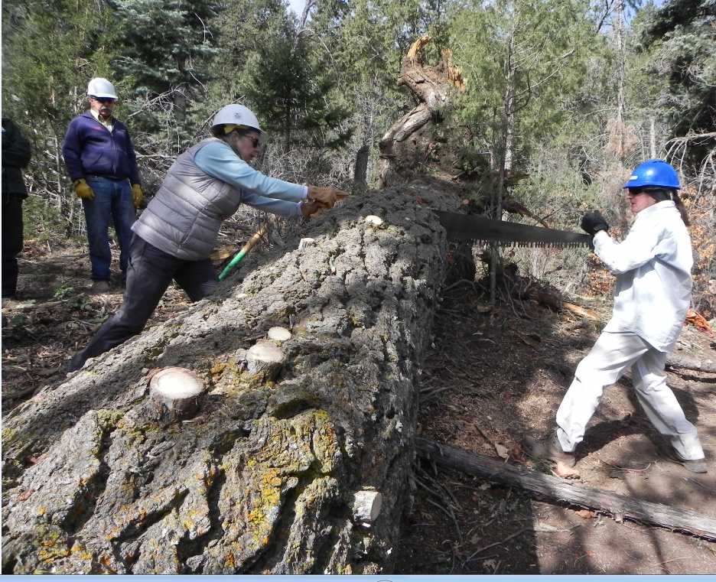
Rene and Dana with Determination

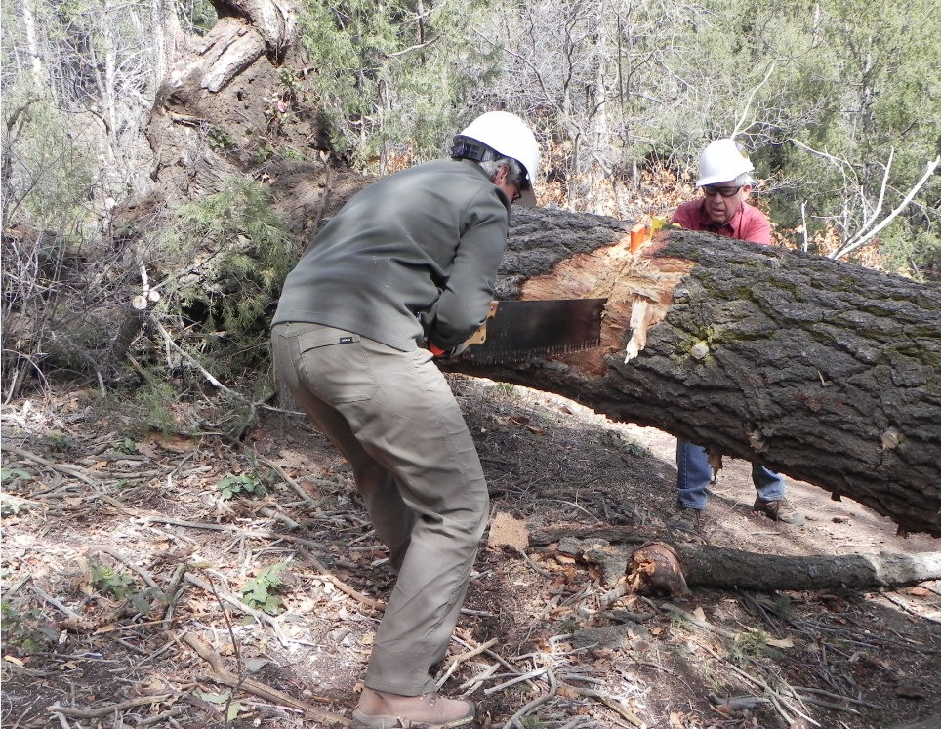

Susan and John pass the half-way point and get serious

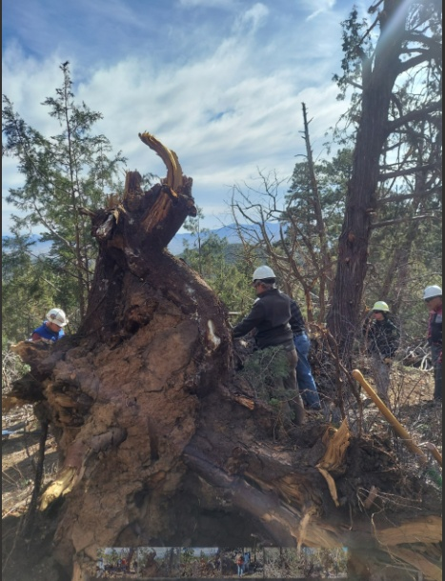

Rav readies for the next shift

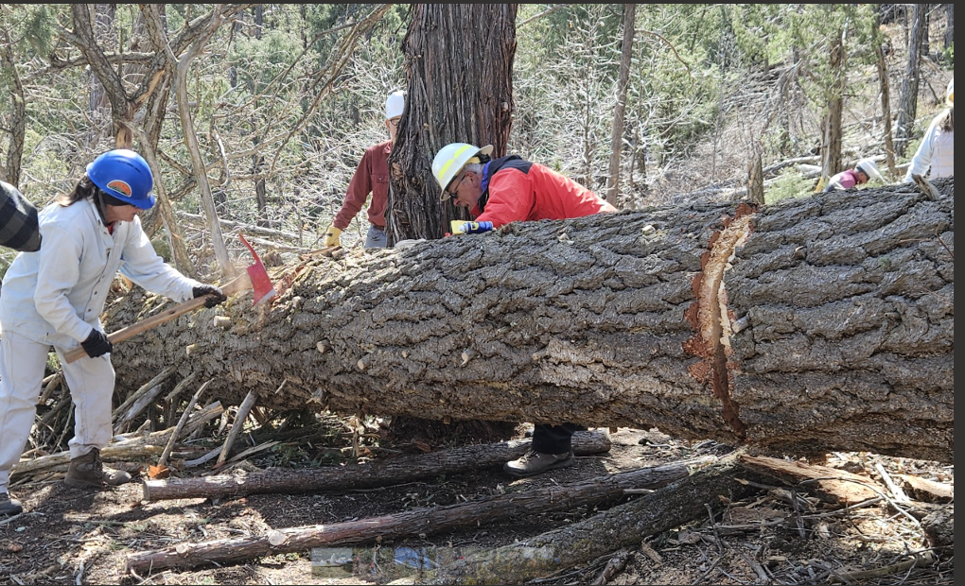Karas

Dana and Dave prep for the second cut

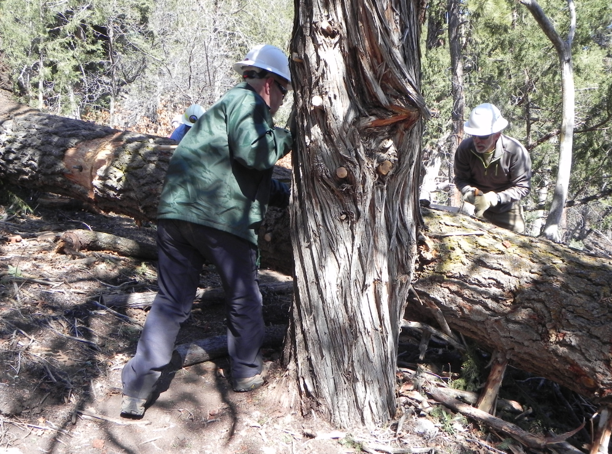Jamey and Paul work the second cut

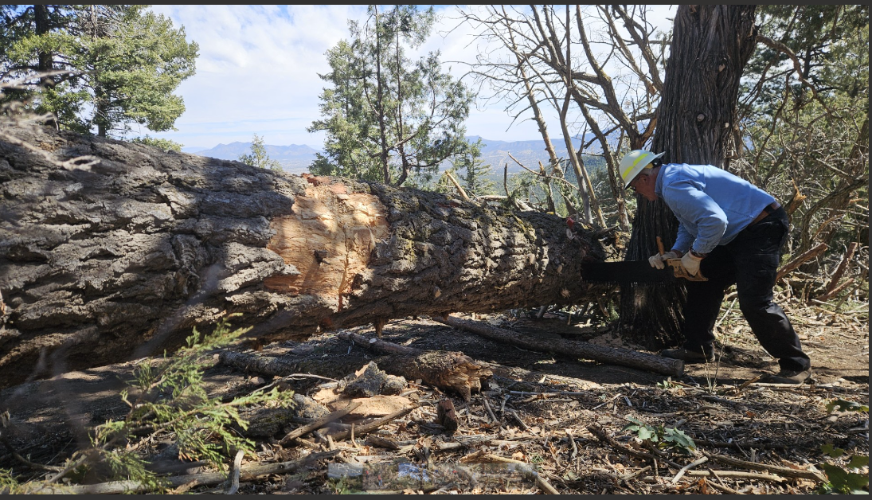Karas
Dave finishes up

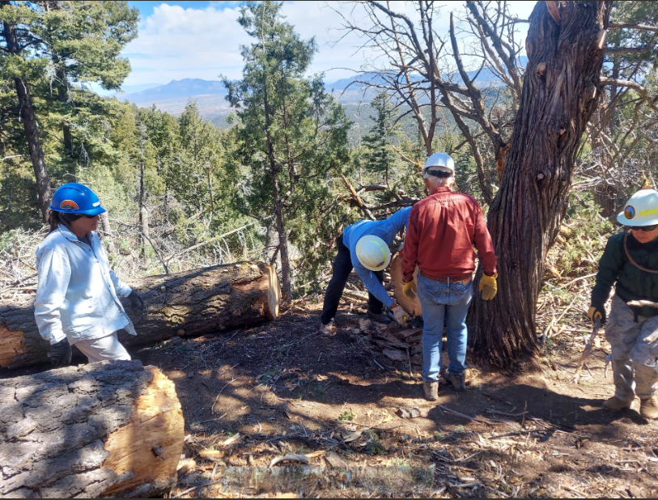Archer
Open for business

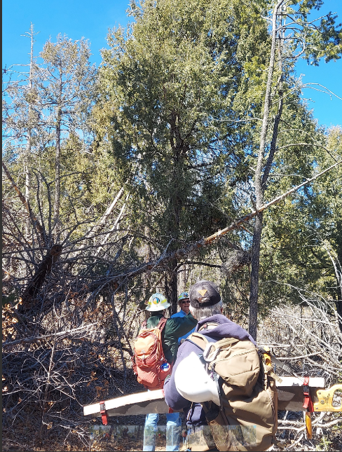Archer
The leaner

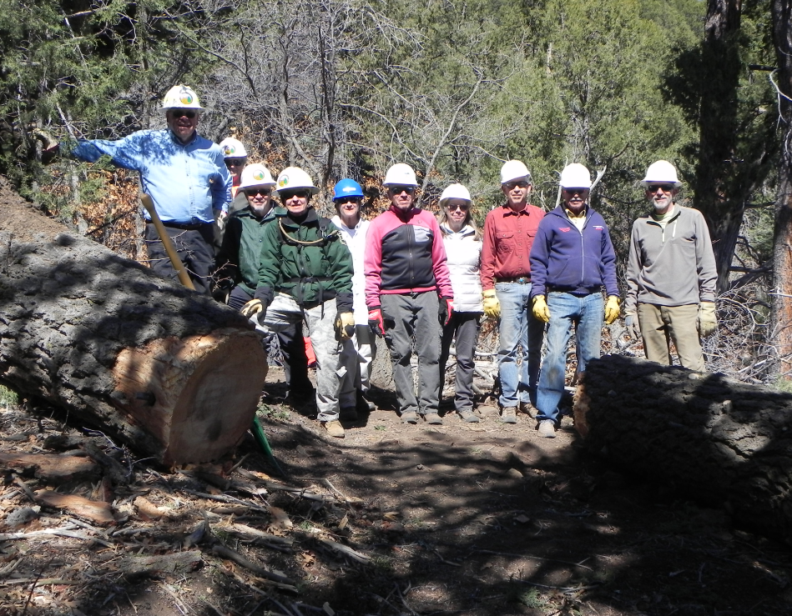
Dave, Susan, Jamey, Rav, Dana, Larry, Rene, John, Ken and Paul

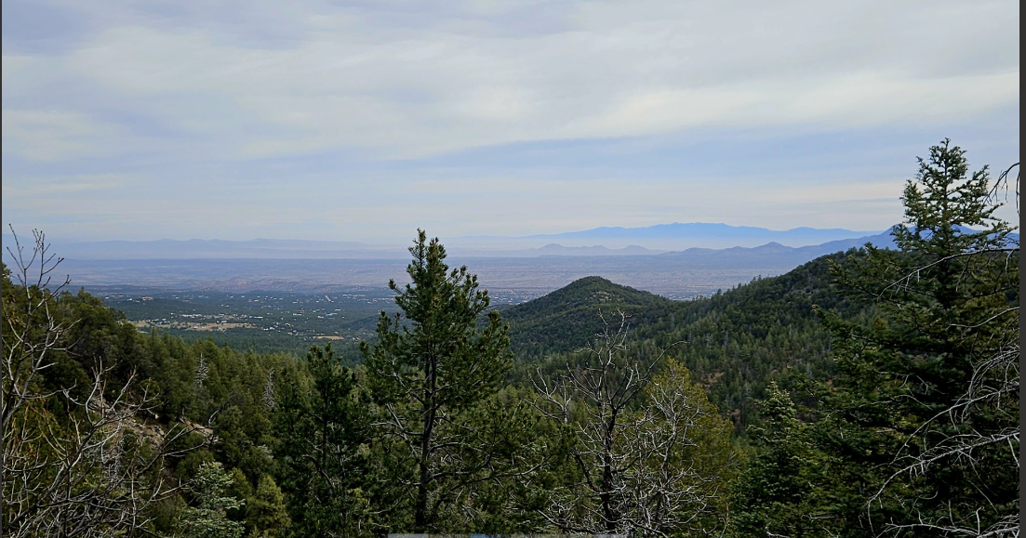Karas
A great view from Faulty North

