Thursday, 03/19/26- Armijo: We did it! The Armijo reroute is completed. Ten volunteers and Jen (SRD) spent Thursday completing and putting the finishing touches on the Armijo reroute and it looks great! The weather turned a little warmer than it should have been and most of us were feeling it but we managed to complete the work and obliterate the old, eroded trail section. We had both hikers and bikers come through while we worked and it was great to see the trail in use.

Volunteers: Byron Garner, Bruce Hansche, Tony Pachelli, Don Fisher,
Claudia Bergsohn, Kerry Jones, Luis Cuadros John McNett, Eric Russell and
Laura Leon

Pictures: Laura Leon

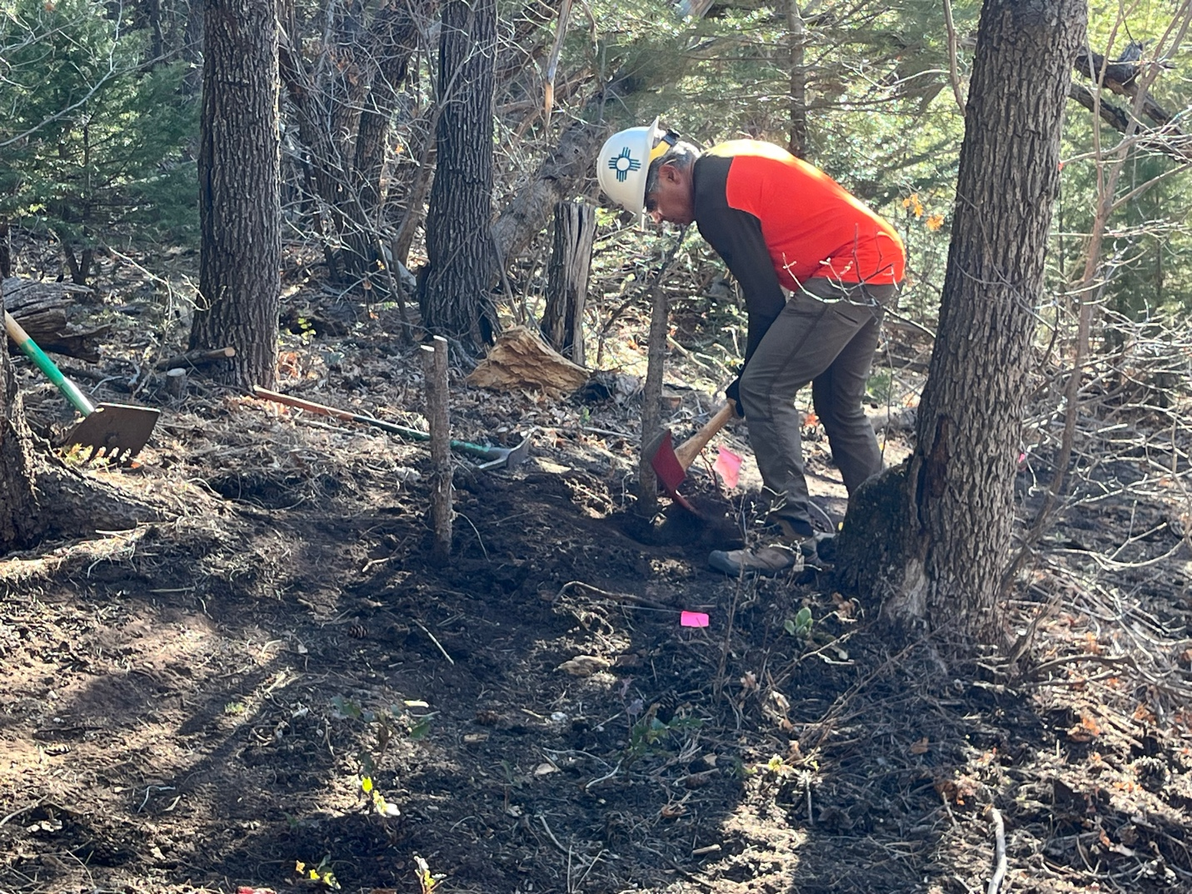

Luis got started on the end section of trail and had to work out many stumps.

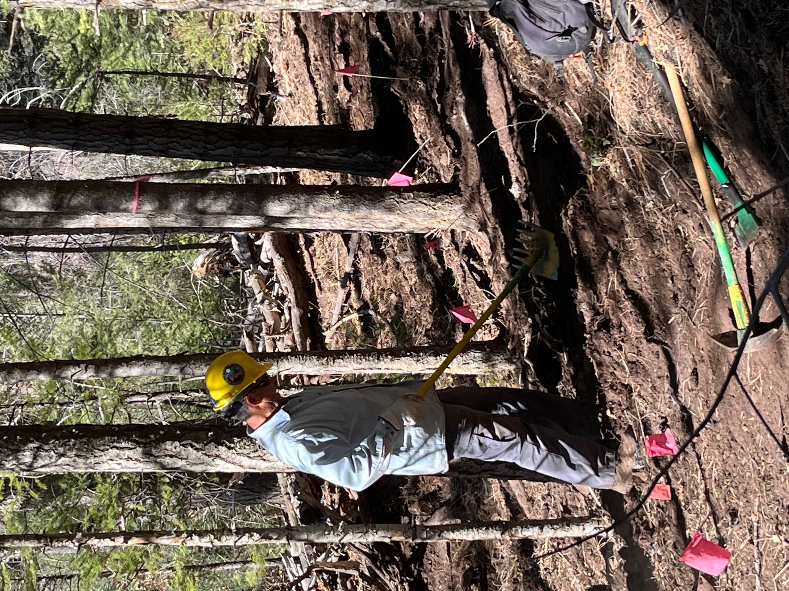

Tony worked a fussy section between trees that needed smoothing.
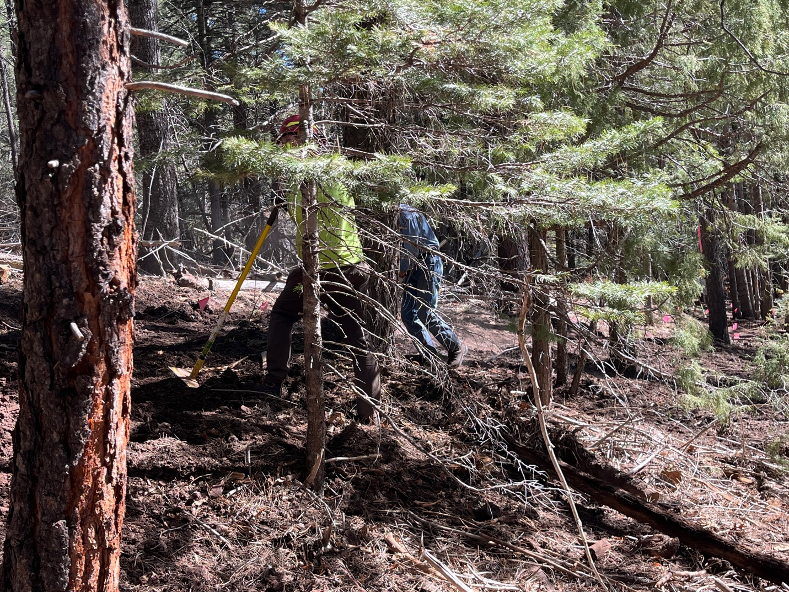

Kerry and Byron are hiding in the trees, digging through the duff.

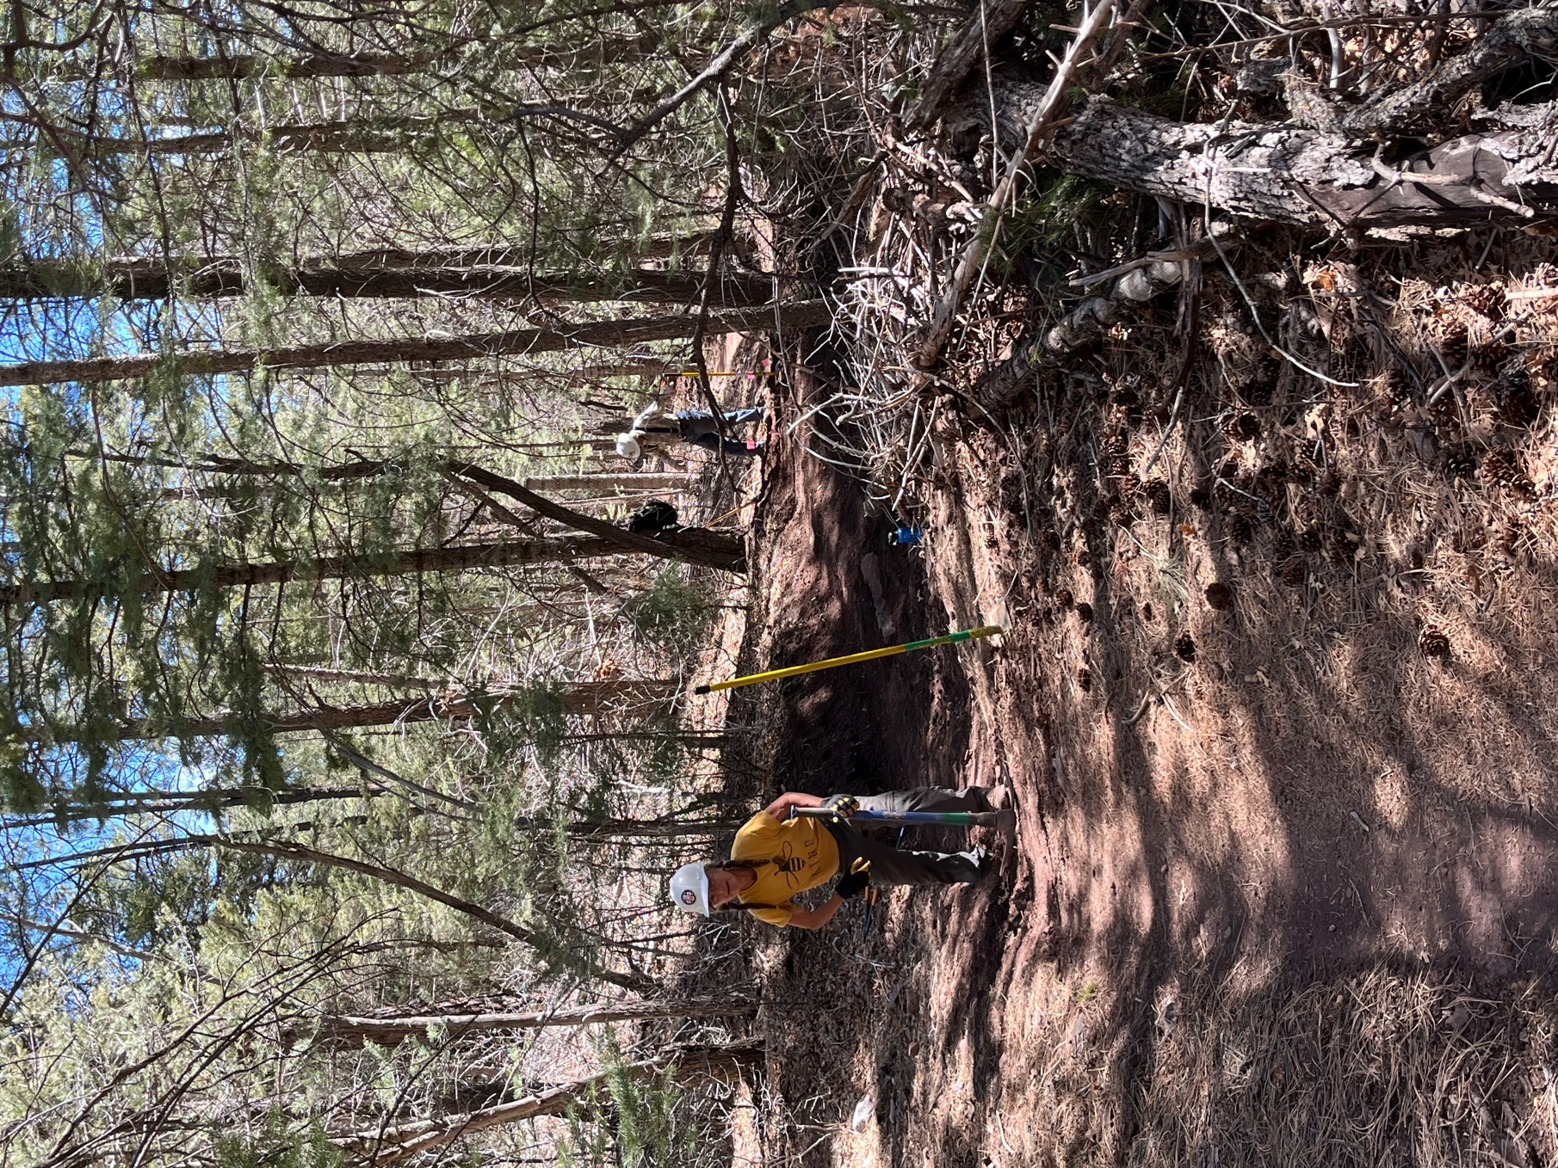

Claudia and Bruce opened the Faulty end and then reworked a couple of spots.

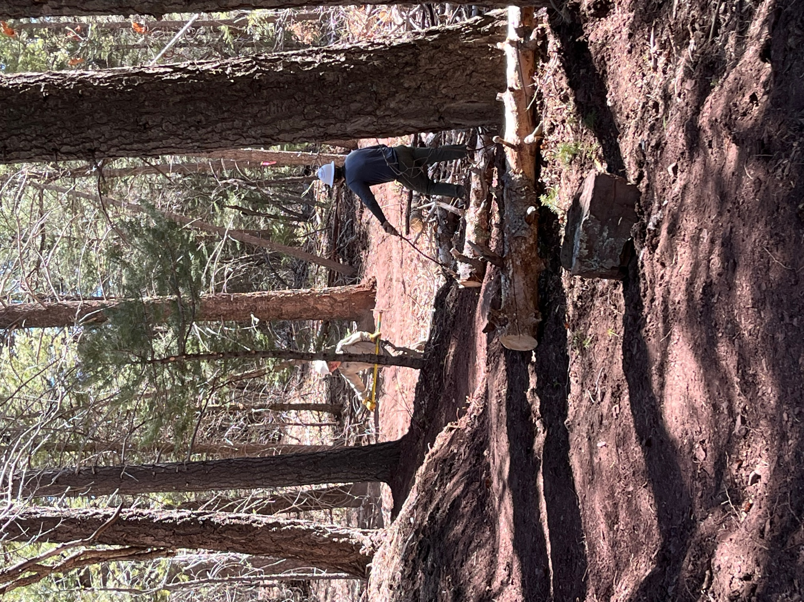

Jen and John pulled down berms of duffs and discussed heady topics.
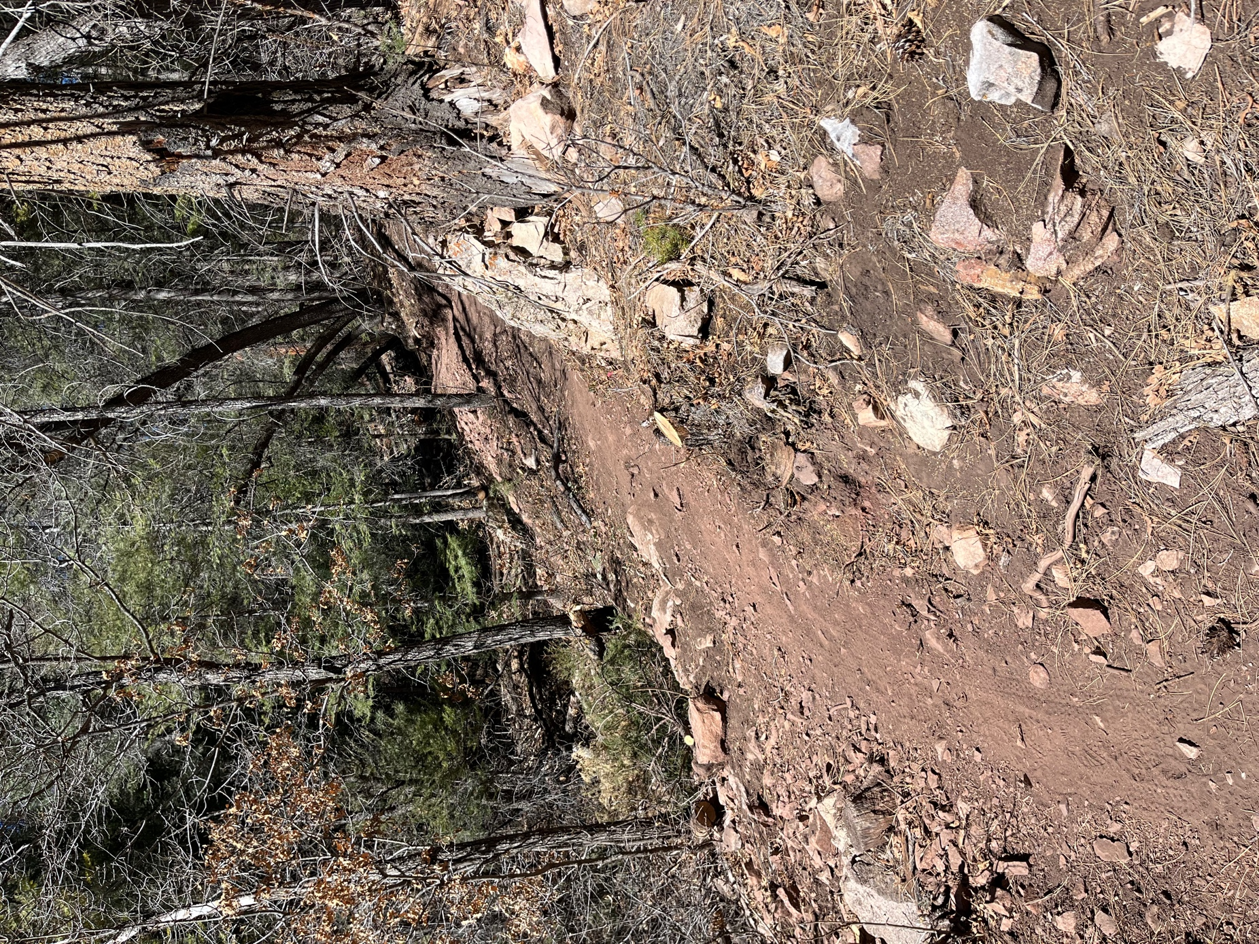

Finished trail with user tracks already on it. The old trail is down on the left.
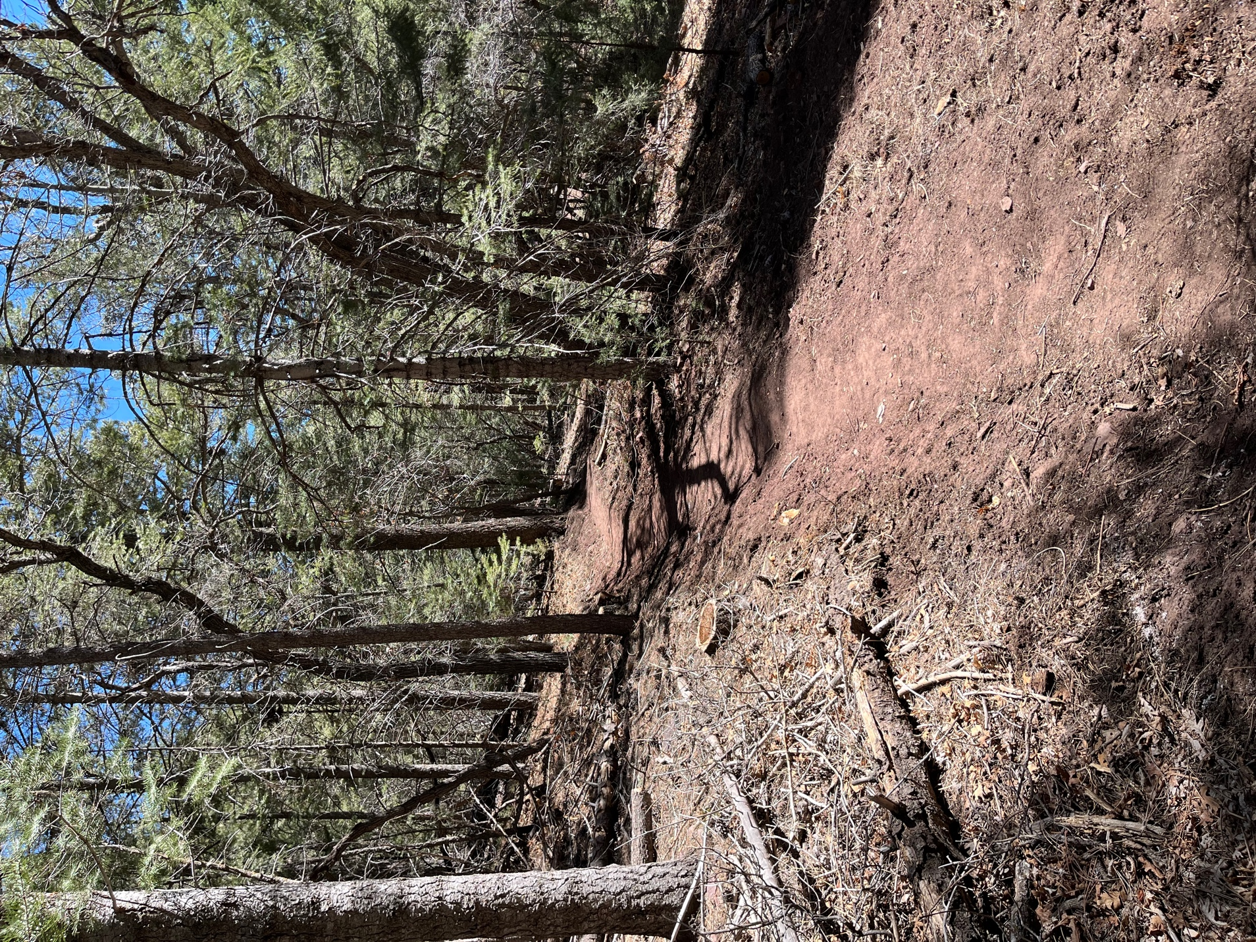

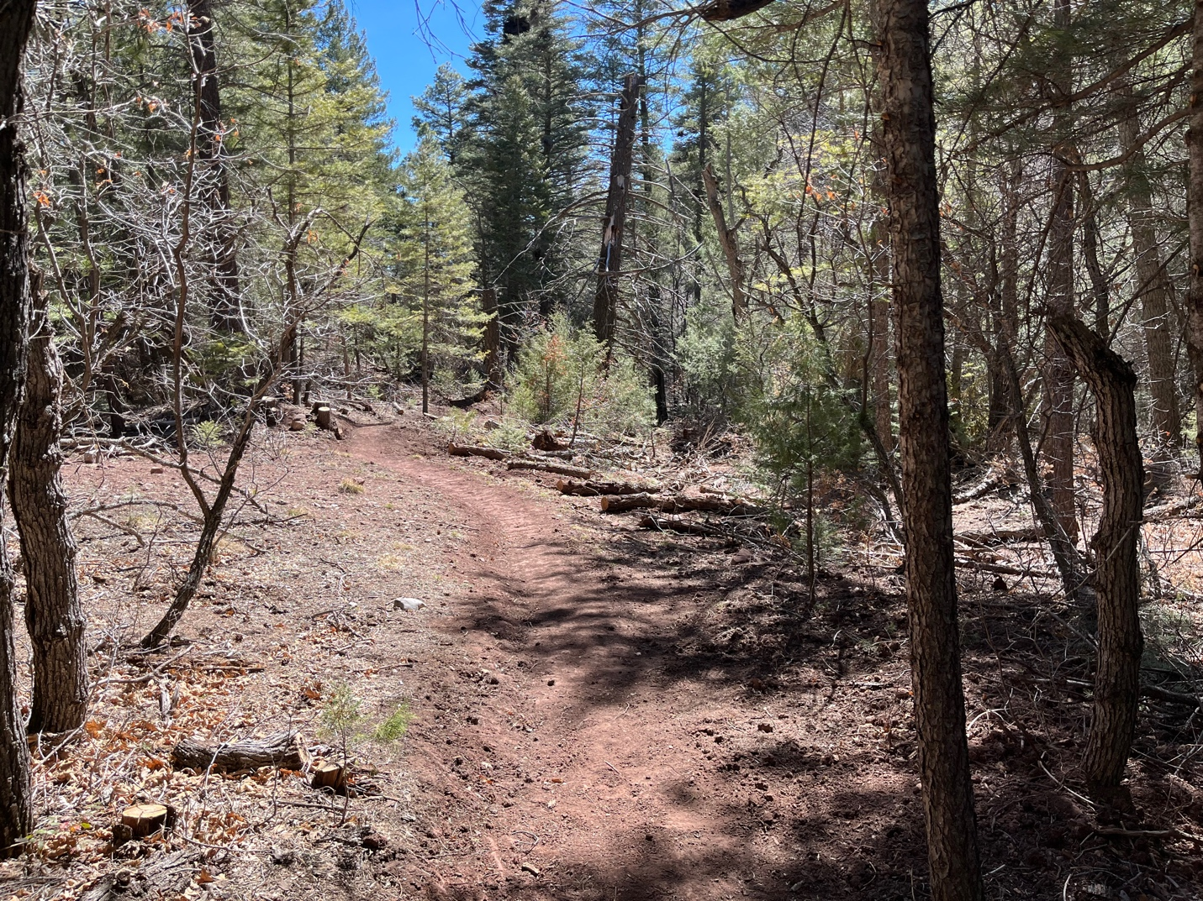

It’s a beautiful trail waiting for hikers and bikers.

