Report of FOSM Project to Restore Four Wooden Signs
at the Intersection of Oak Flat Road and NM-337
South of the Ranger Station on March 15, 17, and 18, 2026

Sam Beard
The four wooden Forest Service signs at the intersection of Oak Flat Road and NM-337 several miles south of the Ranger Station provide the following information: two signs mark the National Forest boundary – one entering the NF and one leaving the NF, and two signs direct visitors to the Oak Flat Group Reservation Picnic Ground. The boundary sign and the east sign pointing to the picnic ground were installed in 1963, 63 years ago. The west sign pointing to the picnic ground was installed in 1987. The signs are constructed with thick redwood backed with 3/8-inch plywood. The redwood and plywood on the boundary and the east picnic ground signs were in good condition but needed paint. The plywood on the back of the redwood on the west picnic ground sign was severely delaminated down a distance of about 10 inches from the top edge of the redwood. FOSM volunteers worked on the signs on three days – Sunday, March 15; Tuesday, March 17; and Wednesday, March 18.
Work on Sunday – Plywood on the backs of the two directional signs was painted with a thick coat of USFS brown paint.
Work on Tuesday – The fronts of the west and east directional signs with numerous routed letters were painted with brown and white paint. The south side of the boundary sign was painted, and parts of the north side of the boundary sign were painted.
Work on Wednesday – 1x2 boards were installed on both edges of the west sign back to prevent additional damage to the plywood. Delaminated plywood on the top of the back of the west sign was removed with a battery-powered circular saw and hammer and chisel. 1x6 boards were carefully cut to fit over the sign structure on both sides of the posts and between the posts and installed with screws where plywood had been removed and where the plywood was in poor condition. The unpainted boards in these areas are obvious in the photos. The final task on Wednesday was to trowel epoxy paste over the entire length of the top edge of the redwood, the plywood, and the new wood attached on the back of the sign. The cured epoxy paste is a permanent waterproof coating to protect the top of all the parts of the sign.
On Tuesday, March 24, the project will be completed when the north side of the boundary sign is painted and the new wood on the back of the west sign is painted.
The FOSM volunteers working on this project are Chuck Logan, Karen Greif, Pauline Ho, Rick Buss, and Sam Beard.
Project photographs are presented below.

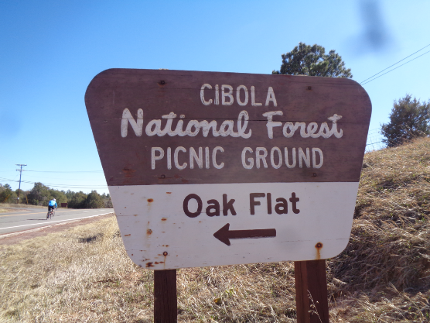
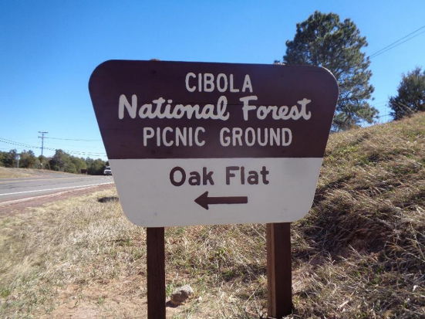
Before and after views of north side of sign on the west side of NM-337 directing visitors
to Oak Flat Group Picnic Ground. Sign was painted by Pauline Ho and Rick Buss.
All photos by Sam Beard
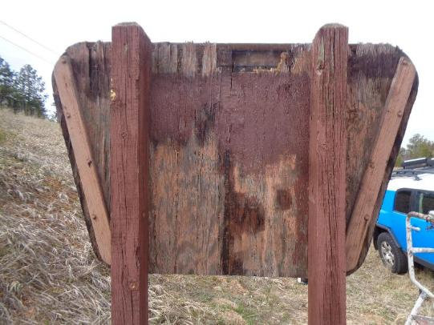
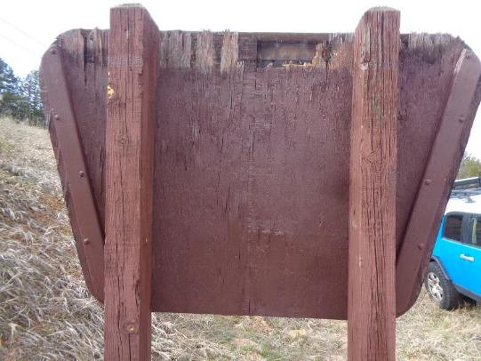
Top: View of west sign showing delaminated top edge of plywood backing. Bottom: Most of the
plywood has been painted. The delaminated area of the plywood will be covered with two 1x6 boards
and painted to better protect remaining plywood and for better appearance.
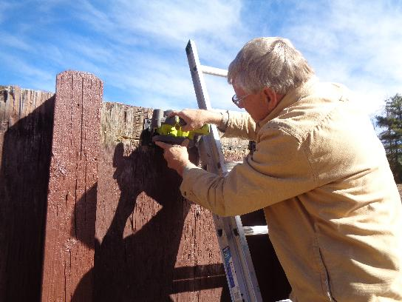
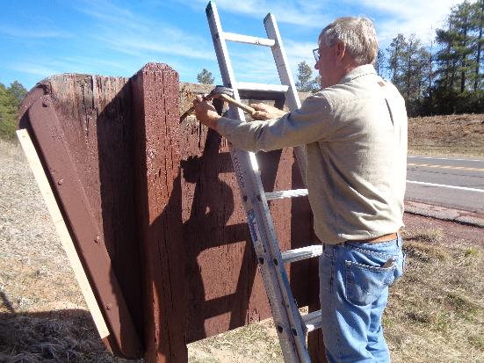
Top: Chuck Logan using his small battery-powered circular saw to cut off delaminated
plywood in preparation for installing 1x6 boards over the delaminated area. Bottom: Chuck
using a hammer and chisel to cut plywood that the saw could not reach.
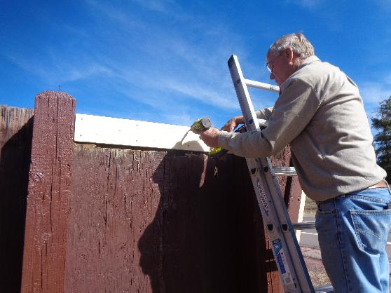
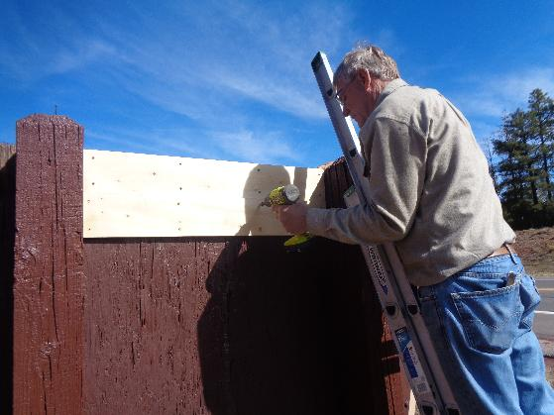
Top: Chuck installing screws to attach first 1x6 over the delaminated area.
Bottom: Chuck installing second 1x6 to cover damaged area.

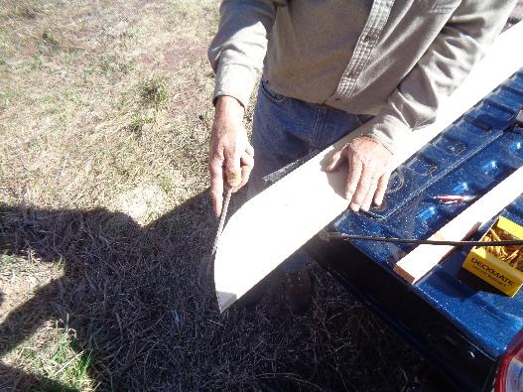
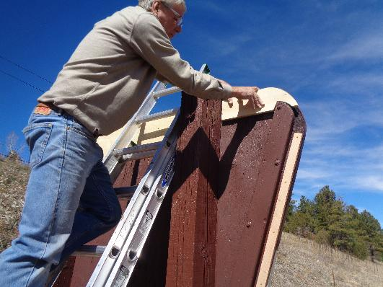
Top: Chuck using rasp to shape 1x6 board to cover damaged area of plywood on upper left
corner of sign shown on page 4. Bottom: Checking fit of wood to cover the damaged area
on the upper right corner of the sign. We did not have a saw to cut curves; therefore, Chuck used his circular saw to cut straight-line segments and to nibble wood to make pieces for the two upper corners of this sign.
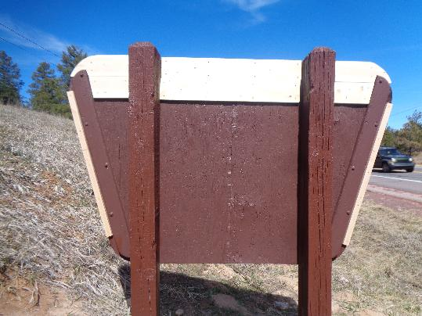
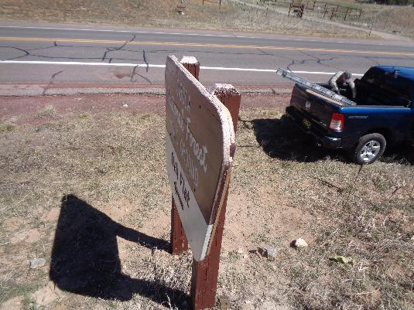
Top: ¾-inich thick wood has been installed over all the damaged plywood areas on the sign.
Bottom: White epoxy paste has been placed over the entire top edge of the sign with a putty
knife to permanently waterproof the edge of the sign and prevent additional water damage.
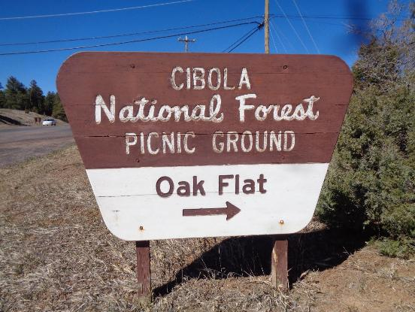
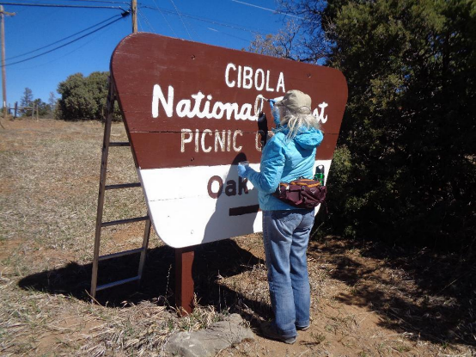
Top: Faded south side of sign on east side of NM-337 directing visitors to Oak Flat
Group Picnic Ground. Bottom: Karen Greif painting the sign.

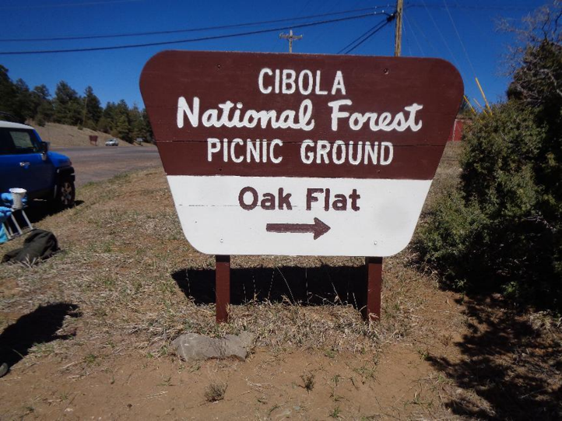
Painted sign directing visitors to picnic ground.
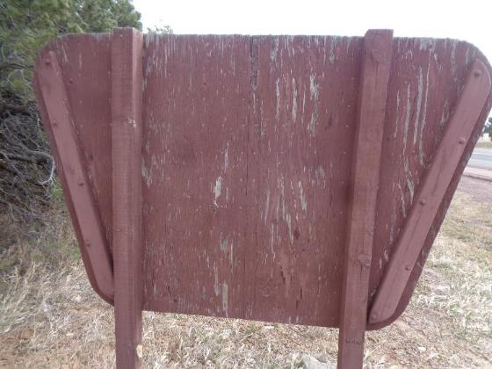
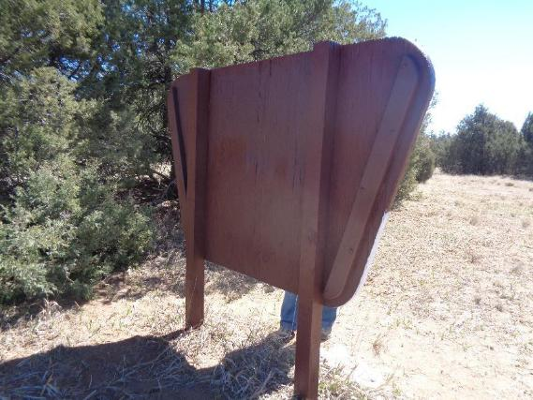
Before and after views of plywood backing on sign on east side of NM-337.
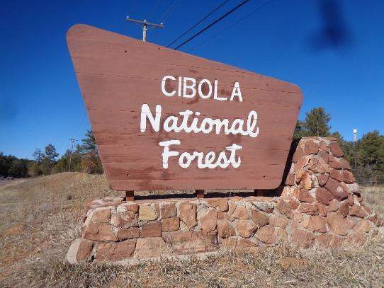
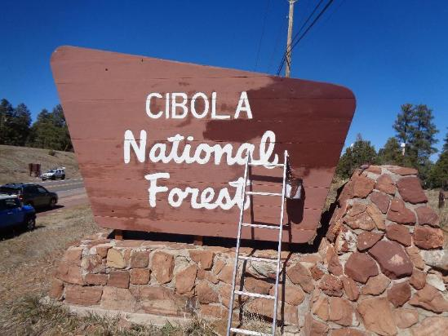
Top: Faded south side of Cibola National Forest boundary sign on east side of NM-337.
Bottom: Partially painted sign to illustrate how faded the sign was.

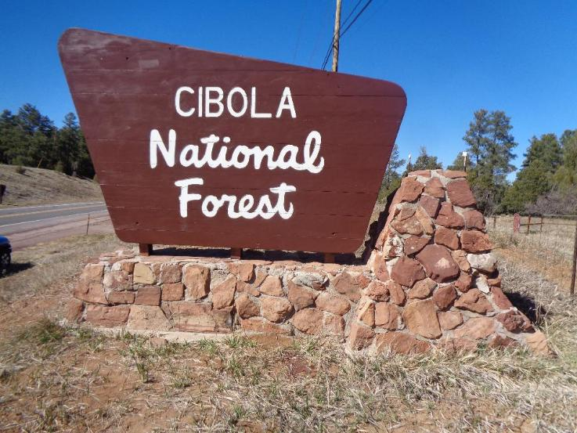
Painted south side of boundary sign. The white letters were generally in good condition; therefore, a few letters were touched up with white paint.

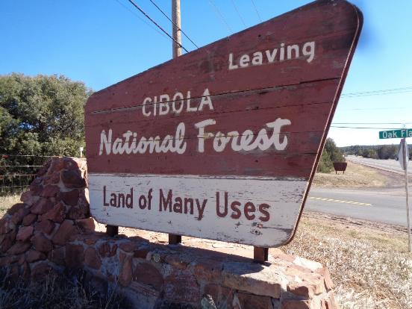
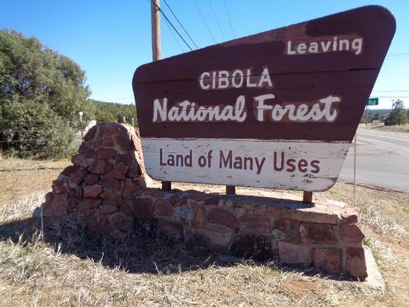
Top: Faded north side of boundary sign. Bottom: Partially painted sign that will be
completed next Tuesday.

