Trail Maintenance Project: Monday, March 23, 2026
Byron Garner

On March 23 the Monday crew headed up one quarter mile from Ellis to check out a "trophy tree" on Kiwanis Meadow trail reported by Kerry Jones. Indeed trophy it was - a long dead 26 incher with large root ball and resting on another 12 incher. Prep work involved limbing and debris clearing for escape routes and access. It was a good day to have two crosscut saws with us as we could safely double team this very long and massive tree for the first half of sawing the two cuts. With a little under two hours of collaborative effort, both trees were clear aided by the down trail slope which made for easy off trail positioning of these chunks of trunk. The somewhat unstable root ball segment was left resting on a large round from a previous project but with some careful leveraging, it too was on the ground and stable. With lunch at Doc Long, we then called it a day. The crew included Rav Nicholson, Phil Cromer, Ken Wilson, John Cooper, Sim Cook, Steve Roholt, Bob Louder and Byron Garner. Photos: Bob Louder, John Cooper and Sim Cook

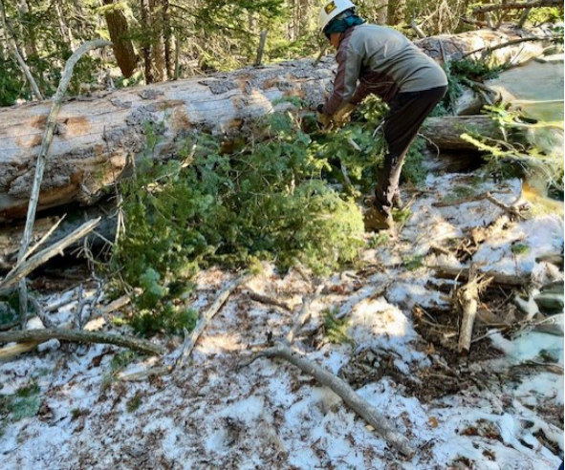
Louder
Steve gets a handle on the prep work

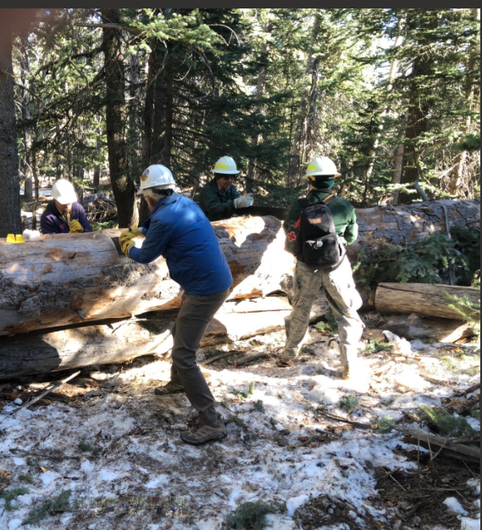Cook
Steve, John, Bob and Rav double teaming

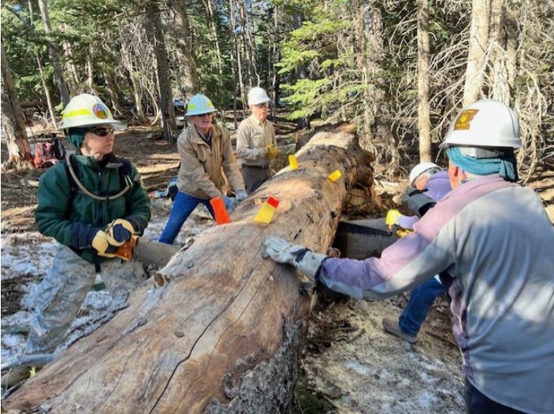
Louder
Rav, Sim, Ken and Steve are on board after shift change

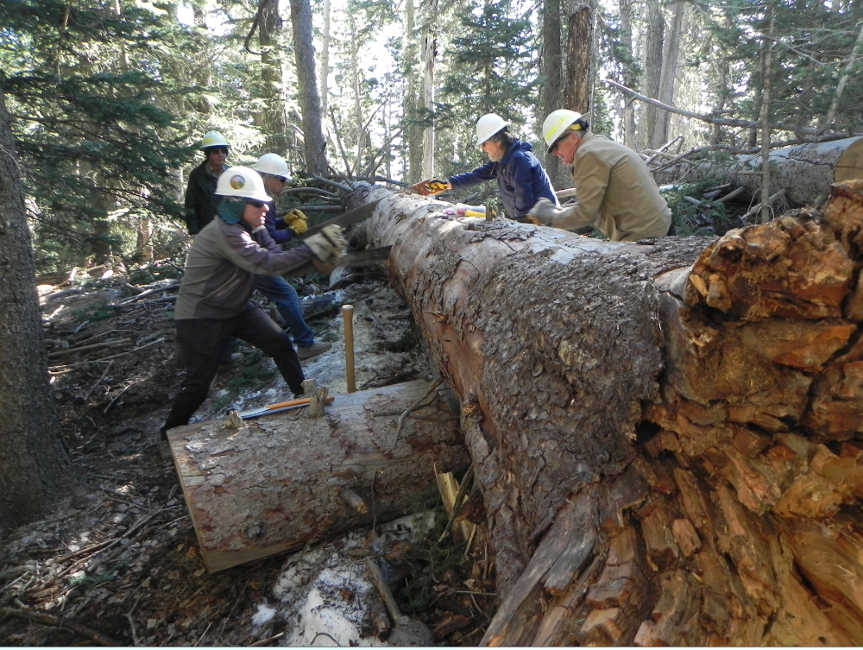
C
And the sawdust flies

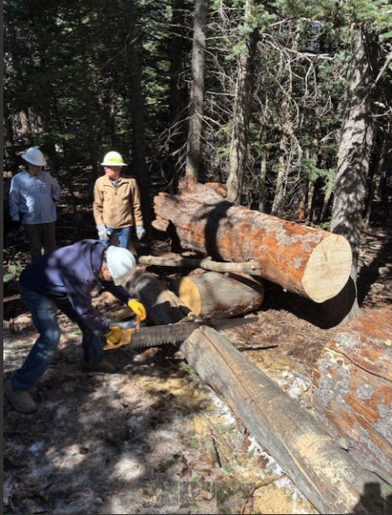Cooper

Ken makes quick work of the 12"er

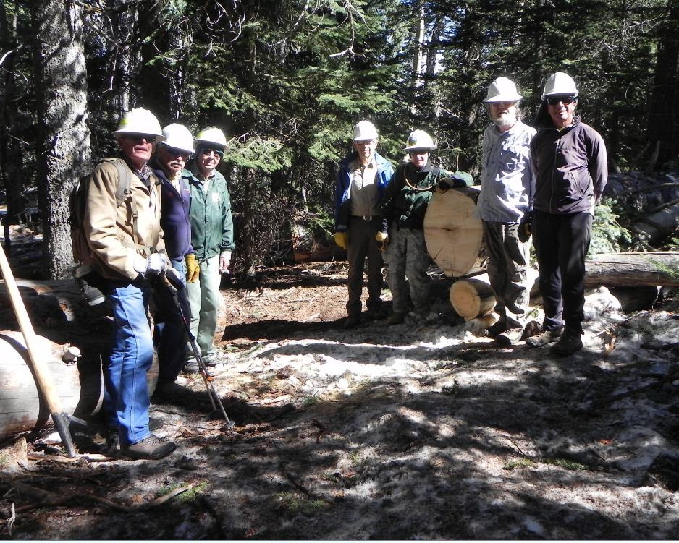

Sim, Ken, Bob, John, Rav, Phil and Phil

