Report of FOSM Project to Paint Selected Signs South
of the Ranger Station, Tuesday, March 24, 2026

Sam Beard

On Tuesday, March 24, Pauline Ho, Rick Buss, Karen Greif, and Sam Beard painted several wooden signs south of the ranger station.
Signs were painted at the following locations:
- Sign pointing to Oak Flat Group Picnic Area – Four pieces of new lumber on back of sign was painted to cover or prevent additional plywood damage.
- Intersection of Oak Flat Road and NM-337 – North side of large National Forest boundary sign.
- Three signs on FR-252 near Cedro Group Campground.
- Sign at vehicle gate behind the ranger station.
Photos of painted signs are presented below.

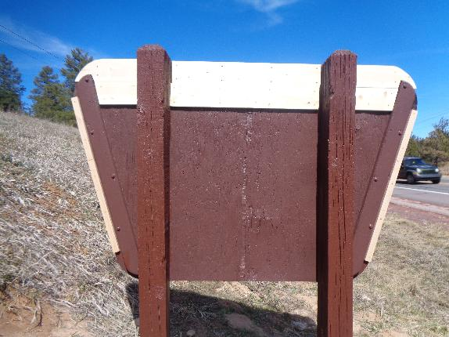
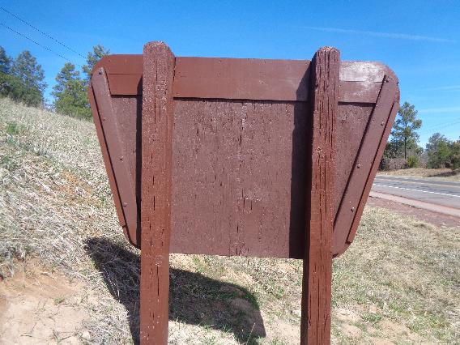
Top: Four pieces of lumber that were added to the sign backing to cover damage to the plywood
or prevent additional damage. Bottom: Painted back of the sign. All photos by Sam Beard
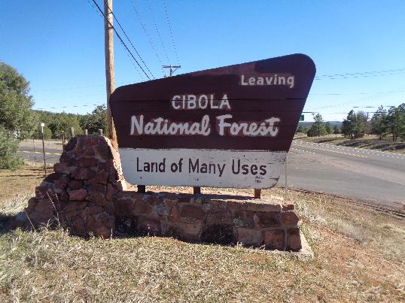
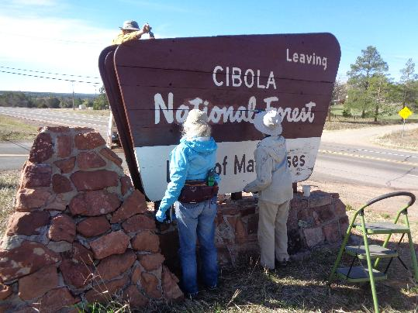
Top: North side of National Forest Boundary sign on NM-337 near Oak Flat Road that
was installed in 1963. Bottom: L to R: Rick Buss, Karen Greif, and Pauline Ho.
Volunteers painting the top edge and north side of the sign.
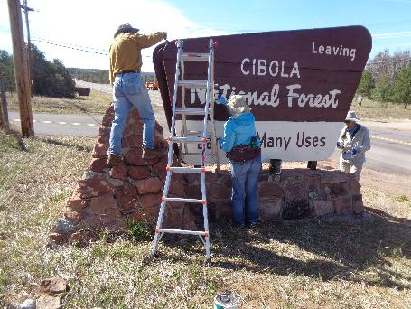
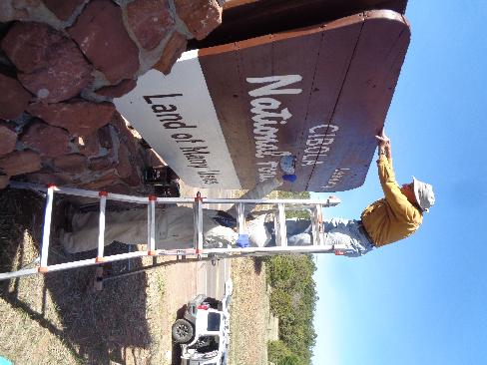
Top: Painting the end and north side of the sign. Bottom: Rick painting the top edge
of the sign while standing on his Little Giant ladder

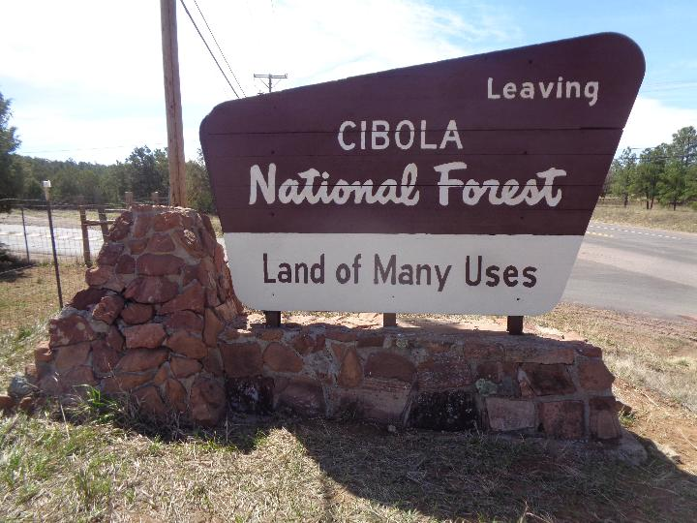
The painted north side of the boundary sign at the intersection of Oak Flat Road and NM-337.

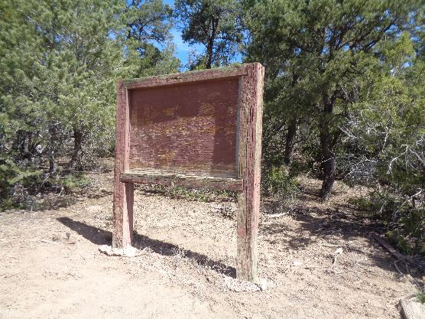
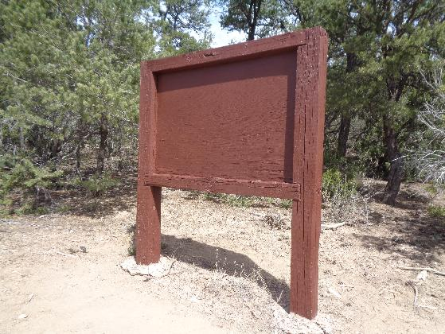
Top: Sign board on FR-252 near Cedro Group Campground that needed paint.
Bottom: Painted sign board.
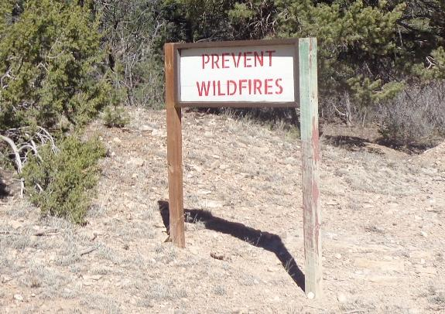
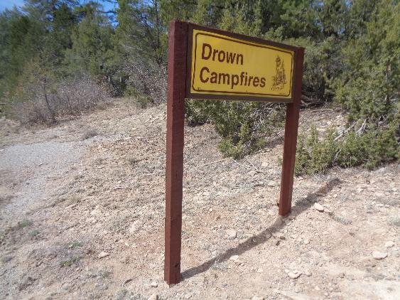
Top: Prevent Wildfires sign near gate on FR-252 east of Cedro Group Campground
with one brown post and one faded brown and green post. Bottom: Painted sign.

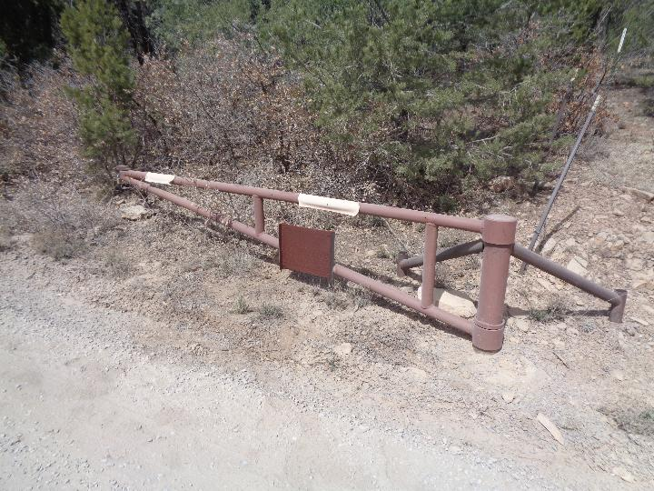
Small painted sign board on gate on FR-252 just east of group campground.

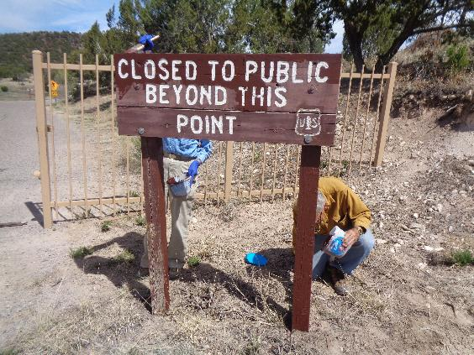
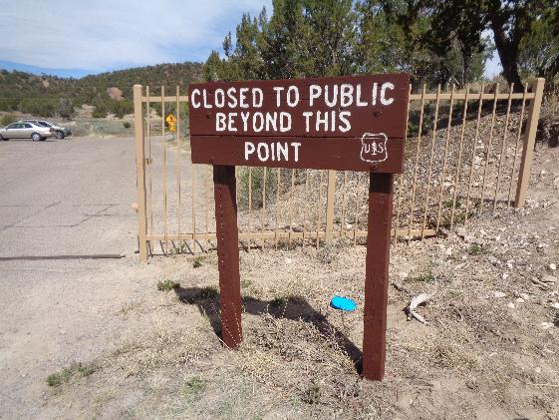
Top: Pauline and Rick painting sign at vehicle gate at ranger station. Bottom: Painted sign.

