FOSM Report of Chipping Slash from a Felled Hazard Tree in Oak Picnic Area
in Oak Flat Group Picnic Ground, Wednesday, March 25, 2026

Sam Beard
Several weeks ago, Canyon Young, SRD Trails and Wilderness Program Manager, felled a 24-inch hazardous ponderosa pine tree in Oak Picnic Ground in Oak Flat Group Picnic Ground. On March 18, FOSM volunteers bucked, split manually, and hauled two pickup loads to the hazmat building behind the ranger station.
On Wednesday, March 25, Manny Chavez, SRD Maintenance Supervisor, towed the chipper to the Oak Picnic Ground where volunteers fed four piles of pine branches into the chipper. The chips were blown into the adjacent forest.
The volunteers chipping slash were Eric Russell, Dan Benton, Sim Cook, Kent Towler, Chuck Logan, Sam Beard, Michael Arndt, and Cliff Giles.
Project photos are presented below.
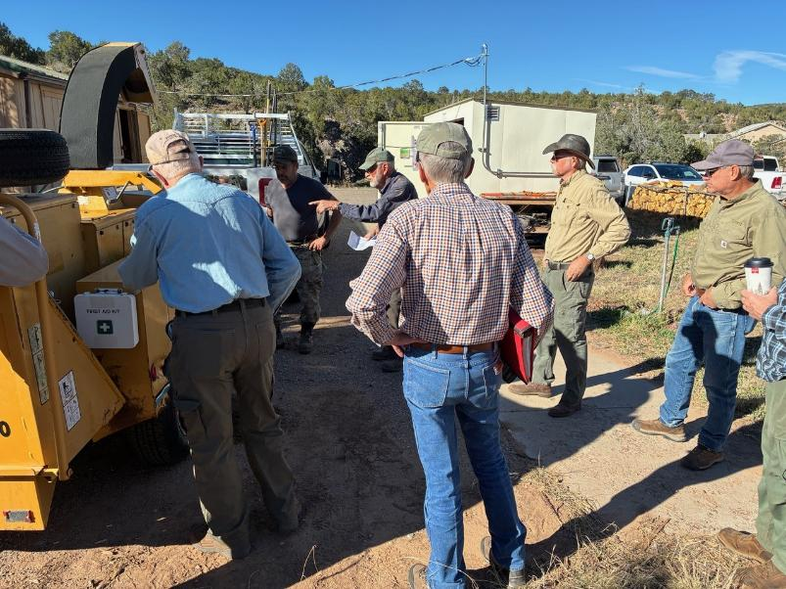
Sam Beard, center, presenting the Job Hazard Analysis safety presentation and discussing the operation
of the chipper and feeding material safely. Manny showed Sam the lubrication label on the right side
of the chipper near the clutch lever. These instructions included using a grease gun to grease the bearings on
both ends of the drive shaft and applying WD-40 to the lower end of the exit chute. All photos by Cliff Giles
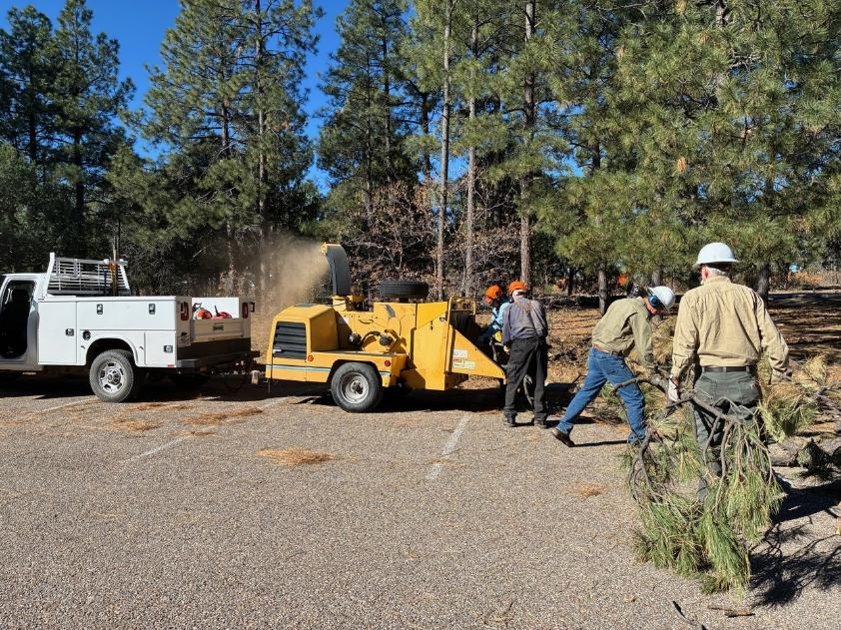
Feeding branches from the first slash pile to the chipper. Note the brown chipped material being blown into the forest.
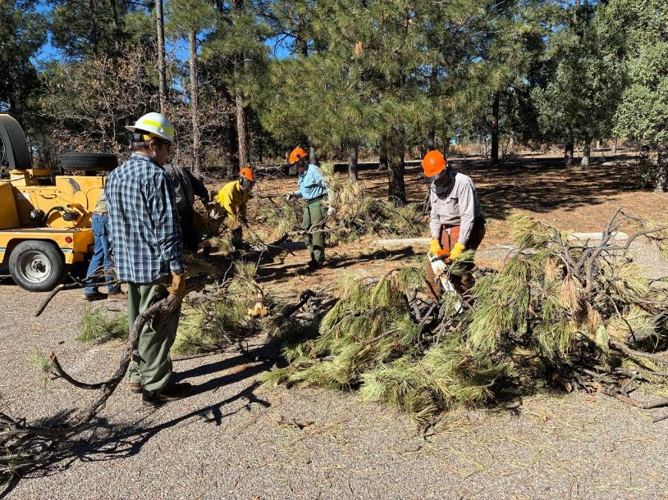
Michael Arndt observing Dan Benton use a chain saw to cut branches so that the material will be easier to feed to the chipper.
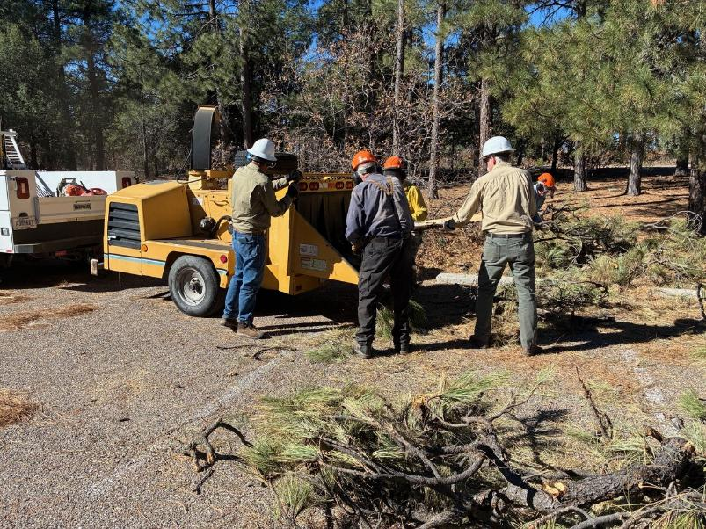
L to R: Chuck Logan, Sam Beard, Manny Chavez, Kent Towler, and Dan Benton. Chuck has his hand on the safety lever
in the event he needs to stop the chipper quickly.
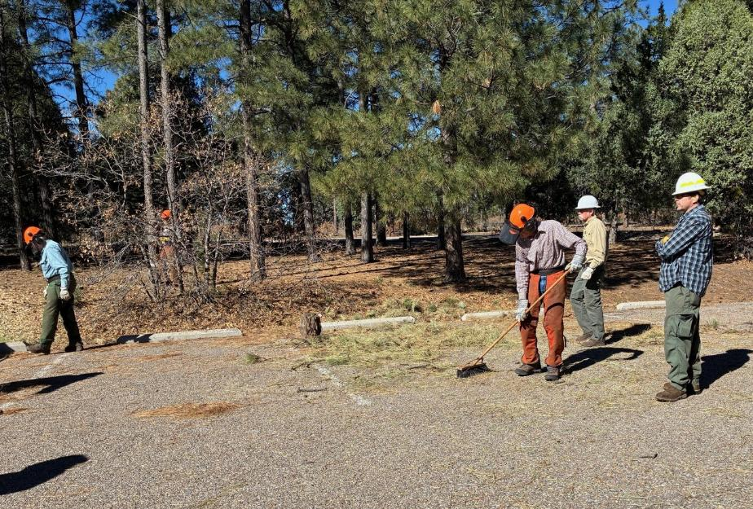
L to R: Eric Russell, Sim Cook, Kent Towler, and Michael Arndt. Sim is sweeping the pine needles from the pavement.
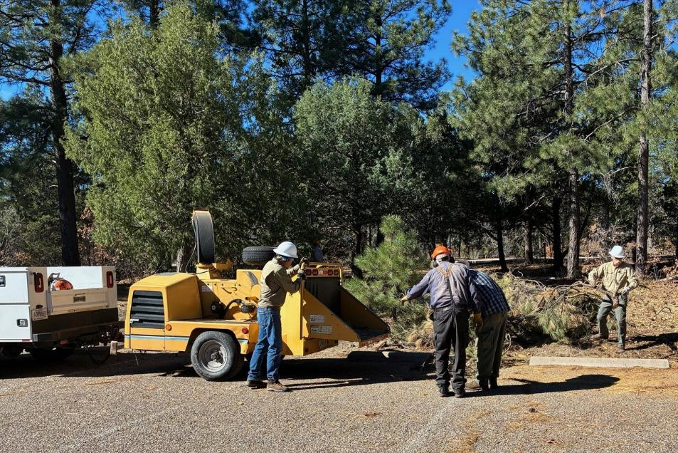
Volunteers are chipping the third pile of slash.
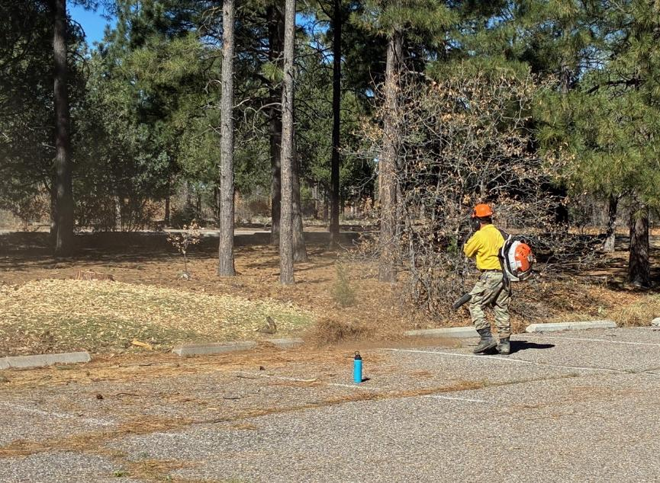
Manny Chavez is using a power blower to remove needles.
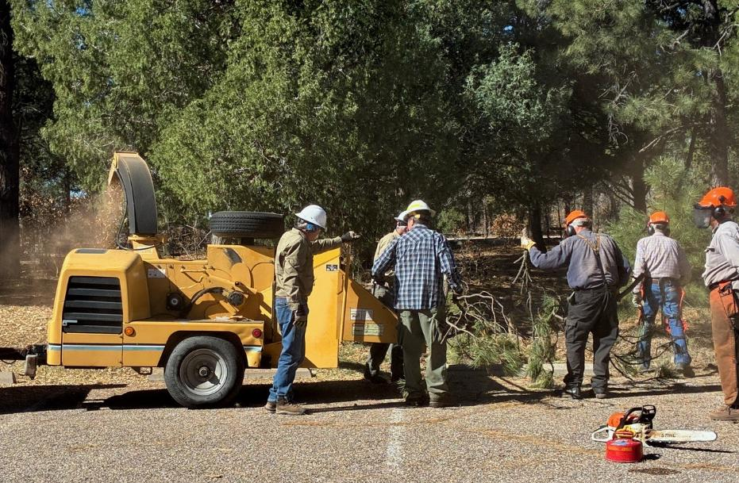
Volunteers are chipping the fourth pile of slash.

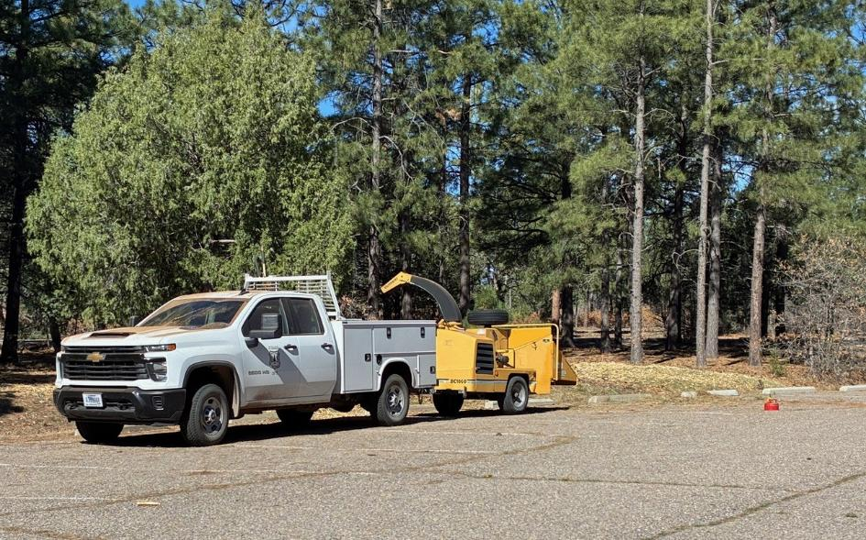
The Sandia Ranger District Vermeer Model 1000 chipper that can chip wood up to 10 inches in diameter.

