Thursday, 03/26/26 – Pokerchip: Off on a new adventure this week. Nine volunteers joined Jen at the Ranger station for a carpool up the very rutted Juan Tomas Road to the Bear Scat/Pokerchip intersection. The hike in was cool and mostly flat until we got to the section that includes the reroutes. There the trail was very straight (up) and eroded and rocky. By the time we got the tools up to the end of the reroutes, the temps had climbed and everyone was huffing and puffing. We got right to work but the going is slow because of all the oak stumps and the rockiness of the terrain. Hoping next week will be cooler!

Volunteers: Bruce Hansche, Eric Russell, Byron Garner, John McNett, Luis Cuadros,
Tony Pachelli, Don Fisher, Kerry Jones and Laura Leon

Pictures: Laura Leon

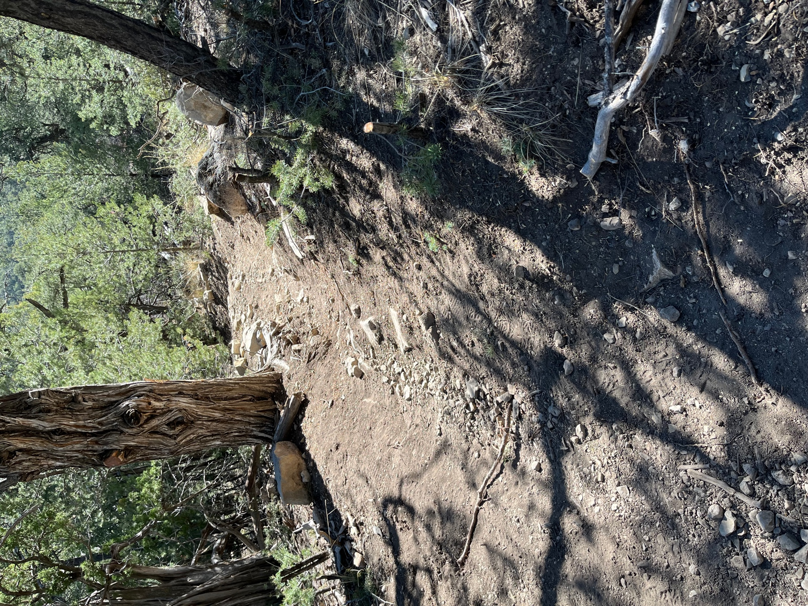

The existing trail is very steep, with few curves so it has become rutted and rocky.

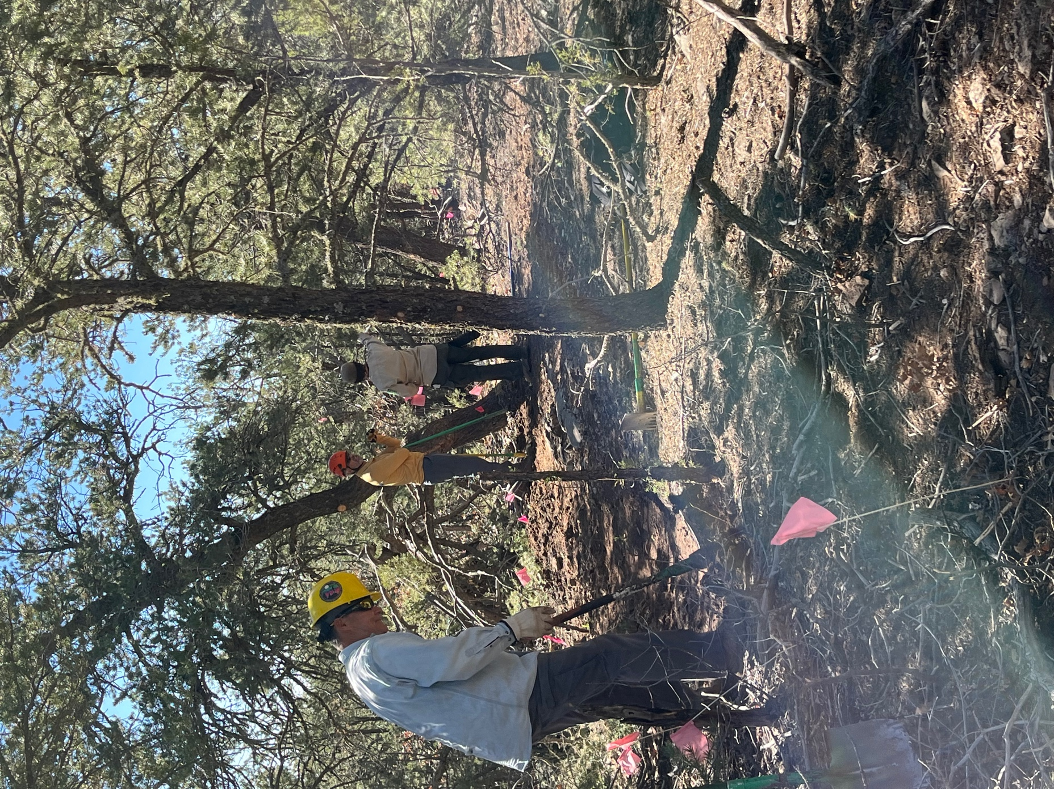

Tony gets to work while Jen and Don discuss the placement of the curve.
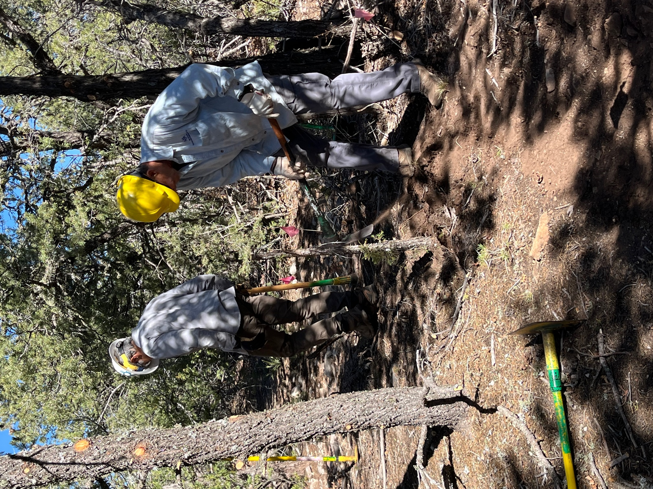

Luis and Tony work on stump removal.

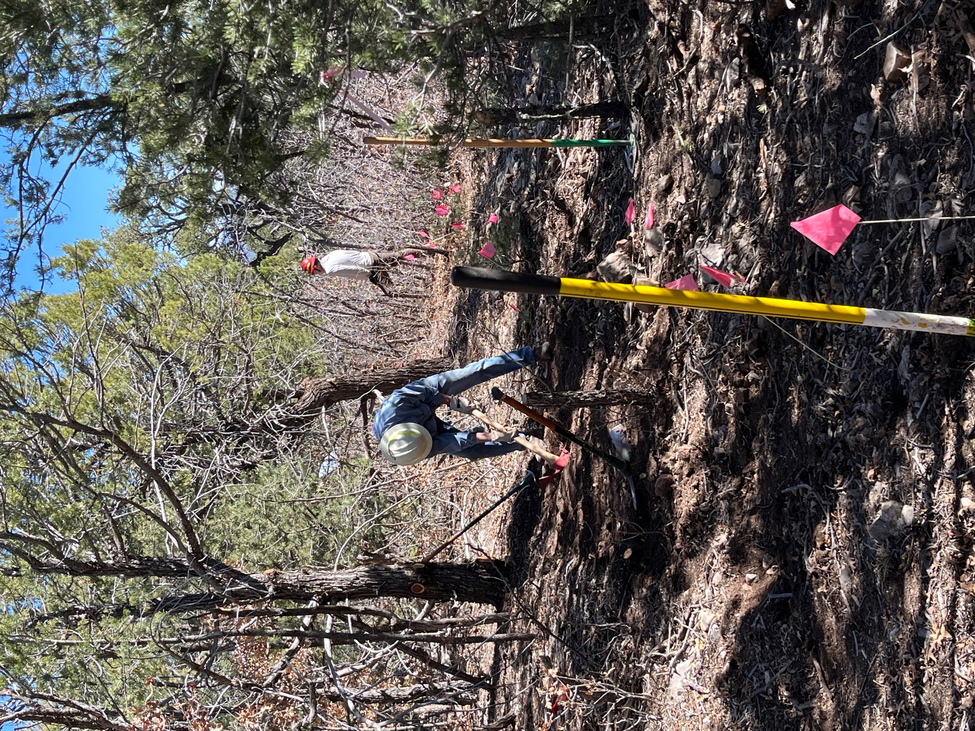

Byron and Kerry dig through the oak stumps.
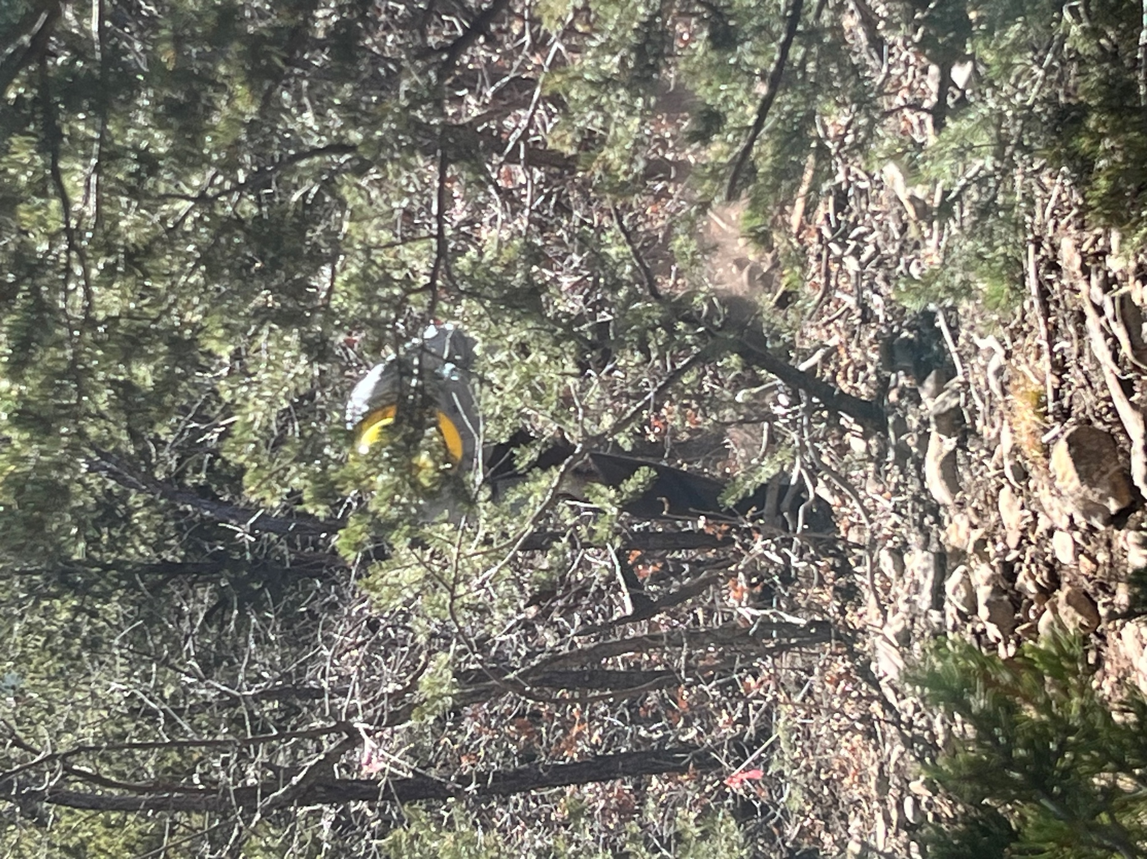

Eric among the brush, clearing a trail.

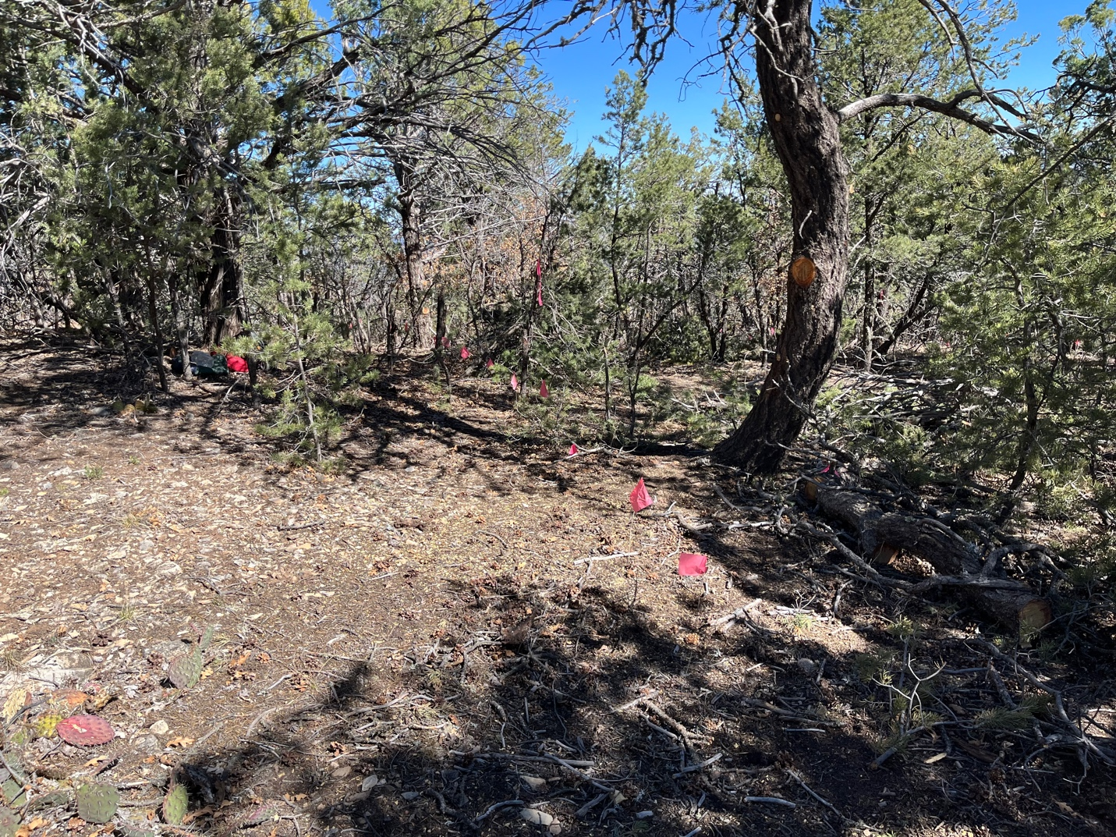

While work started on the first section of the reroute, Jen flagged the second portion. The soil is bone dry, not a drop of moisture in it.

