Trail Maintenance Project: Monday, March 30, 2026
Byron Garner

On March 30, the Monday trail crew had an exceptionally busy and enjoyable day. Beginning at the Crest with ideal conditions, we began the hike on 130N and continued on to Del Agua Overlook, then on to 10K and connecting with Survey ending at Ellis. With the recent reports of "heavy" downfall on 130N and Survey, our crew of six decided to form two teams of three and leapfrog in an effort to work more efficiently with the expected amount of work ahead. Team one soon got bogged down with a large live spruce at the burn area, so team two continued on to encounter their own challenges ultimately working on trees ranging from six to thirty inches with seven cleared. Meanwhile team one charged on and removed eight trees ranging in size between three and twenty-three inches all for a grand total of fifteen trees. Four of these trees ranged nineteen to thirty inches in diameter. With time running short, only prep work could be done on three of these, but remain on the list to be finished as a follow up project (projects). Team one included Rene Archer, Dave Gabel and Byron Garner and in team two was John Cooper, Ken Wilson and Dave McCreery. Photos: John Cooper, Rene Archer and Byron Garner

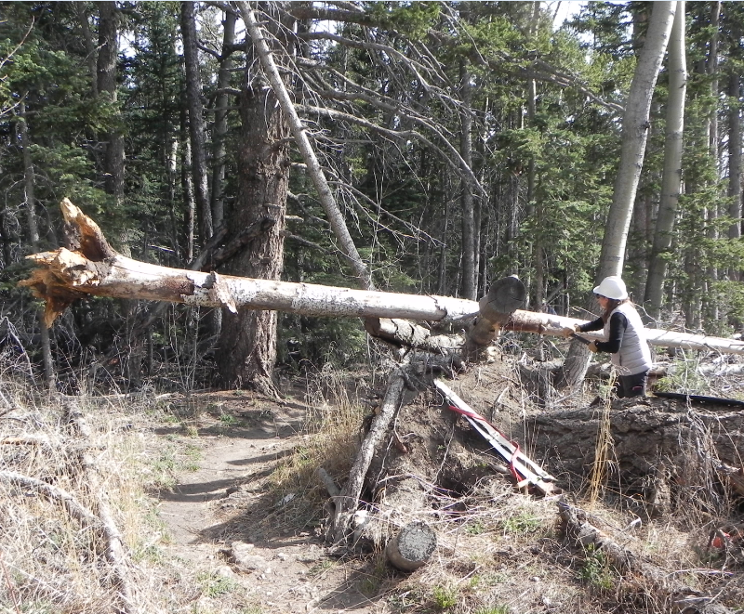
Rene meets the challenge

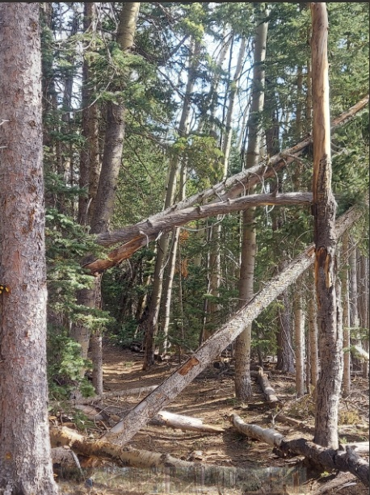Archer
Now you see them

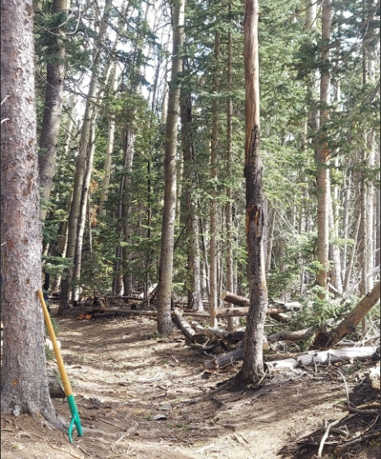Archer
Now you Don't

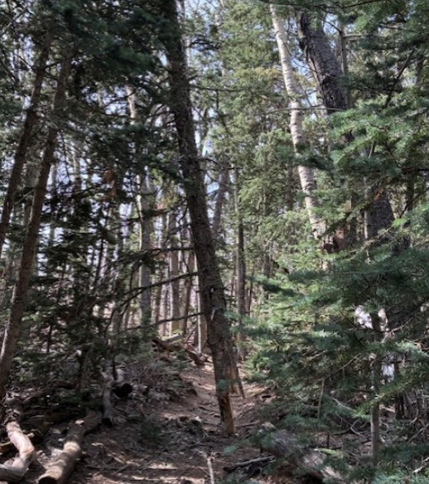Cooper

This one will need a bit heavier artillery

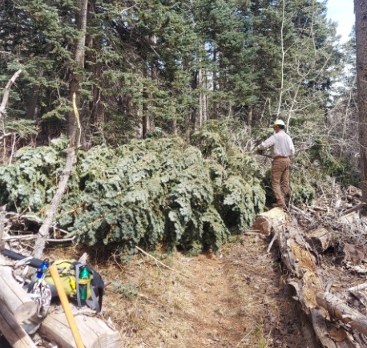Archer
Now we're talking business
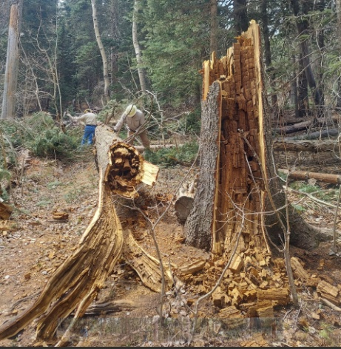Archer
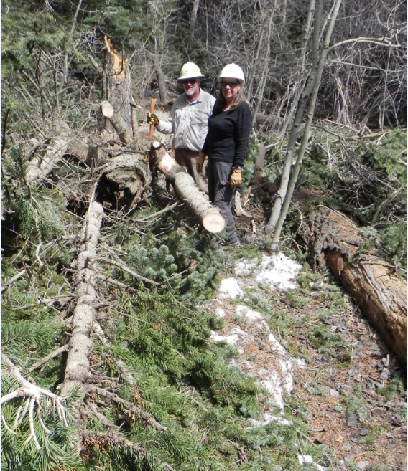
Dave and Rene close to the finish line

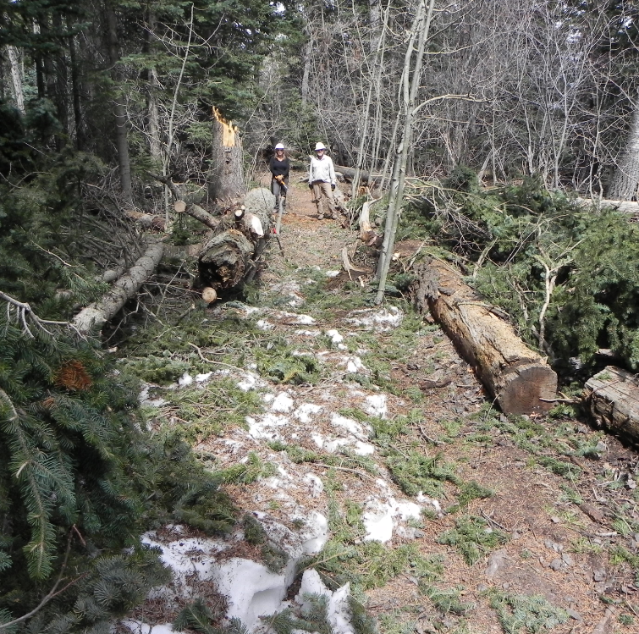
Who left this mess?

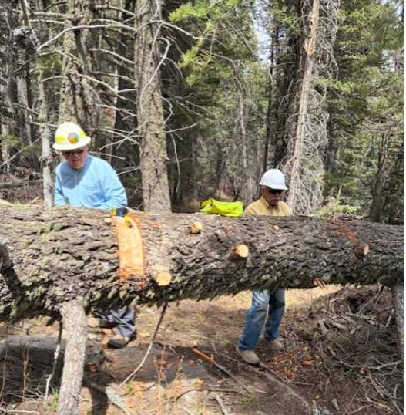Copper

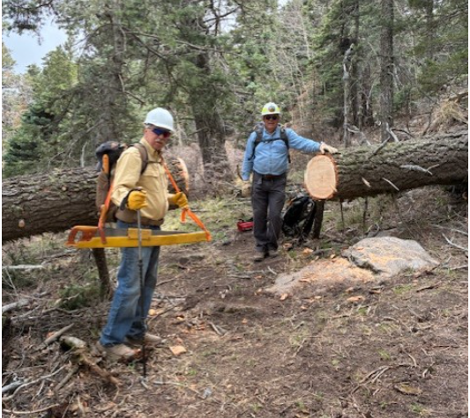Cooper
Dave and Ken demonstrate how it's done
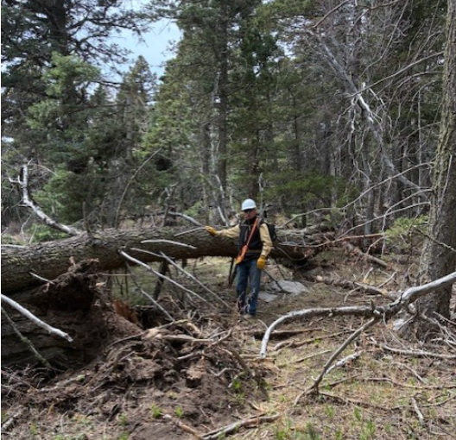Cooper
And they just keep coming

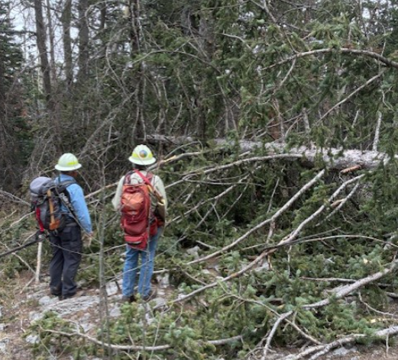Cooper

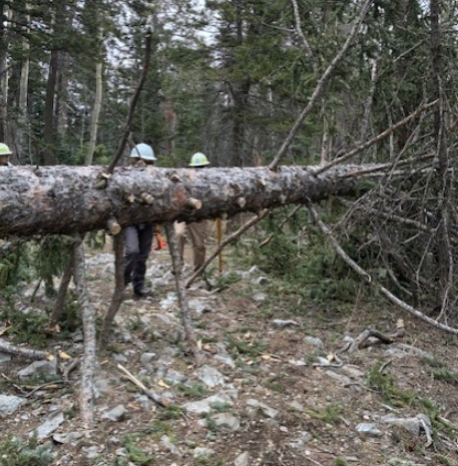Cooper
To be continued

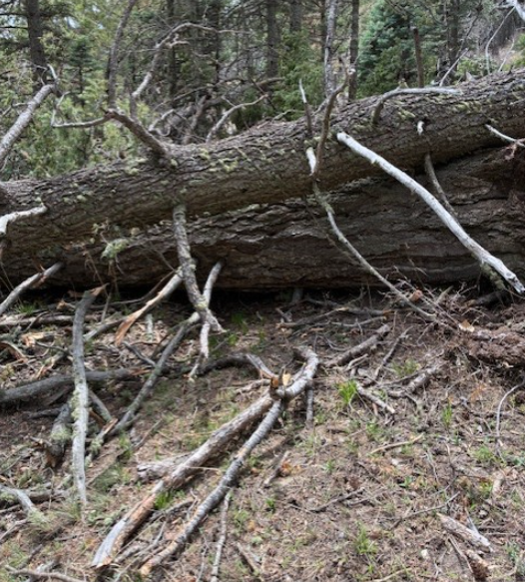Cooper
And they keep getting bigger

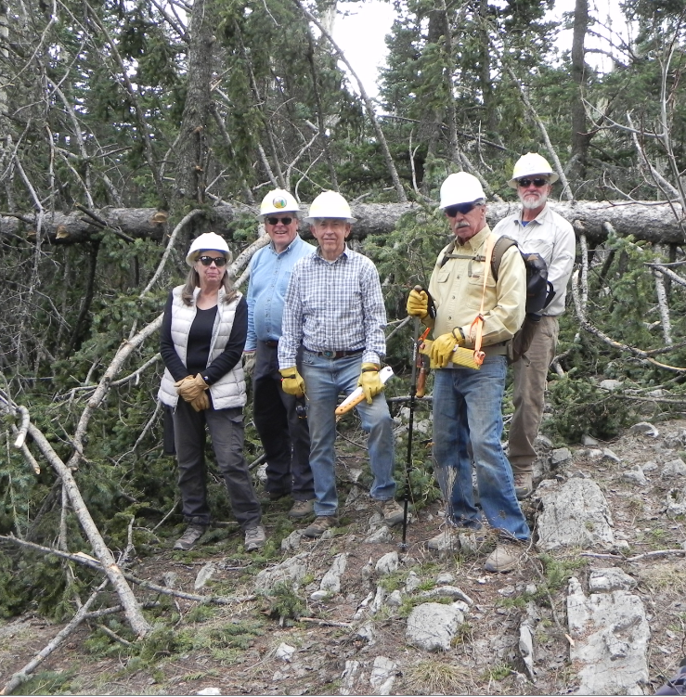
Rene, Dave M, John, Ken and Dave G

