Thursday, 04/02/26- Cienega: Although we started work on Pokerchip last week, this week the road out to Pokerchip was too wet (!!) for travel so four volunteers and Jen (SRD) did some brushing and debris removal on Cienega instead. Back Country Horsemen are going to use Cienega to take water up to the Crest for the overnight brushing project in mid-May so we worked at removing debris that was infringing on the trail. This involved moving some rocks, fallen trees and cutting down leaning trees and branches that were hanging to low or into the sides of the trail. It turned out to be a really nice day, cool and there was even some mud!

Volunteers: Bill Perkins, Luis Cuadros, Claudia Bergsohn and Laura Leon

Pictures: Laura Leon

Brushing doesn’t allow for very interesting pictures but we got a few….

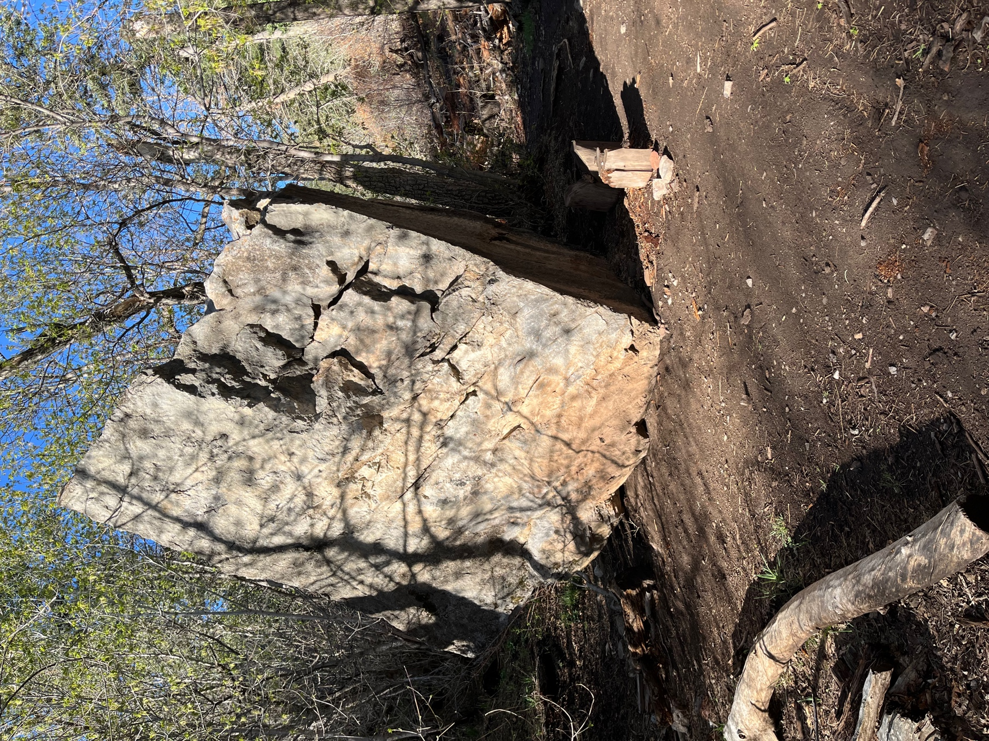

A really nice big rock.

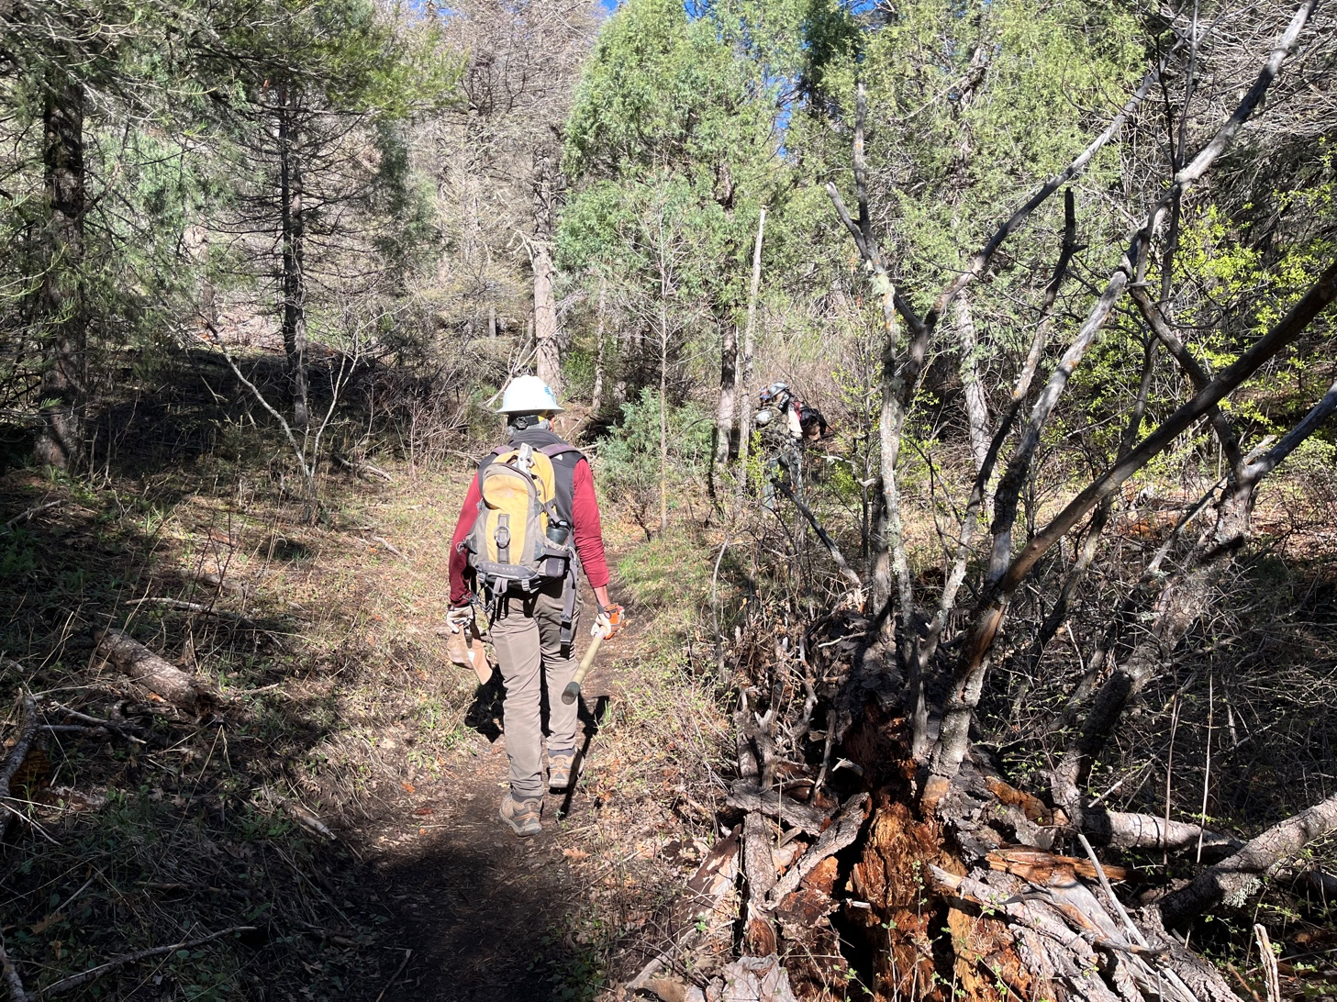

There was lots of dead wood along the trail- some needed to be moved, some was ok to leave.

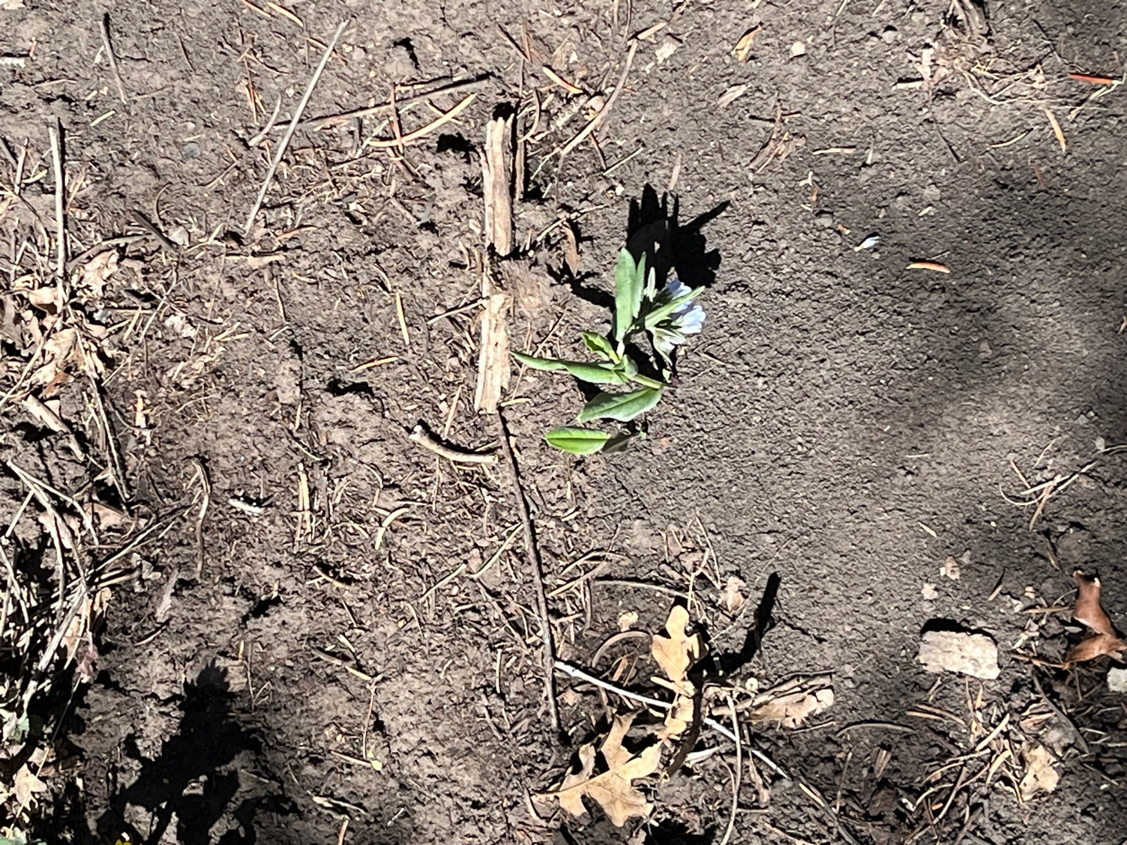

A pretty little Blue Bell- Rocky Mountain Blue bell?

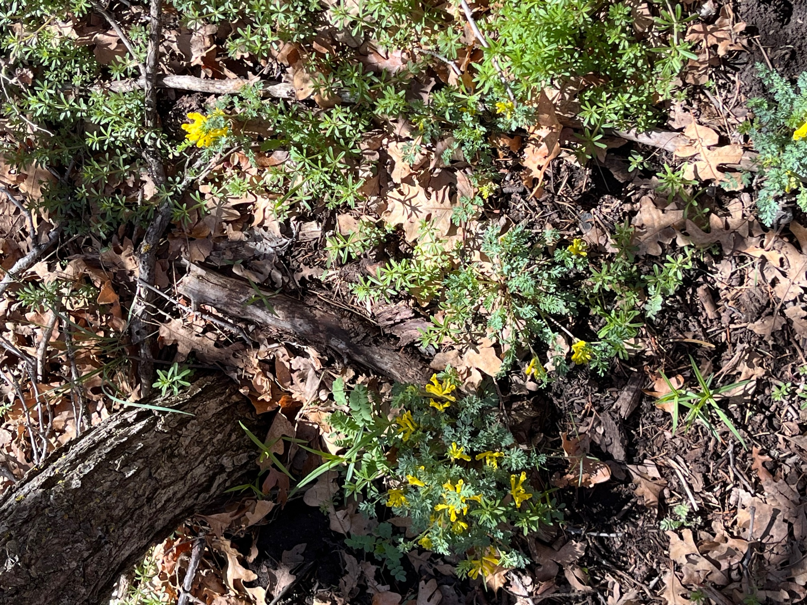

Spring is definitely springing and the rain really did some good.

