Report of FOSM Volunteer Work on Removal of Signs
on Crest Area Trails, Wed., April 1, 2026

On Wednesday, April 1, volunteer crews removed signs and marked other signs that could not be removed in the Crest Area so that they would not be damaged in the thinning and masticating project there. Jennifer Medina-Gray, Sandia Ranger District, organized the project and handed out tools to remove signs.
Reports of the work done by four crews of volunteers are presented below.
Susan Gregory’s Crew Report by Pauline Ho
Rick and I worked with Susan Gregory. We walked to Kiwanis Cabin (which Susan had never been to before) along the road and marked/removed the signs near the cabin. We then went down Kiwanis Cabin trail to the South Crest Trail and worked the signs at that intersection. We were supposed to remove the signs at the South Crest and Gravel Pit Junction, but those bolts were bent and we didn't have a hacksaw, so were unable to remove them. We were supposed to remove the signs at South Crest and Kiwanis Meadow intersection, but they were already gone when we got there. We hiked along and ran into Dorothy Hendrix who said they had removed them, but they had not done the sign at upper Buried Cable/Switchback. We headed up and worked on that sign, but that also had bent bolts, so we couldn't remove them. Then we walked back to the cars, reported to Jen, and gave her the signs and maps.
Jen’s Crew Report by Jamey Browning
Here is the full list of folks from Jen’s email - Chuck Logan, Jamey Browning, Pauline Ho, Rick Buss, Sim Cook, Mike Madden, Sam Beard, Tim Kirkpatrick, Steve Roholt, Cliff Giles, Eric Russell, Susan Gregory, and Kent Tawler. Plus, Jen and Dorothy from the Forest Service.
There were 66 signs identified in the project area, thirty-four to be removed and the rest to be flagged.

Mike Madden, Jerry Carroll, Jen Medina-Gray, and I removed nine trail signs from lower Switchback and Survey. We also loaded the steel map kiosk at the old entrance to Kiwanis Meadow Trail on the Service Road into Jen’s truck for her to take back to the ranger station. The base was set in concrete, so it was a bit of a challenge to get loaded. It will eventually be reused at another location.

Sandia Nordic Ski Club members were present and removed their cross-country ski trails signs.

Dorothy’s Crew report by Steve Roholt
Dorothy Hendrix, Steve Roholt, and Eric Russell started at Ellis parking lot and hiked Switchback Trail to Kiwanis Meadow Trail to it's junction with 130 South. We removed two signs from metal posts at the junction of 130 South and Kiwanis Meadow Trails. The two metal posts were flagged with pink tape. We then proceeded north on 130 South to a sign at the Switchback and 130 South junction. The post was loose, and we pulled it out. The post had rotted off. We gave the rotted post and attached sign to Jen who placed it in her pickup for transport to the Ranger Station. We then proceeded north on 130 South and removed two signs, one at the 130S and Switchback junction and another at the Switchback and Buried Cable junction. The former sign post was loose, removed, and placed on the ground. The latter post was stable and left in place. All remaining sign posts along the way were flagged. We also put a few flags on the new buck and pole fence separating Kiwanis Meadow from 130 South.
Without our great FOSM crew I do not know how all this could have been completed. We finished up around 1130 am and headed down the mountain.
Sam’s Crew Report by Sam Beard
Chuck Logan, Tim Kirkpatrick, Cliff Giles, Kent Tawler, and Sam Beard hiked along the South Crest Trail and Crest Nature Trail. They tied pink ribbons on all the signs that could not be removed. The brown and cream-colored signs with routed letters were removed from their posts and carried to Jen at the Crest parking lot. The large 3-foot by 3-foot sign with a USFS map under plastic at the Kiwanis Meadow Road gate was removed and stored on the south side of the FOSM Guard Station. Over a full roll of pink ribbon was used in putting ribbons on a few dozen signs and display boards on the Nature Trail along the mountain ridge line and along the Kiwanis Meadow Road from the parking lot to the north corner of Kiwanis Meadow. The temperature was 35F when we completed the work.
Photographs of Sam’s crew at work on this project are presented below.
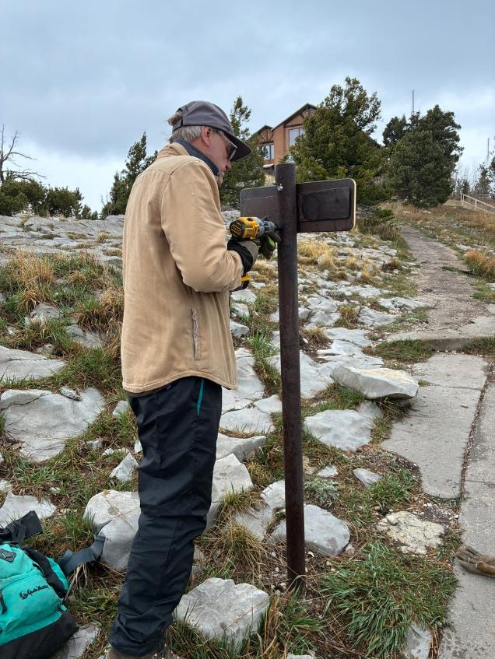
Chuck Logan removing a sign from a steel post on the Crest Nature Trail.
All photos by Cliff Giles
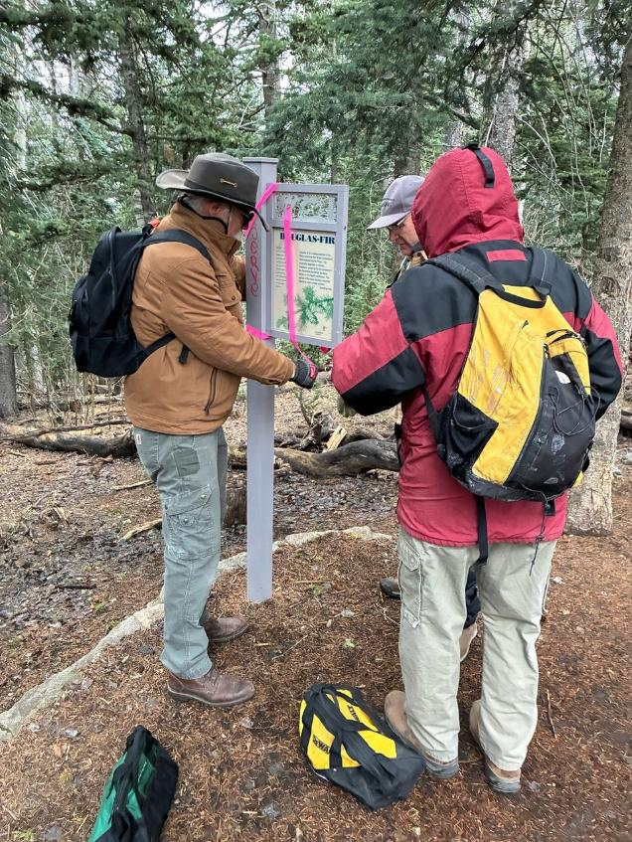
L to R: Kent Tawler, Chuck Logan, and Tim Kirkpatrick putting a pink ribbon
on a Crest Nature Trail sign.
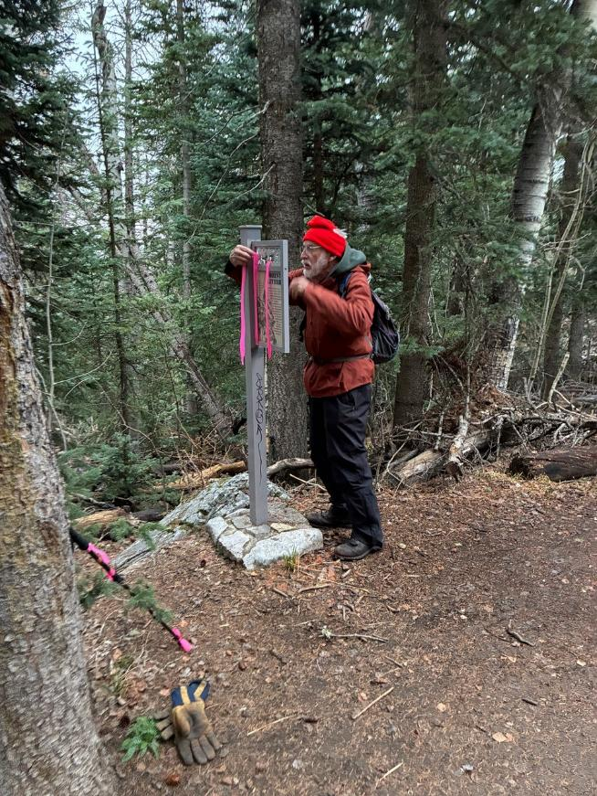
Sam Beard tying a flag on a Nature Trail sign.
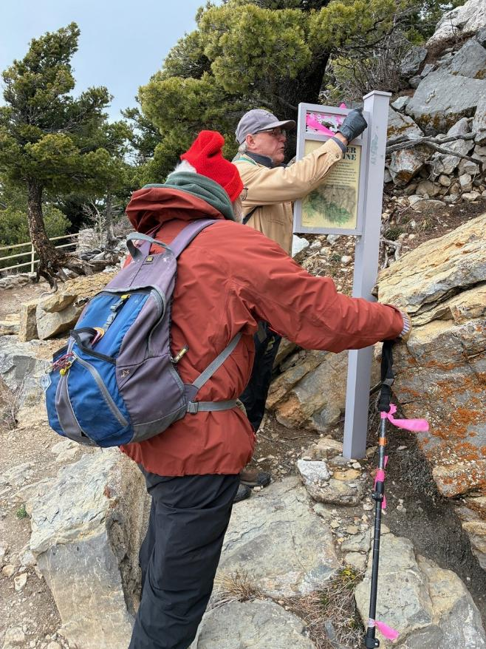
Sam and Chuck putting a flag on a Nature Trail sign near the Crest cliffs.
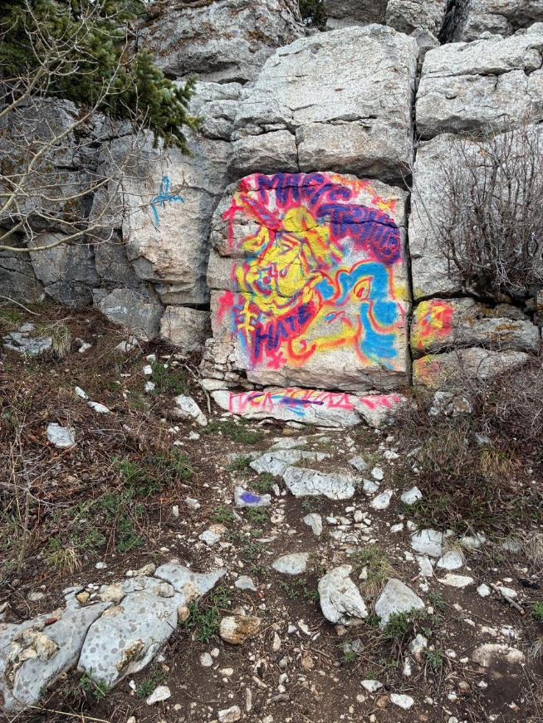
Very large graffiti tag on the Nature Trail near the Crest cliffs.

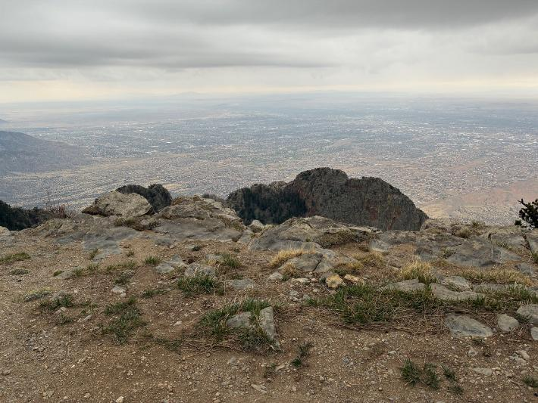
Albuquerque viewed from the Nature Trail.

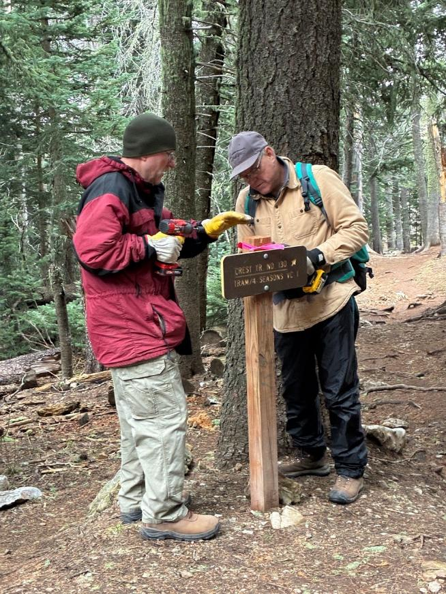
Tim and Chuck putting a ribbon on a post and removing a sign from the post
on the South Crest Trail where it crosses the Kiwanis Meadow Road.
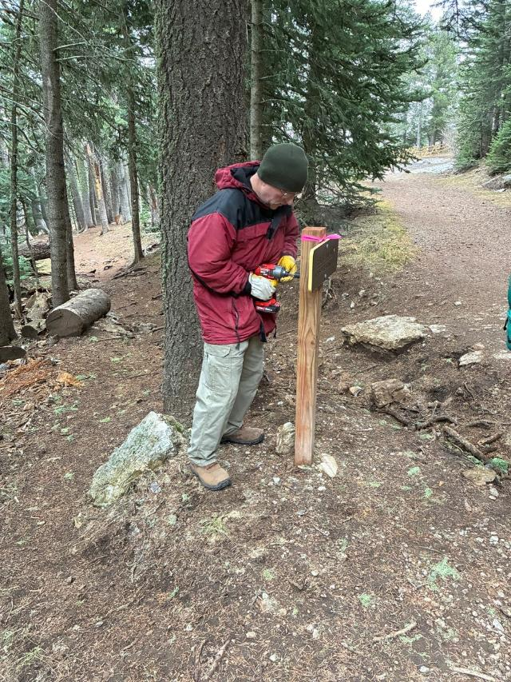
Tim using a battery-powered impact drill and special socket to remove a
tamper-proof nut from a sign.
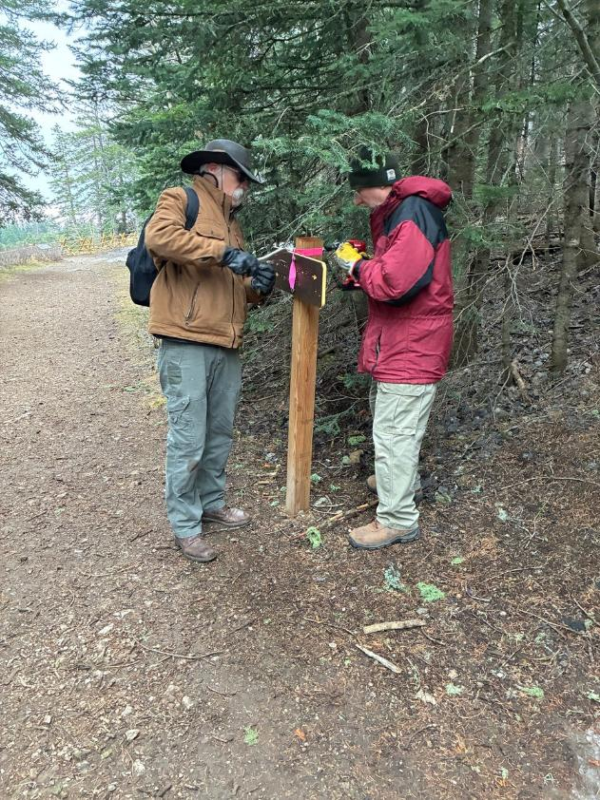
Kent and Tim removing a tamper-proof nut from a sign on Kiwanis Meadow
Road with the Kiwanis Meadow buck and pole fence in the background.

