Report of FOSM Outing to Remove Large Graffiti Tag
on Crest Nature Trail, Thursday, April 2, 2026

Sam Beard

On Thursday, April 2, Pauline Ho, Rick Buss, and Sam Beard worked on removing graffiti tags from a boulder on the Crest Nature Trail and a sign and restroom window at 10K North Trailhead.
Only about one-half of the paint on the boulder was removed after the crew worked 1.5 hours. Much of the tag was covered with two coats of paint. The crew considers this tag to be one of the worst ones that they have attempted to remove. The crew applied about five coats of the removal chemical, and parts of the tag were removed with the FOSM low pressure battery-powered washer with a maximum pressure of 550 psi. They are considering borrowing the Sandia Ranger District battery-powered washer that produces higher pressures in an attempt to remove more of this tag.
The crew stopped at 10K North Trailhead on the way down the mountain and removed a black tag on the back of an aluminum sign, smaller tags on the restroom windows, and tags on a trash container. They also noticed that the restroom exterior needs paint that can be applied during the closure of the upper part of the mountain.
Pauline also reported that after they finished at 10K North Trailhead, they went to Balsam Glade and worked on three graffiti tags on the outside of the restroom windows. They were only somewhat successful at cleaning them off, as those plastic windows are textured, and the ink in the cracks is hard to remove.
She also stated that the restroom at Doc Long PG has graffiti on it, but they did not have time to work on it Thursday.
Project photographs are presented below.

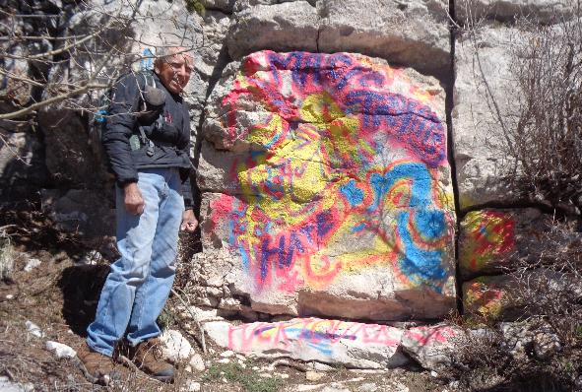
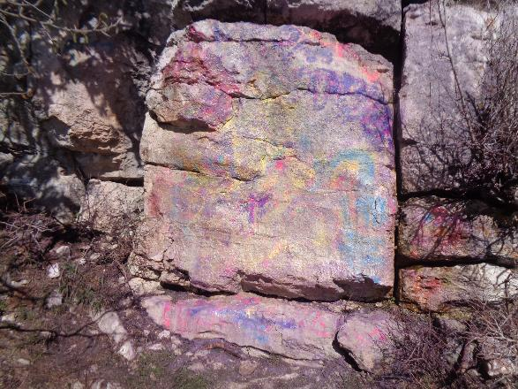
Top: Rick Buss standing beside the very large graffiti tag on the Crest Nature Trail.
Bottom: Maybe half of the tag has been removed after 1.5 hours of work
by three volunteers. Much of tag was covered with two coats of paint.
All photos by Sam Beard unless stated otherwise.
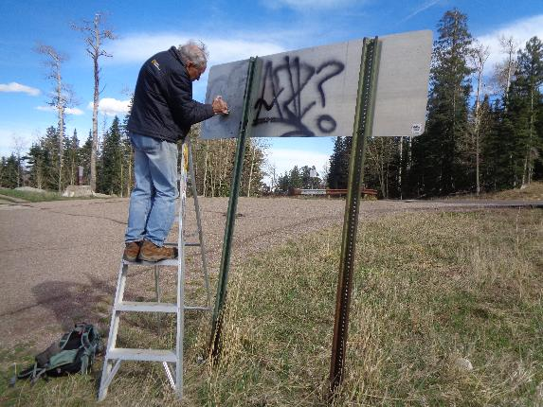
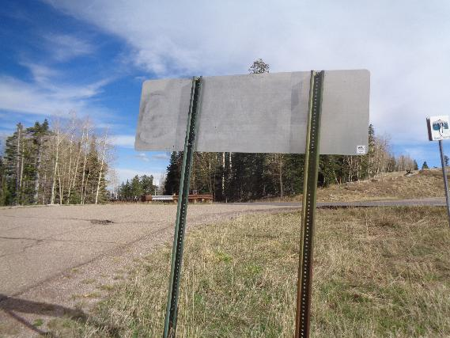
Top: Rick removing black tag from back of 10K North Trailhead sign.
Bottom: All of the tag has been removed.
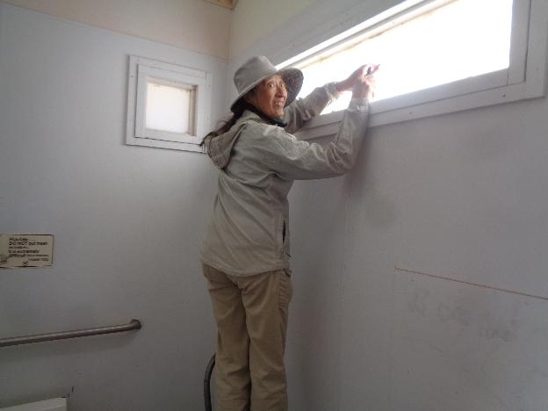
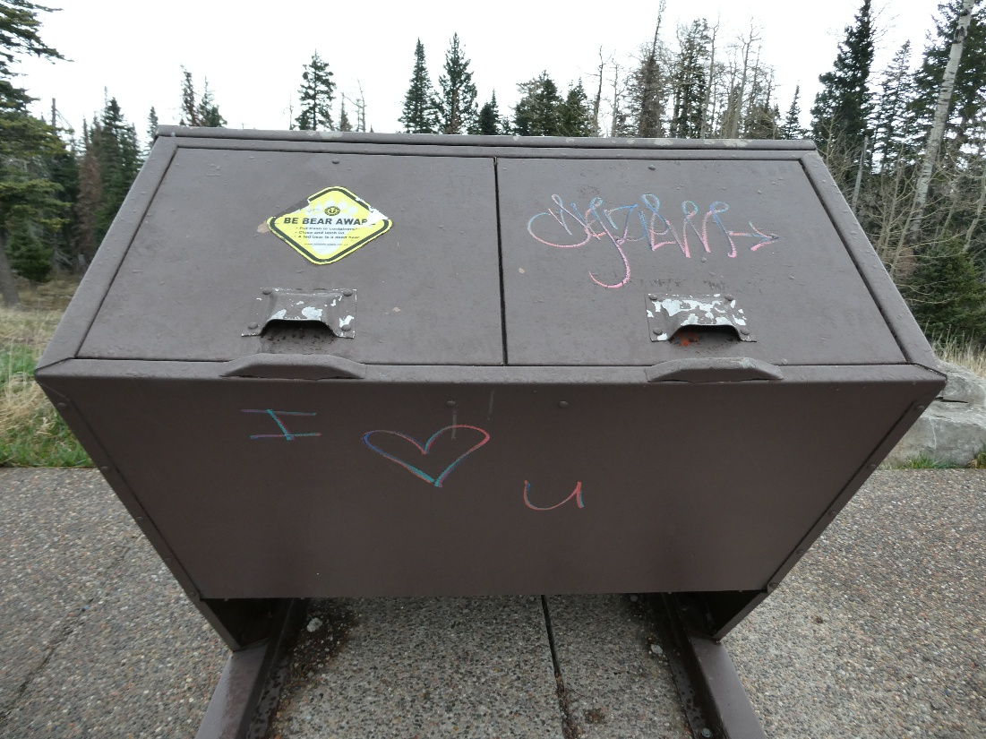
Top: Pauline Ho removed tags on both the outside and inside of this window
in the women’s restroom at 10K Trailhead. Bottom: Tags on this trash container
were painted over with brown paint. Photo by Pauline Ho.

