Tijeras Pueblo Archaeological Site
Volunteer Docent Program
New Docent Training (Level 1)
APRIL 17TH, 2026 9:00AM - 2:30PM
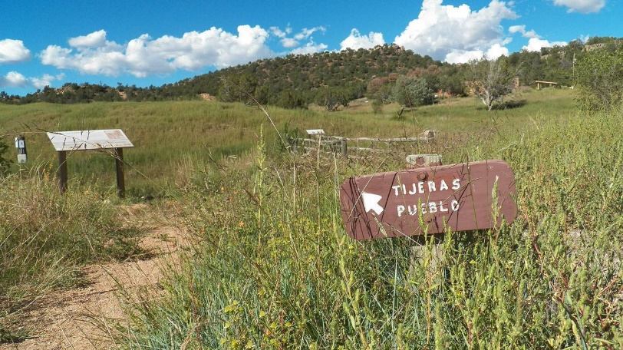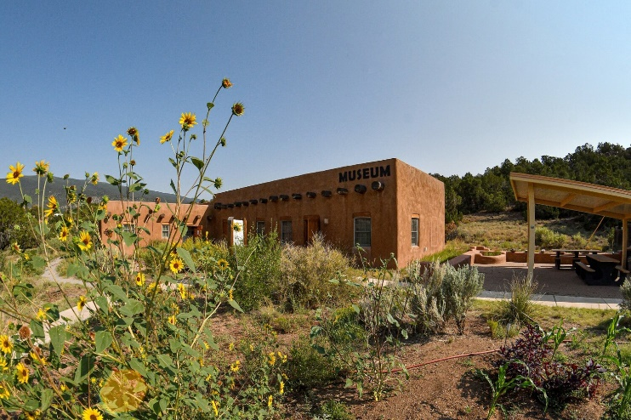
Join our Tijeras Pueblo Archaeological Site Volunteer Docent Team!
Join the Tijeras Pueblo Archaeological Site docent program! The Forest Service will be conducting initial (Level 1) docent training for individuals interested in staffing the self-guided spaces at Tijeras Pueblo - including the museum exhibits, the Tiwa World mural/map, and the trail. These docents are essential for providing basic visitor information and sharing knowledge of the resources found at the site and in the museum. A second required training for individuals interested in leading public, school and private tours (Level 2) will be conducted later this spring (date TBD). Tijeras Pueblo Archaeological Site volunteers are pivotal to ensuring the Forest Service’s commitment to education, preservation and community service. We would be thrilled to have you join our team!

Why Join?
The Mission! - The Tijeras Pueblo Site and Museum preserves, protects, and highlights the rich history and culture of the Ancestral Pueblo people of the central Rio Grande region of New Mexico. As a docent it is your privilege and responsibility to share this history and culture with others. Given the significance of this place to modern descendant Pueblo communities it is critical to present this history with accuracy and respect. | The Knowledge! - Beyond initial training, our docents are offered optional learning experiences such as field trips (e.g., Pueblo of Isleta Cultural Center, Indian Pueblo Cultural Center Museum, UNM’s Maxwell Museum of Anthropology, Rock Art of Cedro Canyon), presentations, and workshops. They also have access to an on-site library which includes copies of Tijeras Pueblo field notes.
Register Now:
If you have any questions or are interested in attending the training on April 17th, 2026, please email: Sandra Arazi-Coambs, Mountainair/Sandia Zone Archaeologist (sandra.coambs@usda.gov).

