Report of FOSM Project to Complete Two Tasks Related to Hauling of Donated Wood to the Church Woodlot and Movement of Large Rounds to the Crest Highway Shoulder, Wednesday, April 8, 2026.

Sam Beard
On Wednesday, April 8, eleven FOSM volunteers loaded two piles of bucked wood from near the Electronic Site onto Mile Oliver’s trailer to be hauled to the church woodlot to be given to families in the East Mountains next winter. The second task was to move a large pile of very heavy rounds to the Crest Highway shoulder. These rounds will be manually split next Wednesday and hauled to the woodlot. The objective of this project is to move all this wood before the highway is closed for the thinning project.
The FOSM volunteers working on this project were Jerry Carroll, Steve Roholt, Lou Romero, Sam Beard, Chuck Logan, Tim Kirkpatrick, Sim Cook, Eric Russell, Kent Tawler, Cliff Giles, and James Epps.
Project photos are presented below.

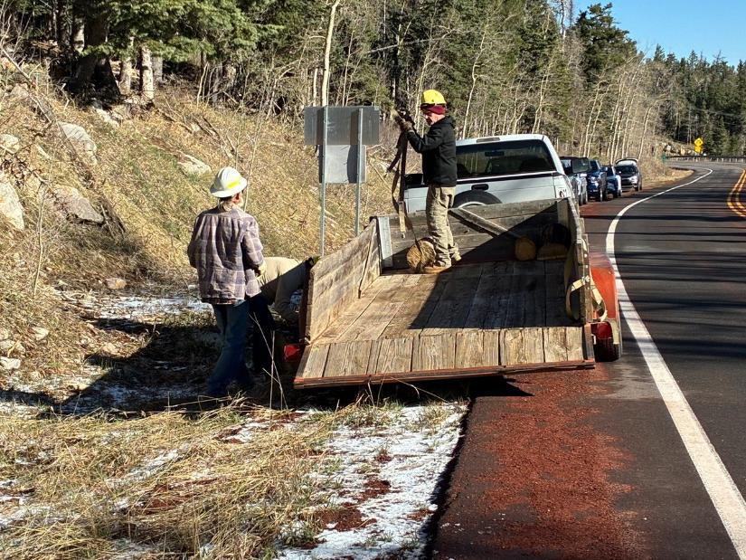
Mike and his friend starting to load trailer at the first pile of rounds about one-quarter mile below the Crest parking lots.
All photos by Cliff Giles unless noted otherwise
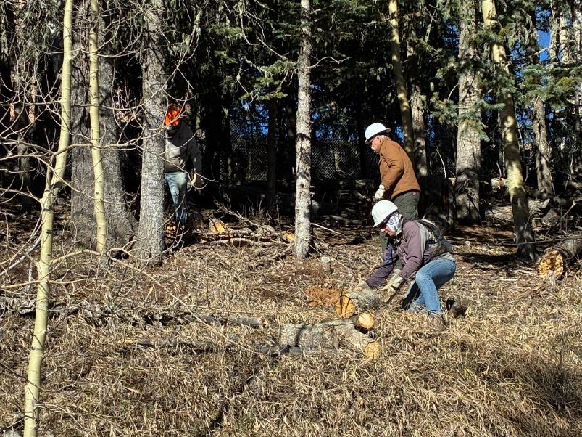
Jerry Carroll, Kent Tawler, and Steve Roholt retrieving rounds that were bucked last fall.
Note the new chain link Electronic Site fence in the background.
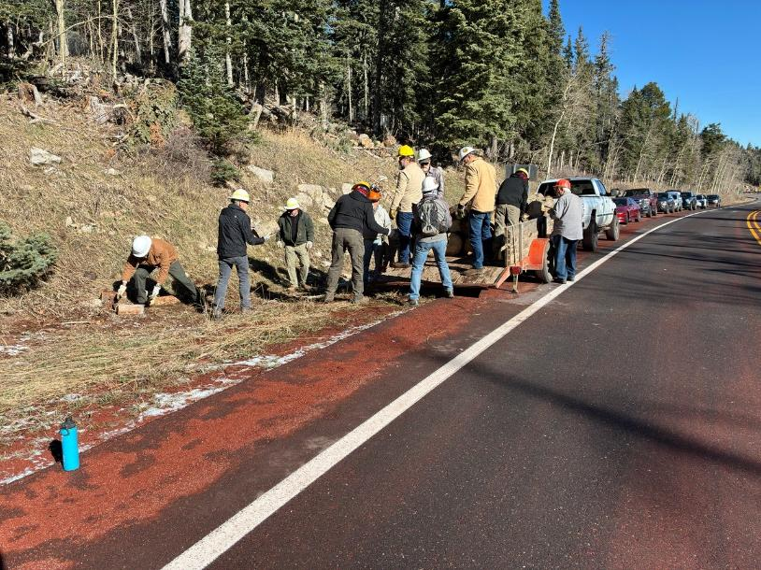
Crew using fire brigade technique to load trailer.
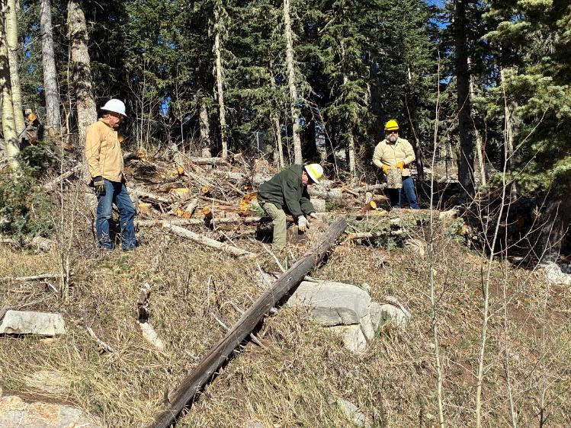
Chuck Logan, Tim Kirkpatrick, and James Epps retrieving rounds at the second pile below the Electronic Site fence.
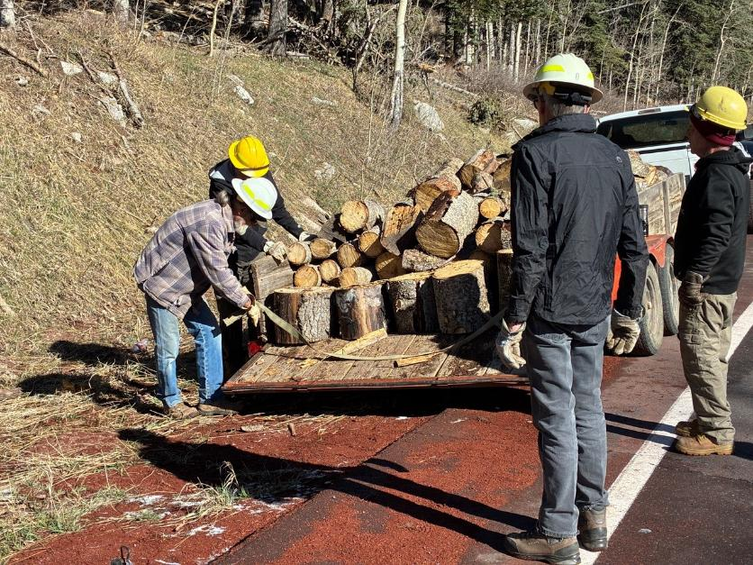
L to R: Mike Oliver, Eric Russell, Sim Cook, and Tim Kirkpatrick. The trailer is almost full.

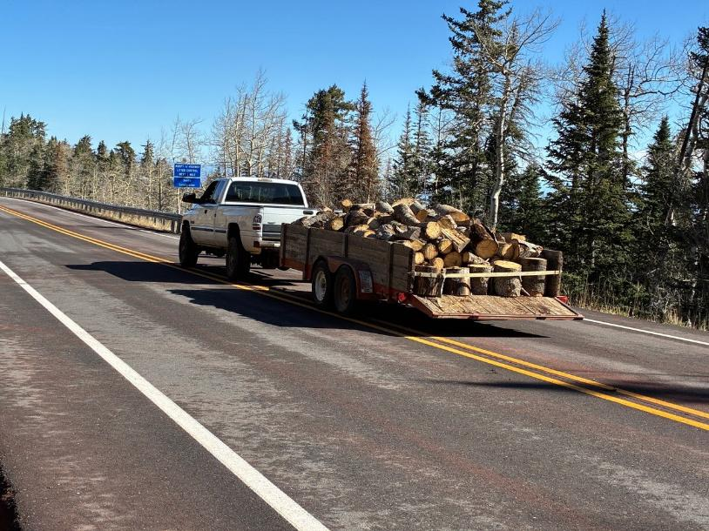
Mike is hauling the load of donation wood to the church woodlot on his land.
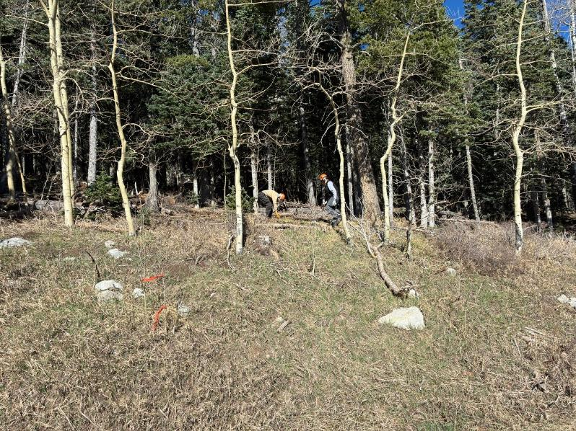
Sam Beard and Sim Cook clearing a path to move the very large rounds down to the highway cut bank.
The rounds had been stored in the forest near the left side of the photograph since last fall.
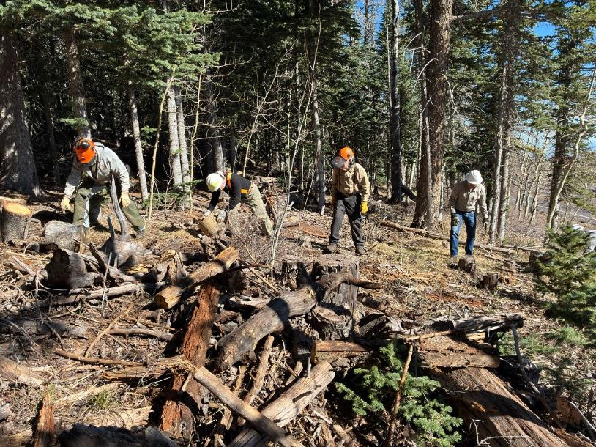
L to R: Jerry, Tim, Sam, and Chuck moving small rounds to top of the cut bank of the highway on the right.

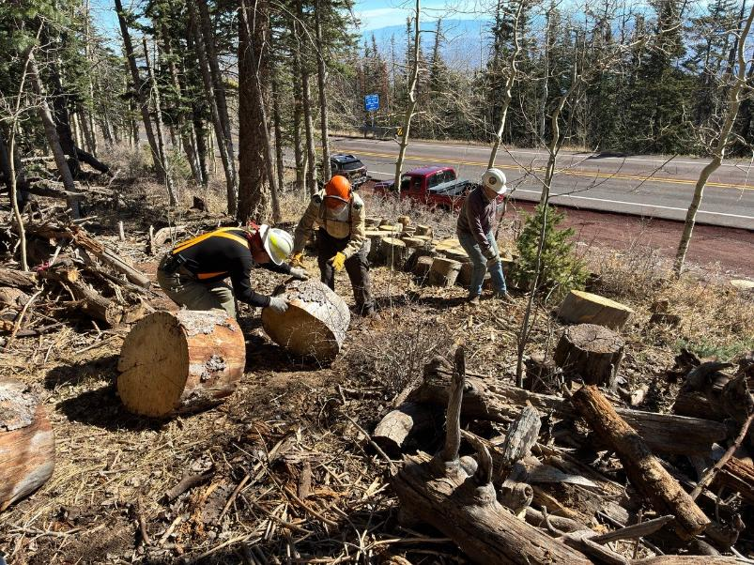
Tim, Sam, and Steve positioning large rounds at the top of the cut bank. These very heavy rounds were about 24 inches in diameter.
These large rounds were placed where Steve is standing and then moved carefully down to the shoulder.
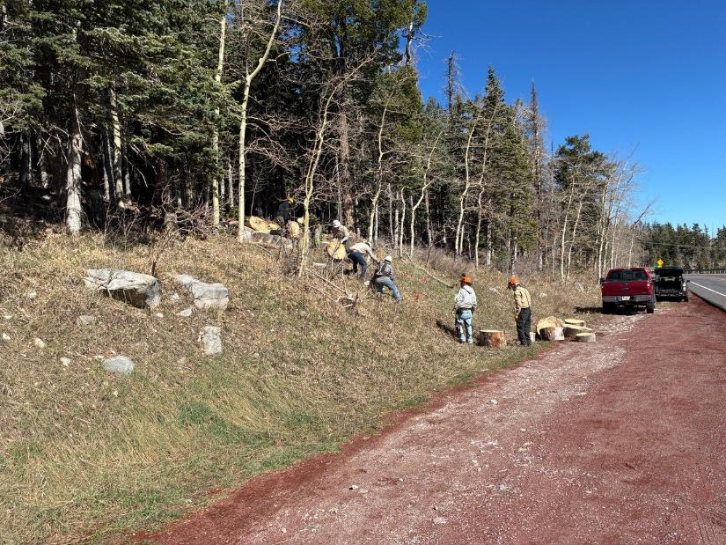
Moving the large rounds down to the road shoulder. In order to maintain control of these rounds and move them safely,
they were initially moved down to the top edge of the cut back and then moved one-by-one slowly down to the shoulder.
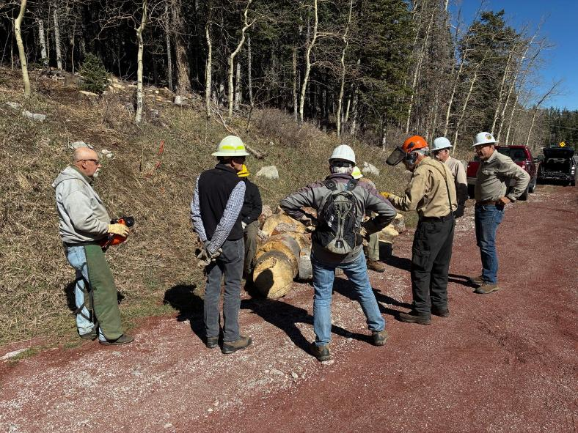
Sam is describing the plan to store the large rounds here and hope that they will not be stolen before next Wednesday
when they will be split manually and hauled to the church woodlot before the highway is closed for the thinning project.
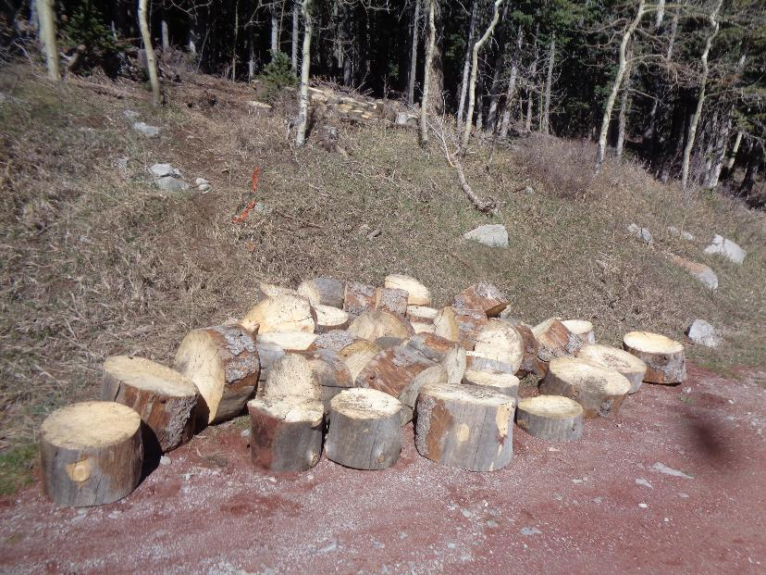
The pile of large rounds on the highway shoulder. Photo by Sam Beard
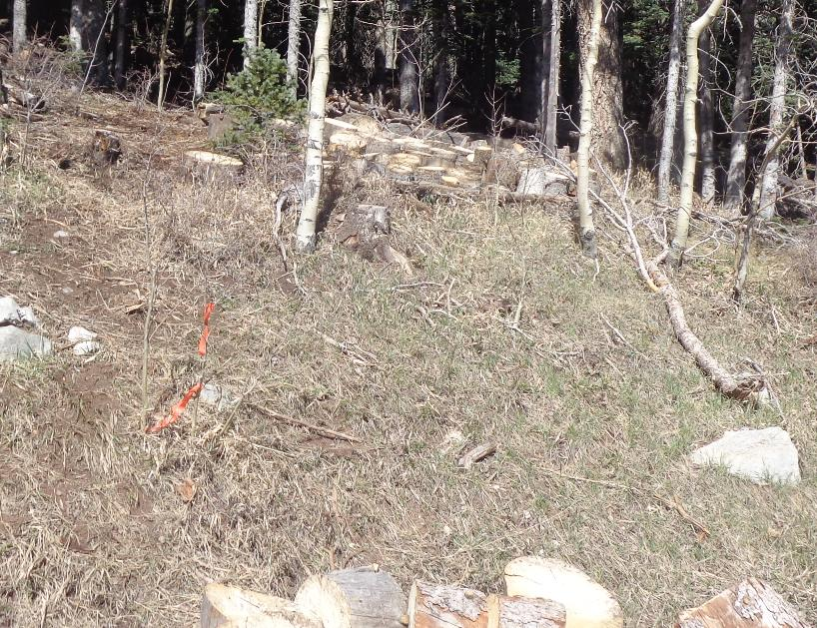
The pile of approximately 30 small rounds is in the forest above the large rounds. Photo by Sam Beard

