Thursday, 04/09/26- Pokerchip: Back to the long drive and long hike this week. Ten volunteers and Jen (SRD) hiked up Bear Scat and picked up our work on Pokerchip. The hike in was nice and the flowers are starting to bloom. We finished up the first reroute section, about 194 feet of reroute and we are about half way through the second reroute. Hopefully the road in will remain passable so we can continue to make progress as there is still a lot to go on this project. The after-lunch time seems to get pretty warm and then there is a long hike out.

Volunteers: John McNett, Cleve Sharp, Eric Russell, Bruce Hansche, Don Fisher,
Claudia Bergsohn, Byron Garner, Luis Cuadros, Steve Forrest and Laura Leon

Pictures: Laura Leon

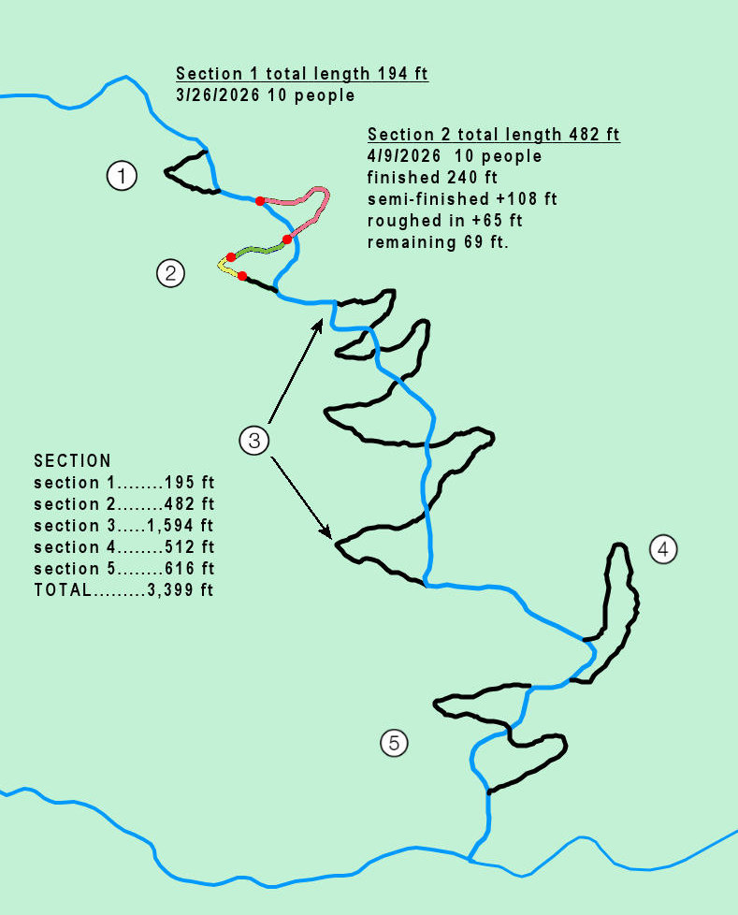
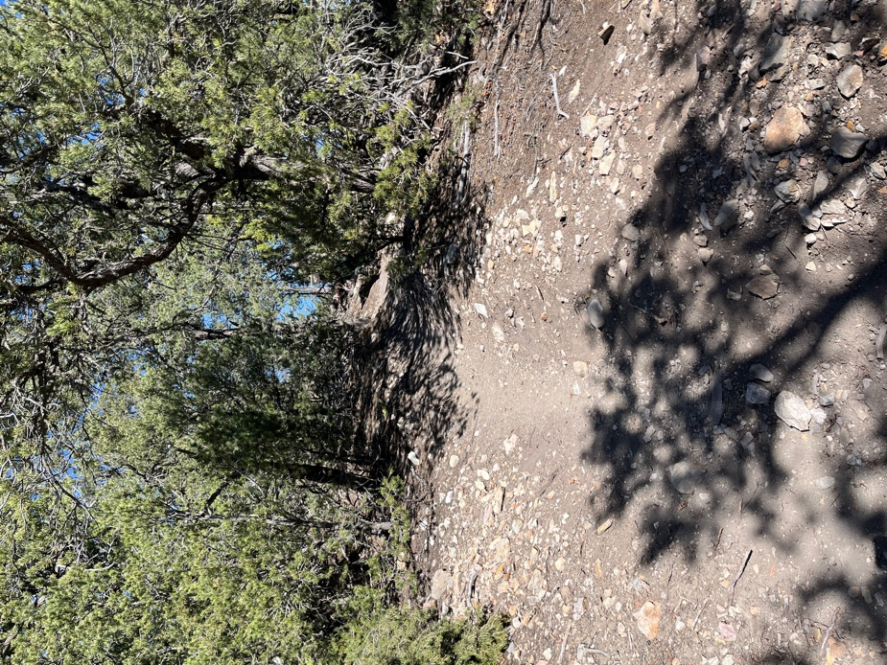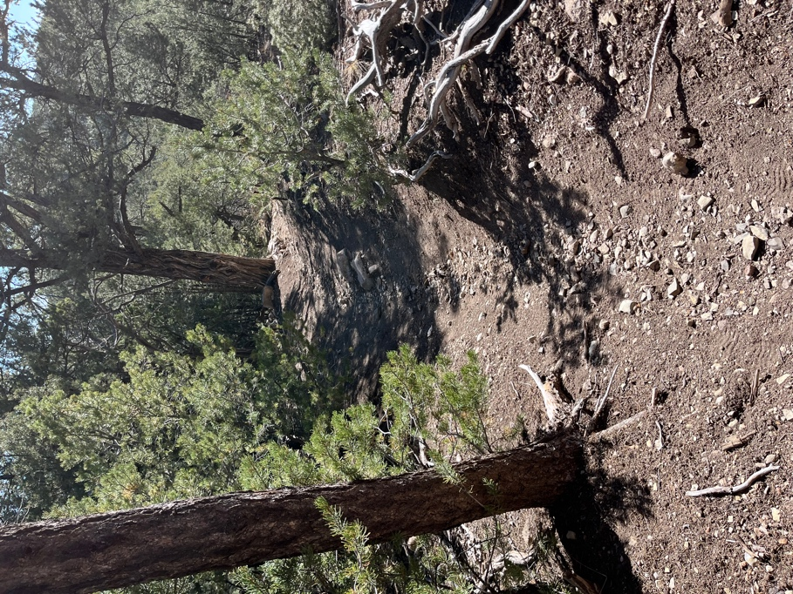

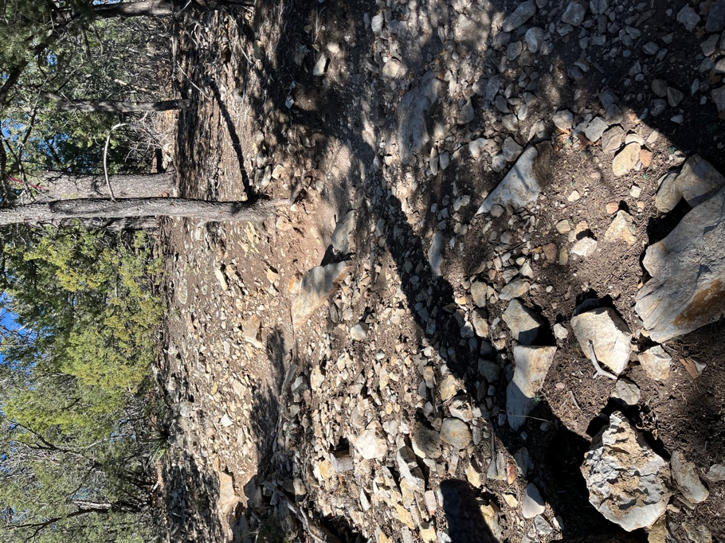 The old trail is very rutted, rocky and steep.
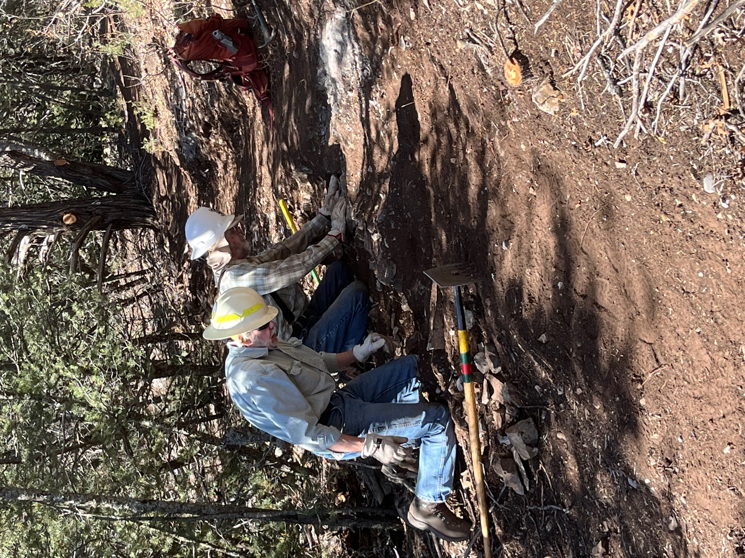

Byron and Bruce finish up some rock issues on reroute 1.
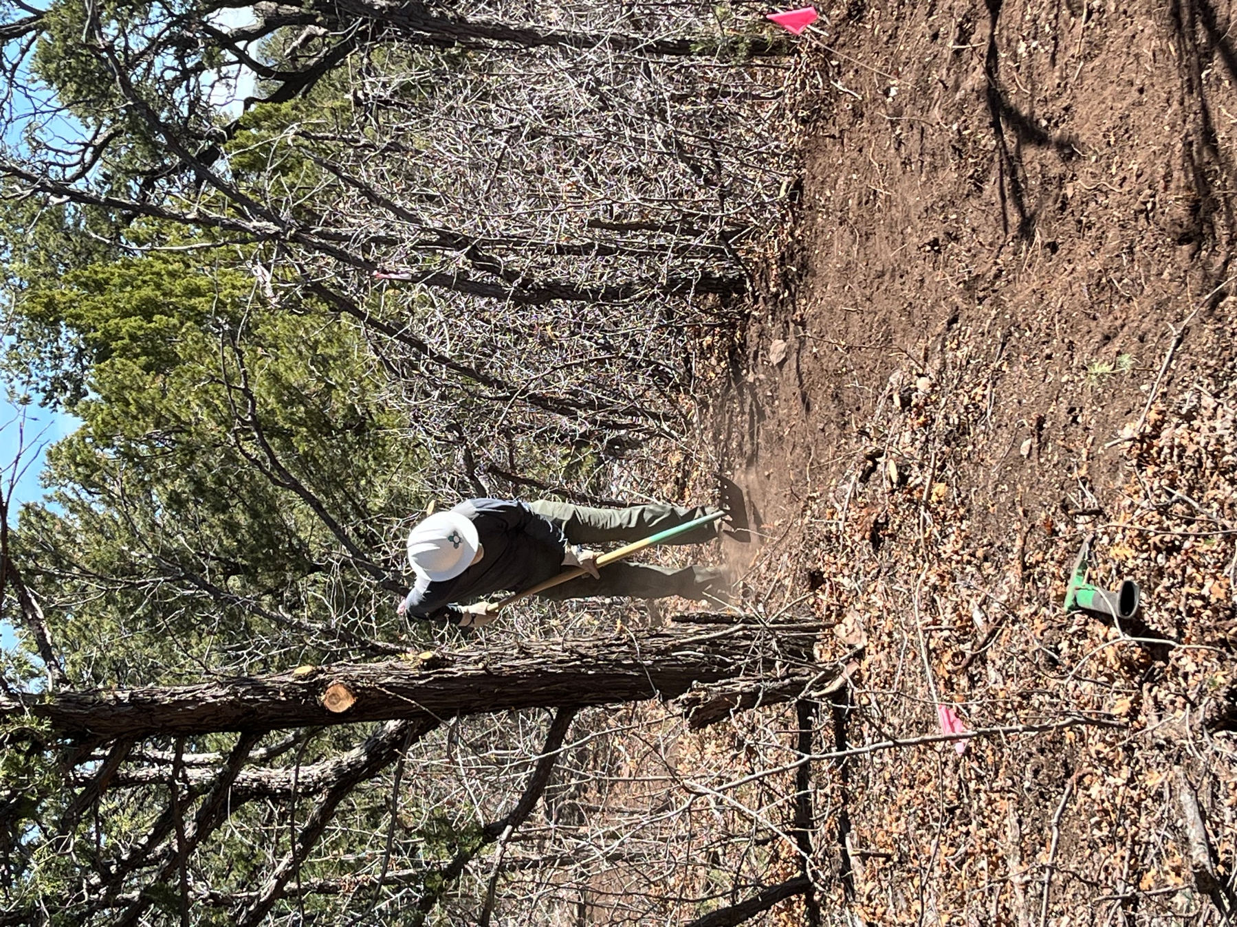

John finishes smoothing out a section of reroute 1. Just a bit dusty.

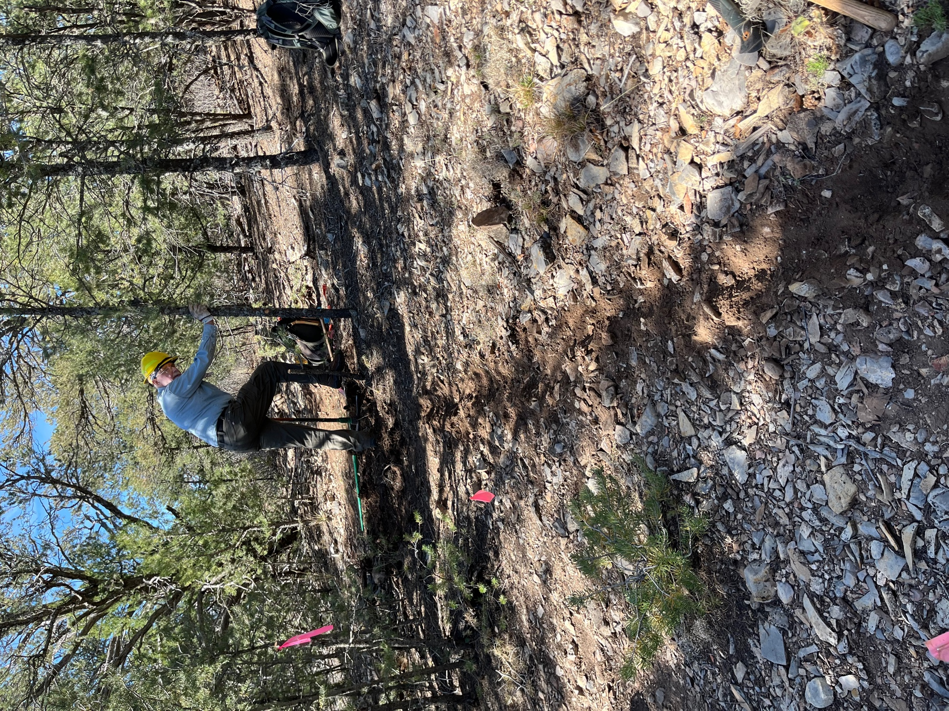

Eric removes stumps from the beginning section of reroute 2.

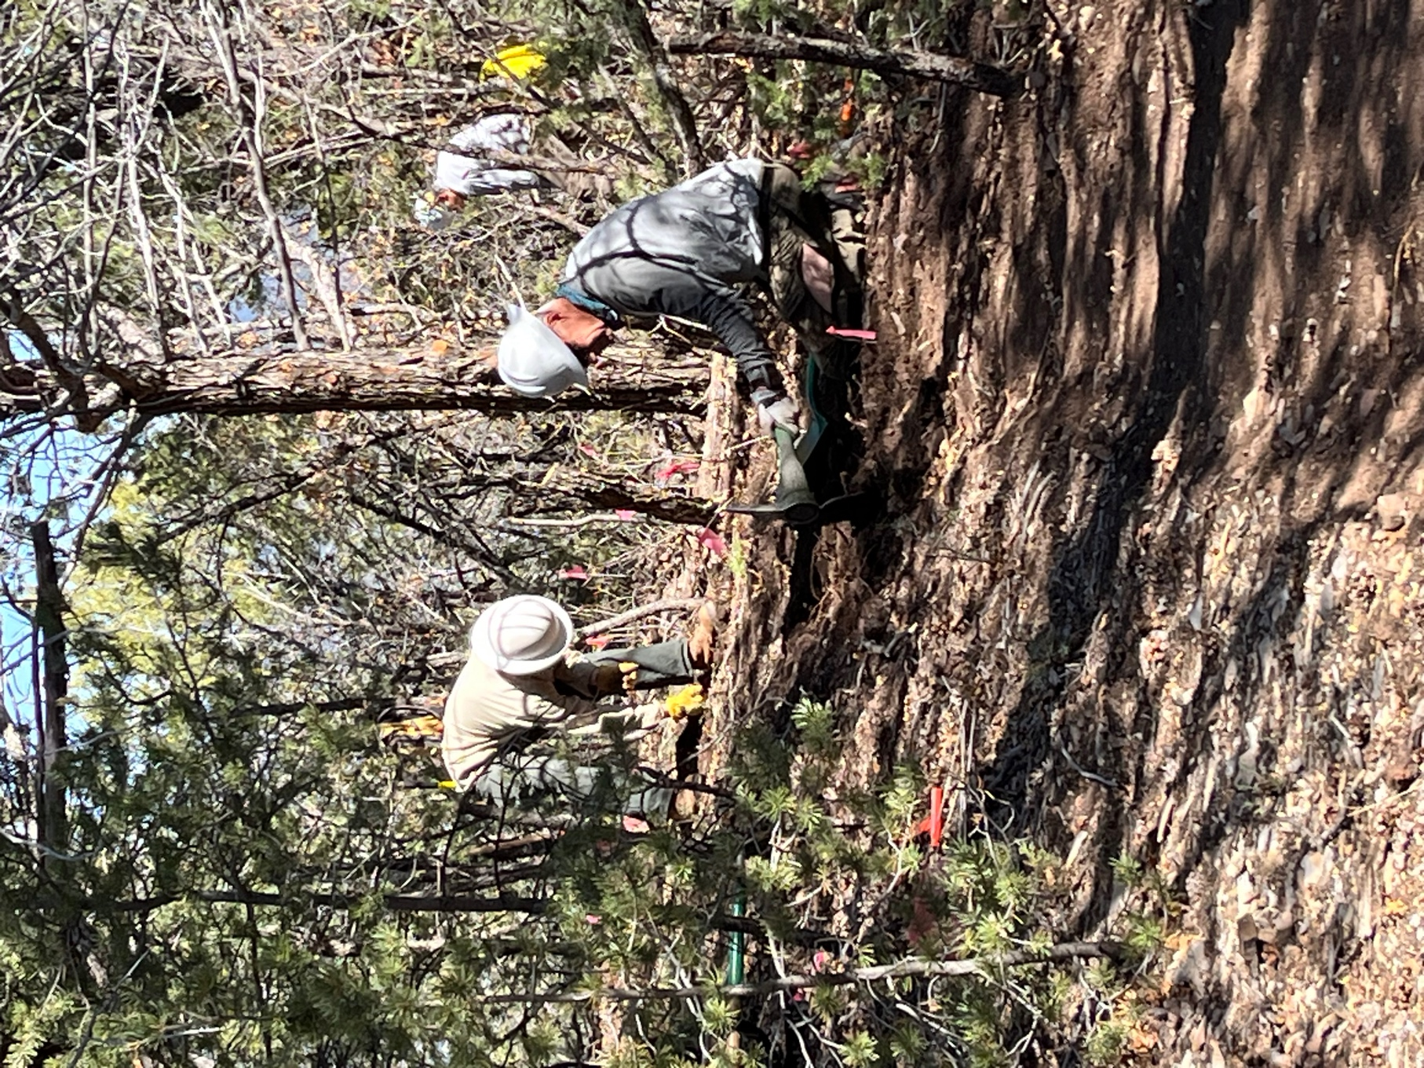

Steve and Jen remove rocks and roots on reroute 2. There was actually a bit of moisture in the soil under the trees.
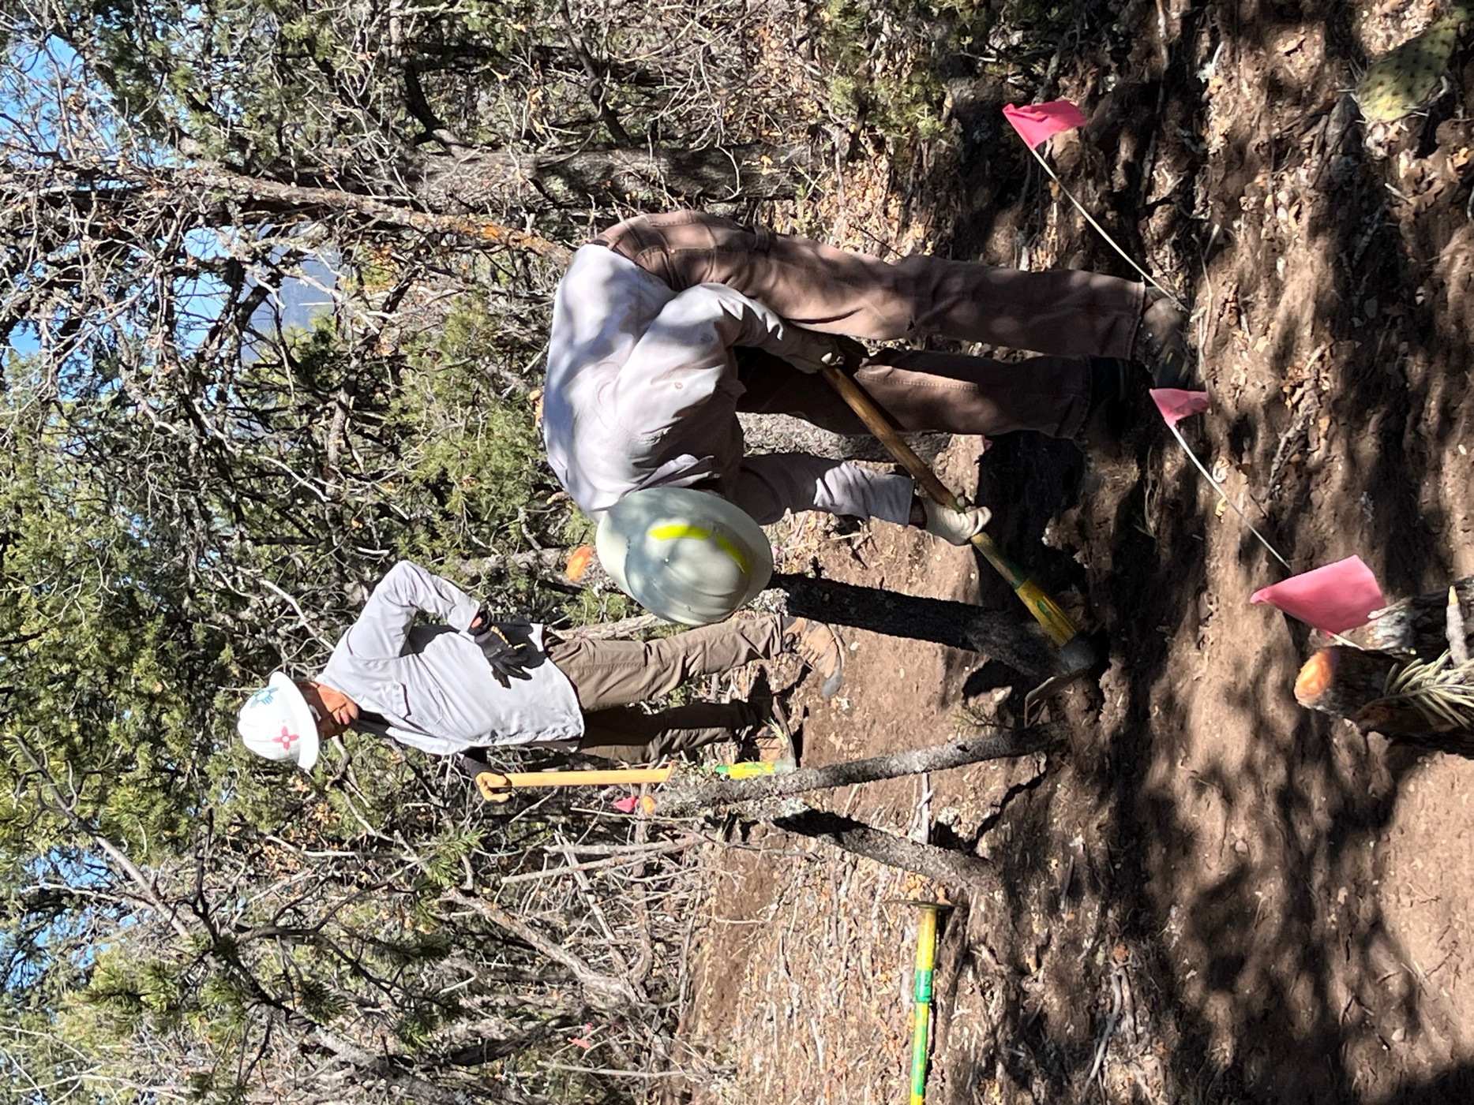

Luis and Cleve work a curve and remove stumps.
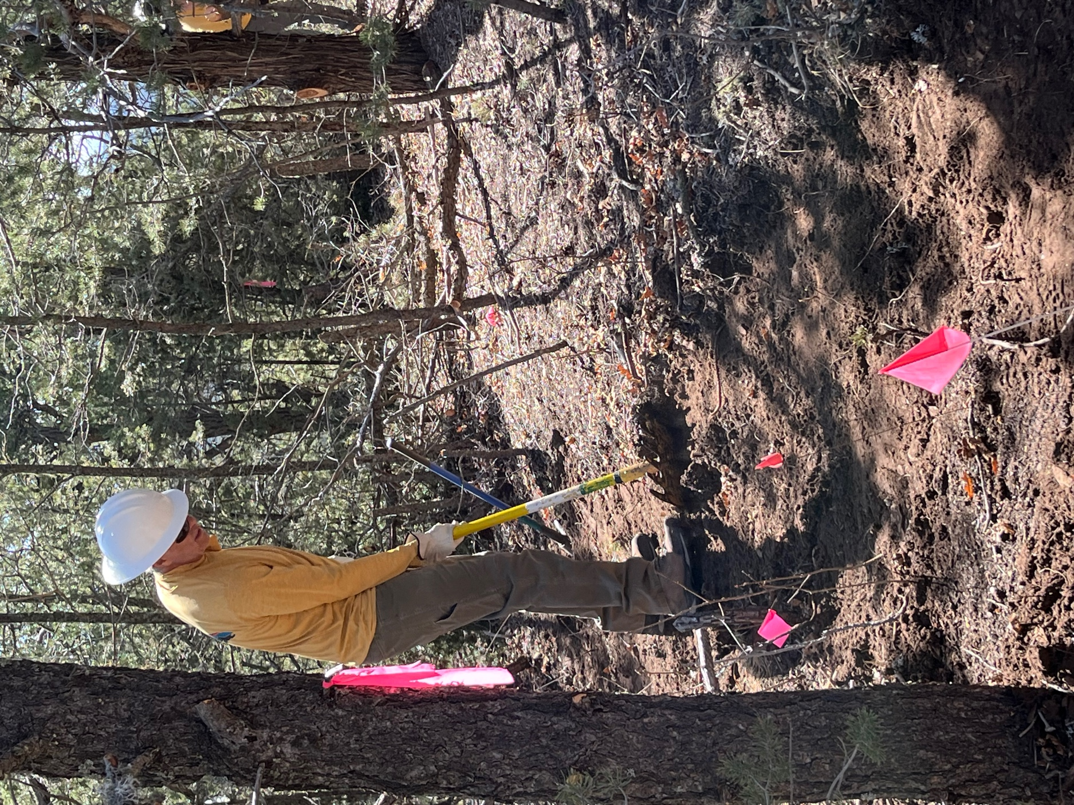
Don is digging along.
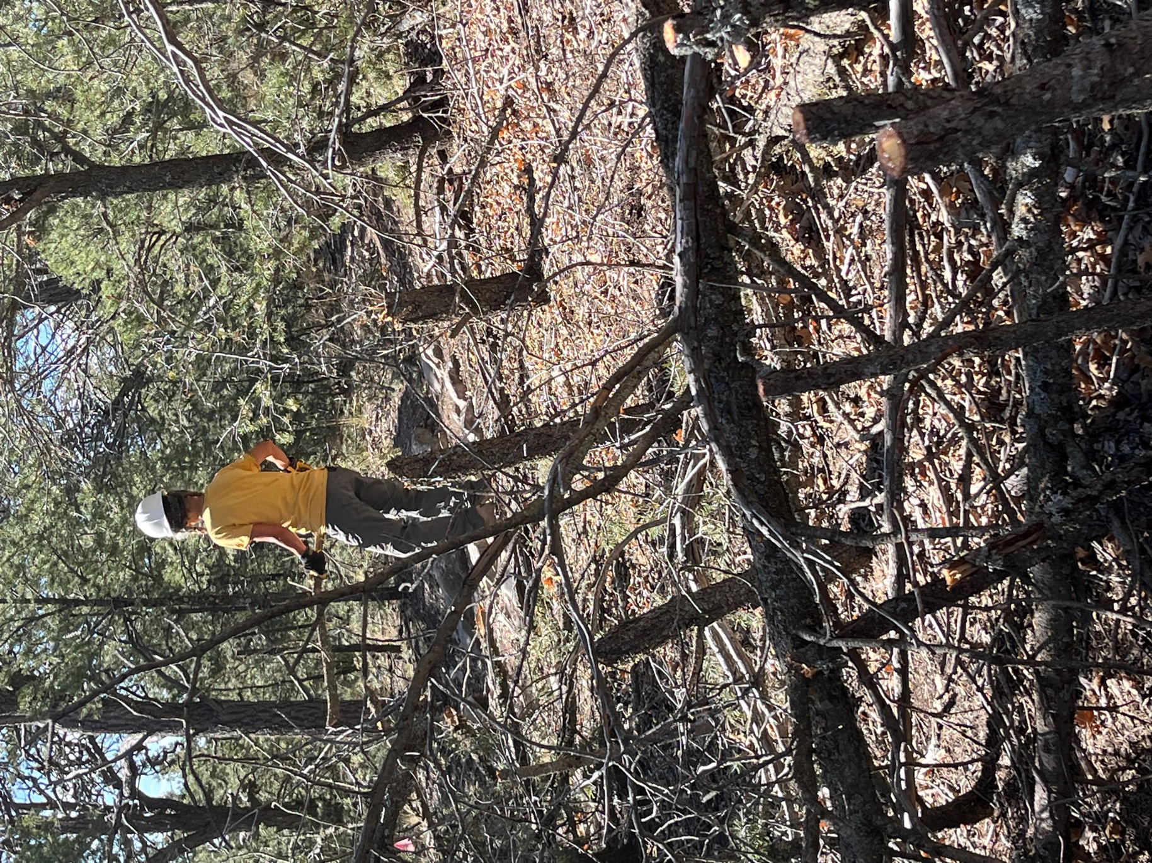

Claudia removes debris. So much oak…
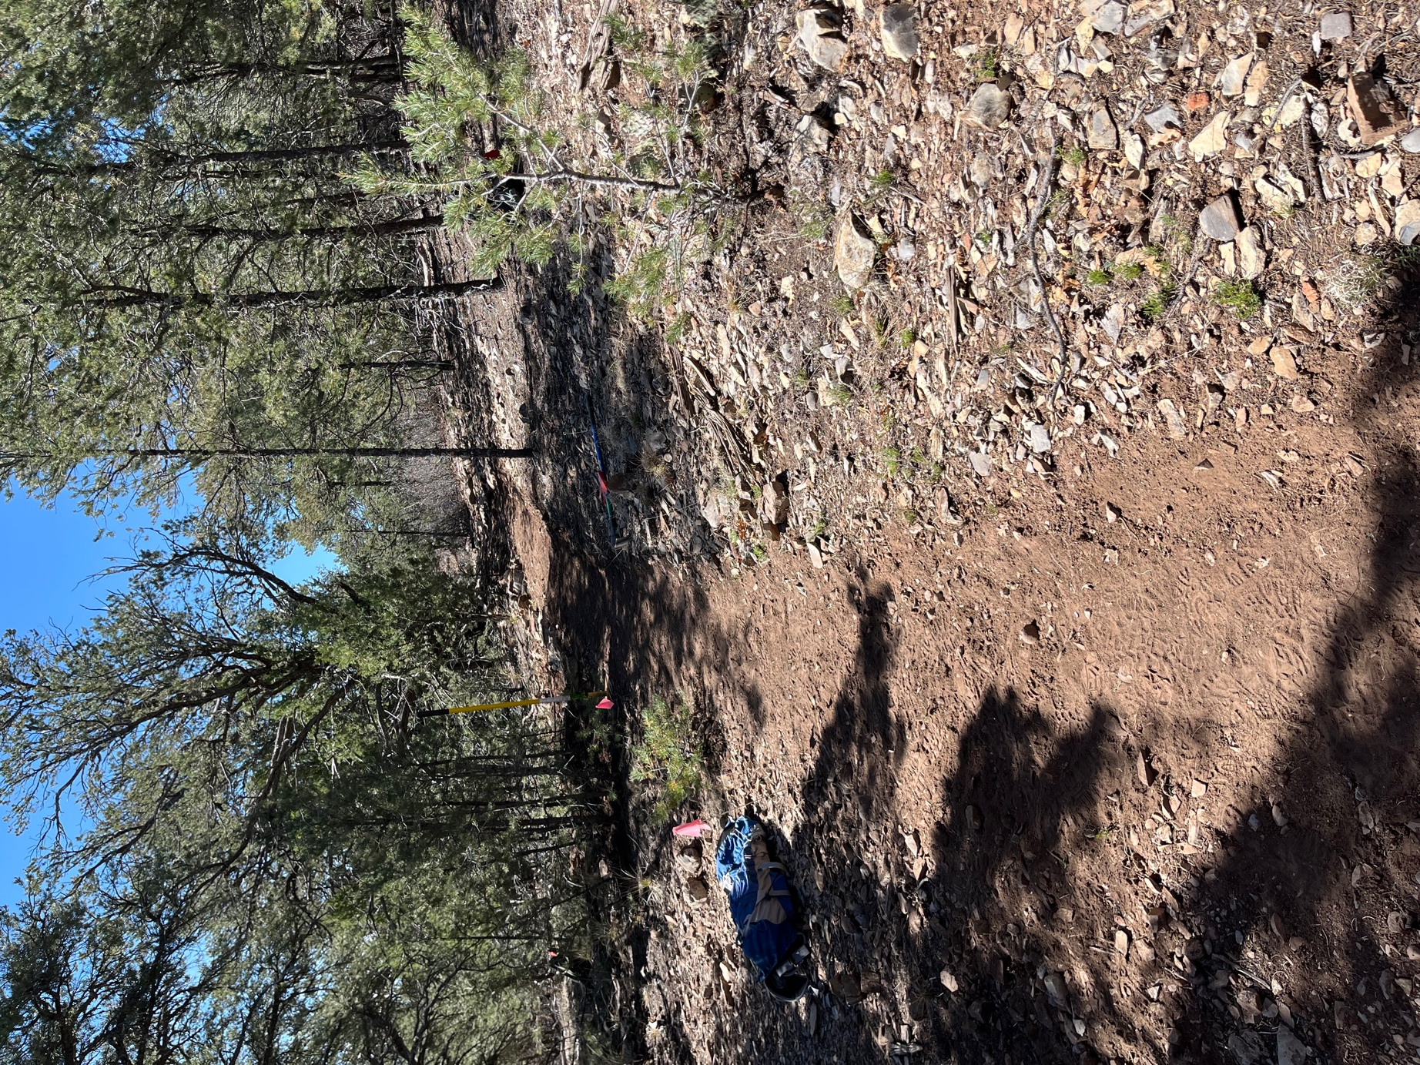

The top section of reroute 2, nice and smooth!
