Trail Maintenance Project: Monday, April 13, 2026
Byron Garner

Our project for last Monday was to continue and finish the work started by the Thursday crew to brush and clear Cienega for pack horses carrying water for the future NMVFO brushing project on the crest. This work included some brushing, high pruning, intrusion cutbacks and felling of three trees ( two cigar butts and an oak) to give the horses additional clearance for the wide loads to be carried. Most of this work was confined to the middle one third of Cienega which is now clear. With the brake in the temps and good breeze, it was a good day on the mountain with an energetic crew who got the job done. The crew included John Cooper, Ken Wilson, Steve Roholt, Sue Harrelson NMVFO, Jen Medina-Gray USFS and Byron Garner

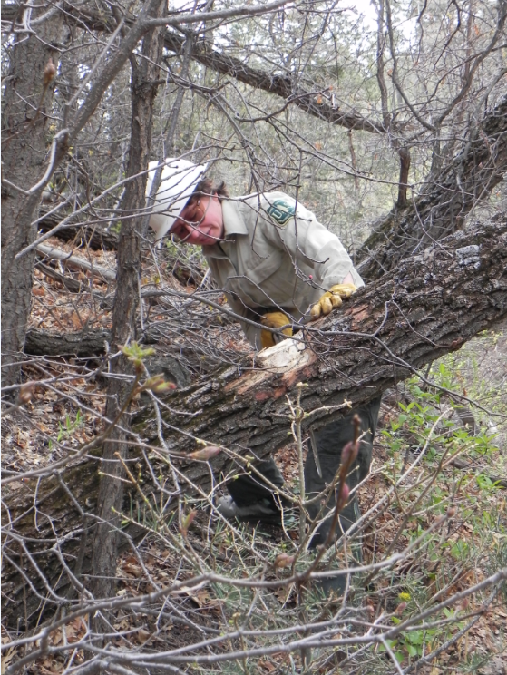
Jen preps this over reaching oak for felling

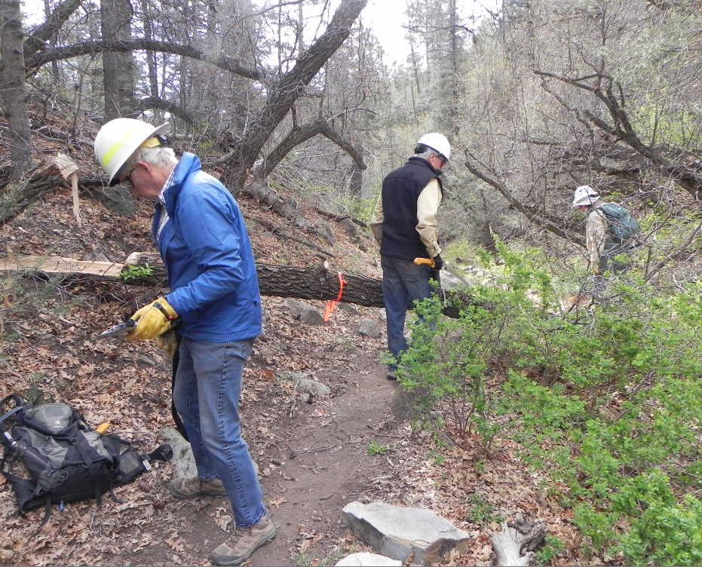
John Ken and Jen work on bucking strategy

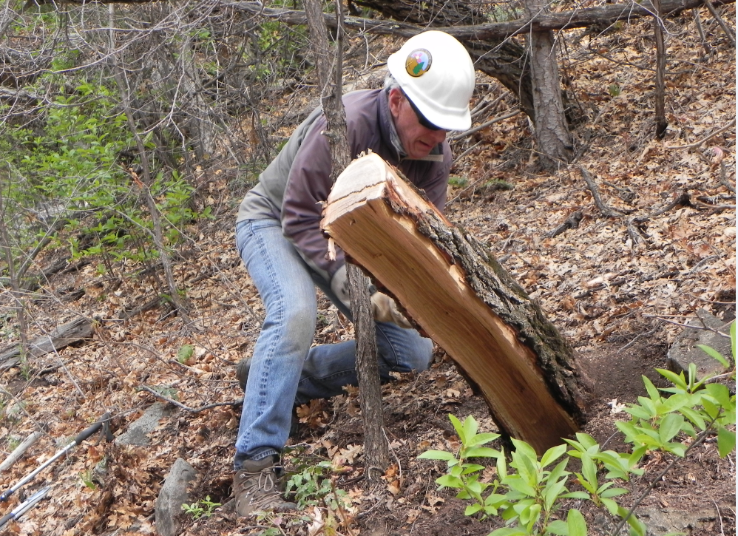
Steve opens the throttle to low stump this very uncooperative oak

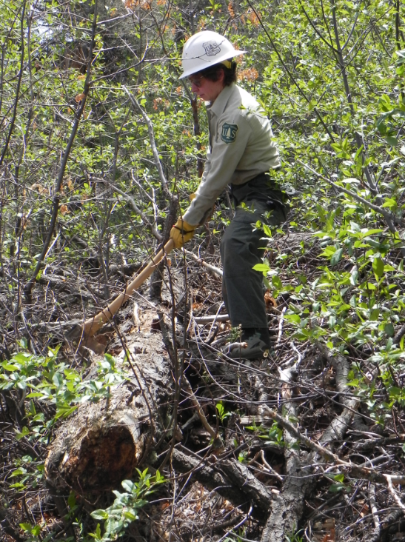
Jen works this intrusion

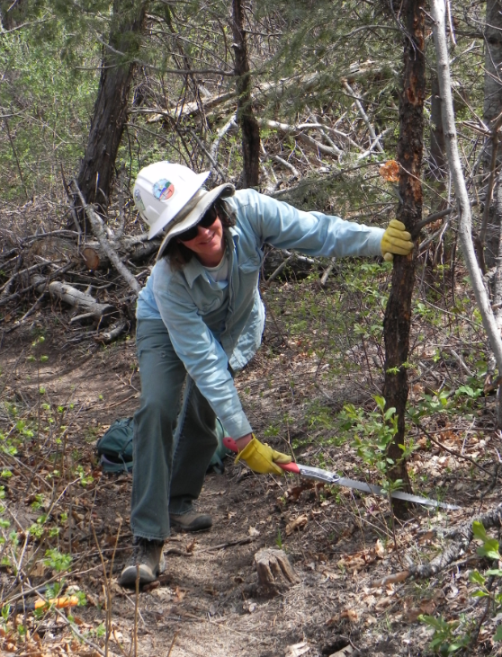
Sue finds another obstacle for horses

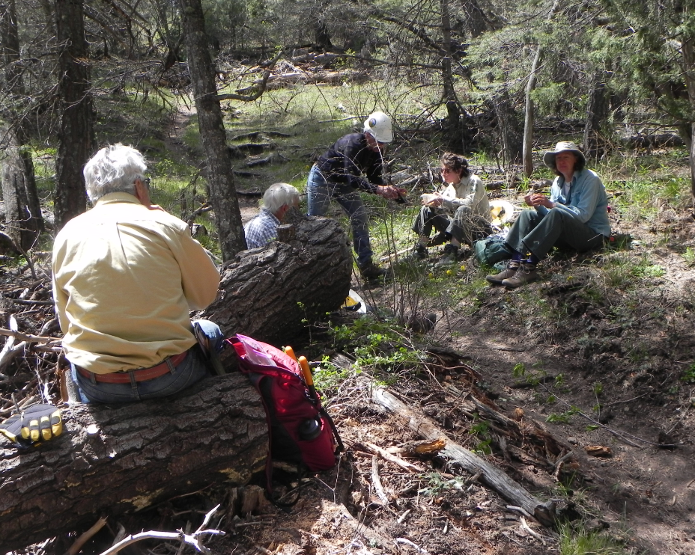
A much needed rest and lunch

