Thursday, 04/16/26- Pokerchip: Eight volunteers returned to Pokerchip to continue reroute work. Luis brought his bike so he could ride the 2-mile hike in and test out the new reroute sections. Thumbs up on that. We had a nice day to work and then it clouded up and became windy for the hike out. We finished up work on the end of the 2nd reroute and made a couple of check dams with rock to limit erosion of the old trail. The other half the group started on the 3rd, large,middle reroute. It’s really just grueling work between the oak stumps and the rock removal/rearrangement. Progress is slow but the work is coming along and it looks very good.

Volunteers: John McNett, Kerry Jones, Jim Houle, Bill Perkins, Luis Cuadros,
Claudia Bergsohn, Bruce Hansche and Laura Leon

Pictures- Laura Leon and map work by Luis Cuadros

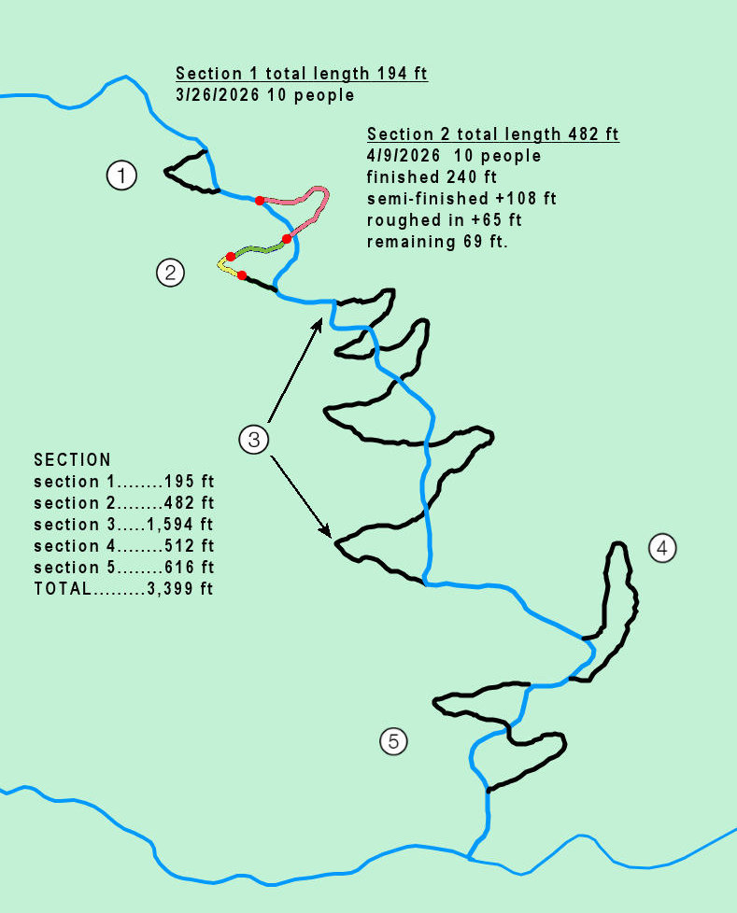

Reroutes 1 and 2 are done. We are starting work on 3- looks like it will take a while! A little over 600 feet done and a mere 2,700 to go!
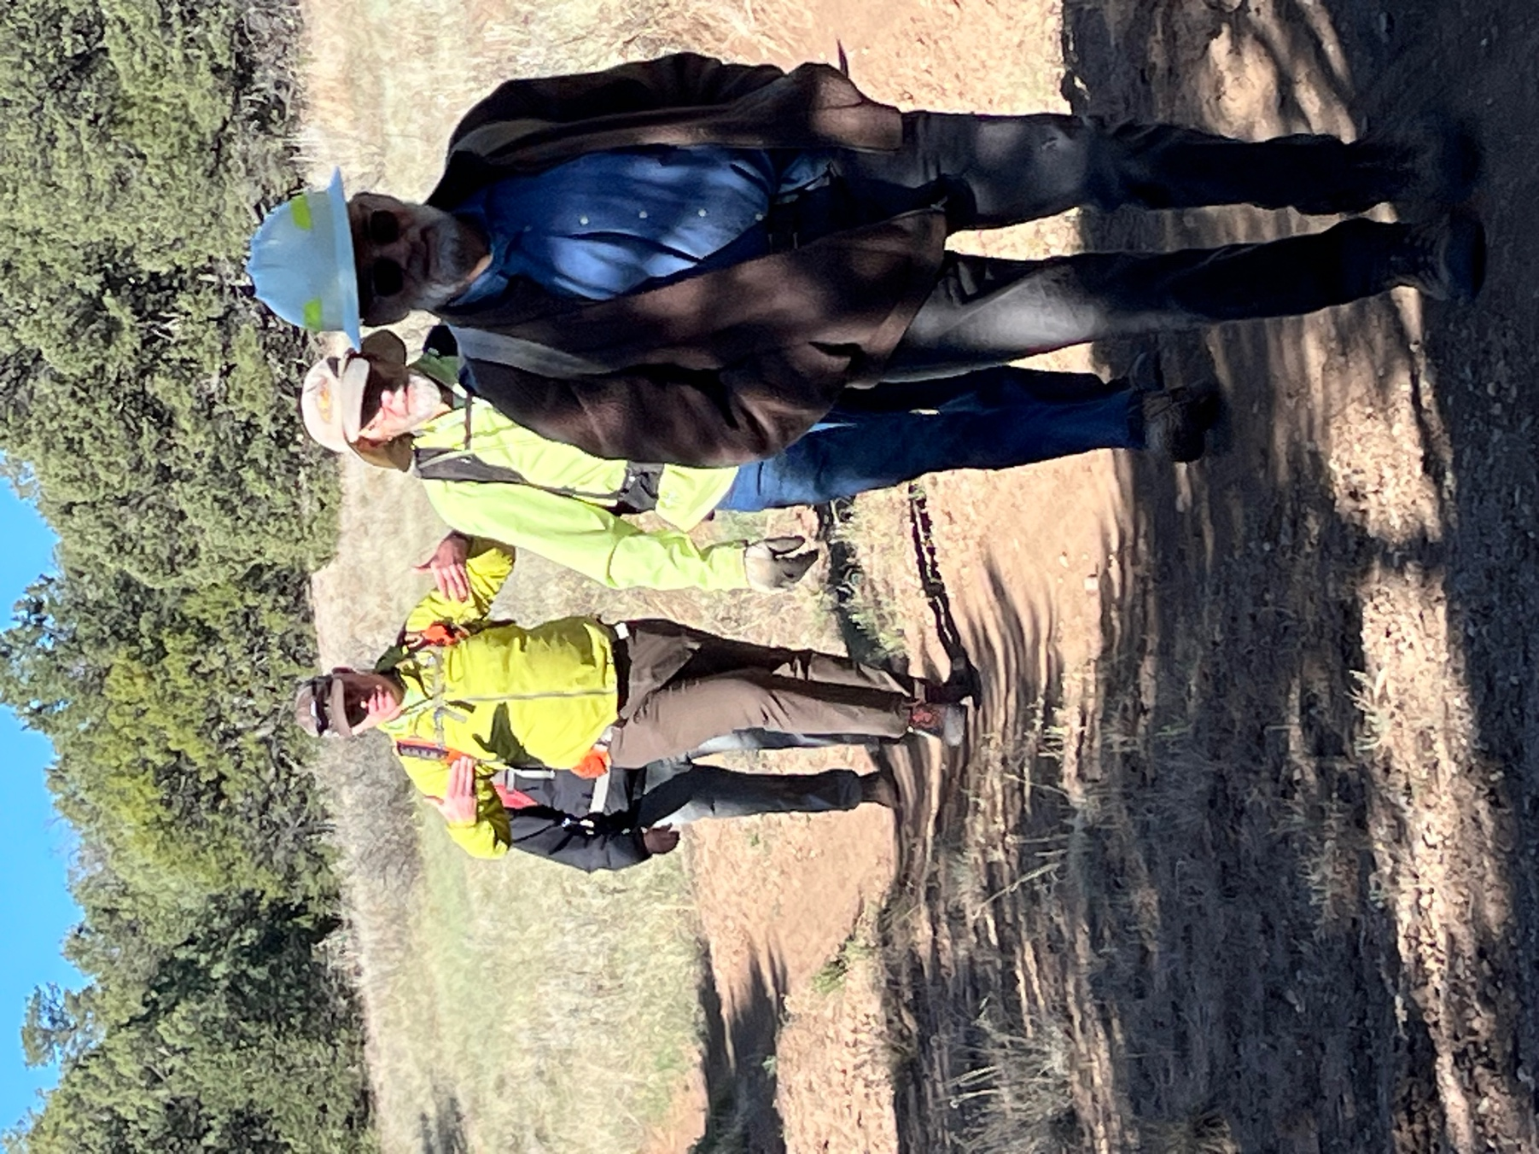

Hi Ho! Off to work we go! Jim, Bruce, Kerry and Bill look excited!

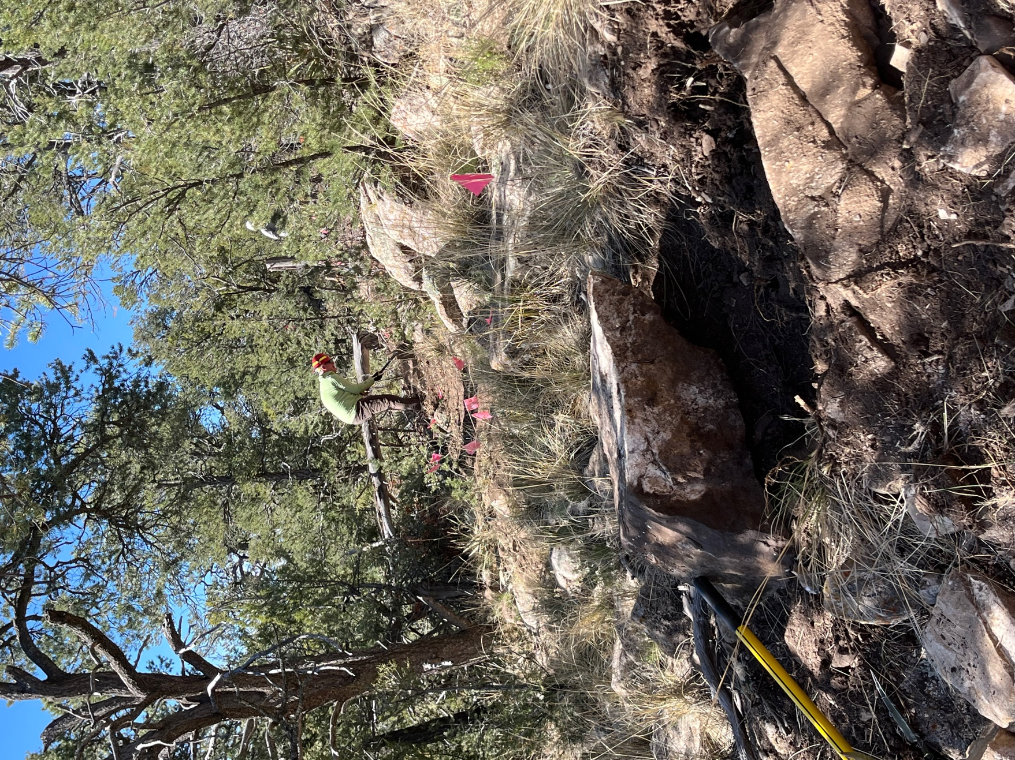

Kerry starts work on the end of reroute 2. Lots of prickly pear and rocks and rocks and rocks. You go to move a small one out of the way and suddenly you’ve got 3 that need to go.
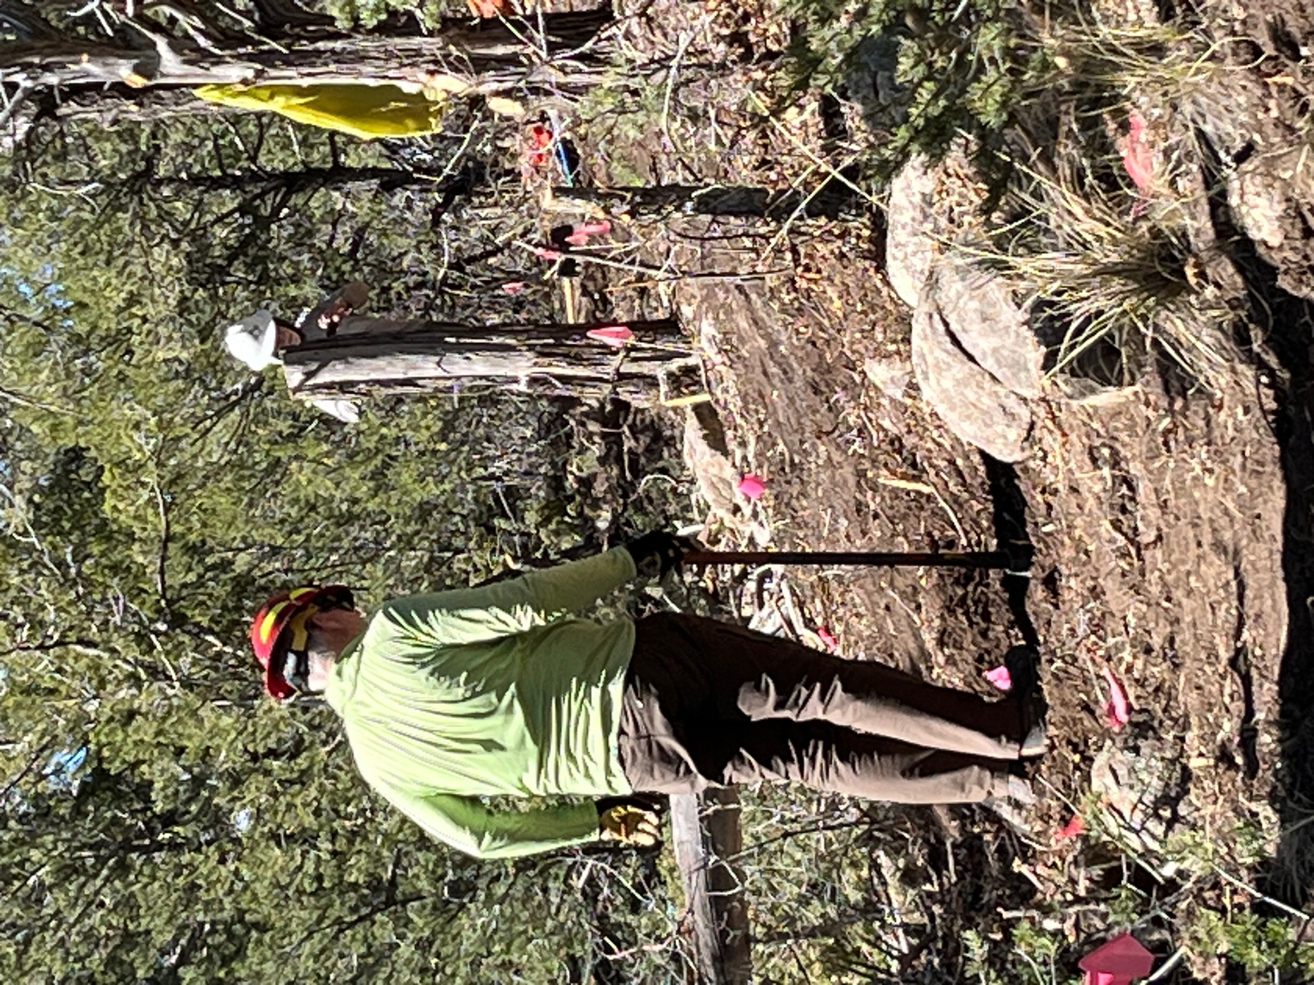

Kerry and John try to make this section work- it took lots of ideas and all day.
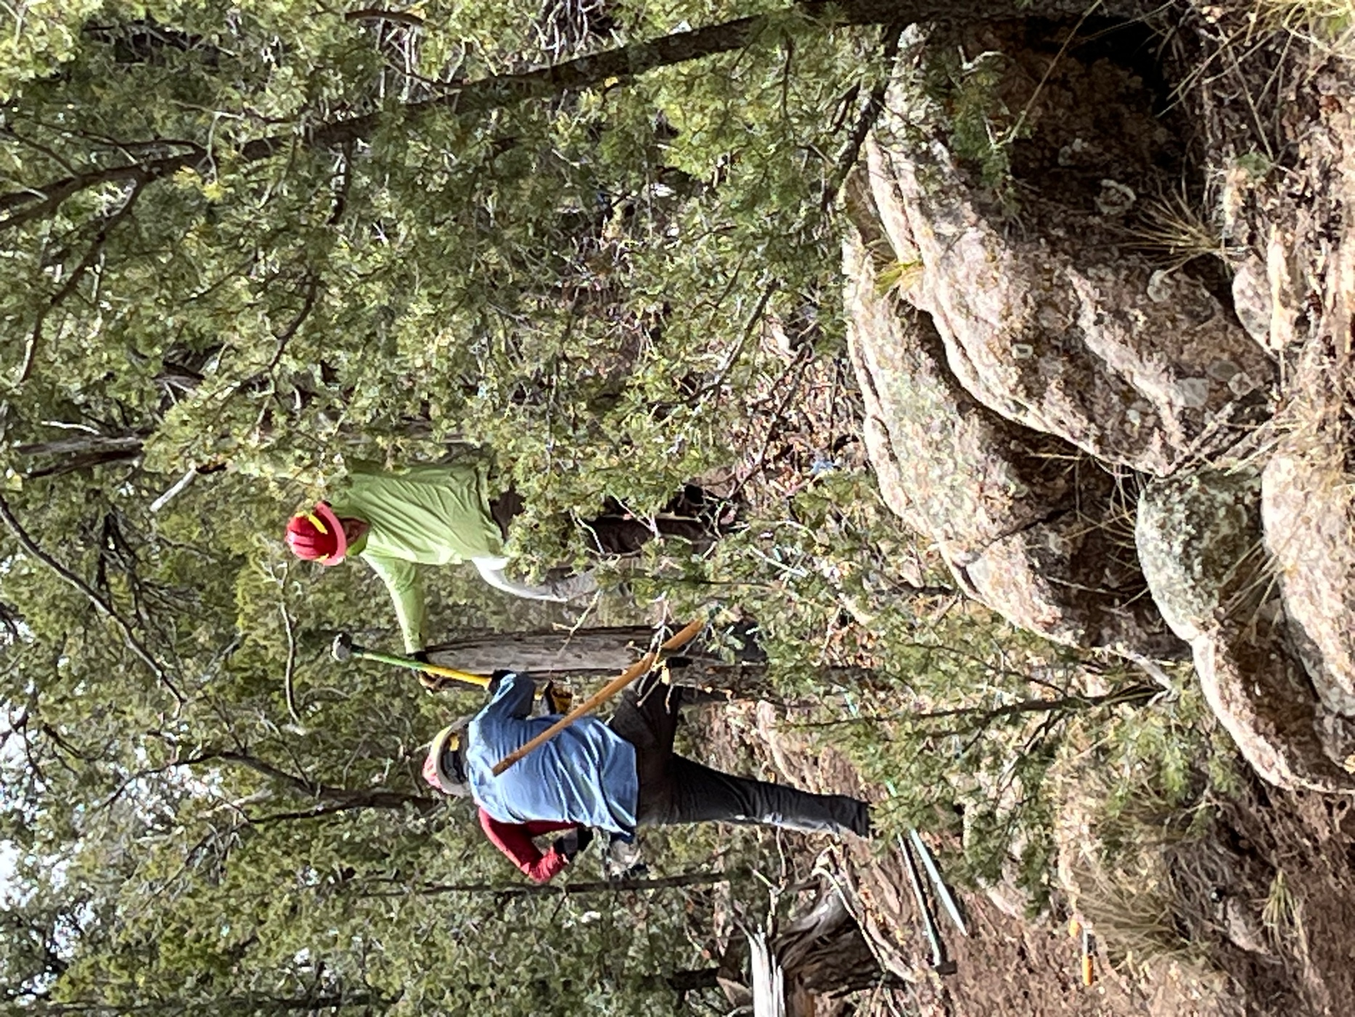

Later, Jim and Laura and Luis all added to the problem solving.
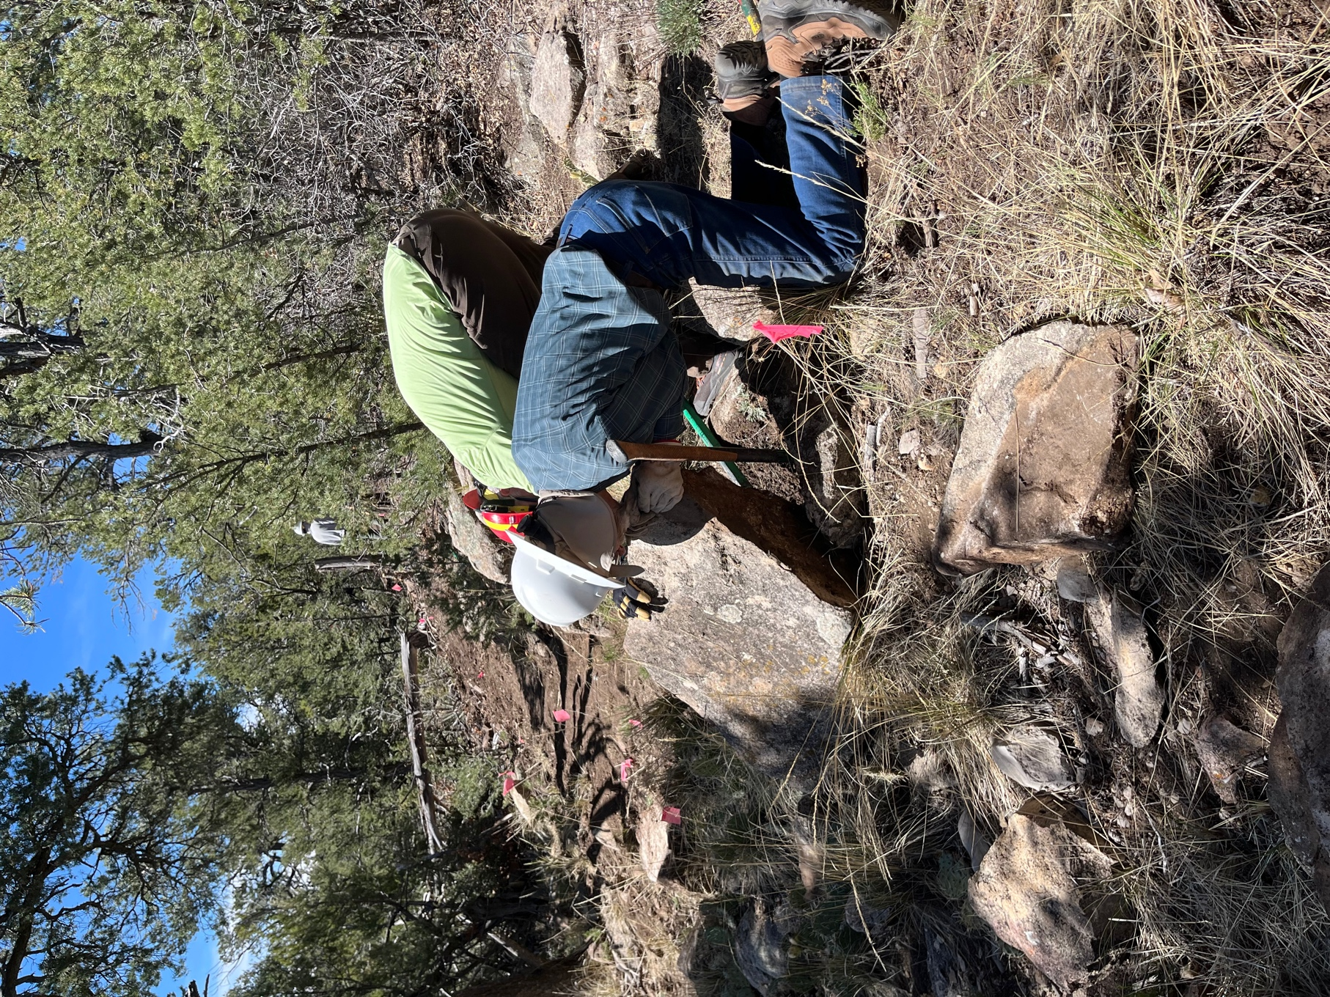

Kerry and Bruce move a rock that we had hoped to keep in place but which proved unstable.
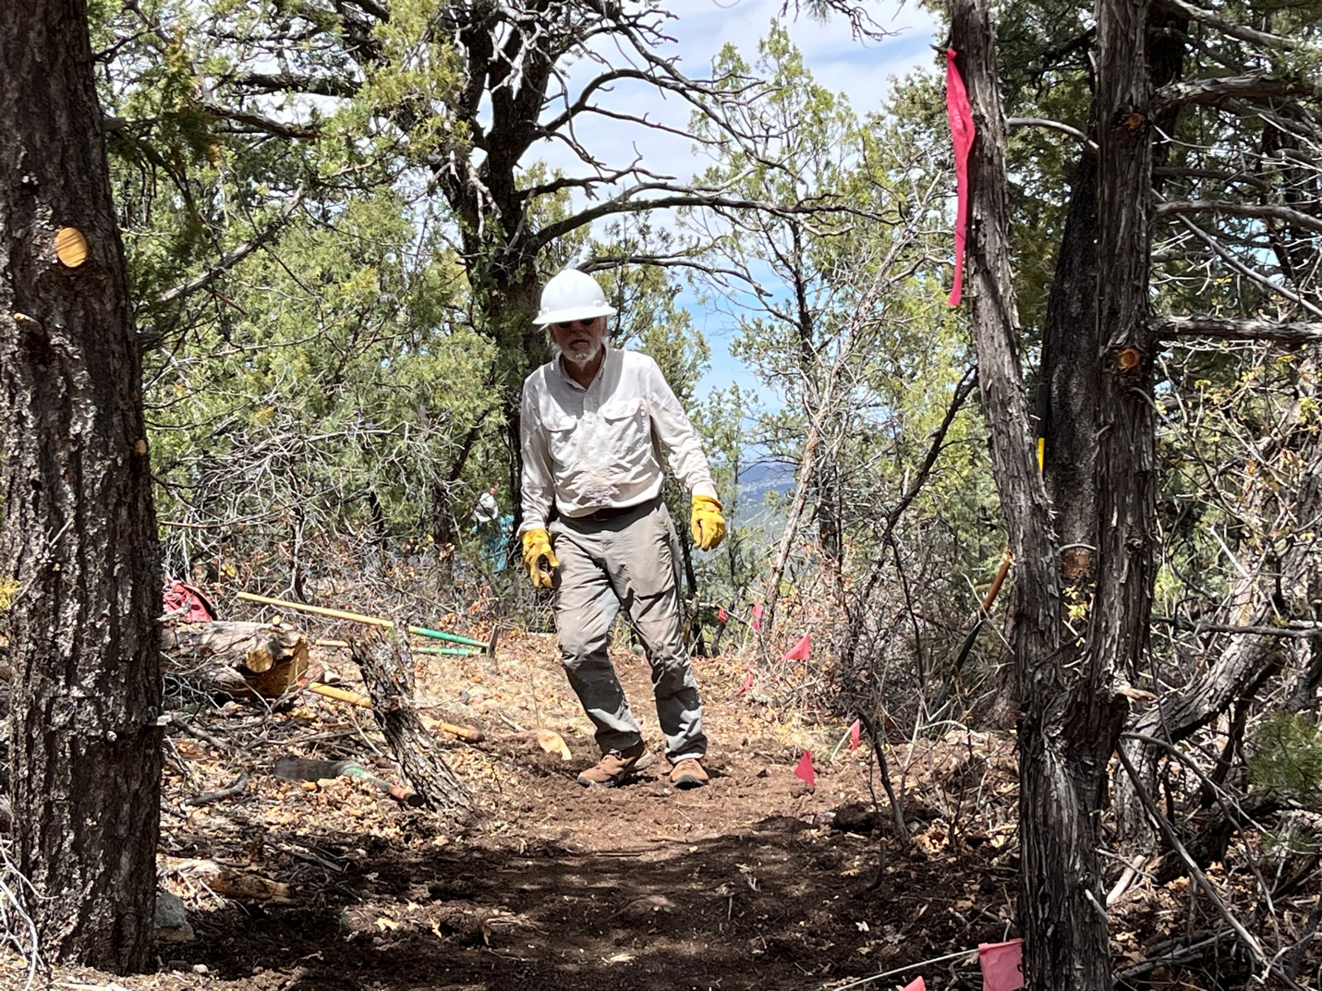

Meanwhile, Luis stashed his bike and then couldn’t find it – hiding in plain sight but most of us missed it.
Bill, Claudia and Luis started in on reroute 3 and all its many splendid stumps.

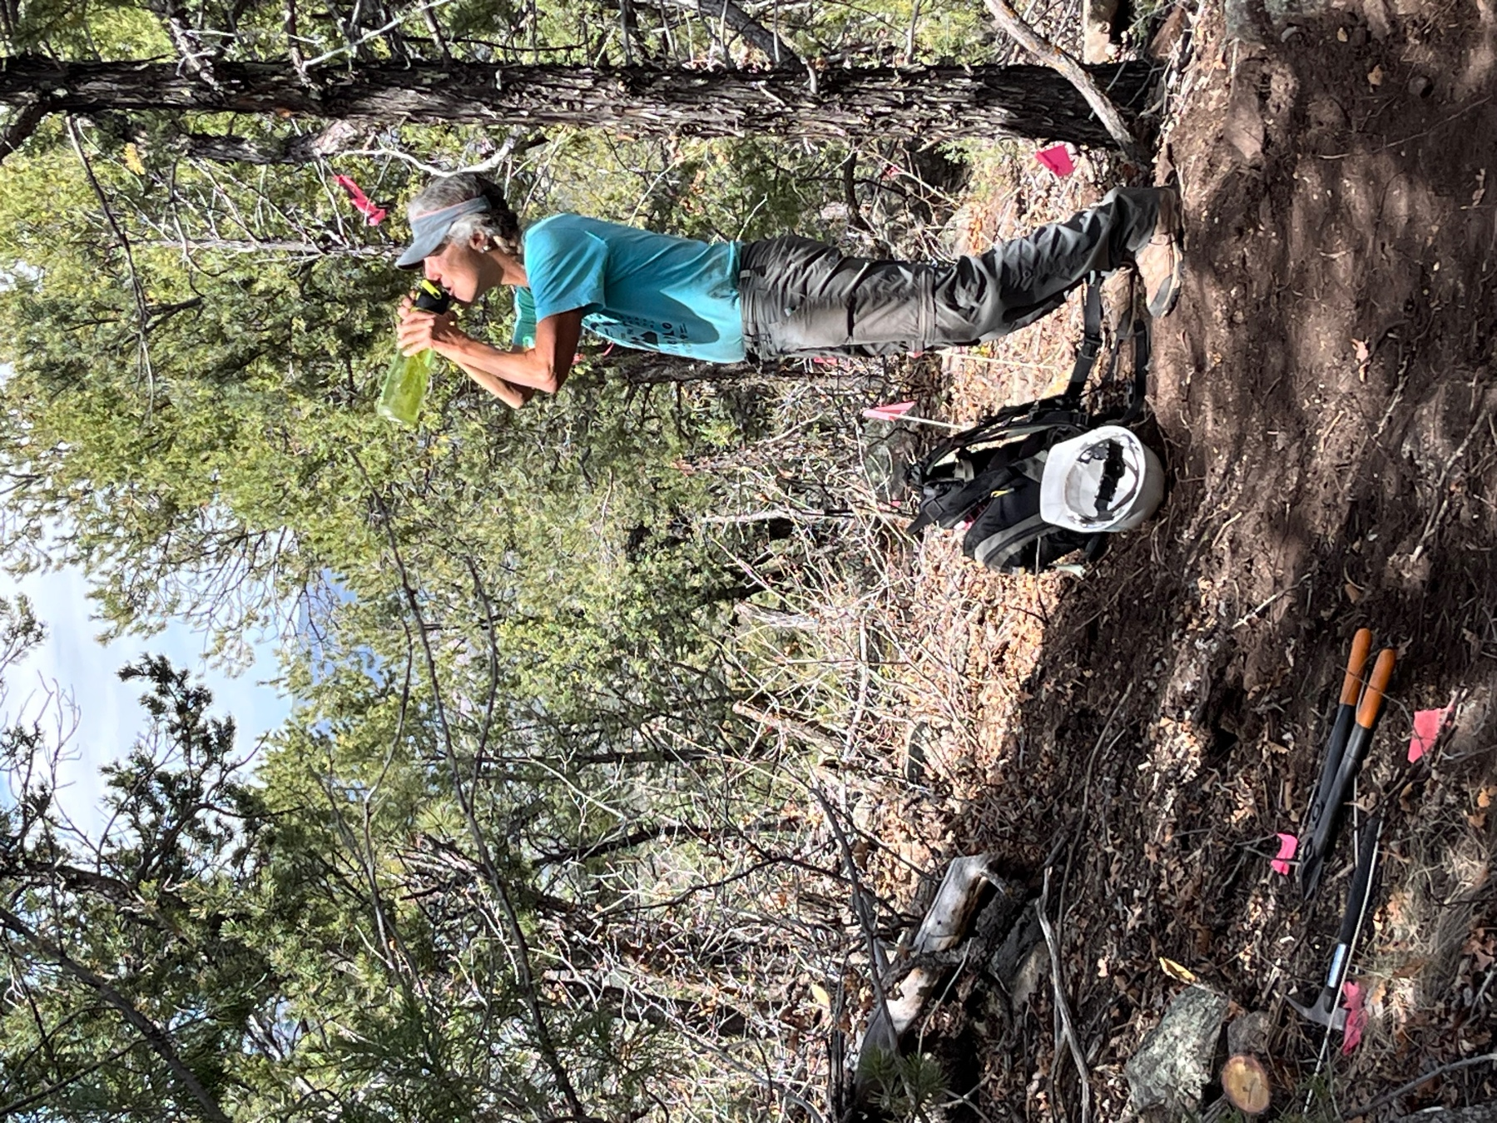

Time to hydrate, stash the tools and hike out. Claudia looks thirsty!

