Report of FOSM Project near the Crest to Process Fuel Wood That Will Be Hauled
to the Mountain Christian Church Woodlot and Given to East Mountain Families
Who Heat Their Homes with Wood, Wednesday, April 15, 2026

Sam Beard
On Wednesday, eight FOSM volunteers manually split a trailer load of fuel wood at two sites on the Crest Highway that was hauled to the Mountain Christian Church woodlot and will be given to East Mountain families who heat their homes with wood next winter. At the site below the Crest Electronic Site, they found only about one-quarter of the 50 large rounds that they had stored there last Wednesday. The other three dozen rounds had been stolen. After manually splitting these dozen rounds and loading them and other smaller rounds on Mike Oliver’s trailer, they went down to the entrance of Nine Mile Picnic Ground where they had noticed rounds going up the highway.
Here, approximately a dozen bucked rounds were found and additional rounds were cut off of a large spruce log in the forest near the highway. These rounds completely filled the trailer, and Mike hauled them to the church woodlot.
The volunteers working on this project were Cliff Giles, Sam Beard, Ken Towler, James Epps, Jerry Carroll, Sim Cook, Chuck Logan, and Lou Romero.
Project photos were presented below.
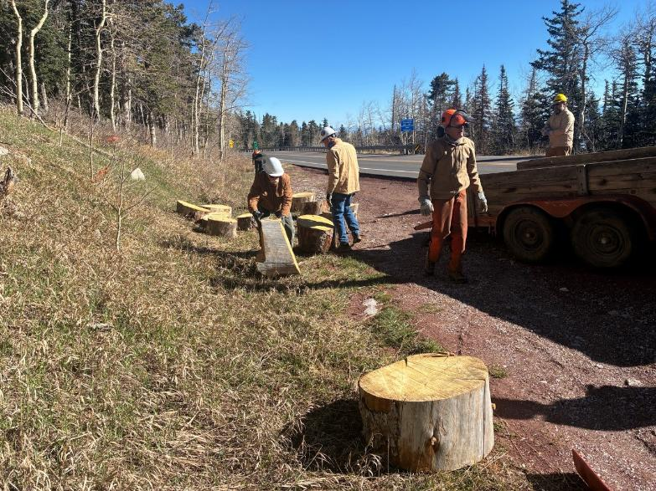
These large rounds on the Crest Highway below the Electronic Site are just one-quarter of the approximately 50 rounds
that the FOSM volunteers left here last Wednesday. The other three dozen rounds were stolen.
All photos by Cliff Giles
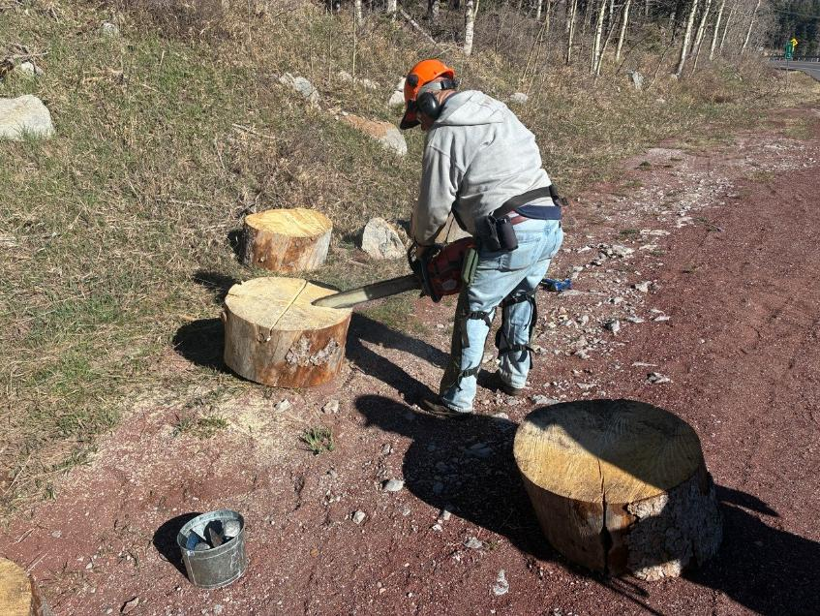
Jerry Carroll scoring the round so that it will be easier to split.
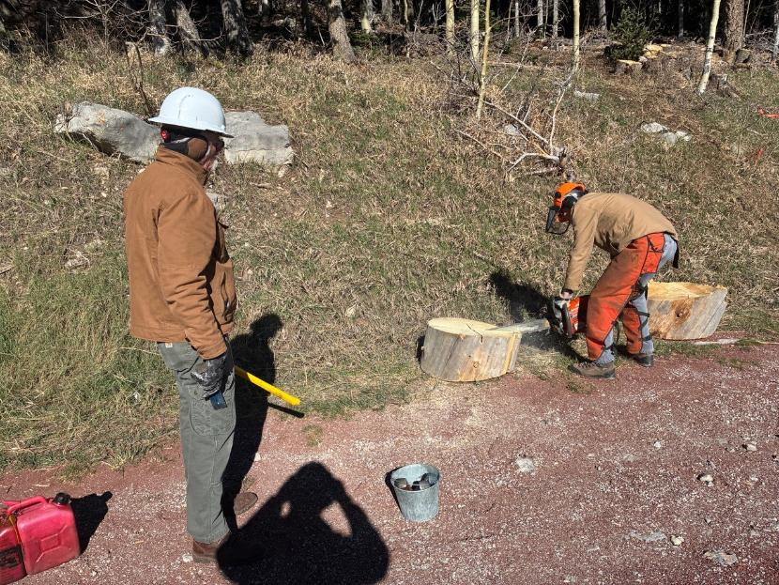
Sim Cook scoring another round with Kent Towler observing.
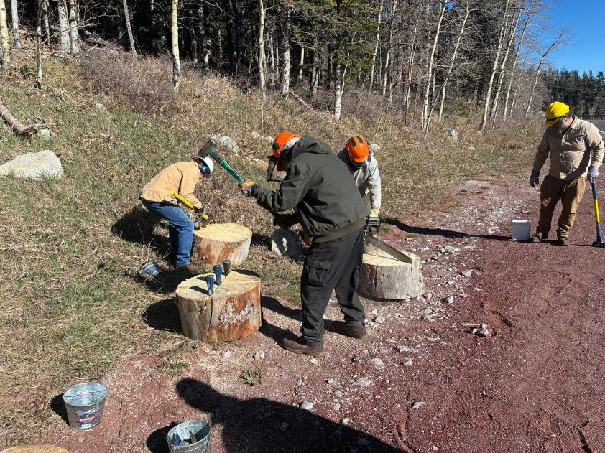
Sam Beard splitting a large round.
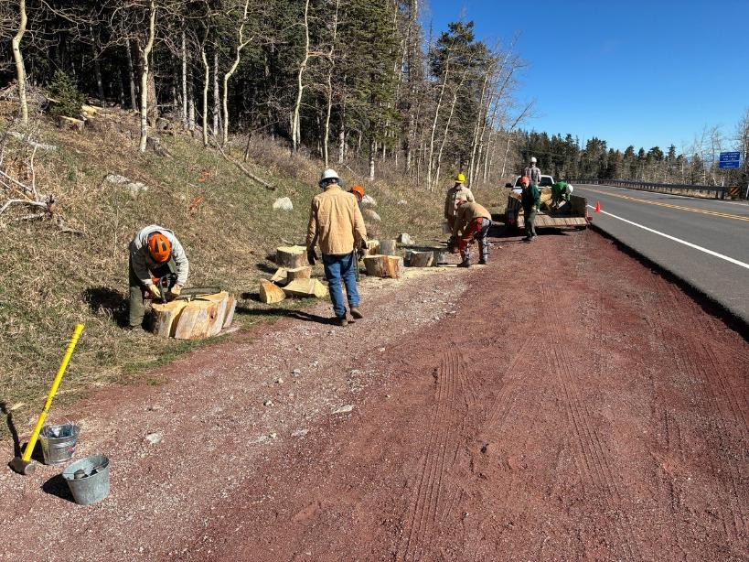
The wood processing and loading site on the Crest Highway shoulder approximately one-quarter mile below the parking lots.
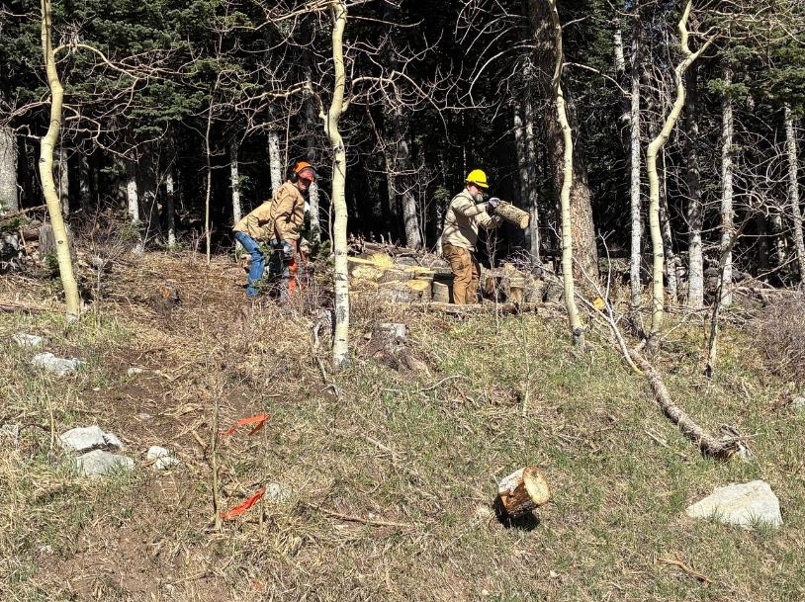
With many of the large rounds stolen, there is room on the trailer for these smaller rounds up in the forest. The volunteers
are rolling them down to the shoulder.
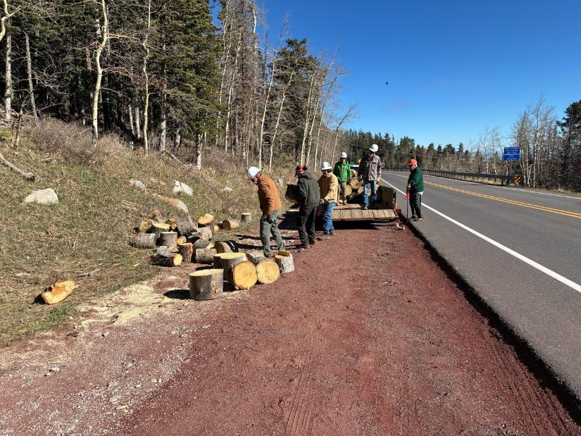
Volunteers are loading the smaller rounds on Mike Oliver’s trailer.
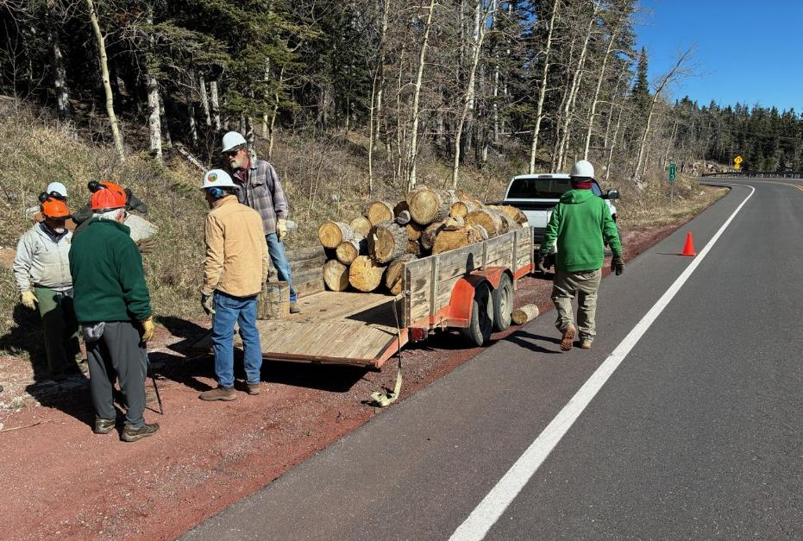
All the rounds at this site have been loaded on the trailer.
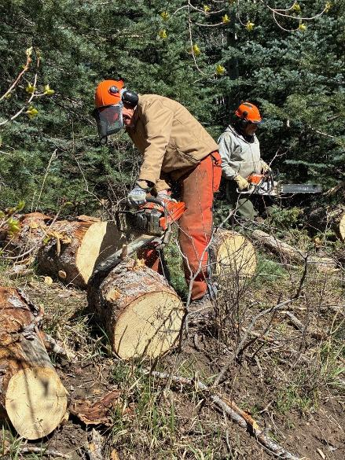
Volunteers noticed these rounds near the highway shoulder across the road from the entrance to Nine Mile Picnic Ground
when they were going up earlier. The volunteers are processing these rounds to be loaded on the trailer that was only half-full.
Sim is cutting off a branch, and Jerry is ready to cut a round off of a long spruce log in the forest.
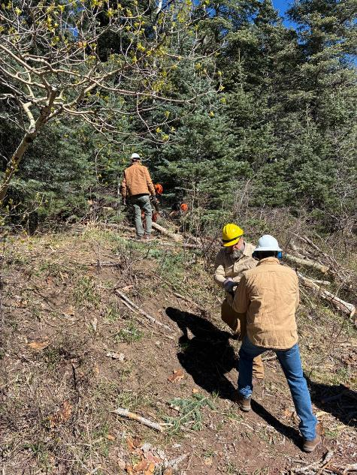
James Epps is handing a round to Chuck Logan who will put it on the trailer.
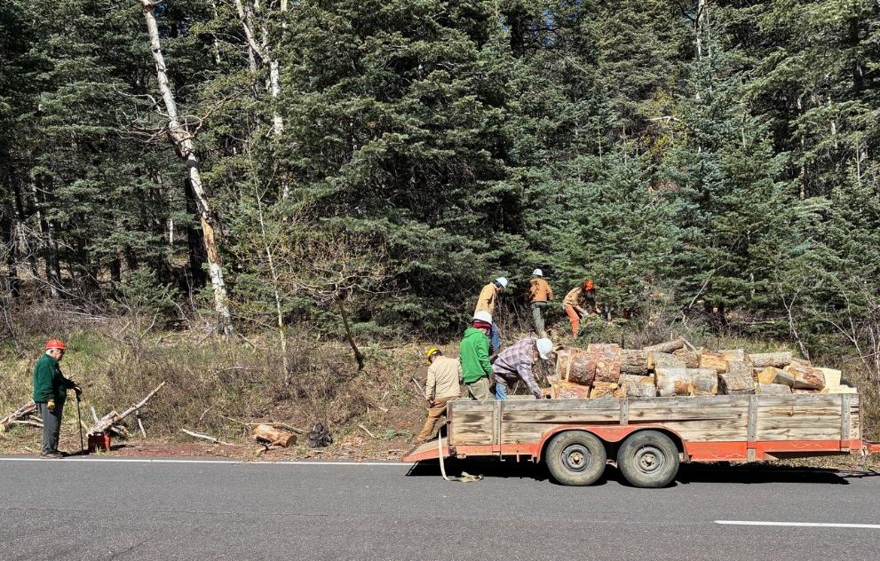
Lou Romero on the left is observing the volunteers, Mike, and his neighbor Joe loading the spruce rounds on the trailer.
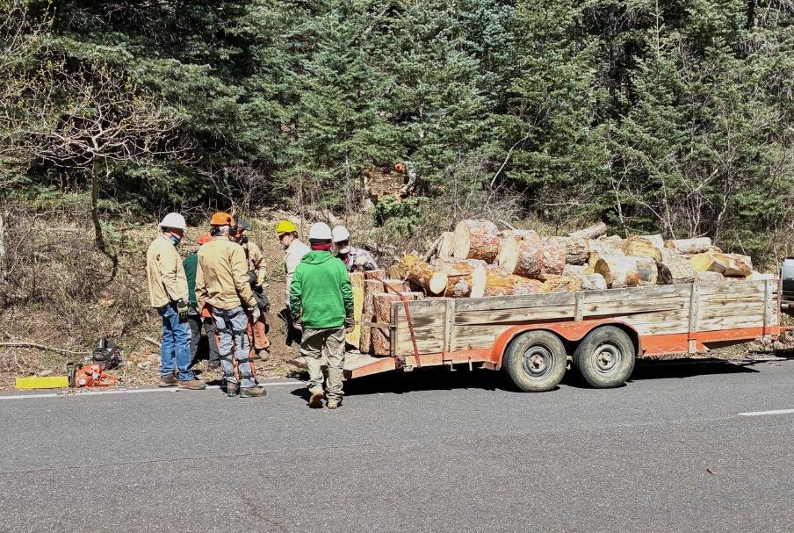
The trailer is fully loaded, and Mike and Joe will haul it to Mike’s woodlot where it will be split by the Wood Ministry members
of the Mountain Christian Church who will give it to East Mountains families who heat their homes with wood.

