Report of FOSM Projects to Prune along Tijeras Pueblo Trail and to Replace a Broken Post in Cienega Canyon Picnic Area, Wednesday, April 22, 2026
Sam Beard
On Wednesday, April 22, FOSM volunteers pruned junipers along Tijeras Pueblo Trail at the ranger station, and another crew replaced a broken fence post in Cienega Canyon Picnic Area.
Kent Towler, Cliff Giles, and Sam Beard pruned one-seed junipers along the short trail adjacent to the Tijeras Pueblo mound archeological site. These multi-trunk trees are much more difficult to prune than single trunk trees. Selecting branches to be cut must be done very carefully in order to get an attractive pruned tree without irregular shapes and a “butchered” appearance.
Dan Benton’s crew of Sim Cook, Don Carnicom, and Eric Russell removed four cylindrical poles or rails from the broken post by cutting the rusty threaded rod securing the rails to the posts. Digging the lower part of the broken post from the hole is usually the most difficult task when replacing a post. Four 5/8-inch holes are drilled through the post to match the holes in the rails. Then, ½-inch diameter new threaded rod or the original rusty rod is inserted in the hole with washers, and nuts are screwed on both ends of the threaded rod and tightened. The FOSM supply of 6-inch diameter pressure-treated posts is stored at Don Carnicom’s home with several 4-inch diameter poles with a length of 10 feet.
Project photographs are presented below.

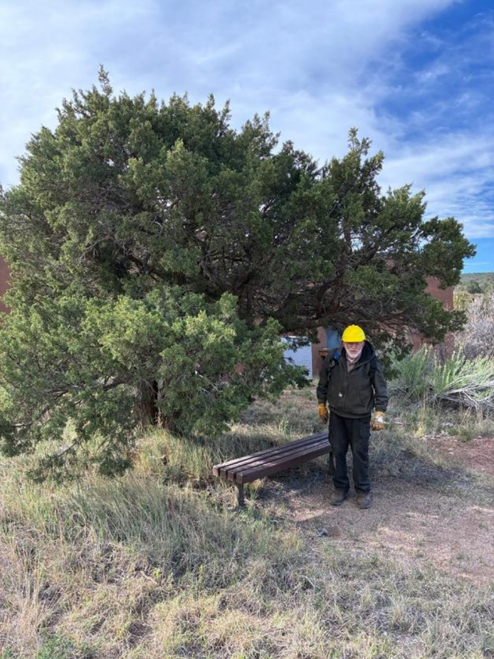
We pruned branches above both ends of this bench so that visitors may sit here and not have
branches hit their heads. The building in the background is the museum.
All photos by Cliff Giles unless noted otherwise
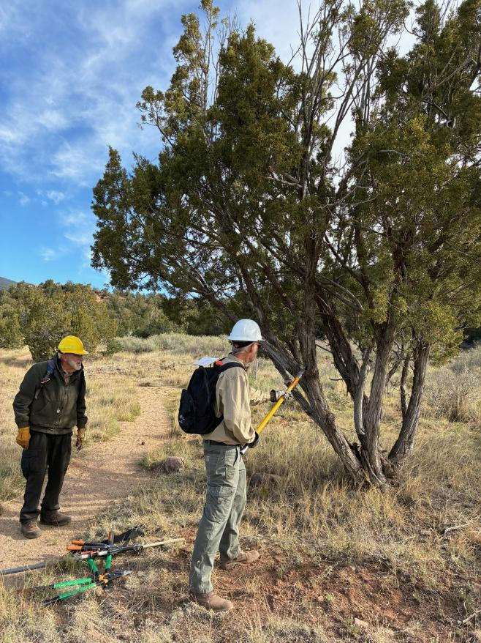
Kent Towler using his very sharp pole saw to cut off a branch while Sam Beard observes.
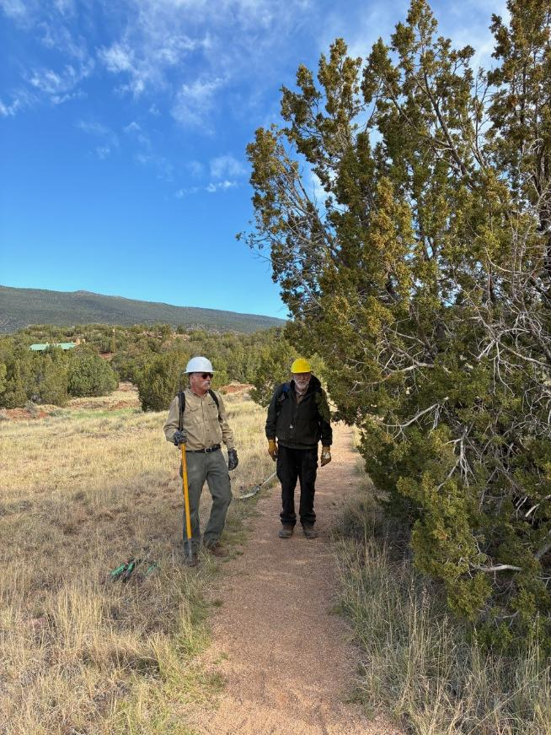
Kent and Sam standing beside a one-seed juniper that has not been pruned.
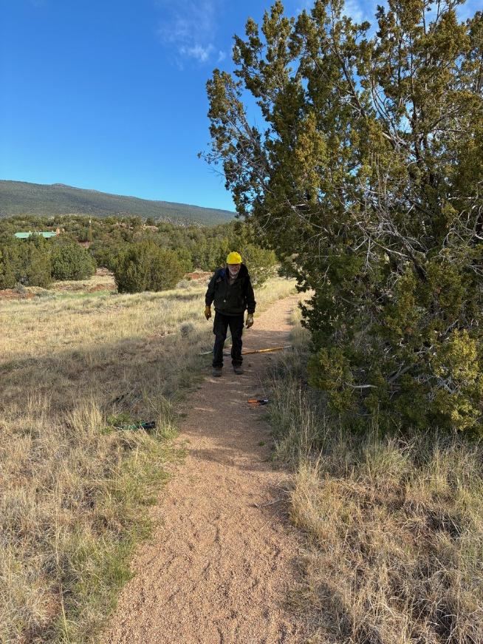
The juniper after it has been pruned. The trail corridor is wider so that a visitor will not hit branches.
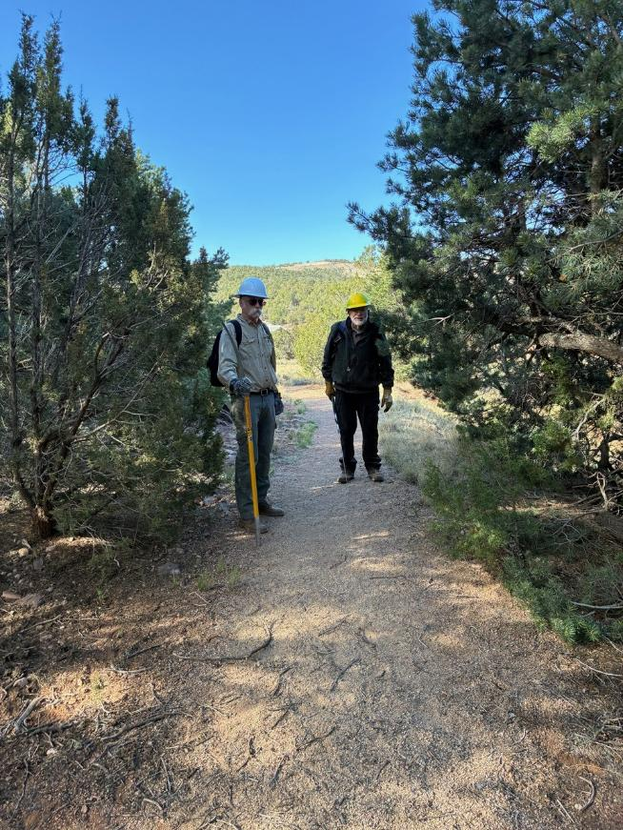
The branches of the unpruned junipers are encroaching on the the trail.
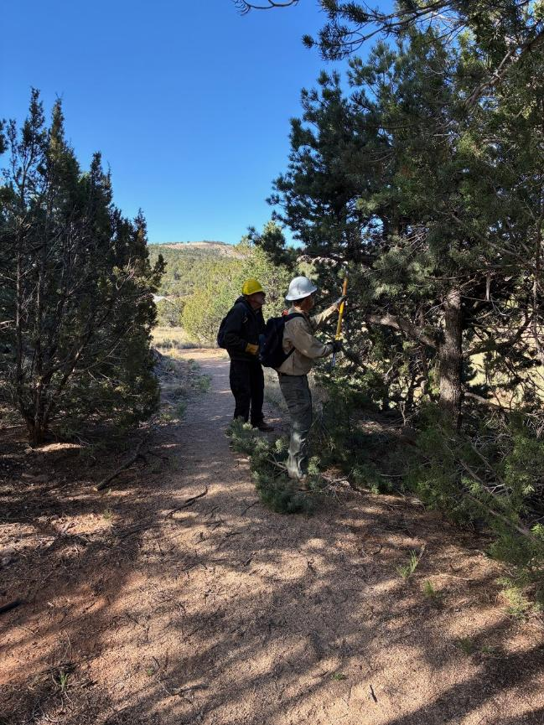
Kent is pruning branche with his pole saw.
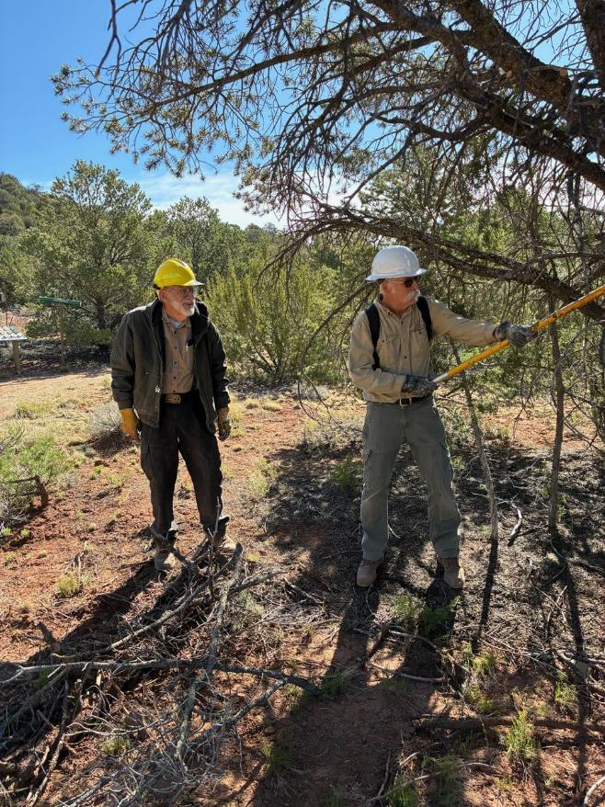
Kent pruning another tree.
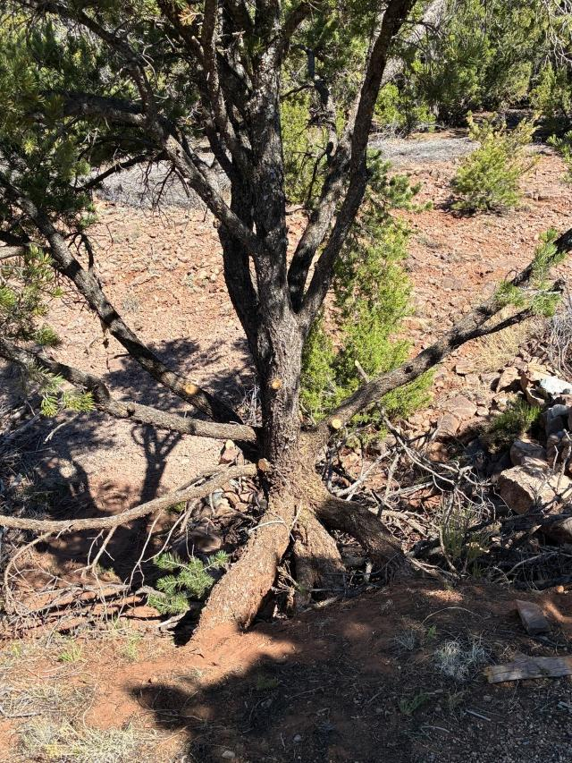
Lower branches of this pinon have been removed. Note that the tree is on the edge of an arroyo
and Is being supported by three roots that are above the soil.
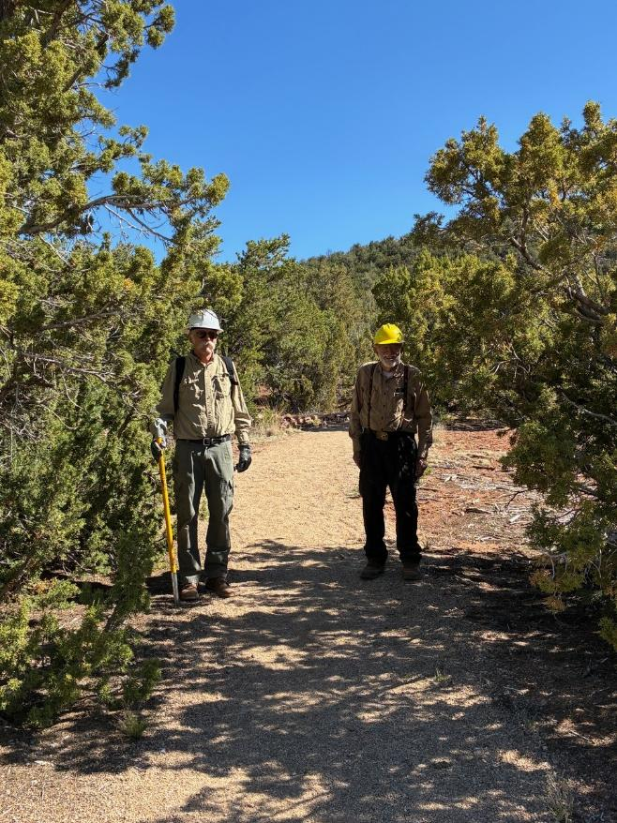
Kent and Sam on the trail between two trees that have not been pruned.
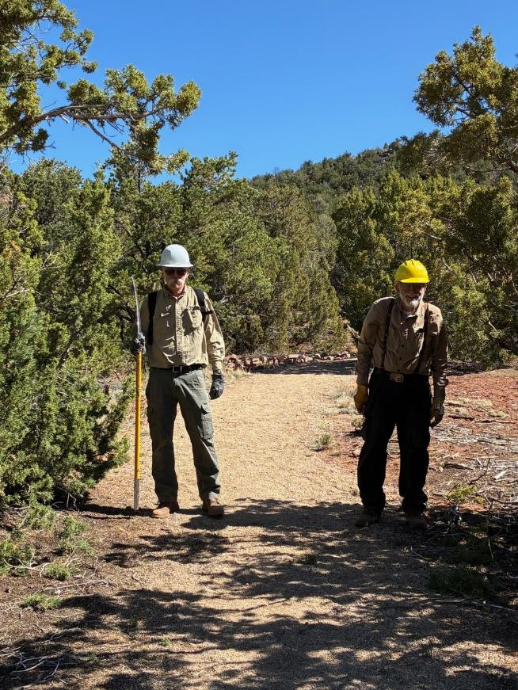
The volunteers after the trees were pruned. Note that there are fewer branches on both sides
of the treail after the trees were pruned.
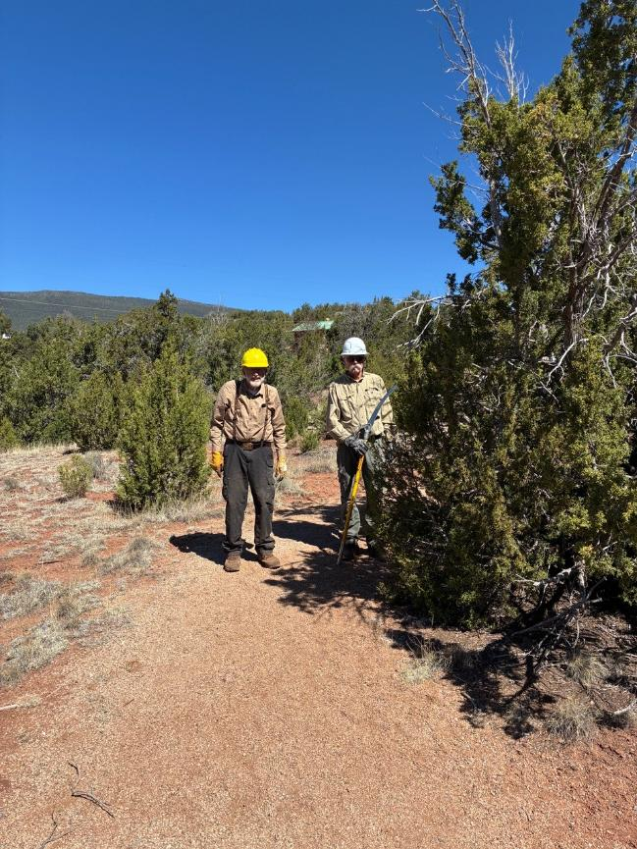
The volunteers beside a tree that has not be pruned.
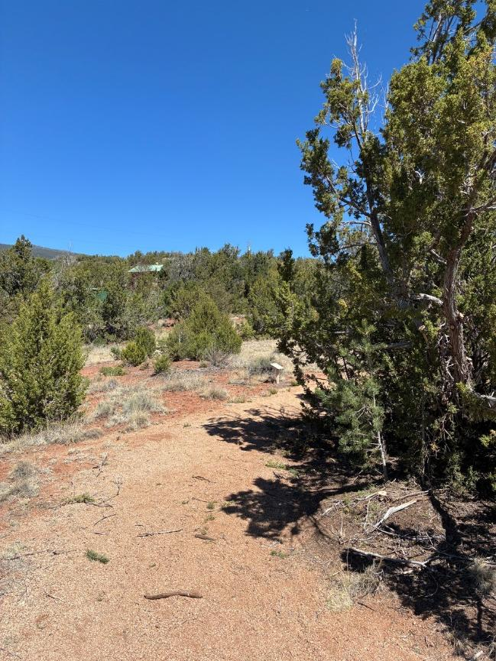
The above tree has been pruned, and two tree trunks are now visible.
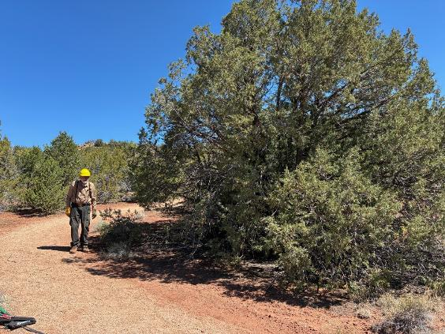
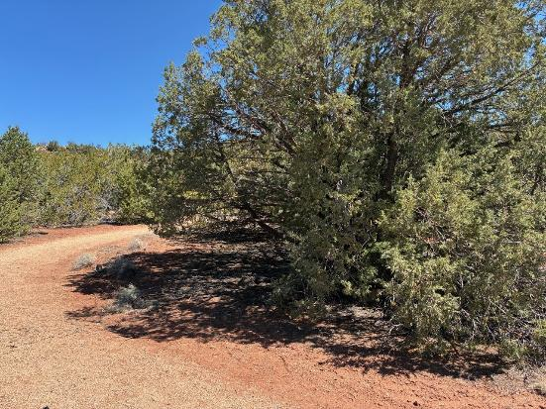
Top: The tree has not been pruned. Bottom: Tree has been pruned. A couple
of trunks are now visible, and the lower vegetation adjacent to the trail has been removed.

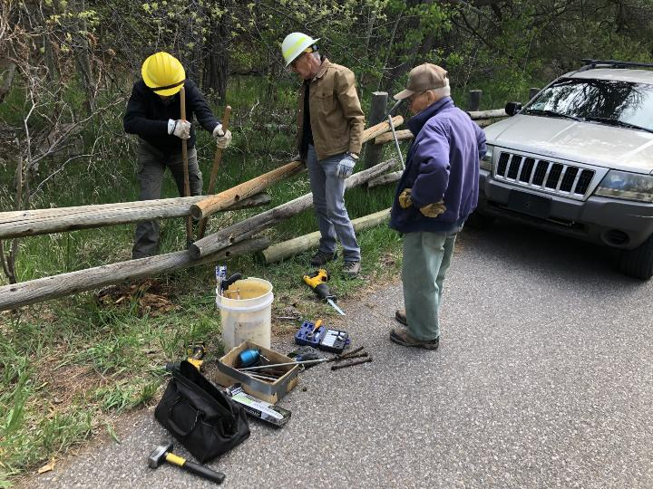
L to R: Eric Russell, Sim Cook, and Don Carnicom. The broken post in Cienega Canyon Picnic Area has been removed, and Eric is cleaning out the hole. Photos by Dan Benton

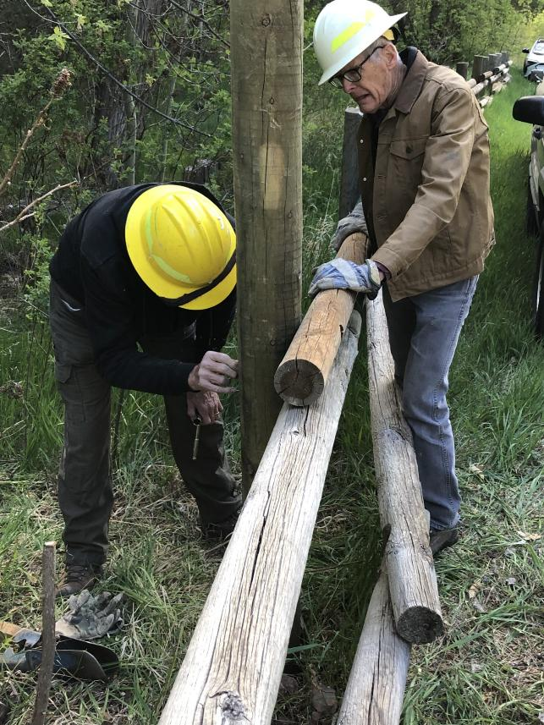
The new post has been installed, and Eric is putting the nut on a piece of threaded rode
through the rail and post
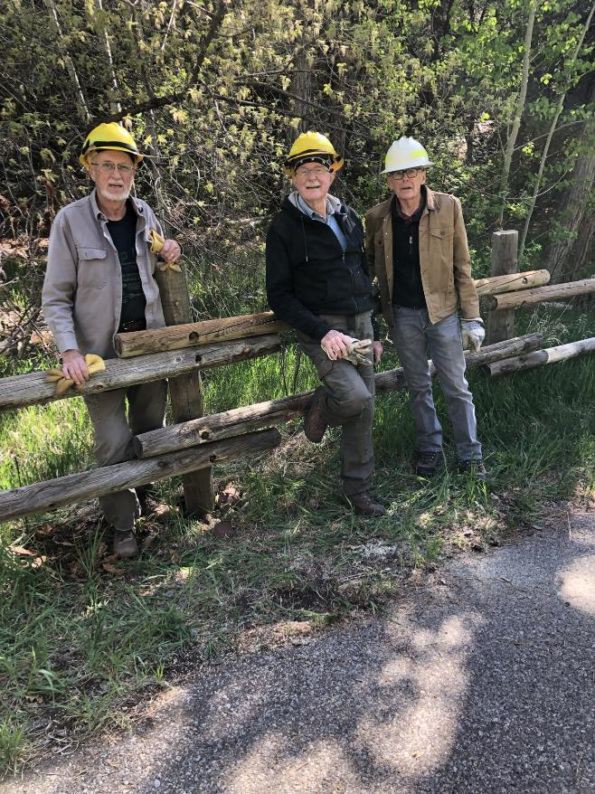
The crew beside the repaired fence.
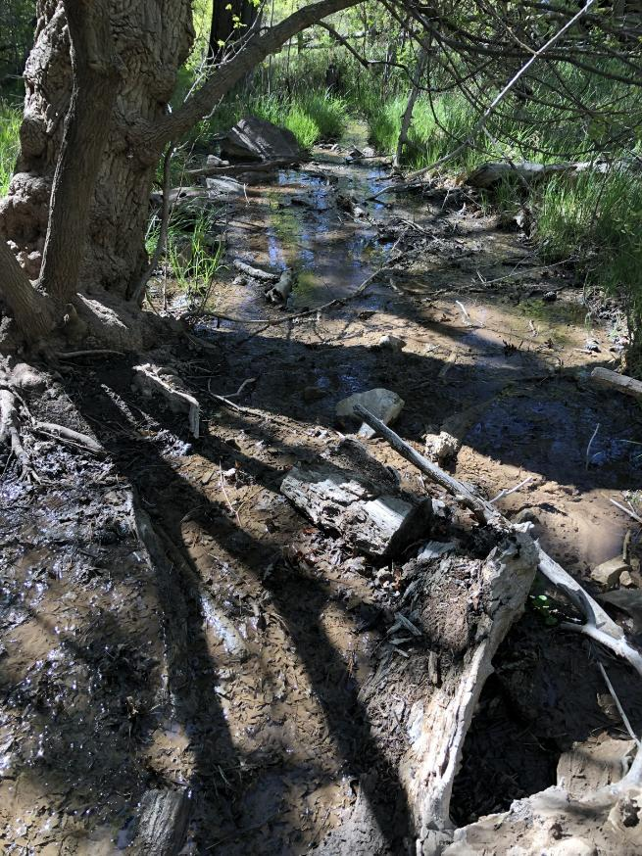
Dan noted that water is still flowing in Cienega Creek. Later in the summer, the stream bed will be dry.

