Report of FOSM Project to Complete Painting the Large Roundabout Sign and to Paint Parking Stripes
in Doc Long and Sulphur Canyon Picnic Areas, Tuesday, April 21, 2026

Sam Beard
On Tuesday, April 21, four FOSM volunteers completed painting the large scenic byway sign at the NM-14 and NM-536 intersection roundabout.
They also painted parking stripes in Doc Long and Sulphur Canyon picnic areas.

Project photographs are presented below.
The volunteers were Pauline Ho, Rick Buss, Karen Greif, and Sam Beard.

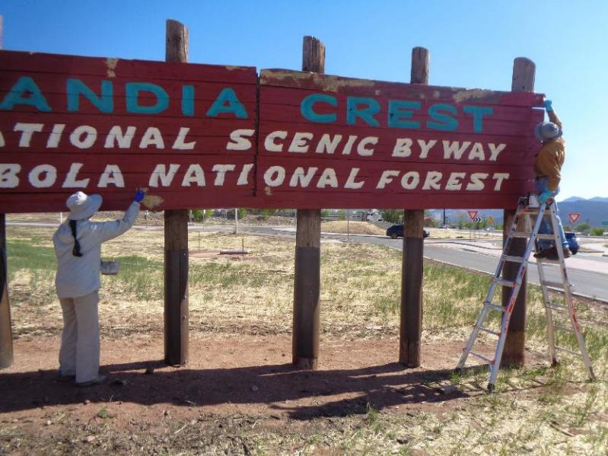
Pauline Ho is painting over yellow System Three epoxy paste that had been put over a rough place low on the south side of the sign.
Rick Buss on the ladder is painting the top right 2x8 board where paste had been put in one hole and on several rough areas.
All photos by Sam Beard
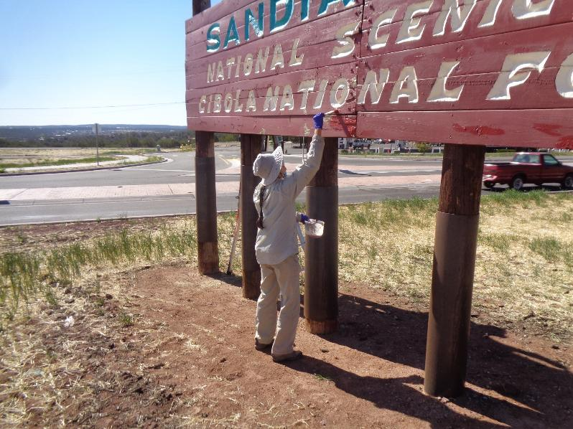
Pauline is applying Red Brick color Behr paint on several small areas on the north side of the sign.
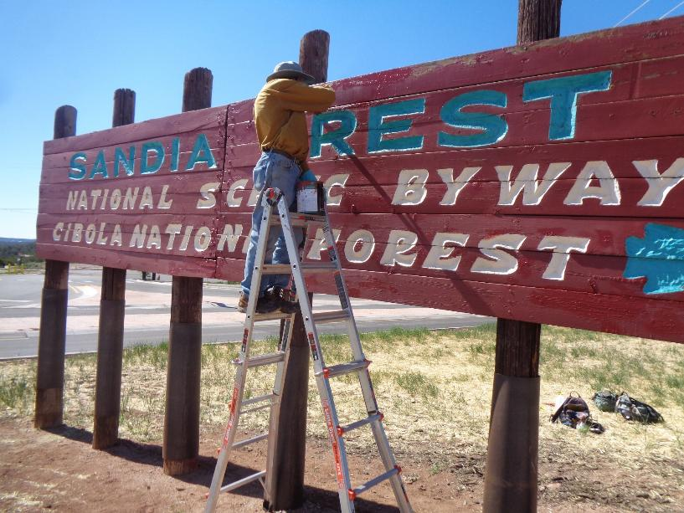
Rick is painting several small areas on the north side of the sign where paint has chipped off.
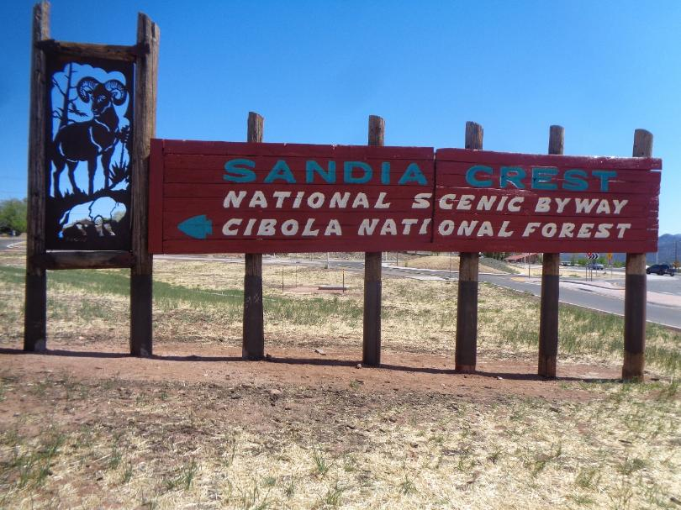
The south side of the sign after the paint project was completed.
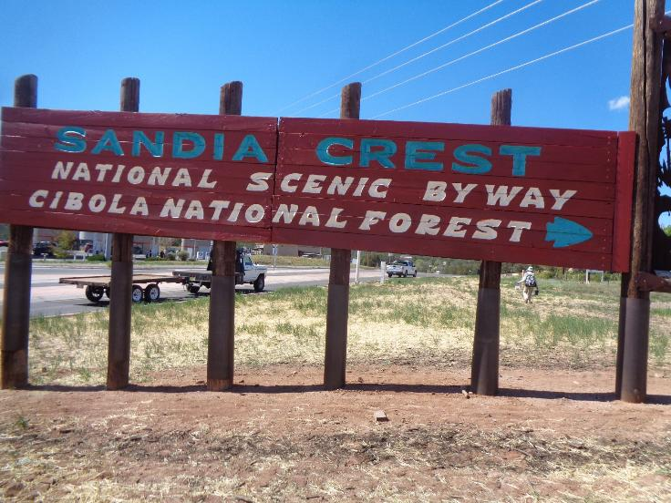
The north side of the sign after the volunteers touched up the red background.
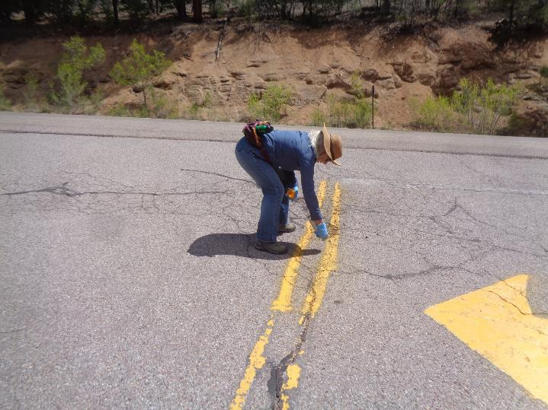
Karen Greif painting about 6 feet of the double yellow lines after having painting turning arrows at the entrance to Doc Long Picnic Area.
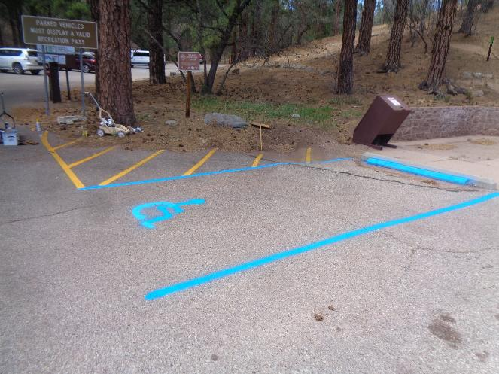
Stripes and wheelchair symbol painted in a handicapped parking space in Doc Long Picnic Area.
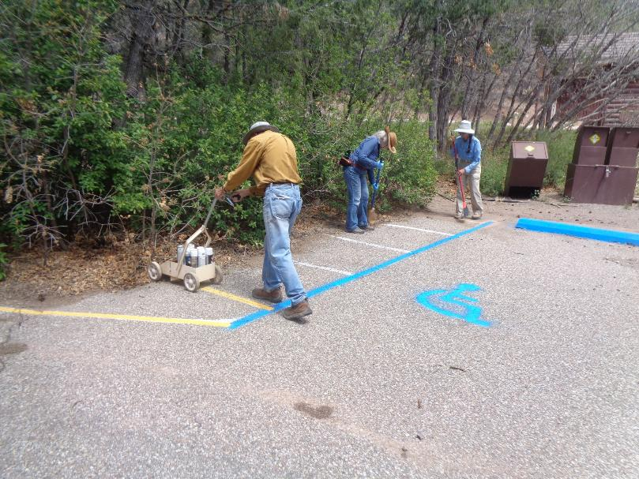
L to R: Rick painting stripes in a No Parking zone, and Karen and Pauline sweeping the lines to be painted in the upper
part of Doc Long Picnic Area.
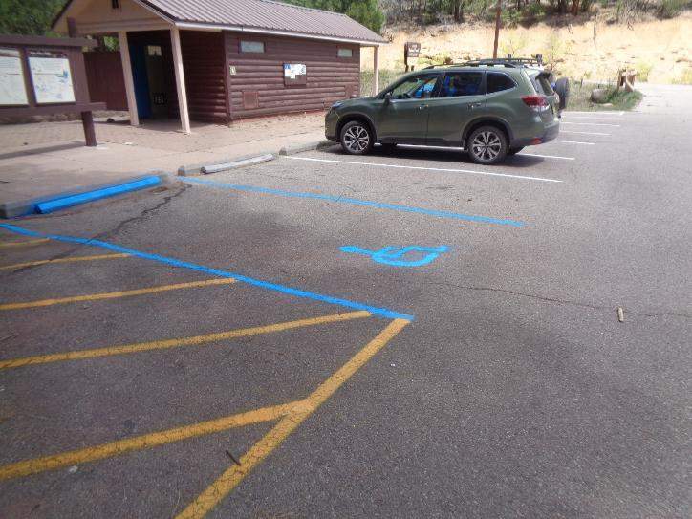
Parking stripes painted at the lower restroom in Doc Long Picnic Area.
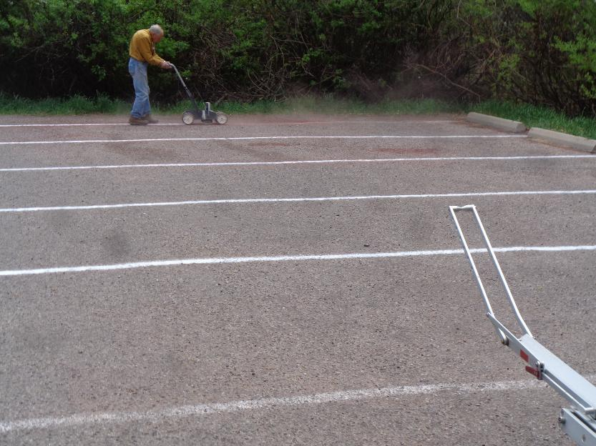
Rick painting stripes in the first parking lot in Sulphur Canyon Picnic Area.

