Thursday, 04/23/26- Pokerchip: Back to Pokerchip for another day of digging, stump removal and rock work. Nine volunteers joined Jen and Chris (Yay, he’s back!) for a pretty nice day of work. The winds were up a bit but that helps on the long walk out at the end of the work day. Nothing to new or novel to report- we’re still at it and making slow but steady progress.

Volunteers: John McNett, Bruce Hansche, Kerry Jones, Claudia Bergsohn,
Jim Houle, Eric Russell, Byron Garner, Mark Werkmeister and Laura Leon

Pictures: Laura Leon

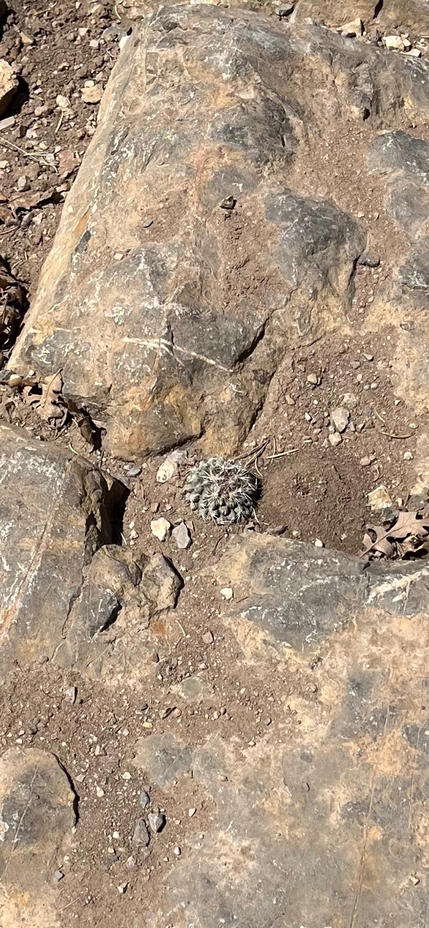

This little guy was peeking out of the rocks on the hike.

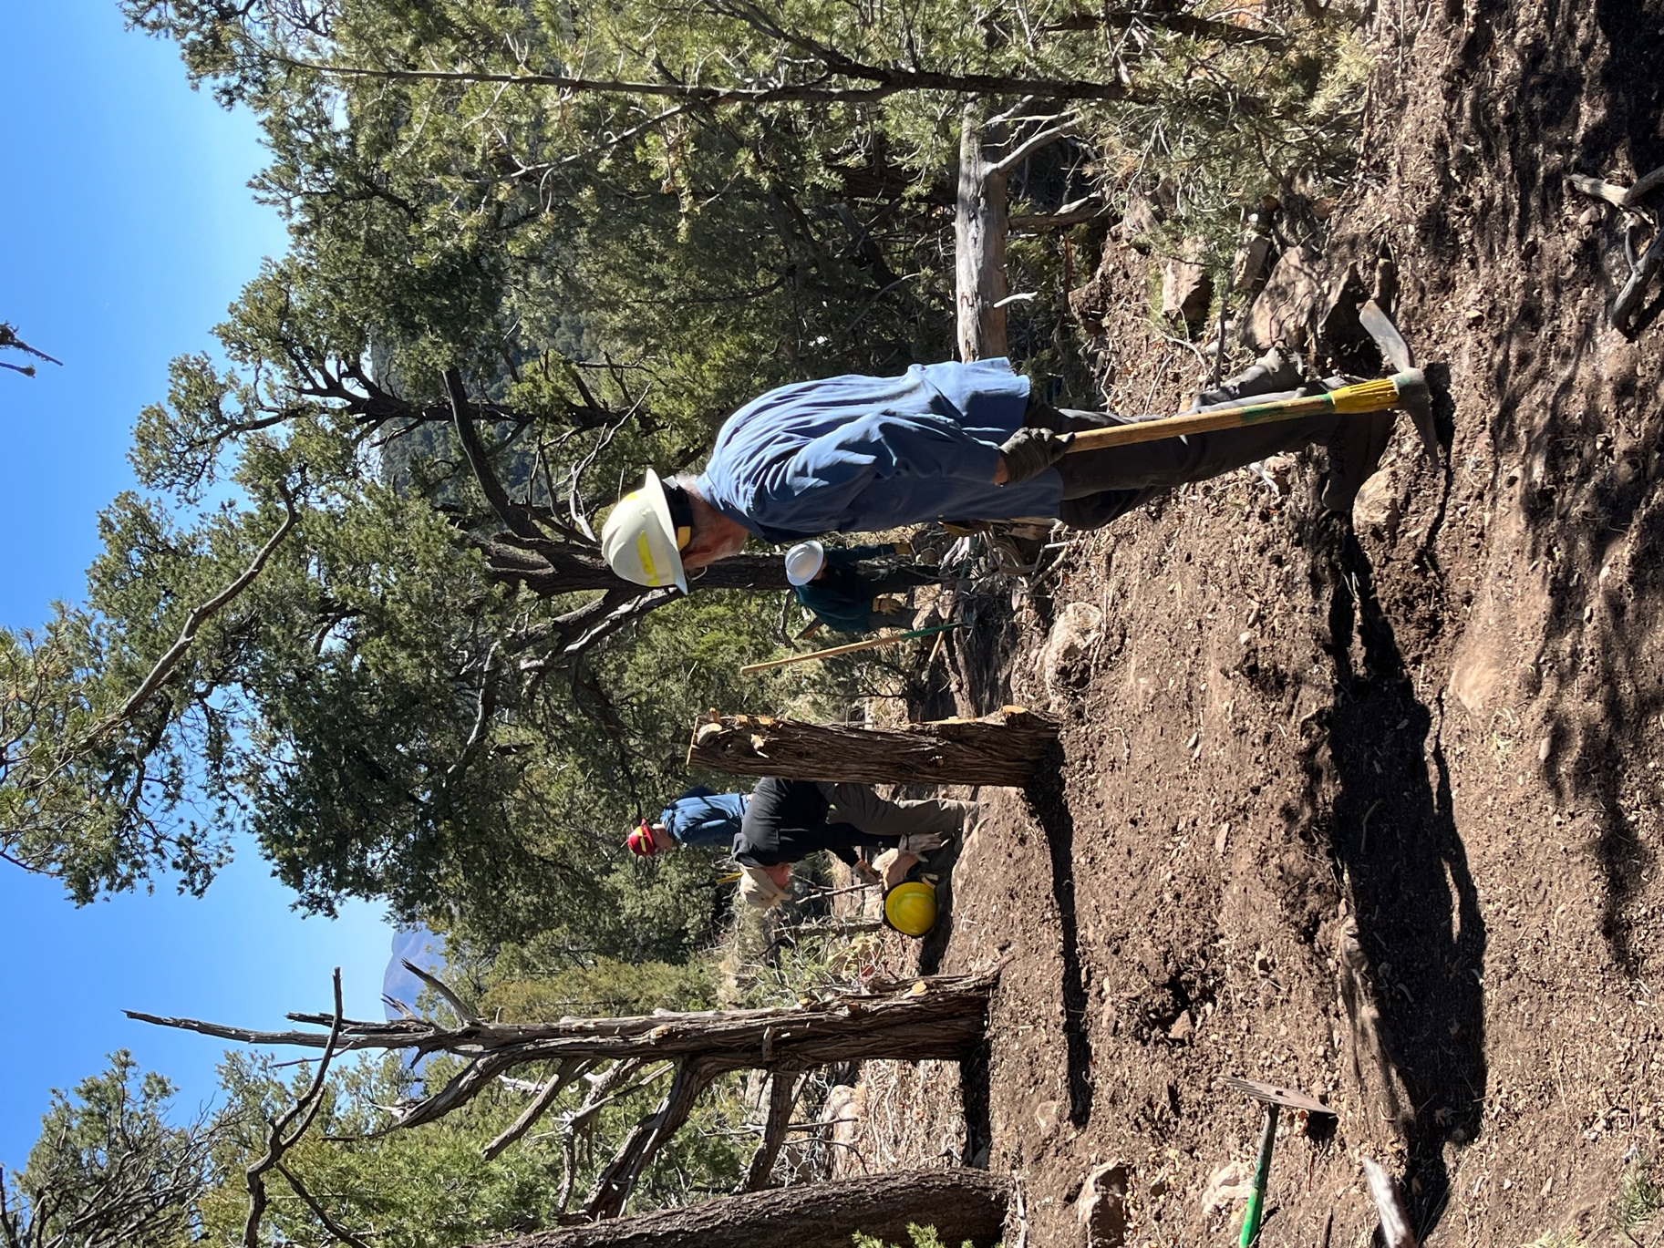

One more time on reroute 2! Eric, Kerry, Jen and Jim ready to make some fixes.
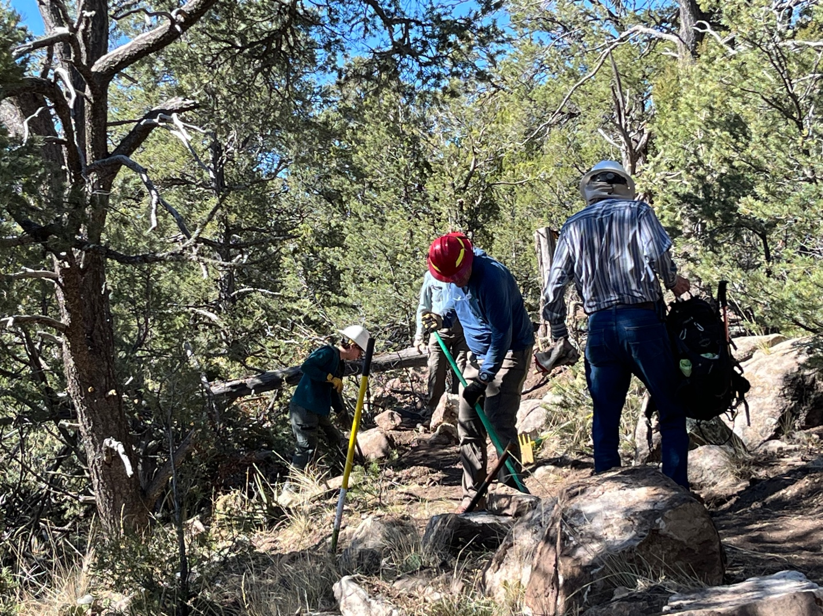

Jen, Kerry and Bruce move a few more rocks on reroute 2.

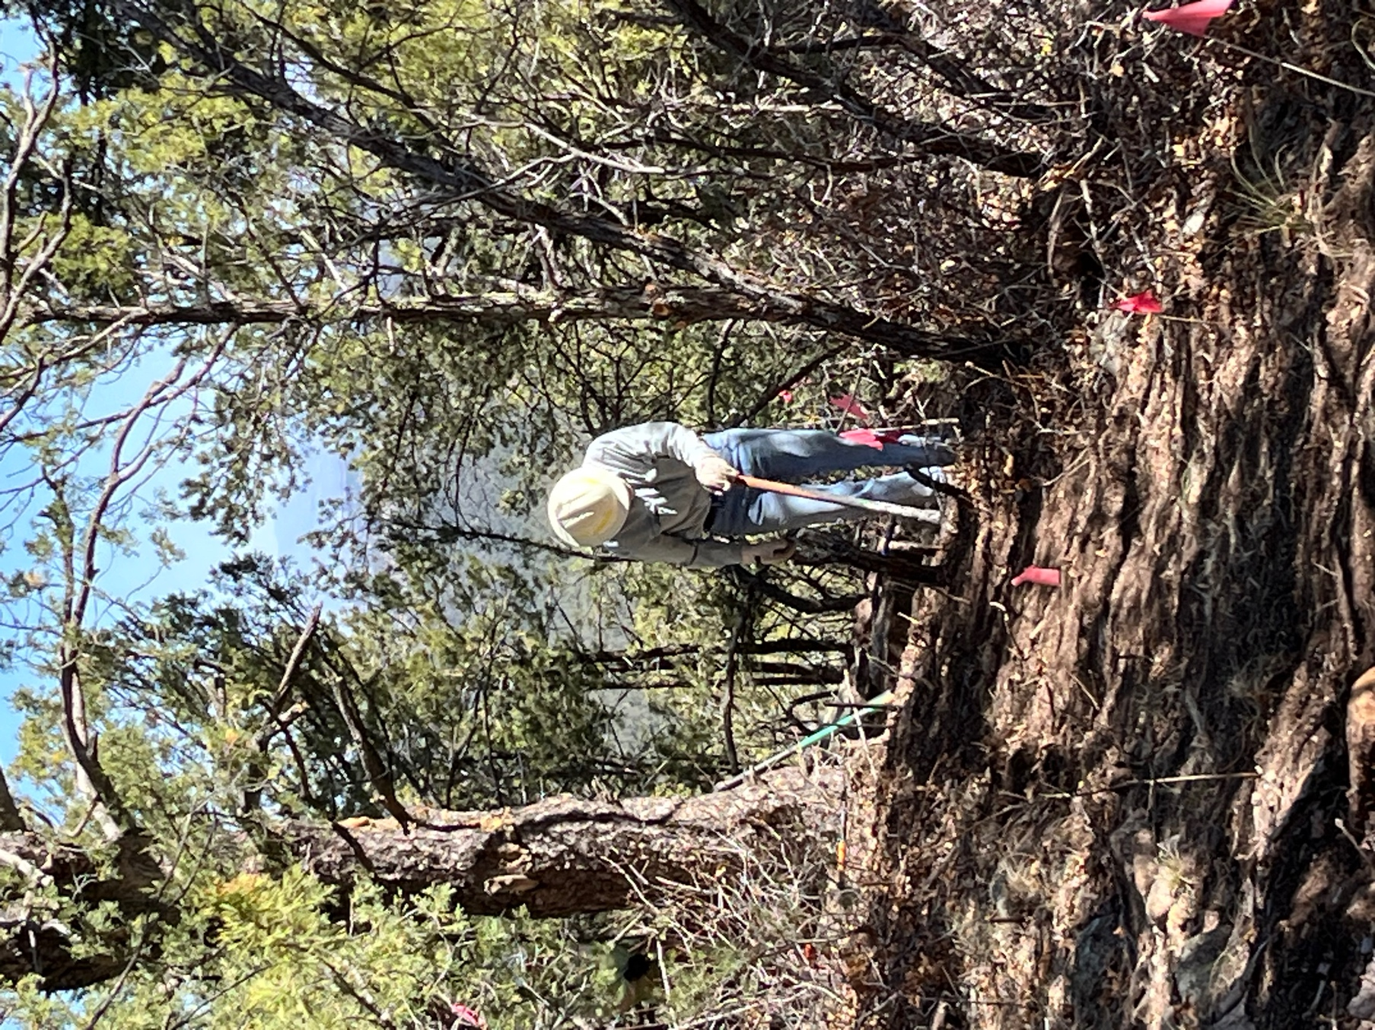

Byron works on removing stumps at the start of reroute 3.

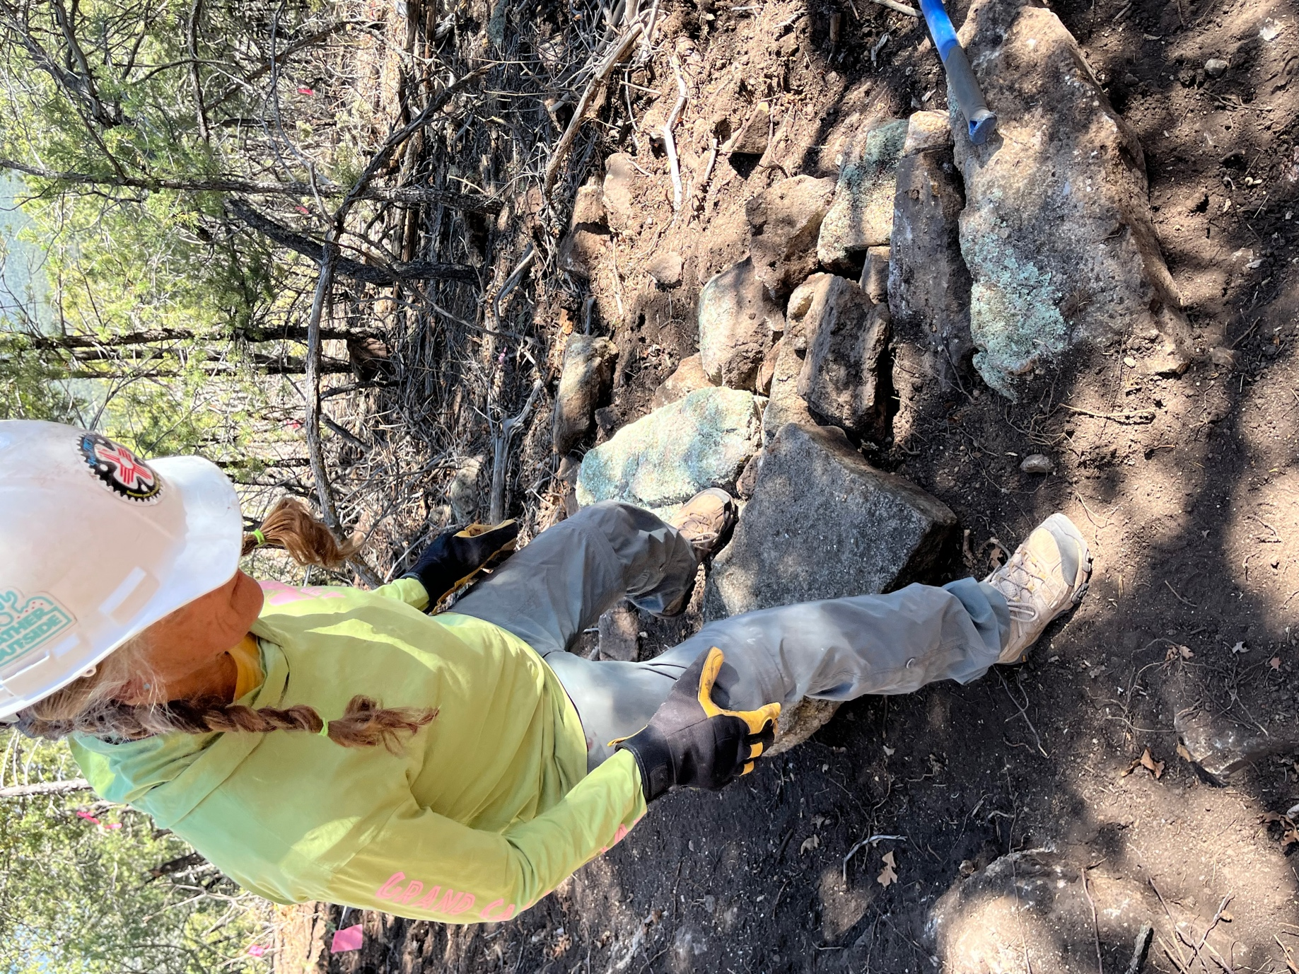

Claudia works on a masterful retaining wall.
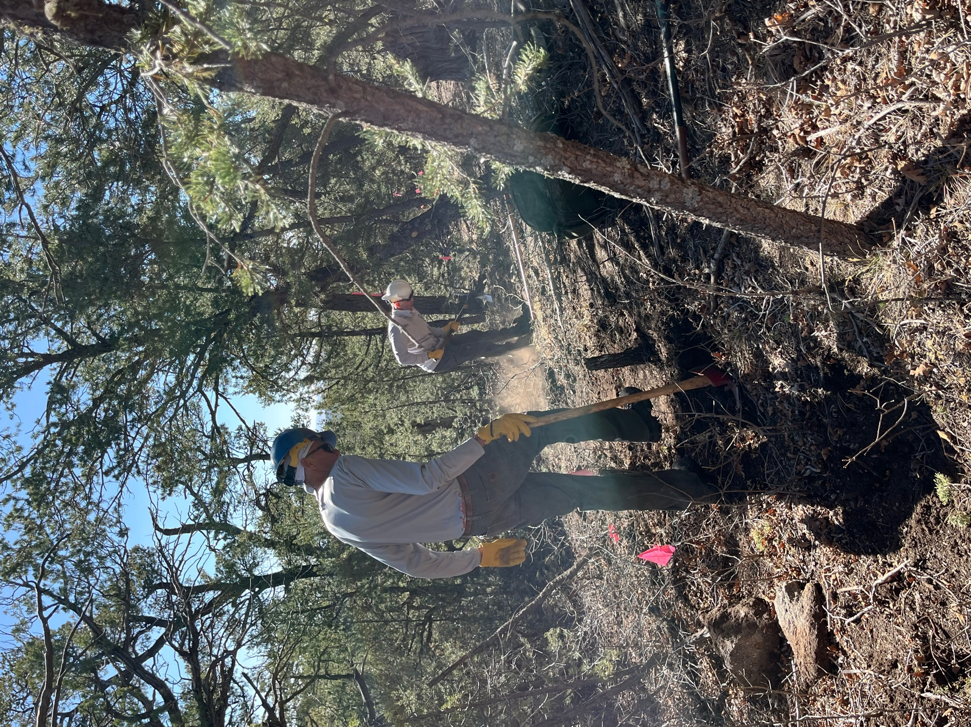

Mark and Chris dig stumps and dig dirt. It’s very dry.

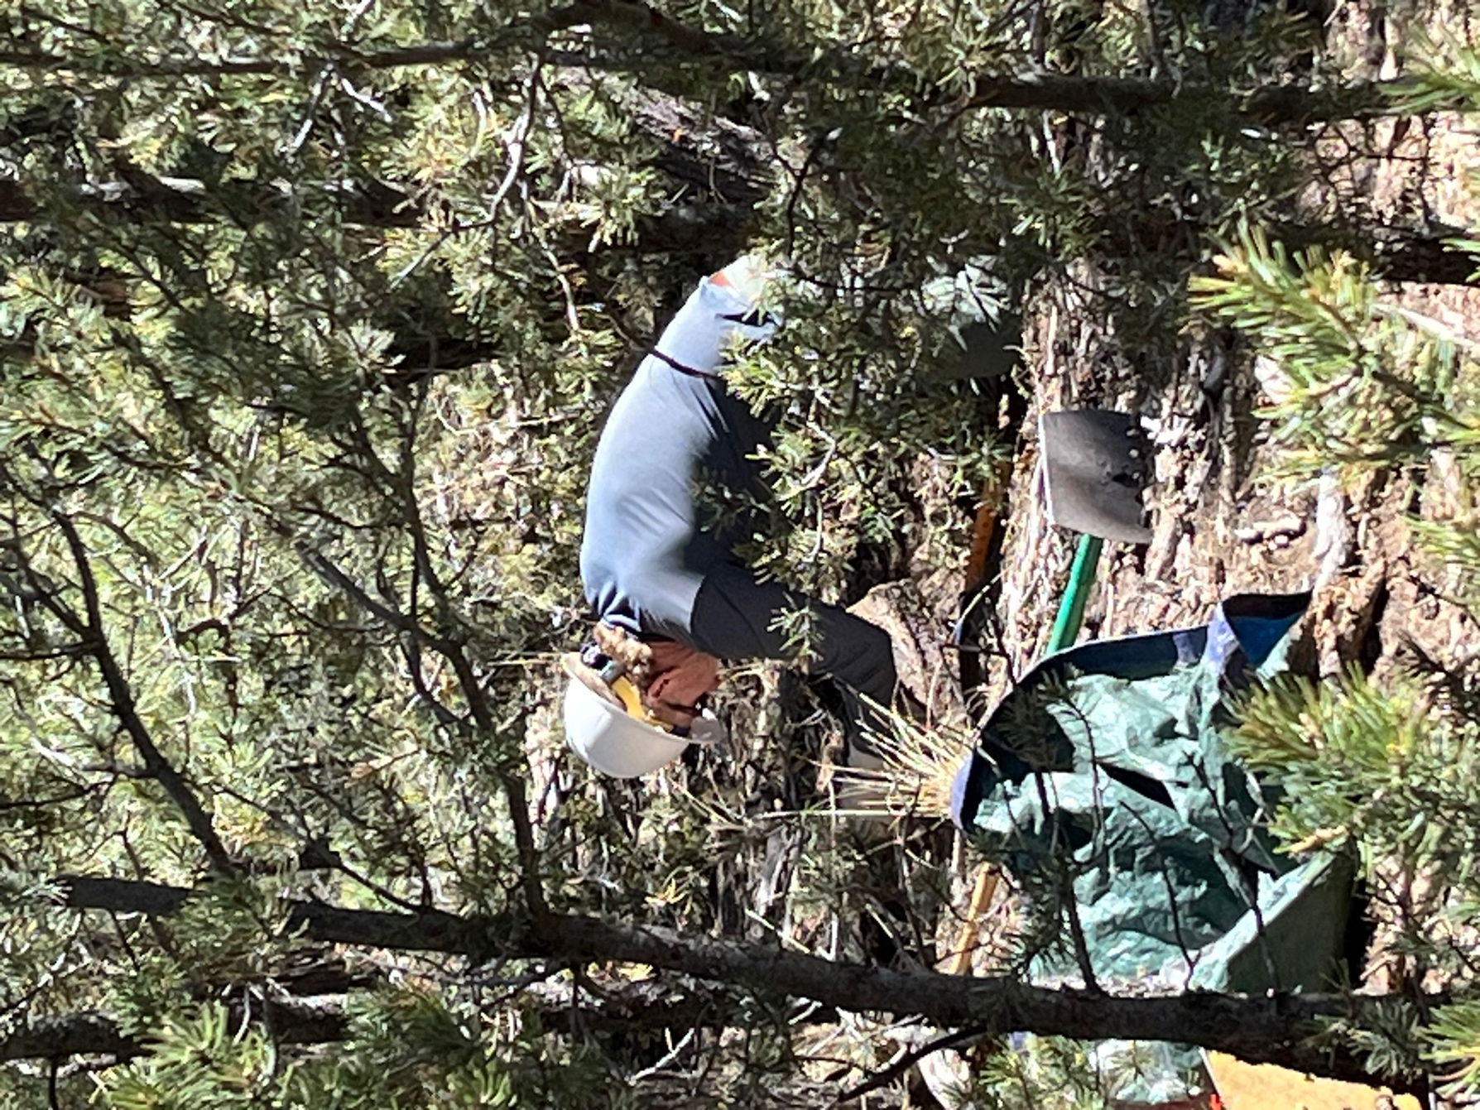

John works on removing…stumps and rocks!

