Report of Graffiti Tag Removal Project at the Big Block Rock Climbing Area below Otero Trailhead
on NM-337 by Rock Climbing Club Members and FOSM Members, Saturday, April 25, 2026

Sam Beard
On Saturday, April 25, thirty rock climbing club members, four children, and FOSM (Friends of the Sandia Mountains) members Sim Cook and Sam Beard removed several large graffiti tags from the stone wall in the Big Block rock climbing area on NM-337 below Otero Trailhead. The area is named for a huge stone block between the creek and the climbing wall. The volunteers used approximately three gallons of the World’s Best Graffiti Removal System chemical for brick and stone. The chemical and paint residue was rinsed off the stone wall with the SRD high pressure EGO power washer and the FOSM low pressure washer. Manny Chavez, SRD Maintenance Supervisor, provided rinse water from a water tank and pump towed behind a pickup. Five-gallon cans were refilled from a hose run from the highway to the bottom of the canyon.
Project photographs are presented below.

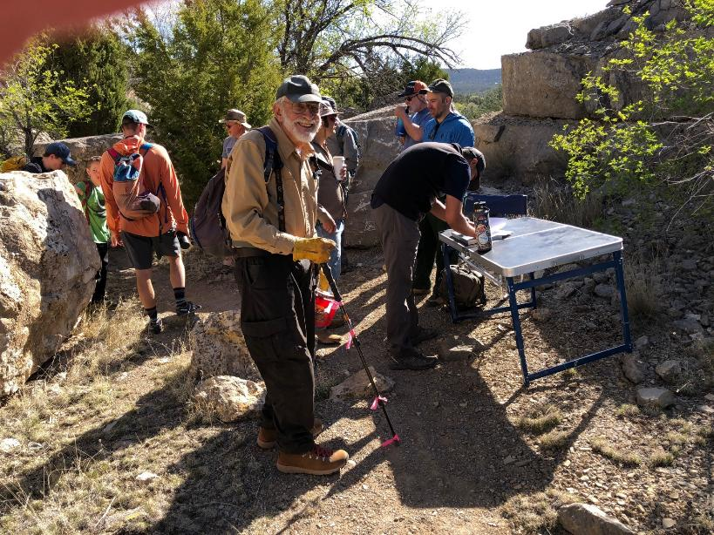
Sam Beard and other volunteers at the sign-in table for the Big Block graffiti tag removal project.
All photos by Sim Cook unless noted otherwise
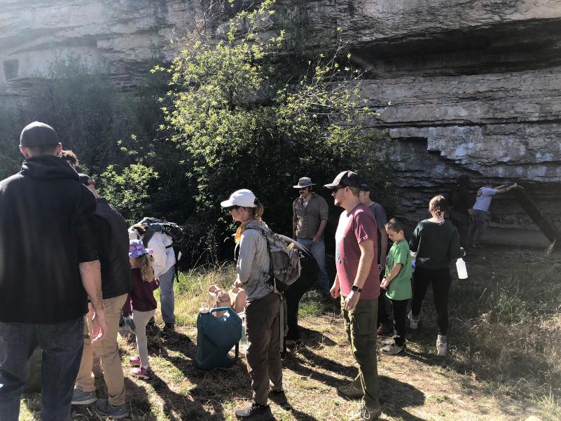
Volunteers receiving instructions at the Big Block site. Person at the upper right corner of the photo is helping
remove an old couch that had been left at the climbing area.
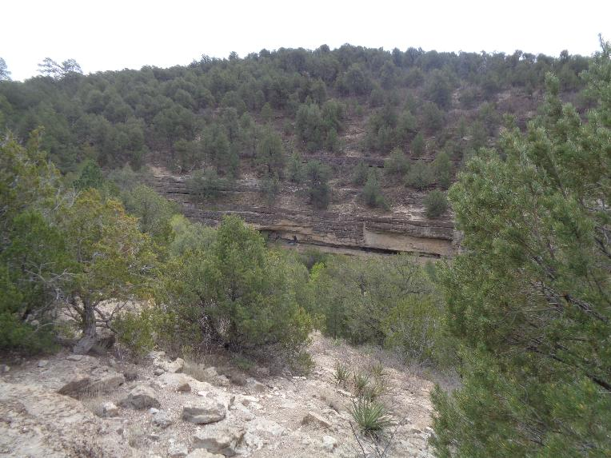
Looking back at the Big Block rock climbing area on NM-337 south of Otero Canyon Trailhead.
The person in the center of the photograph is removing a tag on the upper level of the area. Photo by Sam Beard
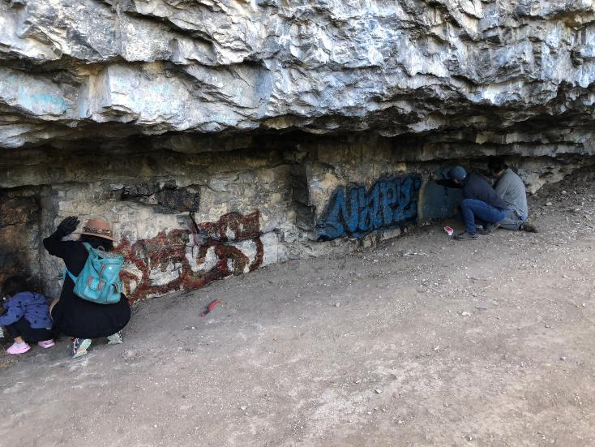
Tags on the stone wall under the overhang. Sam helped remove the large blue and black tag in the center of the photo.
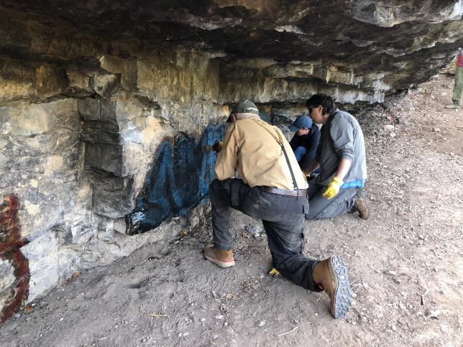
Sam applying WBGRS chemical on the large blue and black tag.
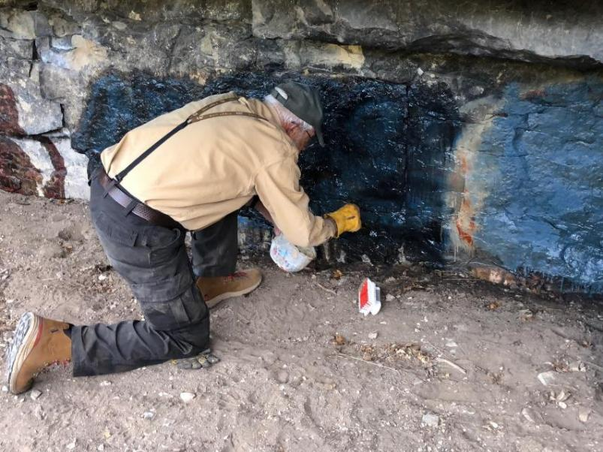
Sam continuing to apply chemical with a small brush. The black tag has been dissolved by the chemical and has run down
over some of the blue color.
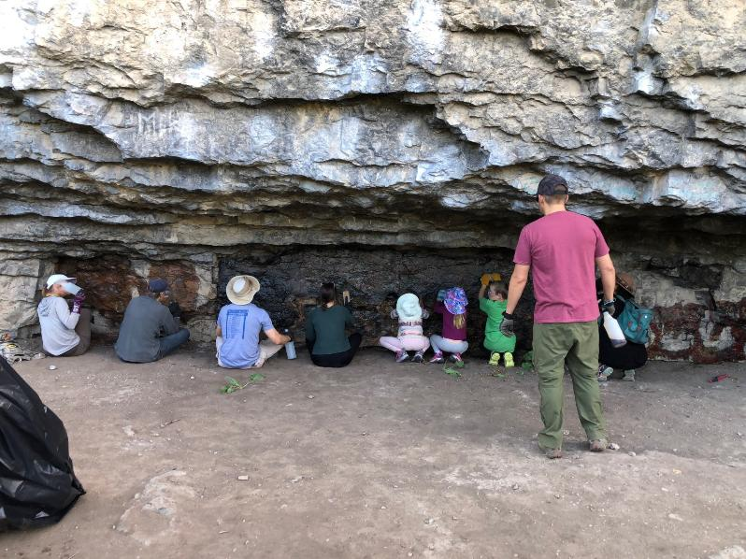
Adults and children applying the chemical and scrubbing the wall to remove the tags. Note the small spray bottle
in the volunteer’s hand that was used to apply the chemical to the tag.
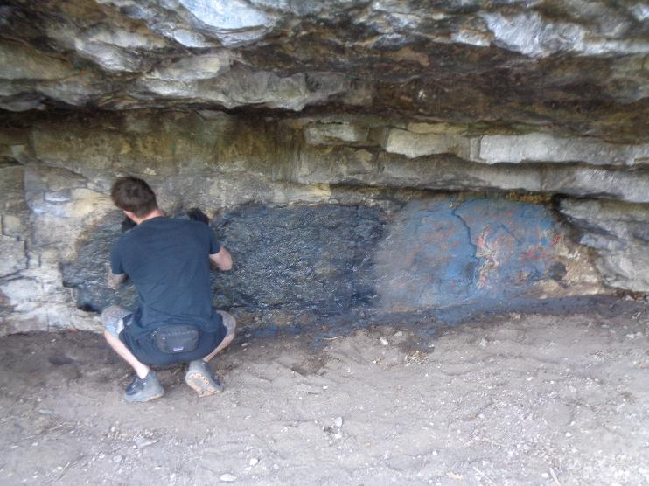
Some of the blue and black tag has been removed, and a volunteer is continuing to scrub it with a brush.
Much of the blue tag on the right has been removed. Photo by Sam Beard
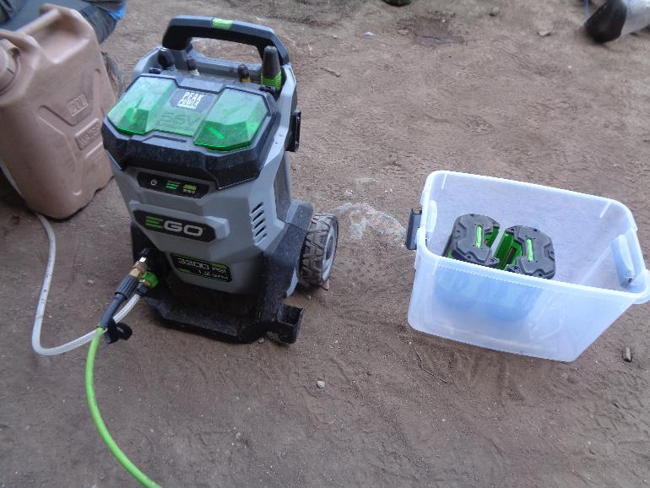
The Sandia Ranger District EGO high pressure washer with a maximum pressure of 3200 psi. Two large batteries are
under the green doors on the unit. Two other batteries are in the tub. Photo by Sam Beard

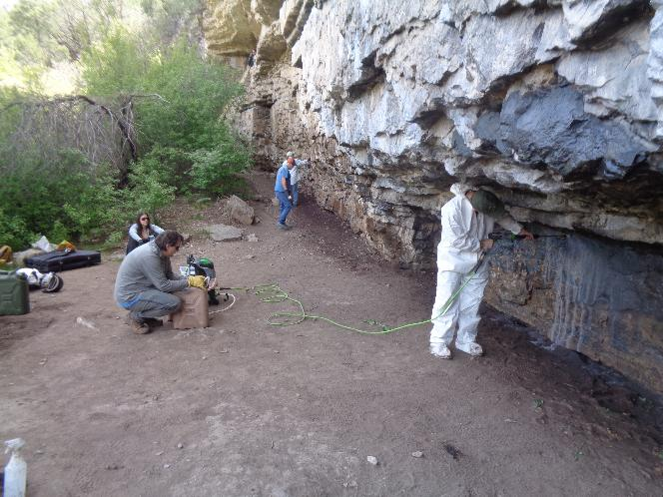
Andrew Ellis, SRD Wildlife Biologist, is using the EGO washer to remove the chemical and paint residue from the rock.
The water source is the brown 5-gallon can in the center of the photo. Photo by Sam Beard
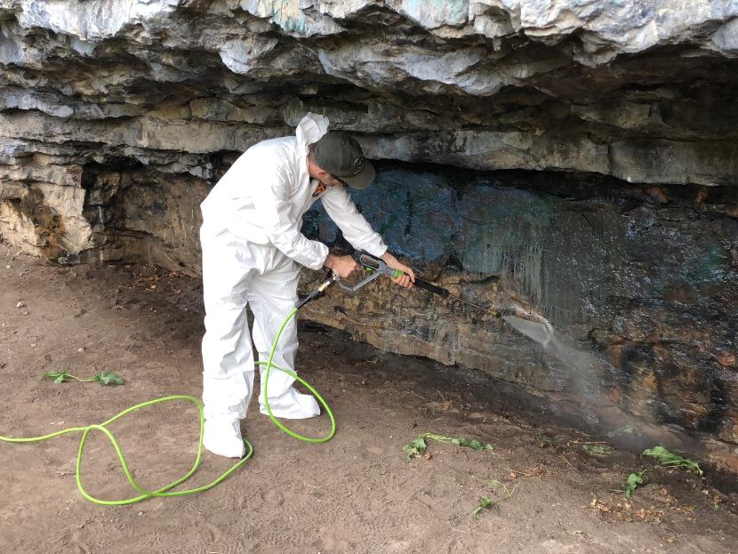
Andrew continuing to use the pressure washer.
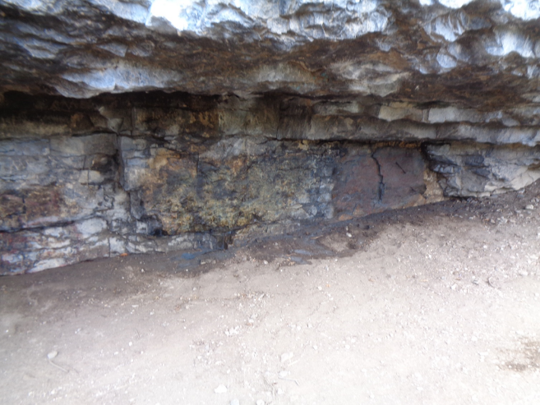
The stone wall is a yellow color after the blue and black tag was removed. On the right, the wall is a dark brown
after the blue tag was removed. Photo by Sam Beard

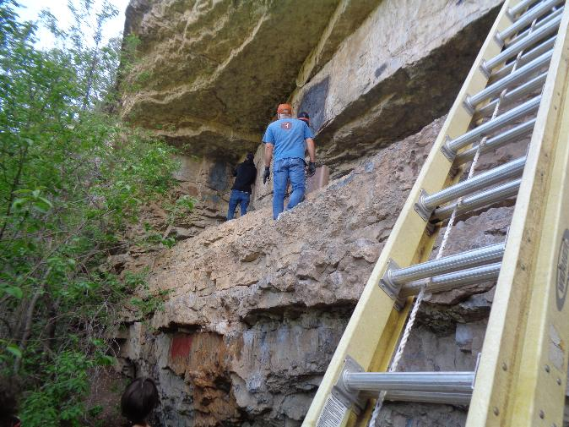
Rock climber club volunteers removing tags on the upper level of the stone wall.
Photo by Sam Beard
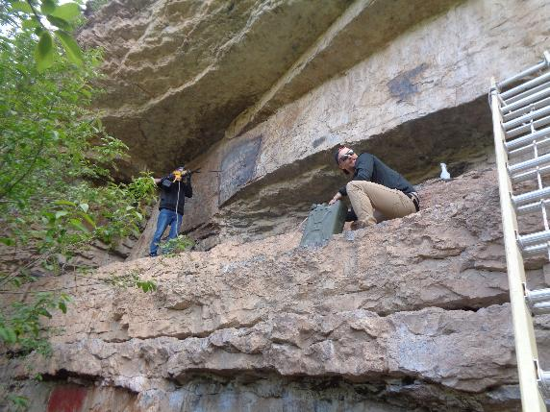
Volunteer using the FOSM low pressure washer to rinse chemical and paint residue from the tag.
Water is in the 5-gallon green can. Photo by Sam Beard

