Report of FOSM Project to Buck and Haul Down Wood between the Upper Crest Highway and the Electronic Site Fence, Wednesday, April 29, 2026
Sam Beard
On Wednesday, April 29, FOSM volunteers continued their project to buck wood that was already down between the upper Crest Highway and the Electronic Site fence. The rounds were rolled down the slope to Mike Oliver and his friend Joe who loaded them on Mike’s large trailer. He hauled the wood to his woodlot, and the Mountain Christian Church Wood Ministry will donate it to families who heat their homes with wood next winter. The Sandia Ranger District issues a permit for donated wood to Lou Romero in FOSM who processes the wood and passes it on to Mike Oliver and other members of the Wood Ministry.
The volunteers working on this project were Cliff Giles, Sam Beard, Lou Romero, Eric Russell, Jerry Carroll, Kent Towler, and Sim Cook.
Project photos are presented below.

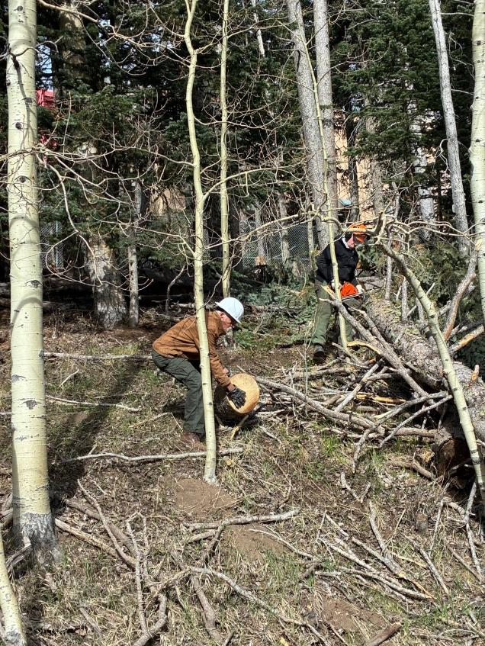
Eric Russell limbing and bucking the large log, and Kent Towler rolling the round
down to the trailer. All photos by Cliff Giles
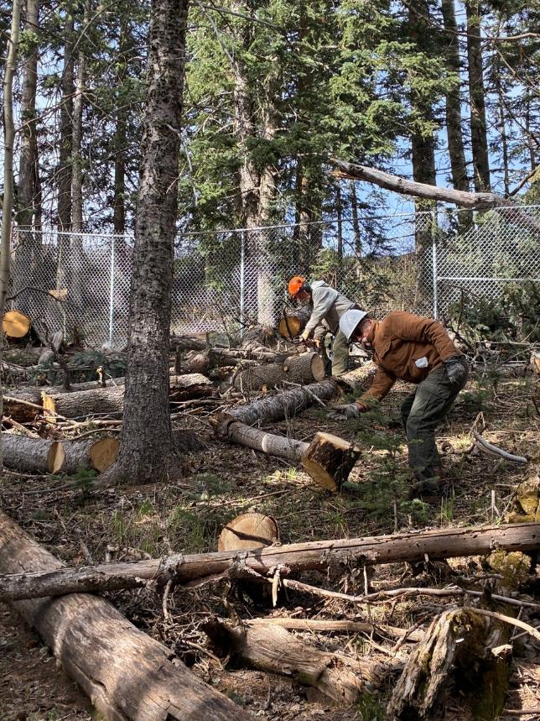
Jerry Carroll bucking a log, and Ken Towler rolling a round down to the trailer.
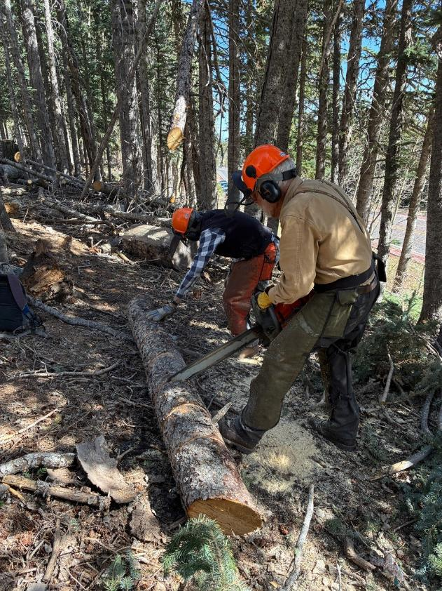
Sim Cook rolling a long down for Sam Beard to buck.
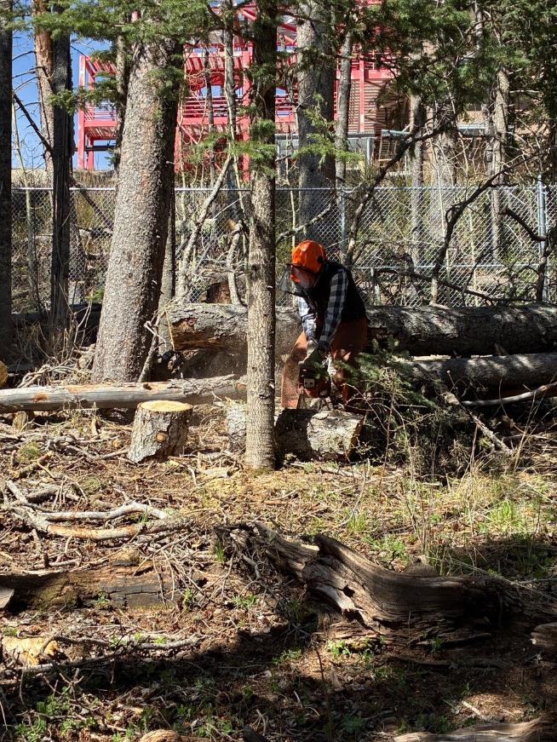
Sim Cook bucking a log with the Electronics Site fence in the background,

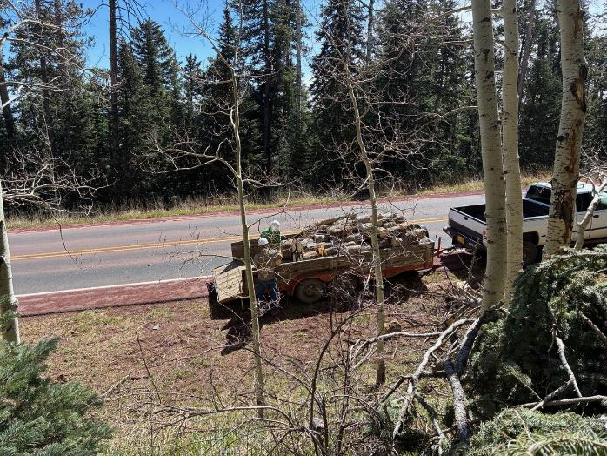
Mike Oliver and his friend Joe loading the trailer.

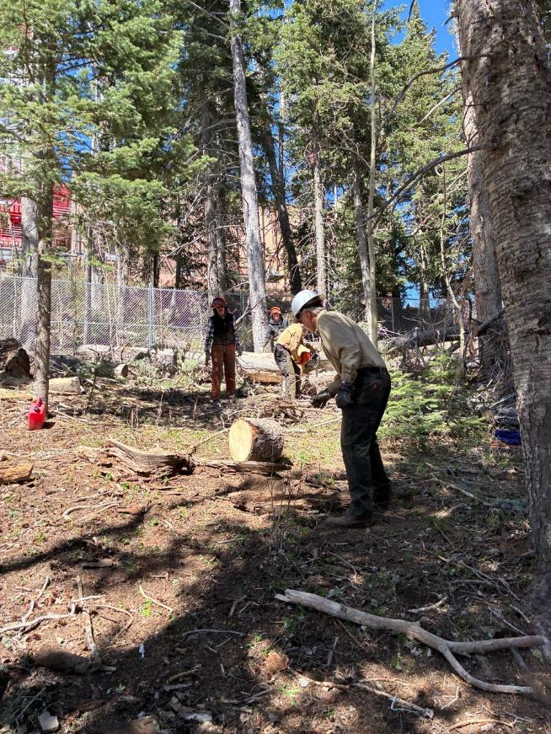
Kent ready to stop a round and roll it down to the trailer.
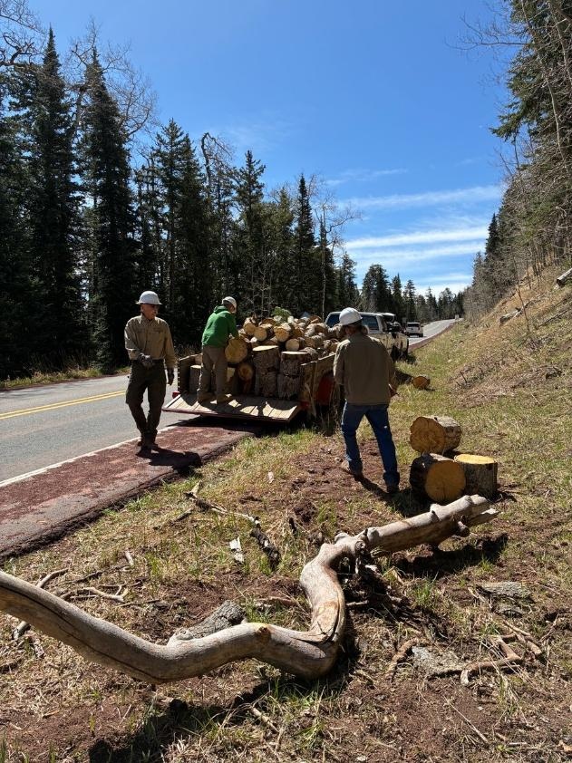
L to R: Kent Towler, Joe, and Mike Oliver loading large rounds on the trailer.

