Thursday, 04/30/26- Pokerchip: It was supposed to threaten rain but we ended up with a mostly sunny and breezy day of work on Thursday. The rain held off until later- hope you got some! Ten volunteers joined Chris and Jen (SRD) to continue work on Pokerchip. The going is slow due to rocks and stumps but we are making progress. In 5 weeks, we have completed 1,096 feet of new tread plus building numerous check dams on the old trail and retention walls where the new trail crosses the old. Only 2,303 more feet to go!

Volunteers: Tony Pachelli, Bill Perkins, Kerry Jones, Luis Cuadros, Byron Garner,
Eric Russell, Mark Werkmeister, Claudia Bergsohn, Bruce Hansch and Laura Leon

Pictures: Laura Leon and map info from Luis Cuadros

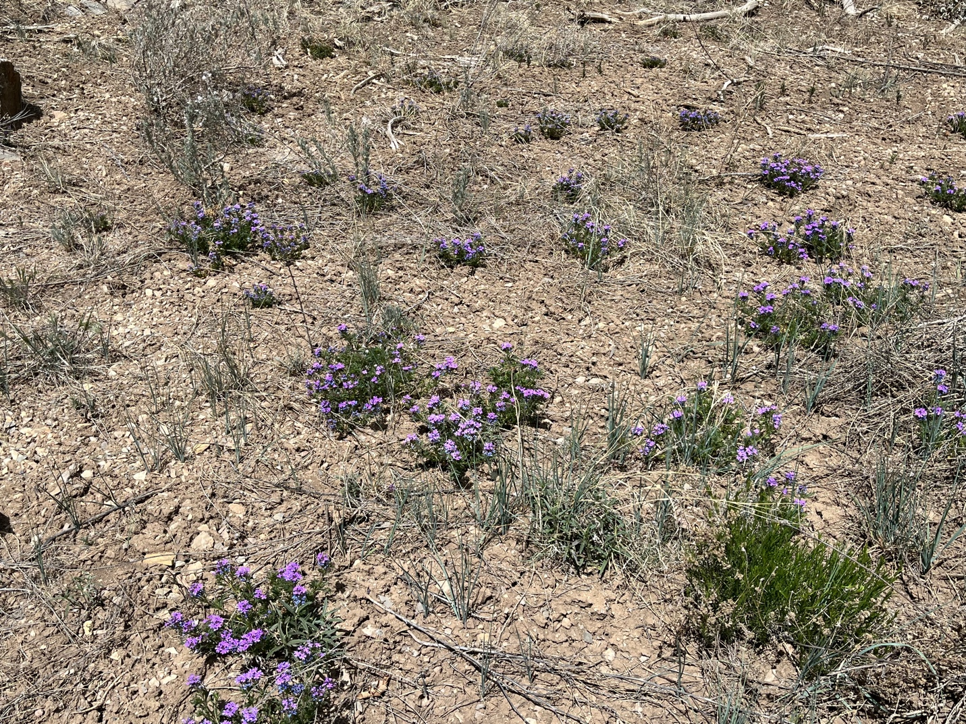

Flowers are blooming. Can’t wait to see what the rain has done!

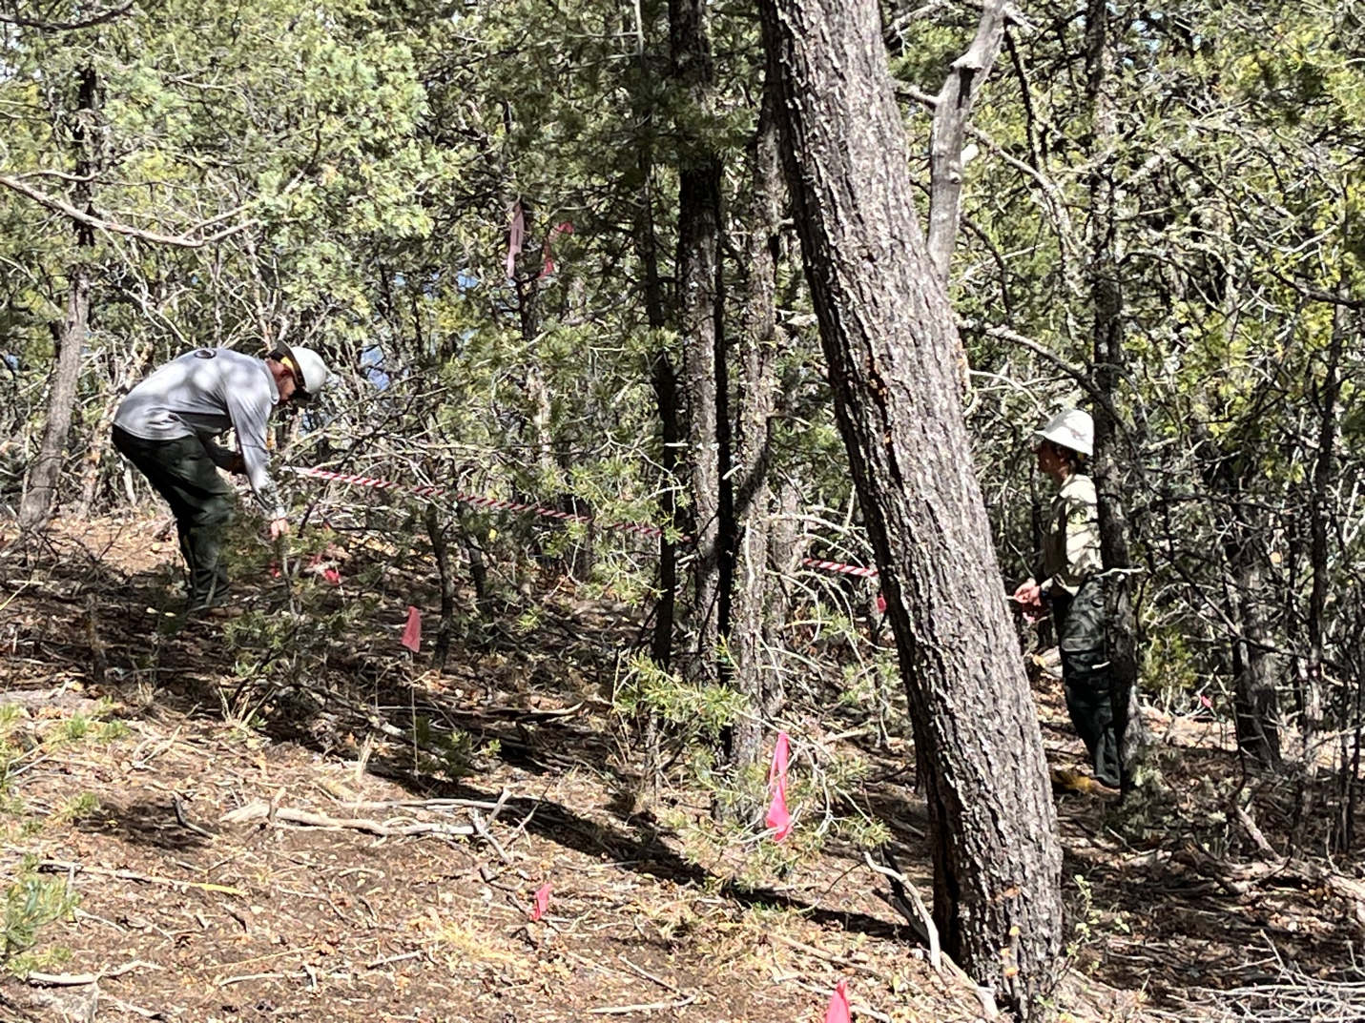

Chris and Jen are using tape to try and flag a useable curve.

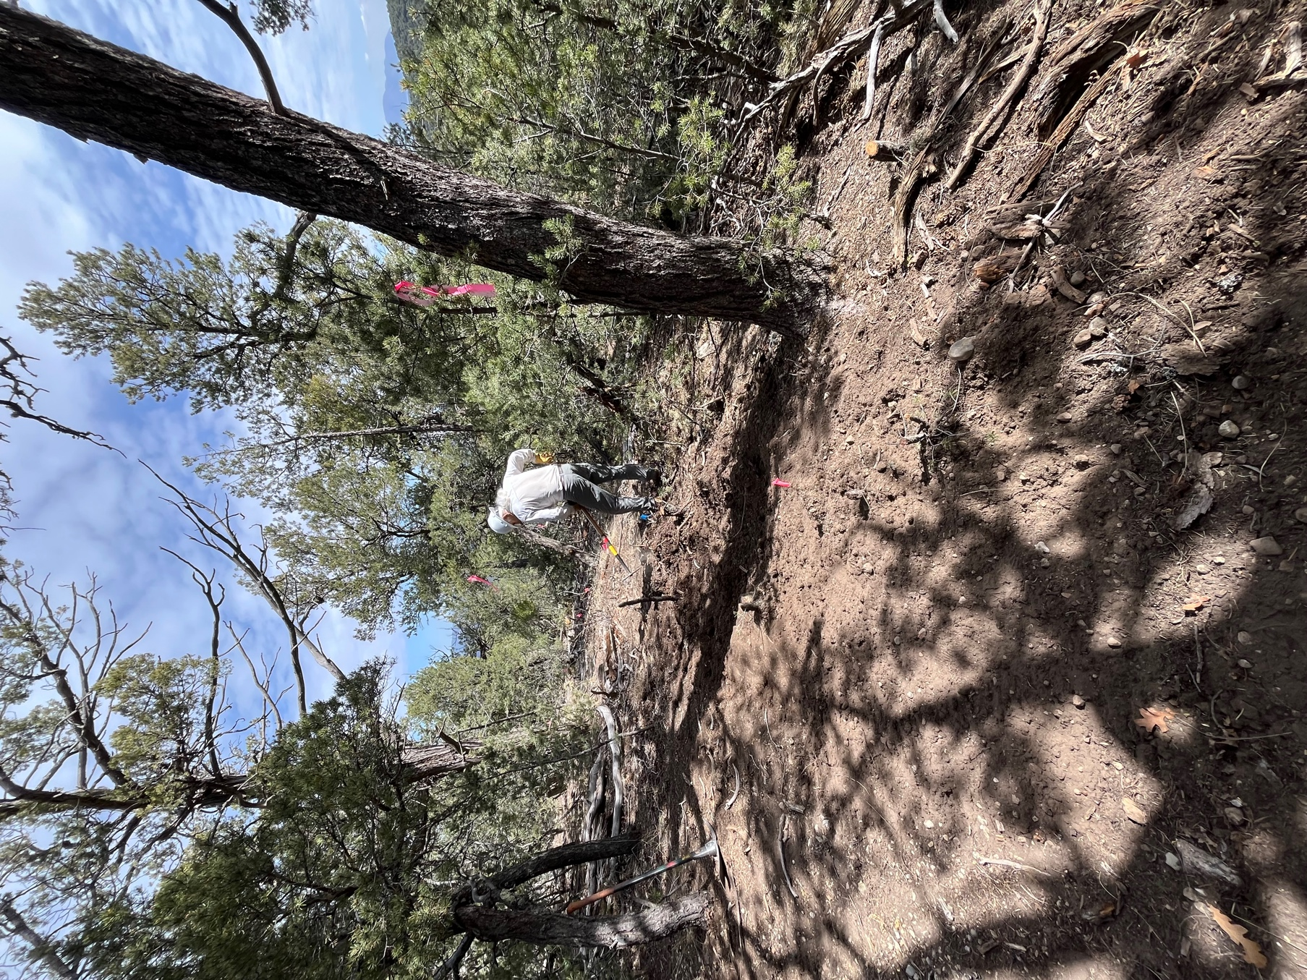

Bill gets started on a new section.

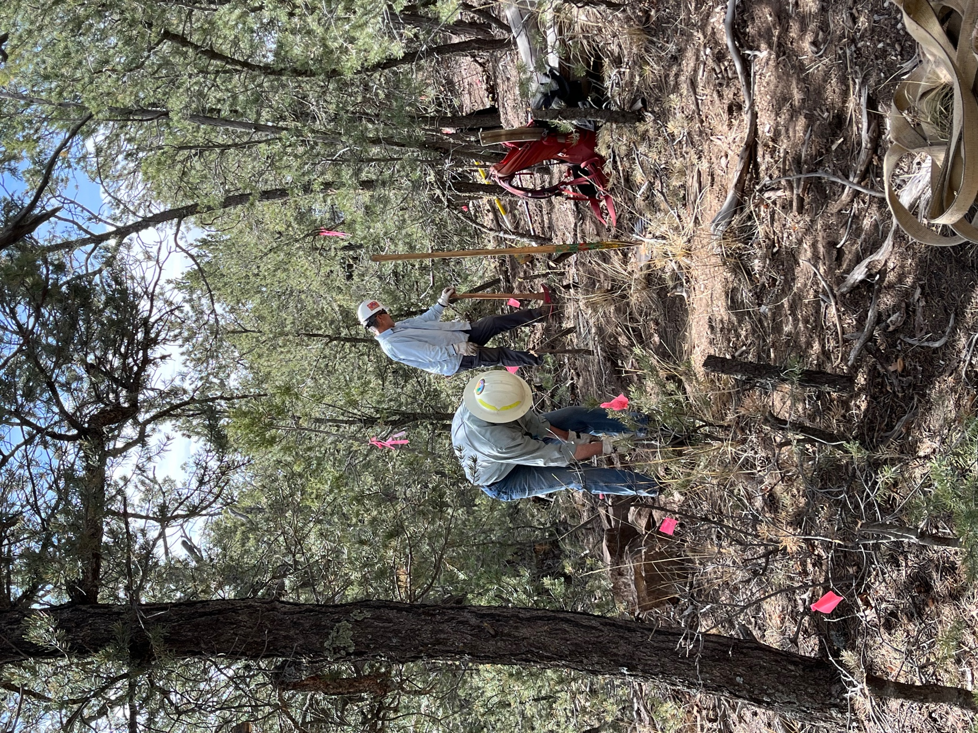

Tony and Byron work to finish off an area.
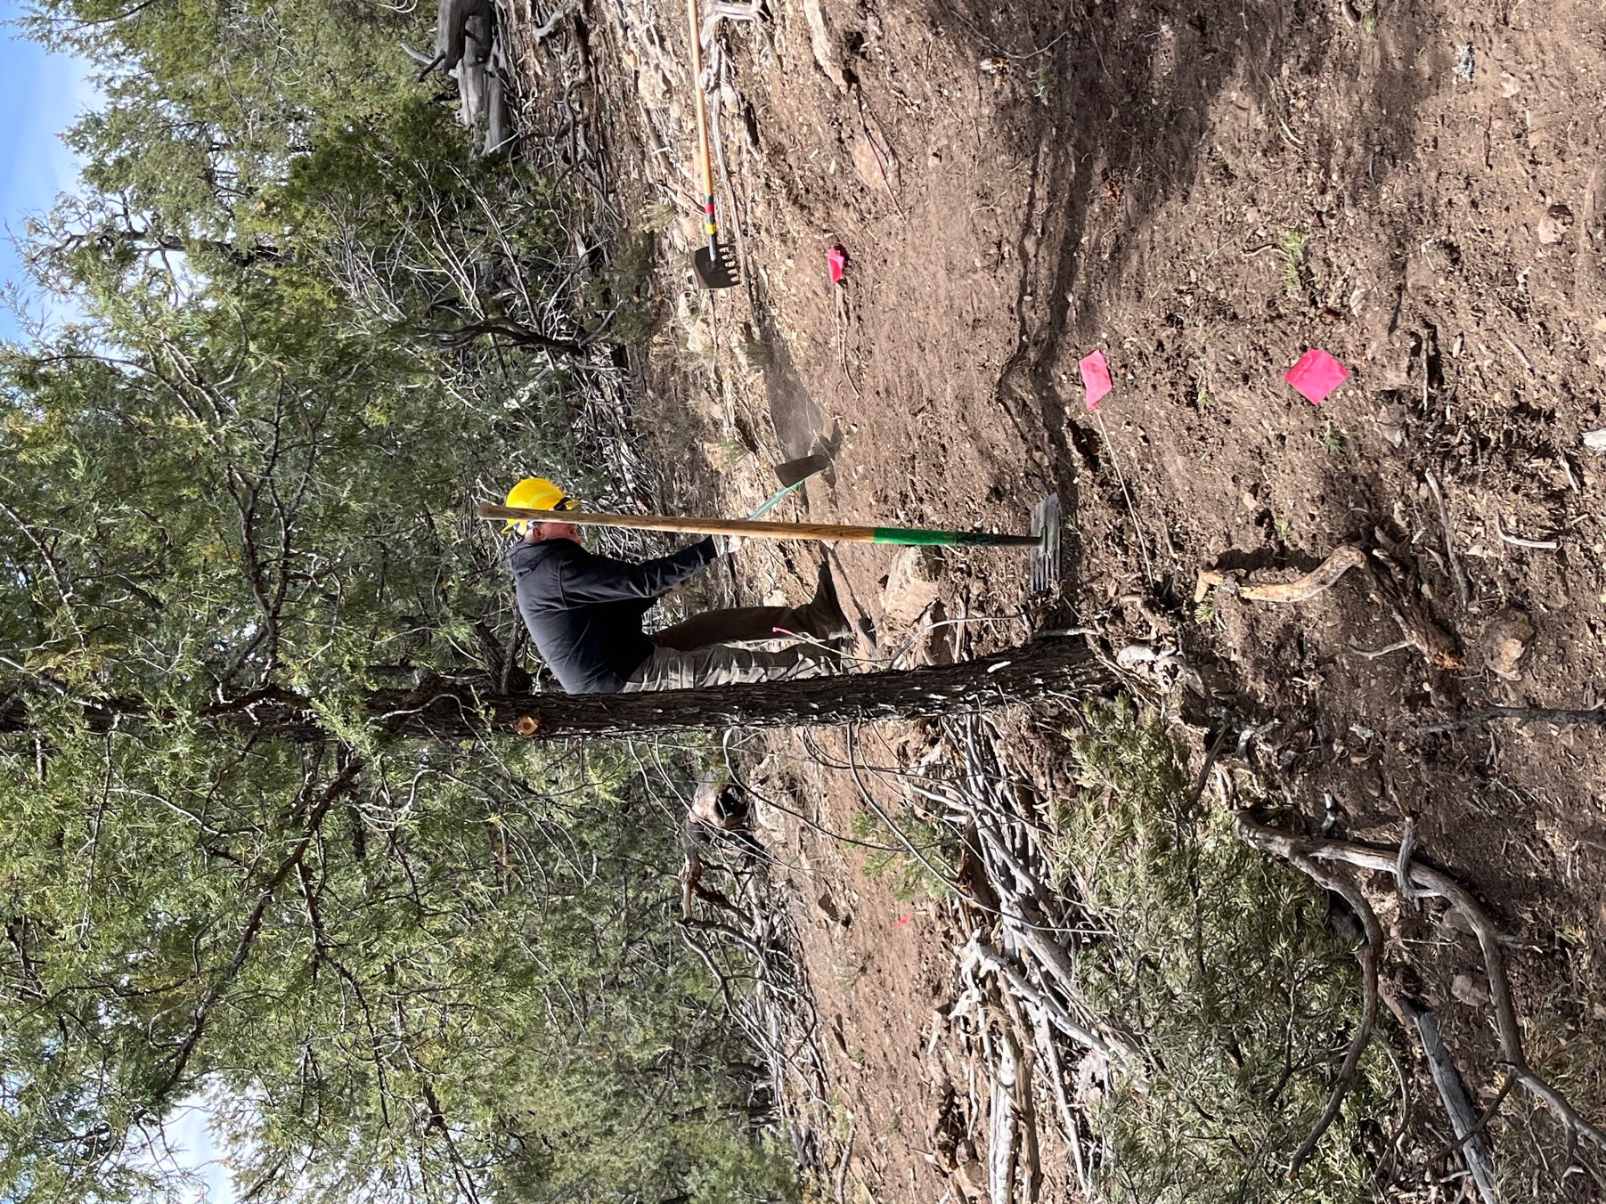

Eric works the uphill side of a curve…

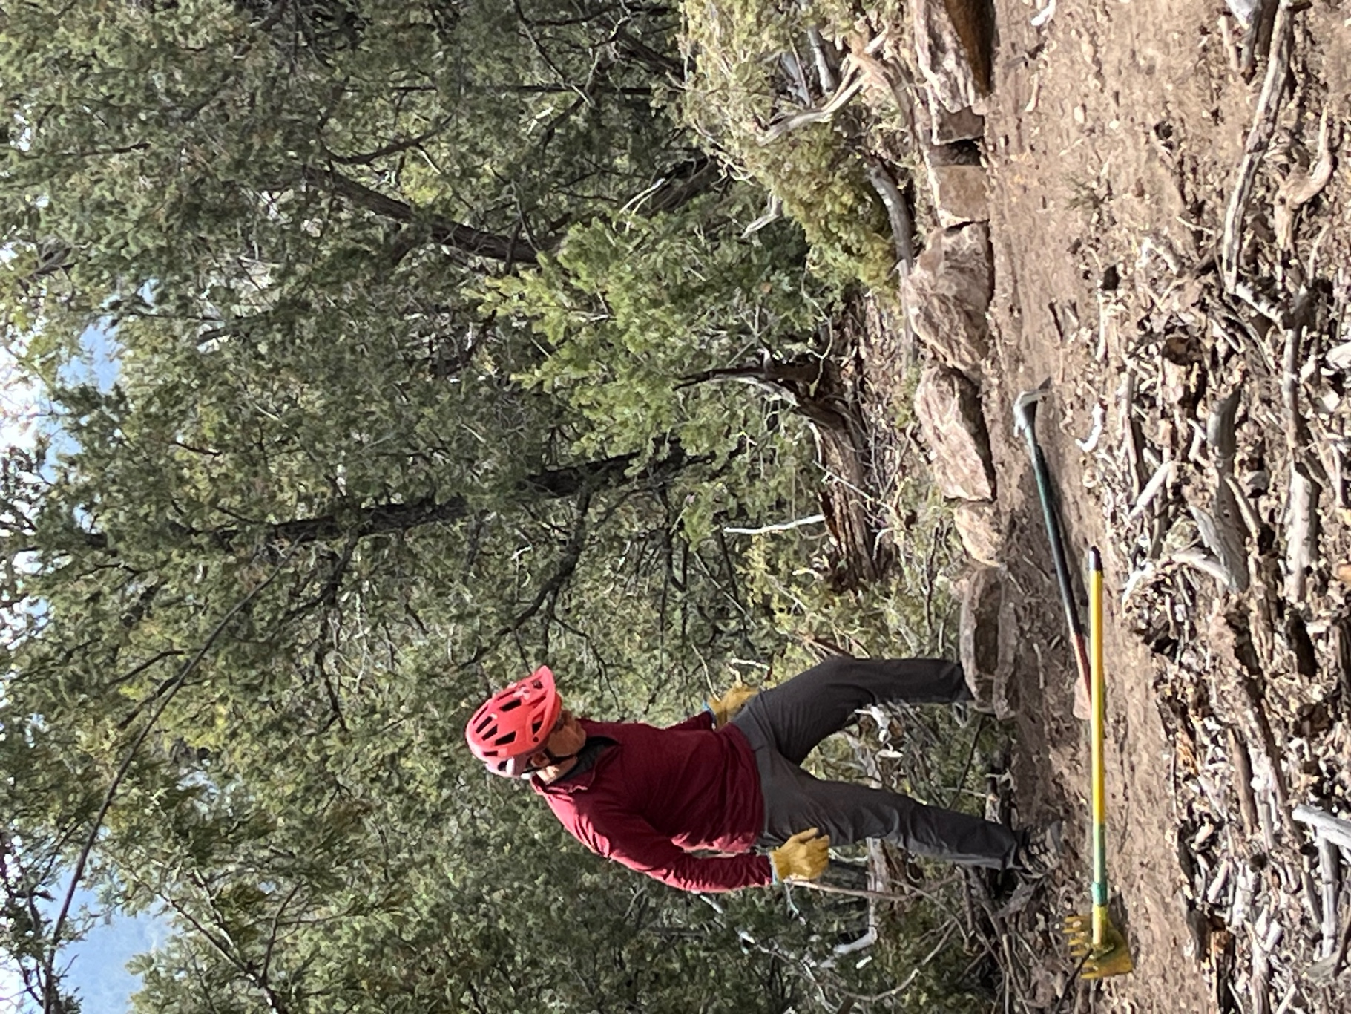

and Luis works the lower outside edge of the curve.

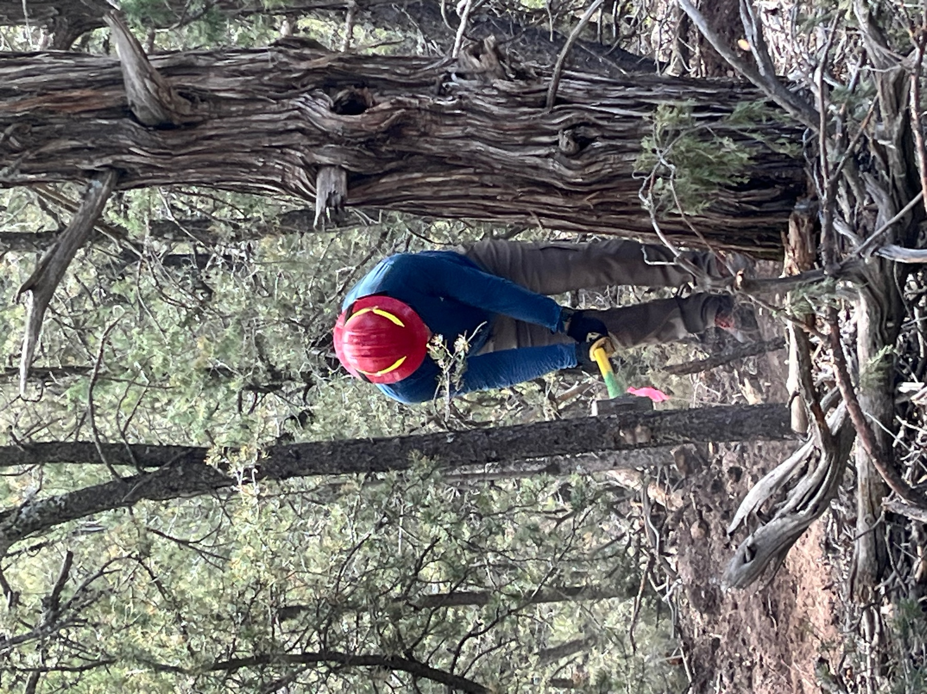

Kerry uses the double jack to smash up some rock fill.
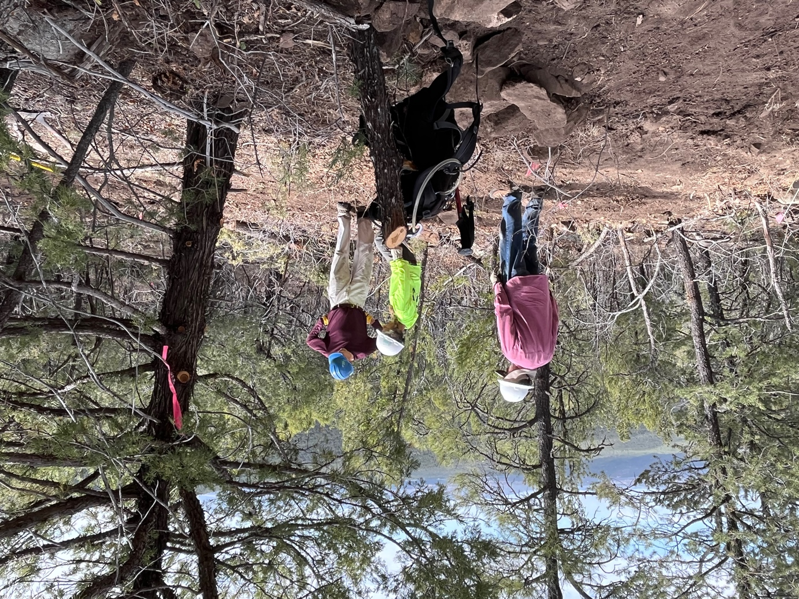

Uphill, Bruce, Claudia and Mark continue to try and make another curve work.
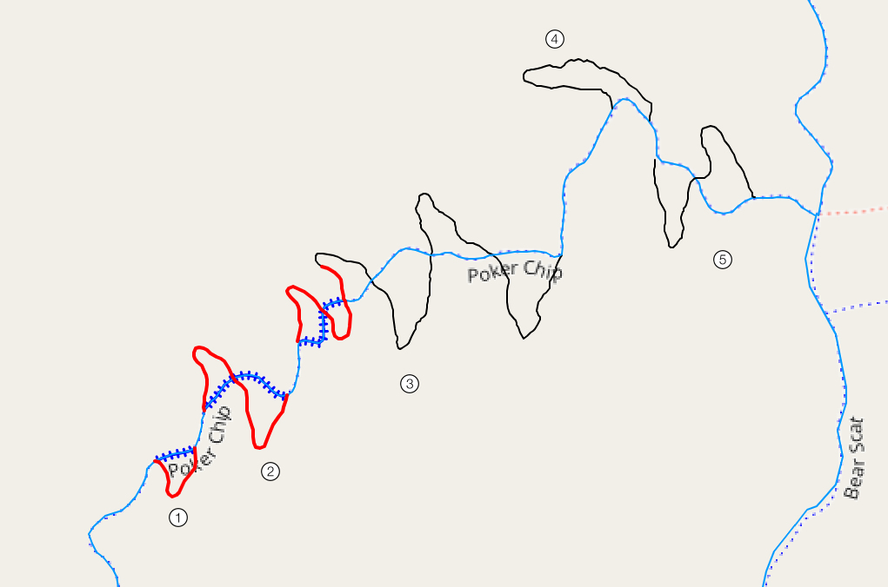
Red is done, black is not. Blue hash is old trail that has been closed.

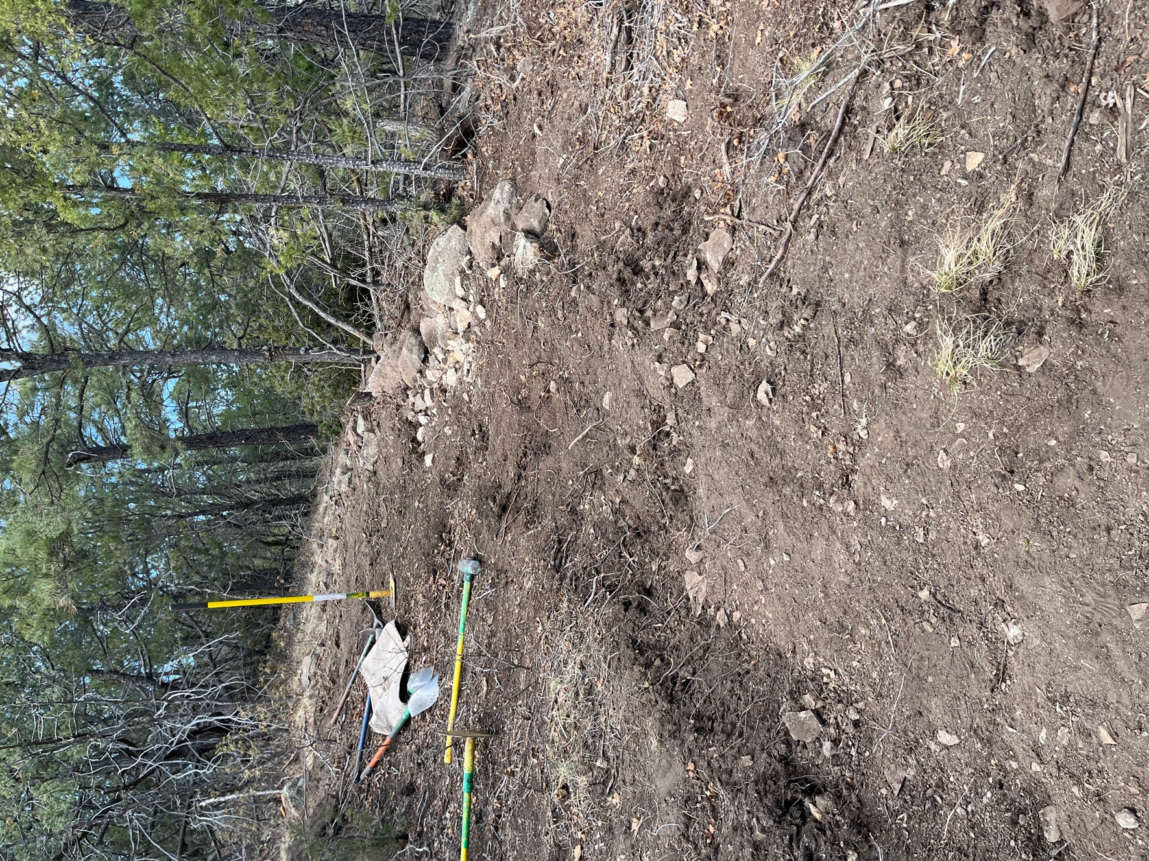

This is the curve solution that Bruce, Claudia and Mark worked out.

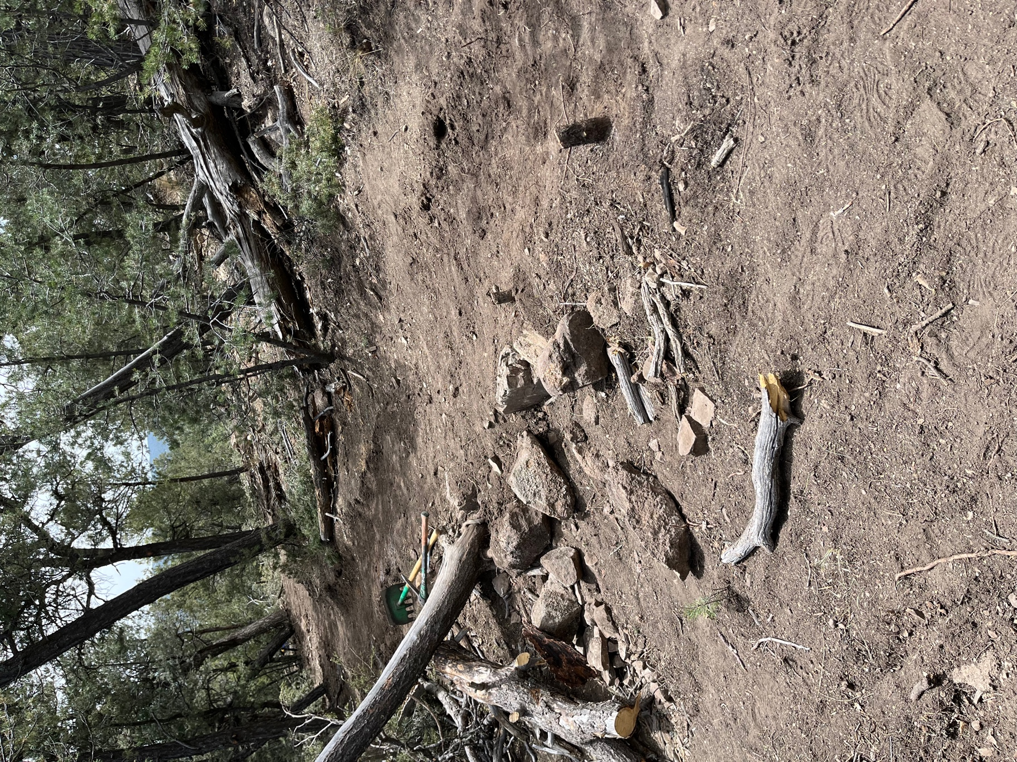

Laura and Chris bult this retention wall where old and new trails cross.
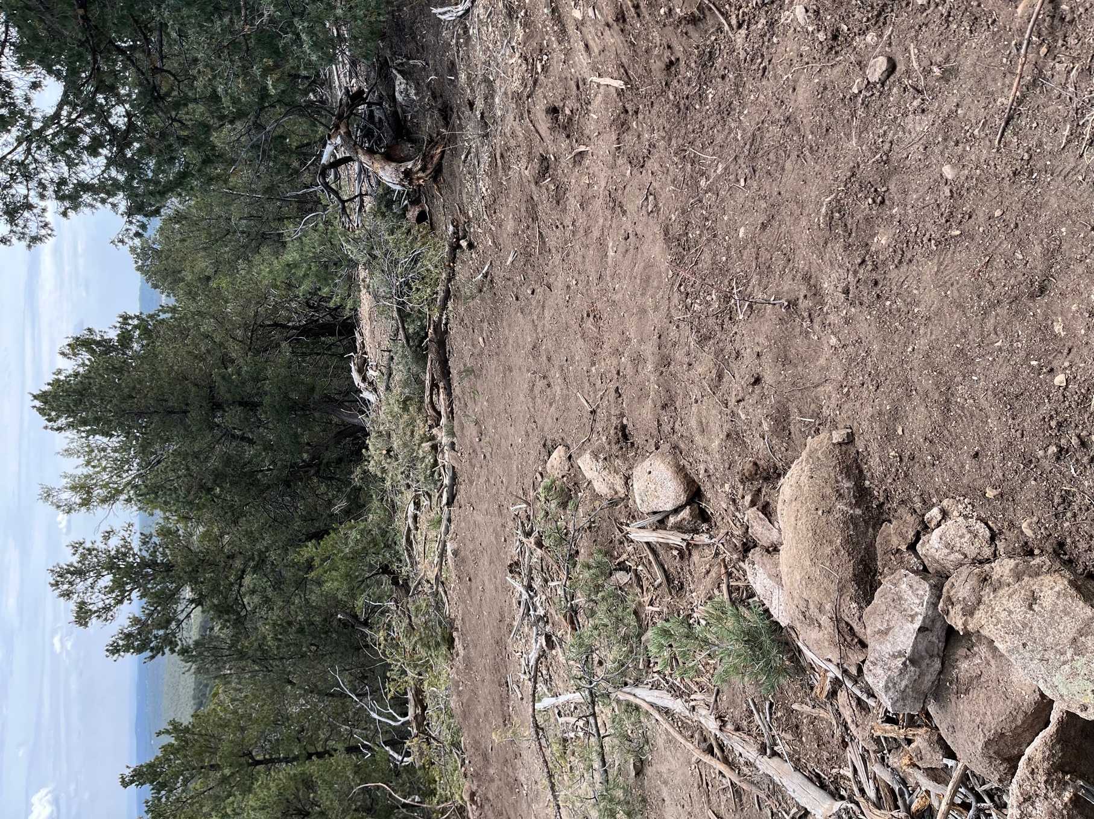

The curve Eric and Luis were working. This is what is slowing us down: lots of rocks to pull out and then cart around to reenforce another area.

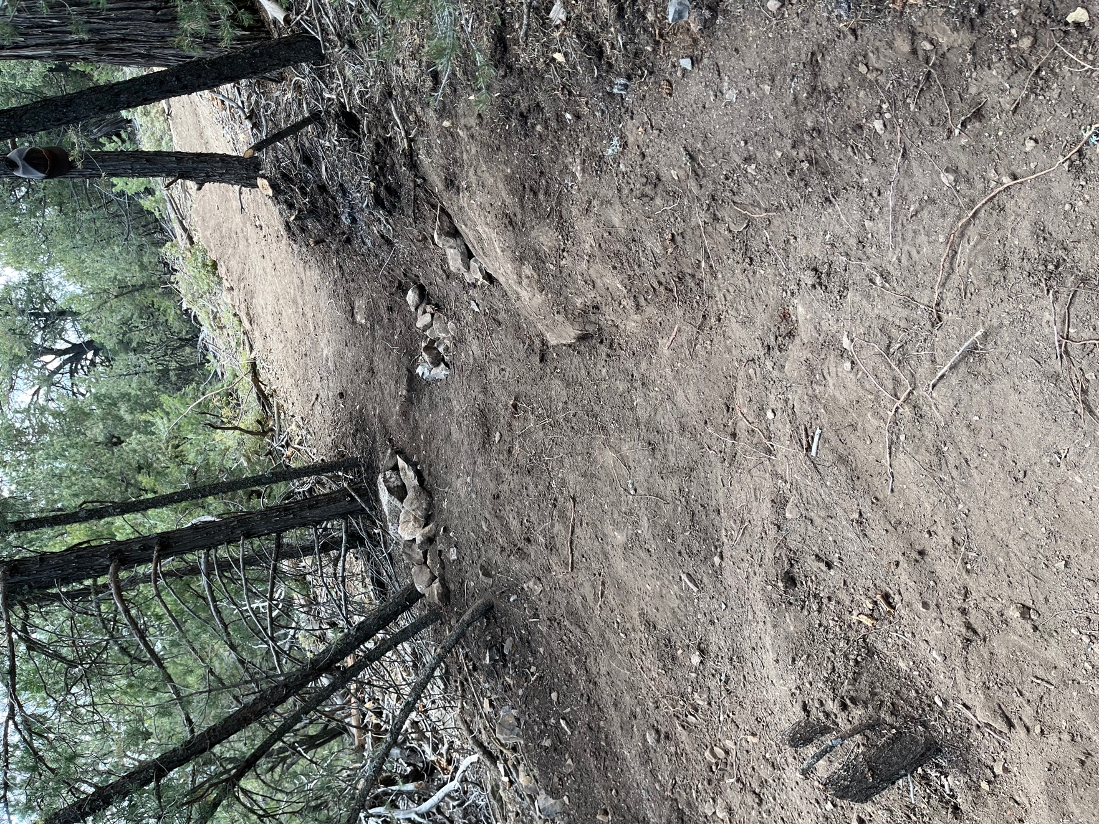

Kerry has been working and reworking this area to make it safe with the features that aren’t going anywhere!

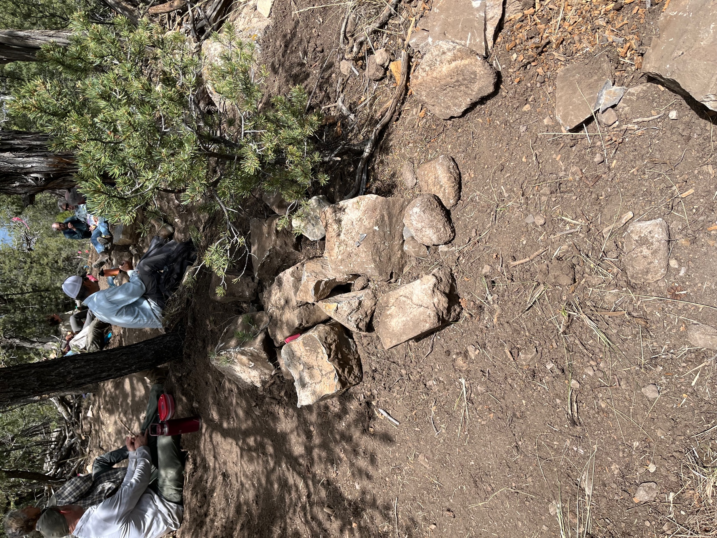

This is the pile of rocks Byron pulled out of his work area.

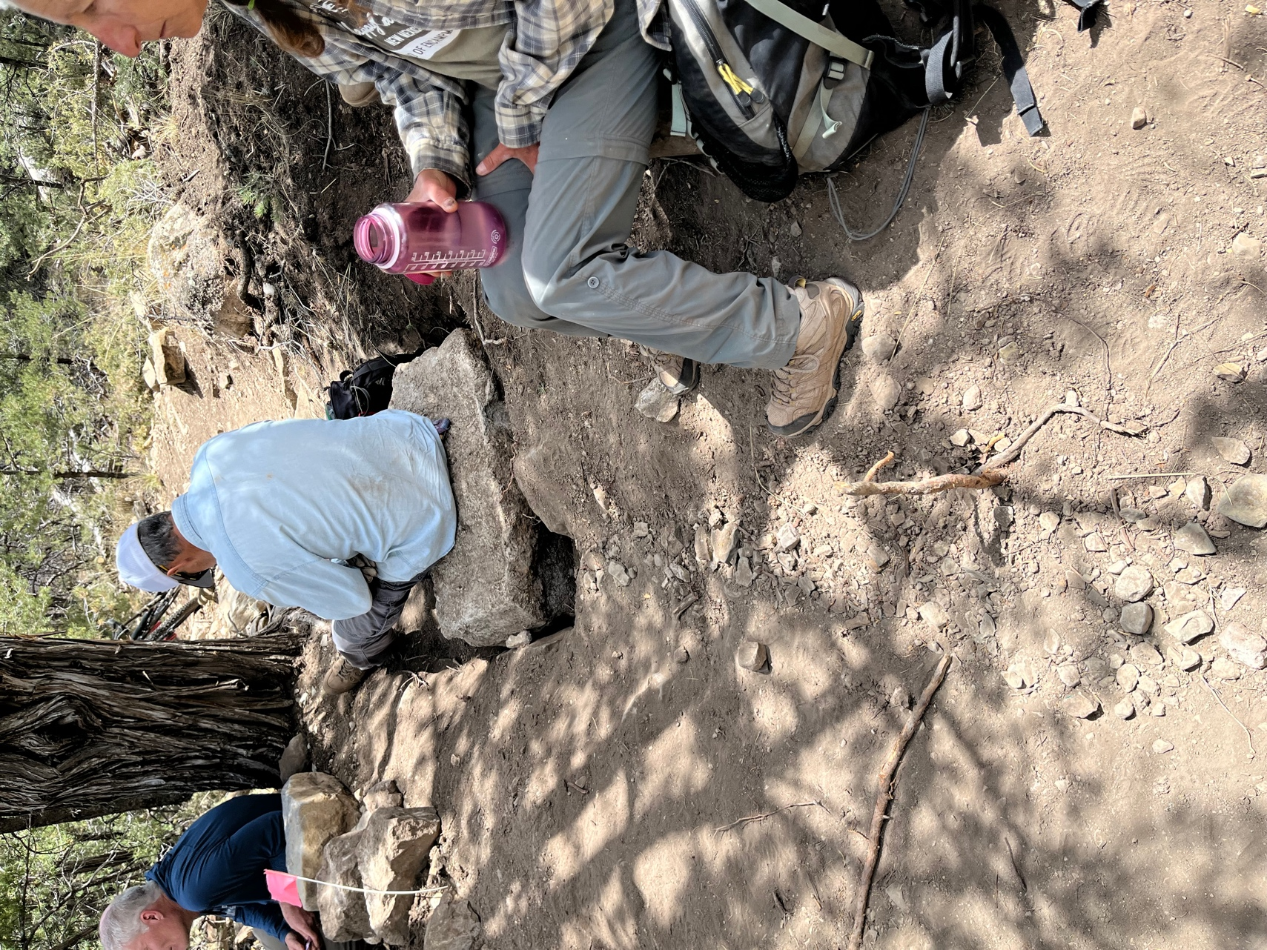

This monster rock was dug up by Eric and then a group wrangled it over to the old trail to use as part of a retention wall where the old and new paths cross. It’s also a fabulous lunch seat.

