Report of FOSM Project to Remove Approximately 30 Graffiti Tags
from La Luz Trailhead, Thursday, May 7, 2026

Sam Beard
On Thursday, May 7, six FOSM volunteers removed approximately 30 graffiti tags from the following La Luz Trailhead sites: 2 restroom windows, 3 doors, 2 interior walls, 2 ventilation pipes, 4 kiosk panels, 1 restroom exterior wall, 2 interior walls, 1 picnic table top, 1 parking permit box side, and 2 parking spaces. Fortunately, the chemical from the World’s Best Graffiti Removal System for stone was able to remove most of the light pink paint that was used to make the tags. The three doors and the picnic table top were painted with dark brown Behr paint. The two tags on the interior walls of the restroom were painted over with white paint. The project began at 10 am and was completed by noon.

Zach from KOB-TV made videos of our work removing the graffiti tags and said that they will probably be shown in one or more of the afternoon and evening news telecasts today.

The volunteers on this project were Fred Hagstrom, Katie Ziegweid, Sim Cook, Todd Hollister, Michael Arndt, and Sam Beard.
Project photos are presented below.

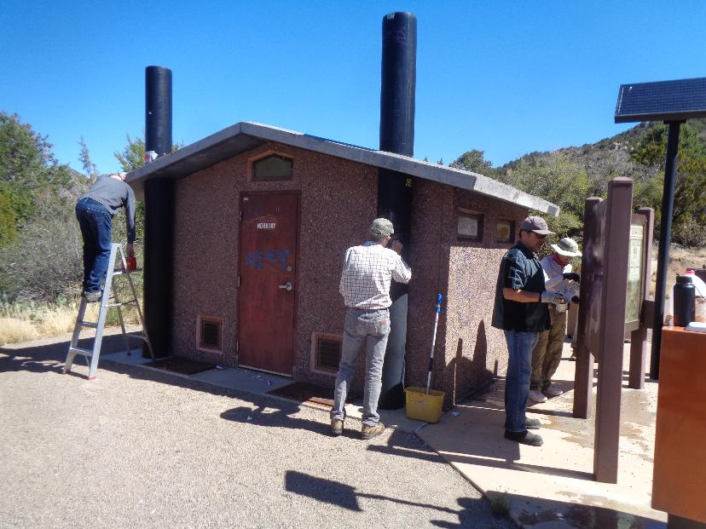
Removing graffiti tags from the restroom and kiosk in La Luz Trailhead. L to R: Fred Hagstrom (removing labels from ventilation pipe),
Sim Cook (removing tags from ventilation pipe), Michael Arndt (removing tags from back of kiosk panel), and Katie Ziegweid
(removing tags for another kiosk panel). All photos by Sam Beard
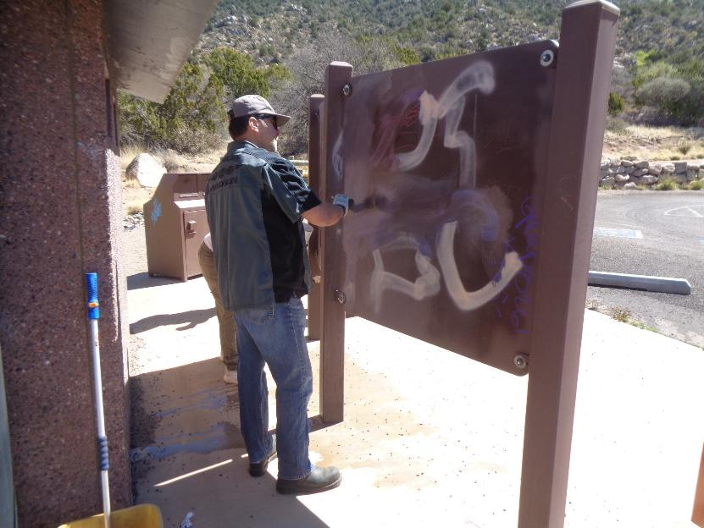
Michael Arndt is using the chemical to remove a large tag from the back of one of the kiosk panels.
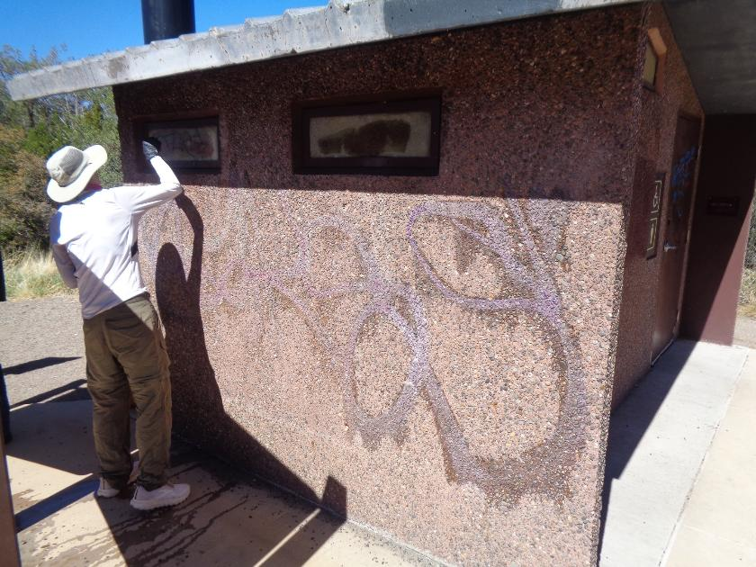
Katie is applying chemical to tags on the restroom windows. The chemical had been applied to the large tag on the wall, and the paint
and chemical residue had been removed with the FOSM low-pressure washer. Other parts of the restroom were rinsed with water
from Michael Arndt’s pressure washer.
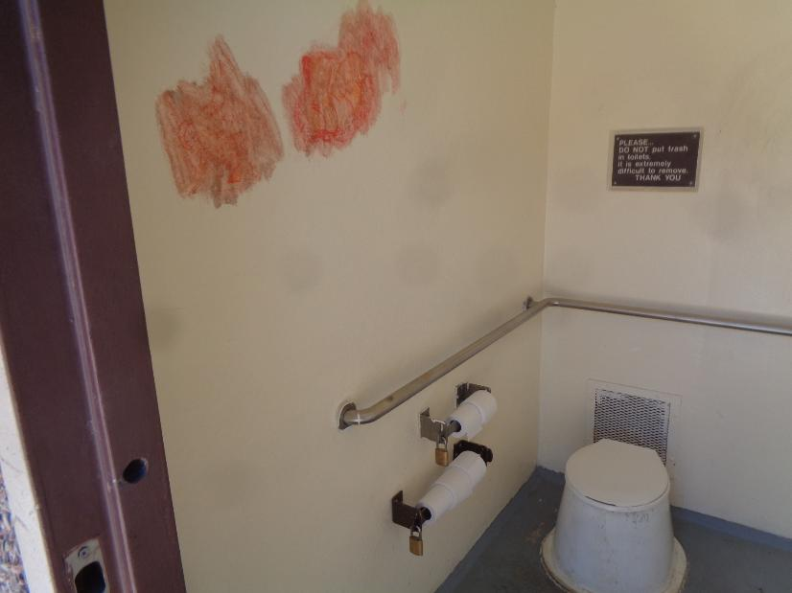
Tags on the wall of the men’s restroom.
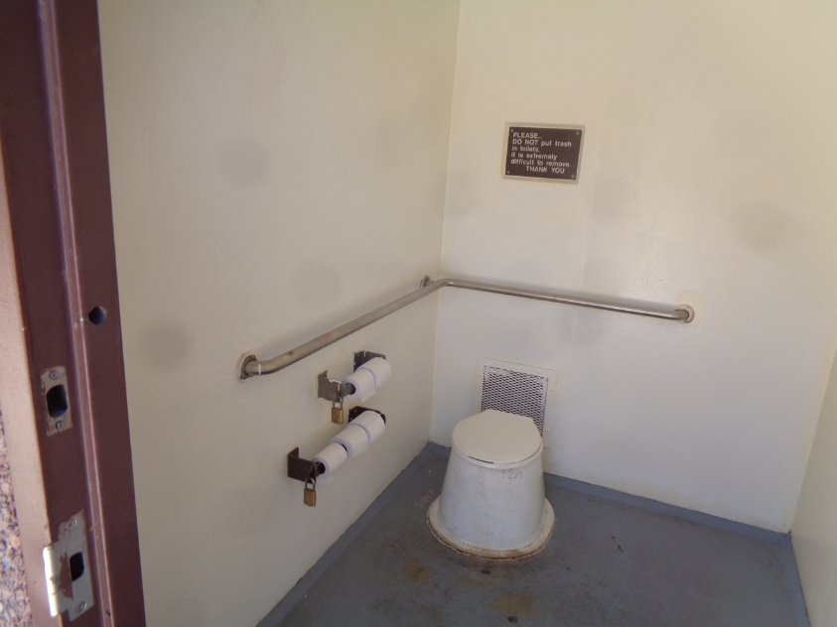
The tags in the men’s restroom were painted over with white paint.
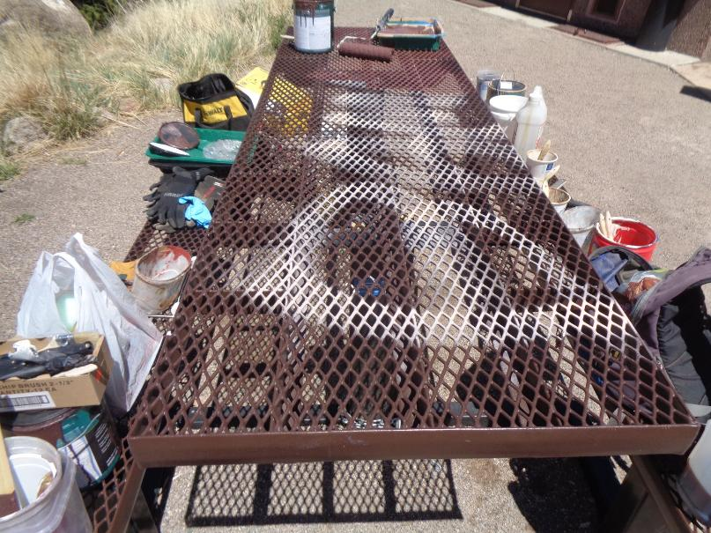
The large tag on the top of the picnic table. The equipment, paint, and other products used to remove the tags
are on the table benches.
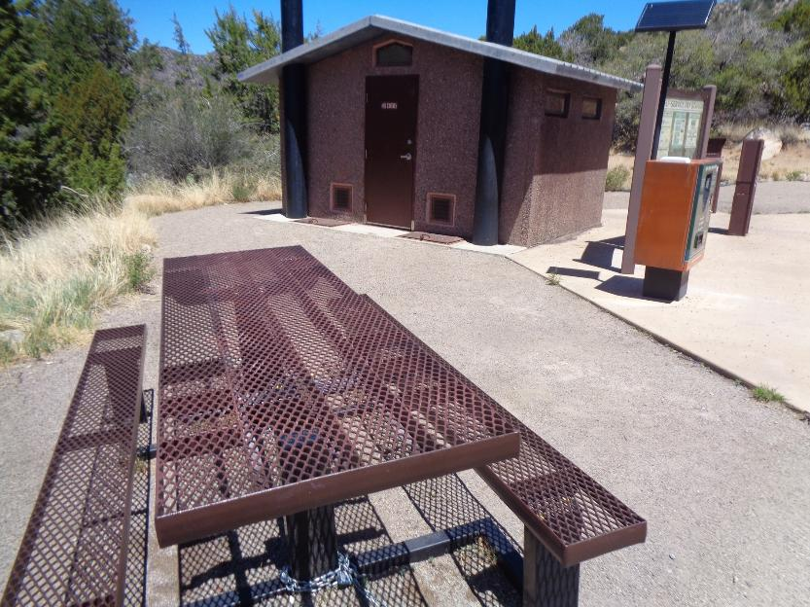
The restroom, kiosk, and picnic table after the graffiti tags were removed.

