Thursday, 05/07/25- Pokerchip: Back up to Pokerchip this week. I’ll confess I was anxious to see what the rain did to our work but unfortunately there was apparently very little rain in the area and the trail is still bone dry. Looks like there has been some traffic trying out the new reroutes though, so that’s encouraging.
We had 11 hardy volunteers out this week with Jen and Chris (SRD) so a big crew and not quite as much rock work and stump removal helped us make good progress.

Volunteers: Bill Perkins, John McNett, Tony Pachelli, Kerry Jones, Luis Cuadros,
Byron Garner, Bruce Hansche, Eric Russell, Claudia Bergsohn, Jim Houle and
Laura Leon

Pictures- Laura Leon, map and stats- Luis Cuadros

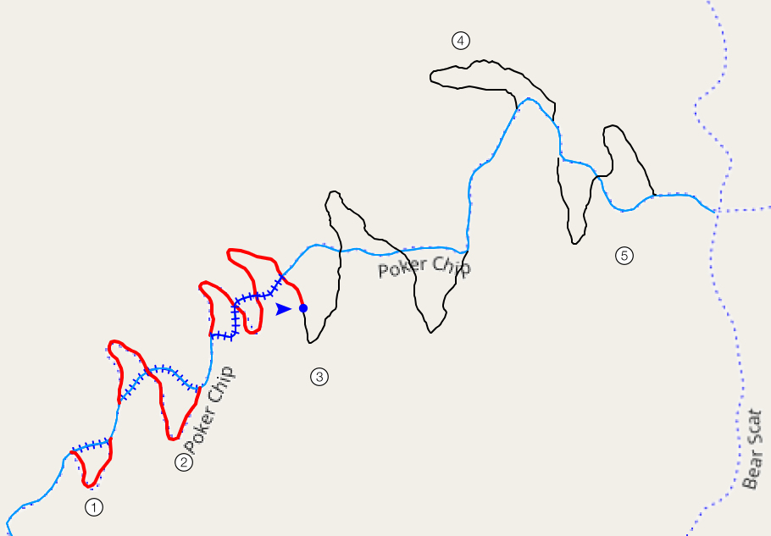
Red is finished work, black is still to do. 1316 ft done and 2071 ft to go!

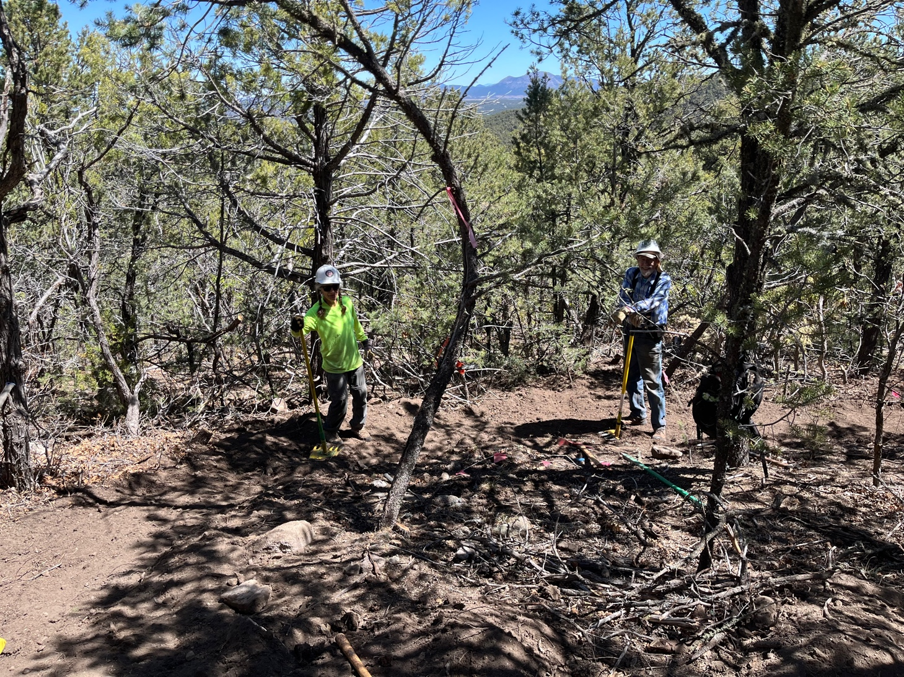

Claudia and Bruce- the dynamic curve duo- are at it again!

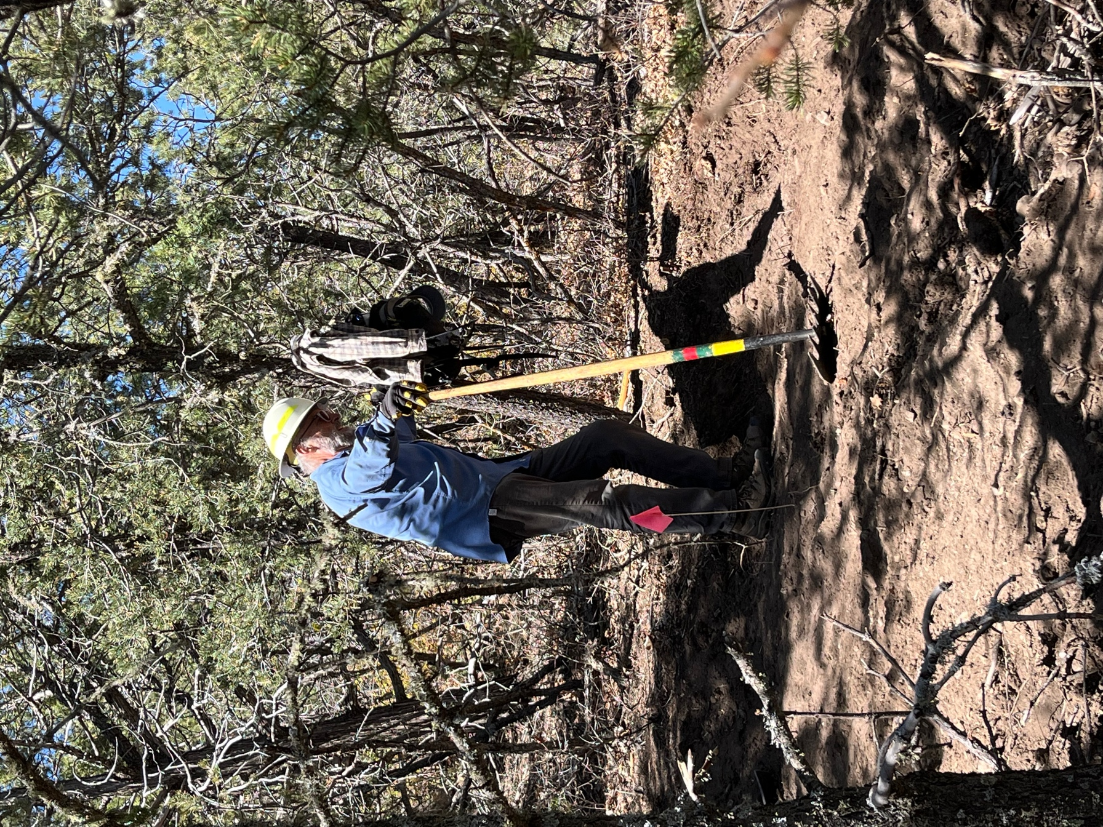

Jim works on the lead in to the Claudia/Bruce curve.

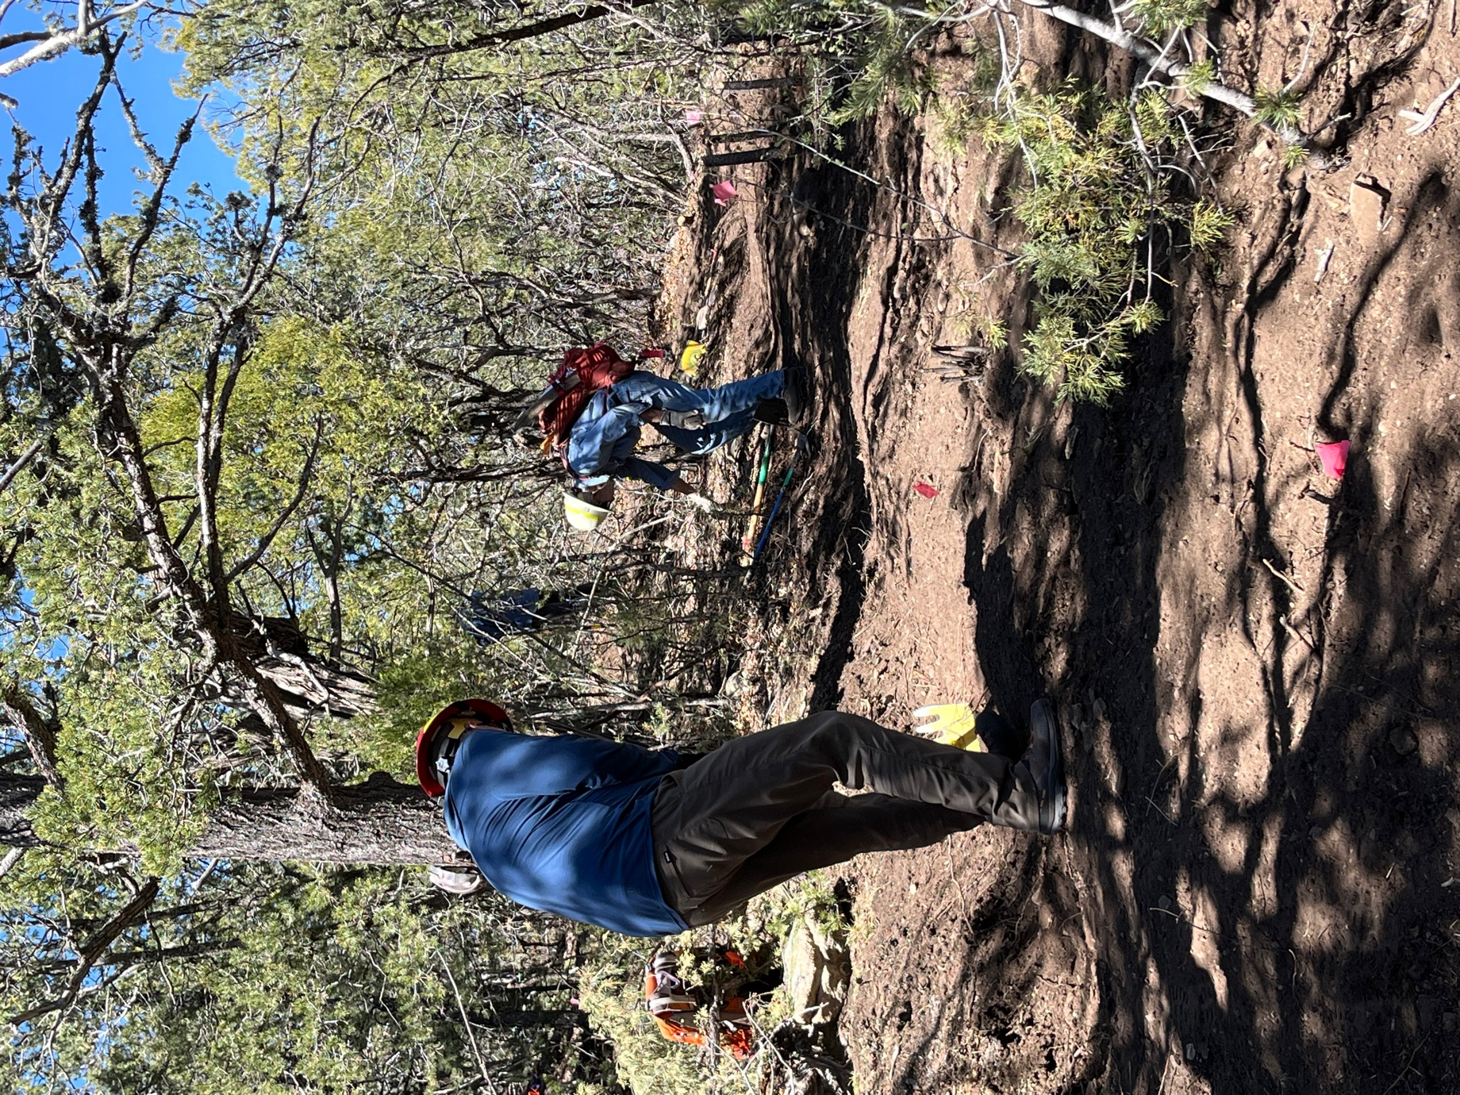

Kerry finishes off a section and Byron gets ready to bump down to a new section.
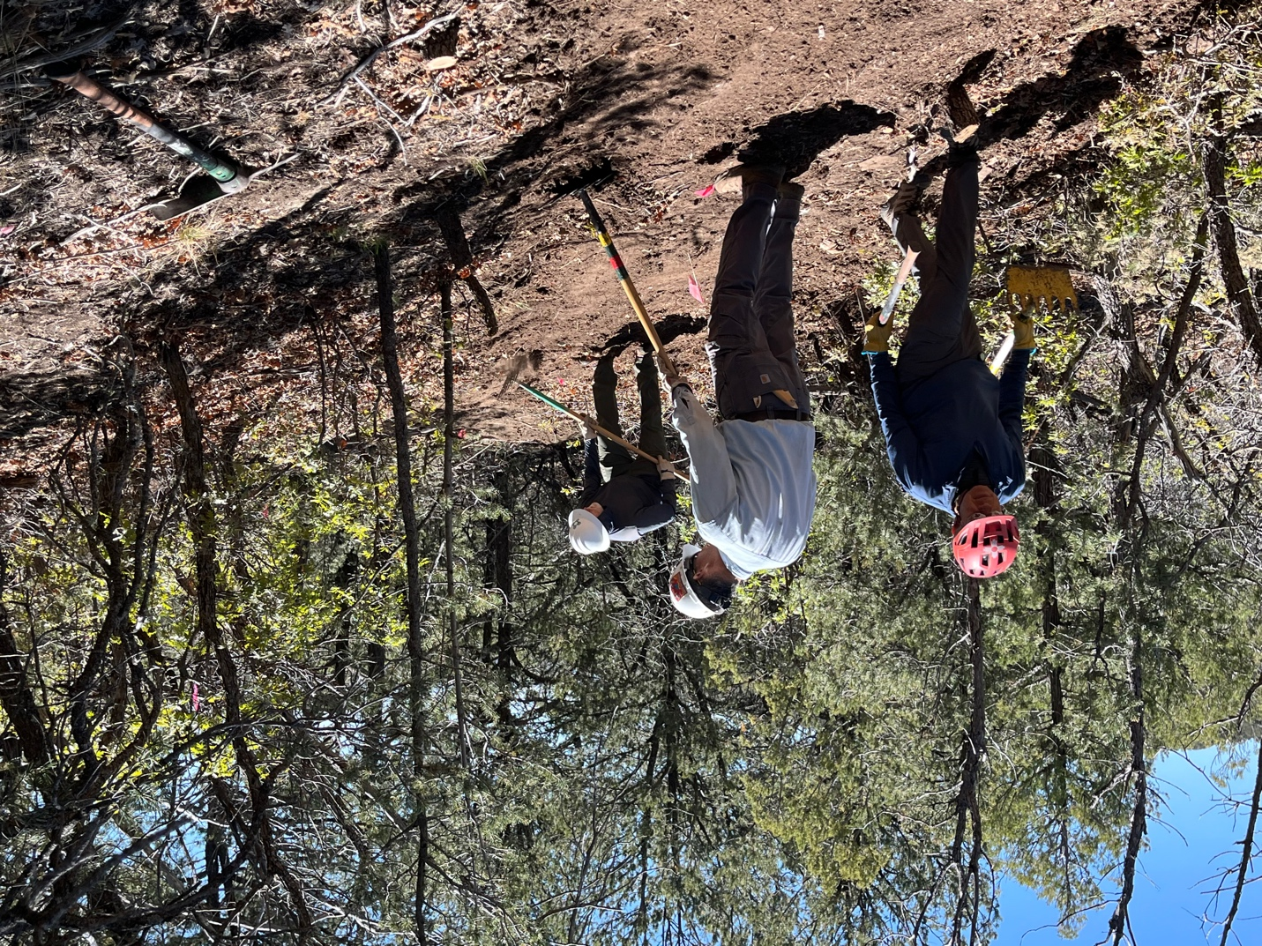

Luis, Tony and John work on finishing touches. Luis has been bringing his bike and giving the new tread a test drive. The sun is out and the temps are heading up.

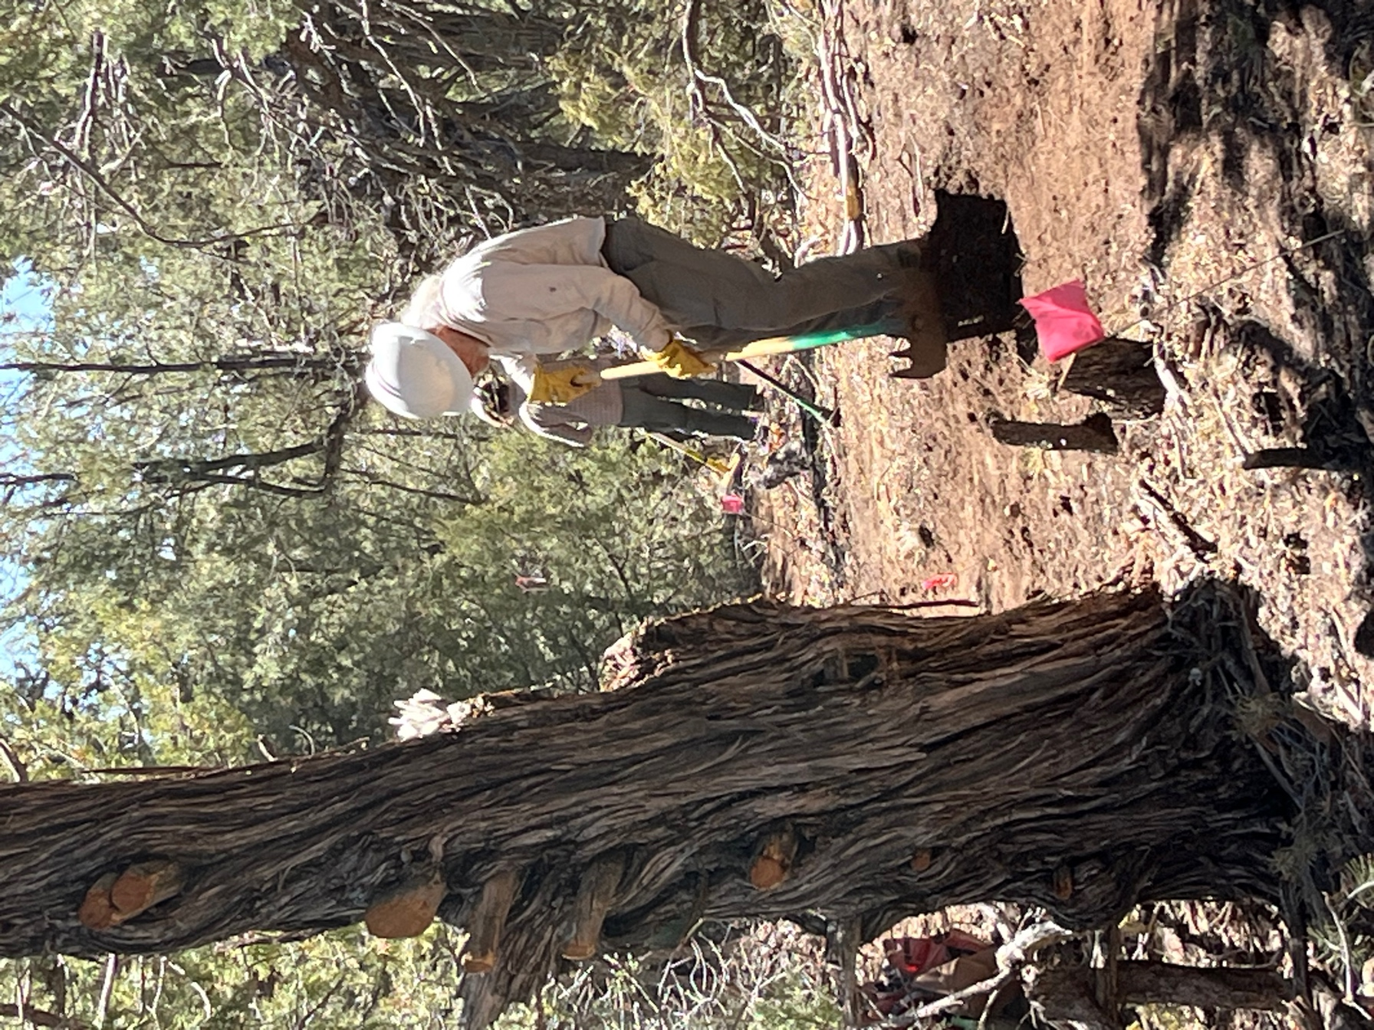

Bill and Jen work on the section that crosses over the old tread.

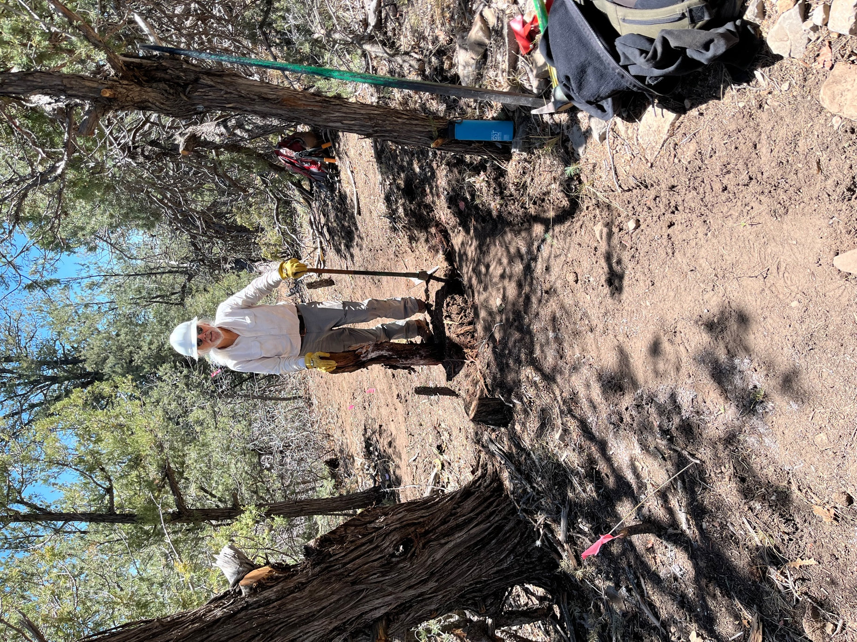

Bill got out the root of the dead Juniper- it smelled wonderful!

