Report of the FOSM Project to Fell Three Hazard Trees
in Cienega Canyon Picnic Area, Wednesday, May 6, 2026

Sam Beard
On Wednesday, May 6, ten FOSM volunteers felled, limbed, and bucked three hazard trees selected by Canyon Young, SRD Trails and Wilderness Program Manager. In accordance with Canyon’s instructions, the bucked wood was left where the tree was felled. The objective of leaving the bucked rounds in the forest was to determine if they would likely be stolen before they could be collected by members of the public with a permit before they were stolen. Usually, FOSM either does not buck logs left in the picnic areas, or they are bucked and hauled immediately to the Mountain Christian Church Wood Ministry woodlot. The wood is then donated to families in the East Mountains who heat their homes with wood.

The following hazard trees were felled and processed: Rocky Mountain juniper, 15 inches in diameter, and 30 feet tall; white fir, 15 inches in diameter, and 50 feet tall; and white fir, 20 inches in diameter, and 80 feet tall.

The volunteers working on this project were, Sim Cook, Dan Benton, Kent Towler, Steve Roholt, Eric Russell, Cliff Giles, Tim Kirkpatrick, Jerry Carroll, Lorna Morrow, and Sam Beard.

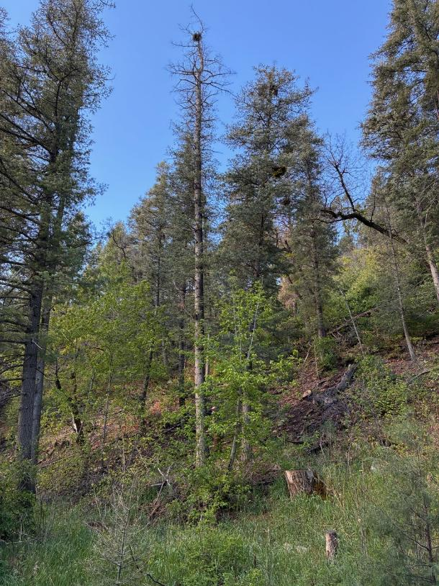
Tall white fir on the left side of the road below the middle restroom. All photos by Cliff Giles
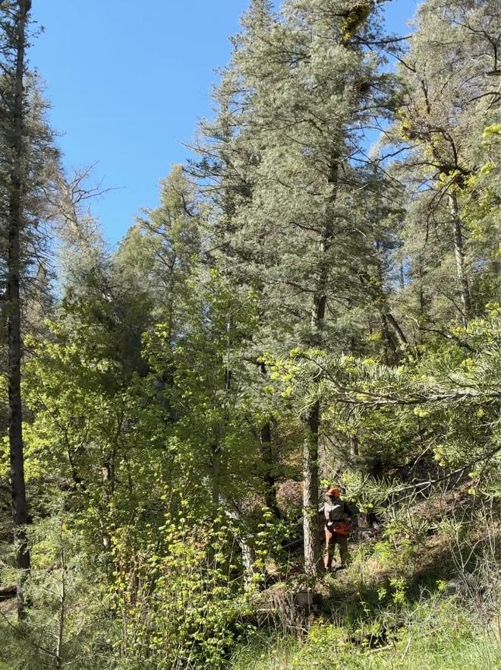
The white fir falling after Dan Benton has completed his back cut.
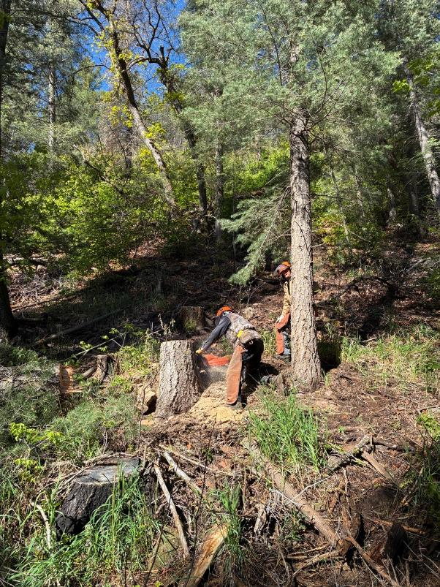
Dan low stumping the tall white fir.
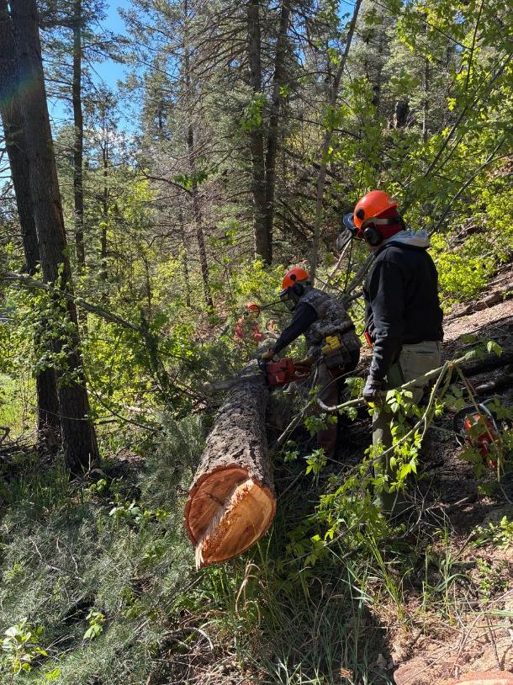
Dan bucking the log while Eric Russell observes.
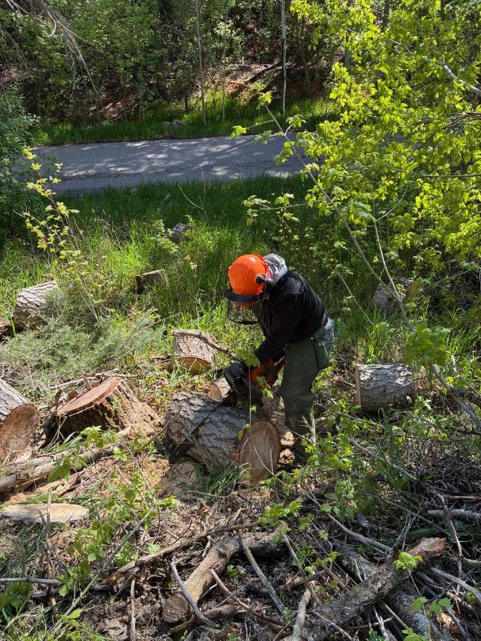
Eric bucking a piece of the log between the road and stump.
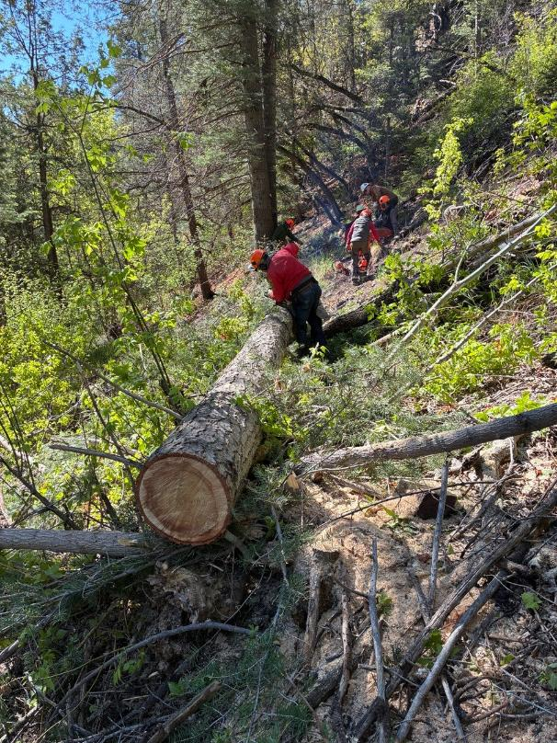
Jerry Carroll bucking the trunk into two pieces so that it will be safe for a couple of
sawyers to buck at the same time.
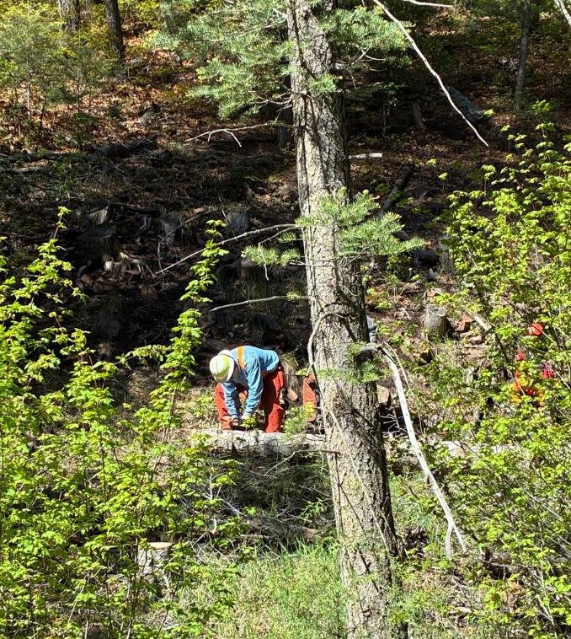
Tim bucking the upper end of the log.

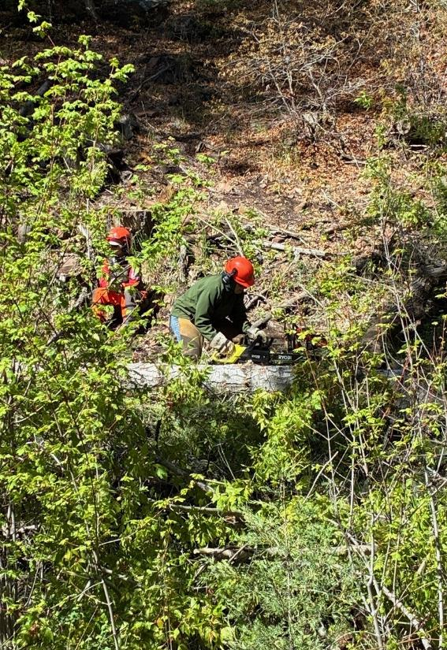
Steve Roholt limbing the tree with his electric chain saw.

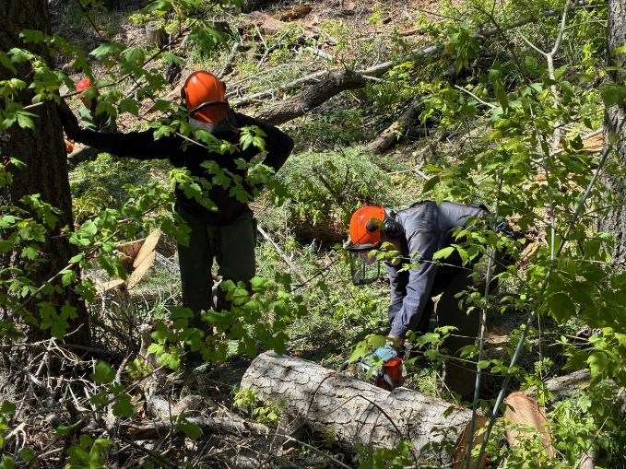
Tim bucking a piece of the trunk.

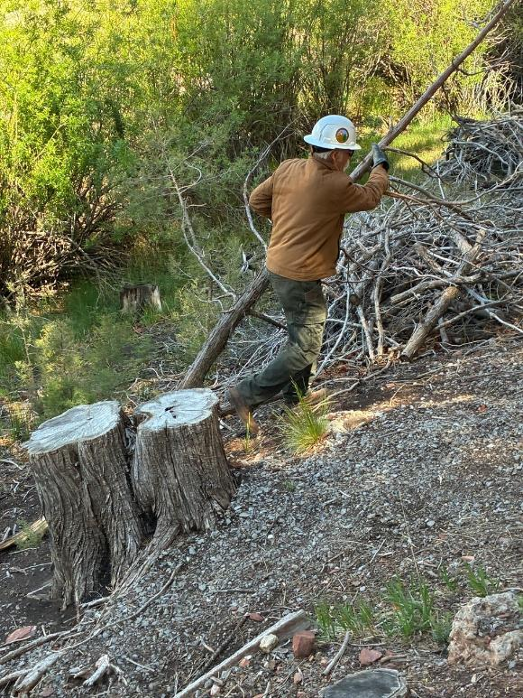
Kent moving slash from the juniper felled along the Cienega Nature Trail.
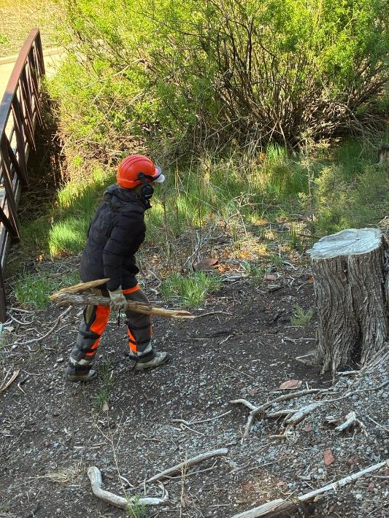
Lorna moving slash at the lower bridge adjacent to the cienega (wet meadow)
in the center of Cienega Canyon Picnic Area.
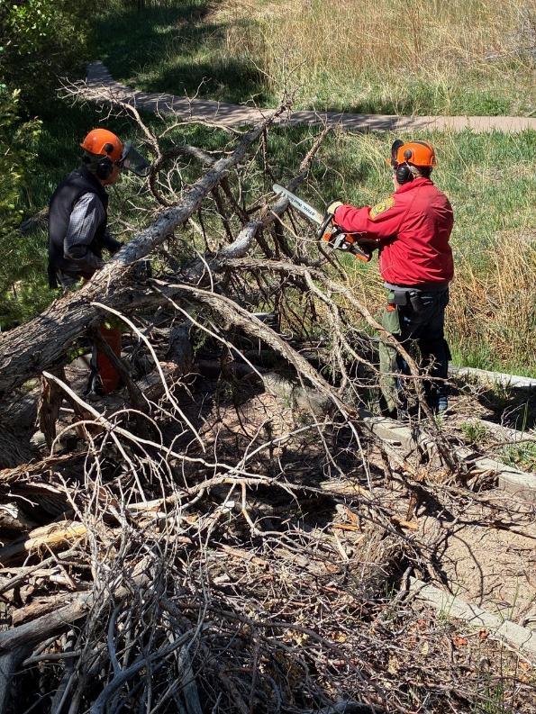
Limbing Rocky Mountain juniper that Eric felled on the Cienega Nature Trail.

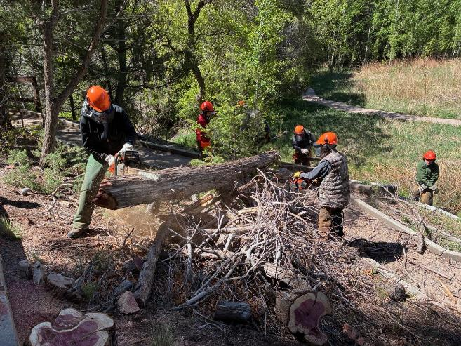
Eric and Dan bucking the juniper.

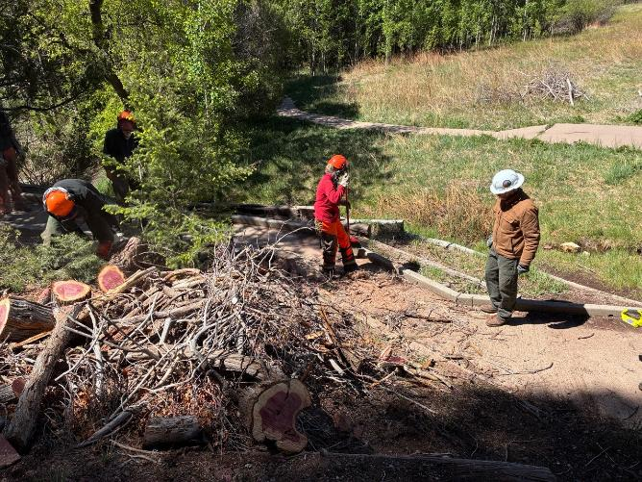
Lorna and Kent cleaning slash from the Nature Trail.

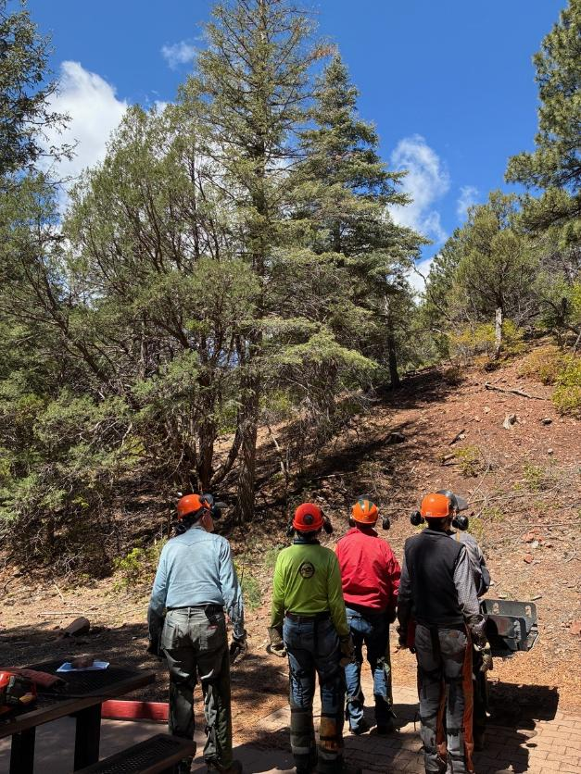
The crew analyzing the hazard tree with a dead top in the group area.
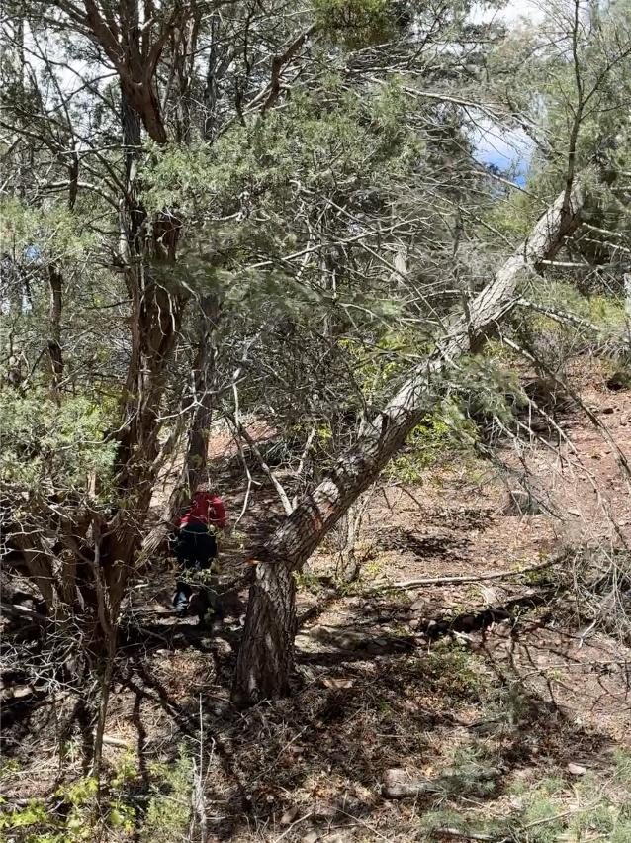
Jerry running away from the hazard tree that he has just felled.
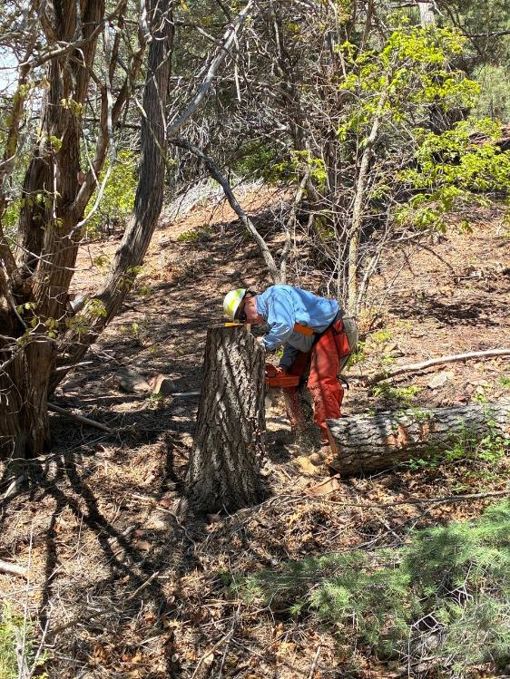
Tim low stumping the hazard tree near the restroom in the group area.
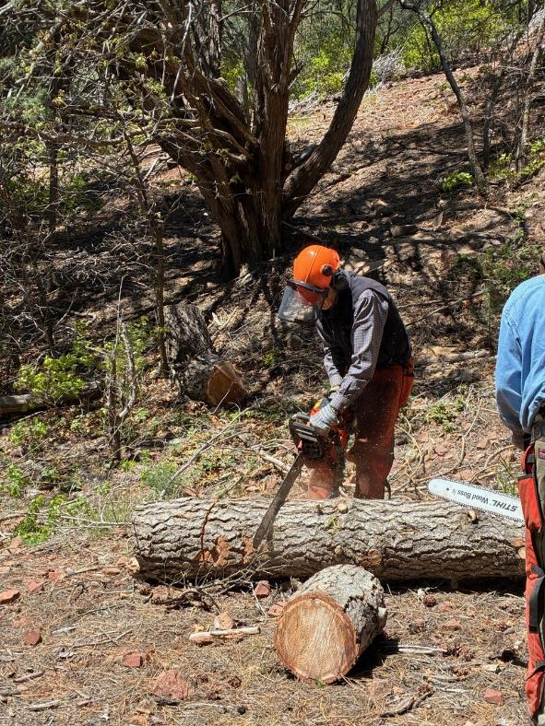
Sim bucking the white fir trunk with a Husqvarna saw with a 24-inch bar.
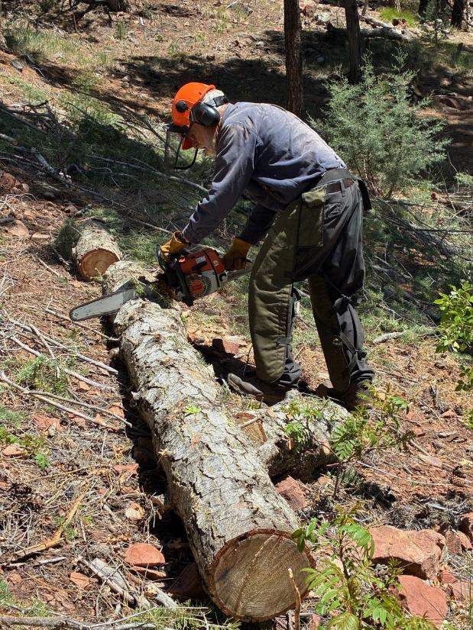
Sam bucking the white fir with a Stihl saw with an 18-inch bar.
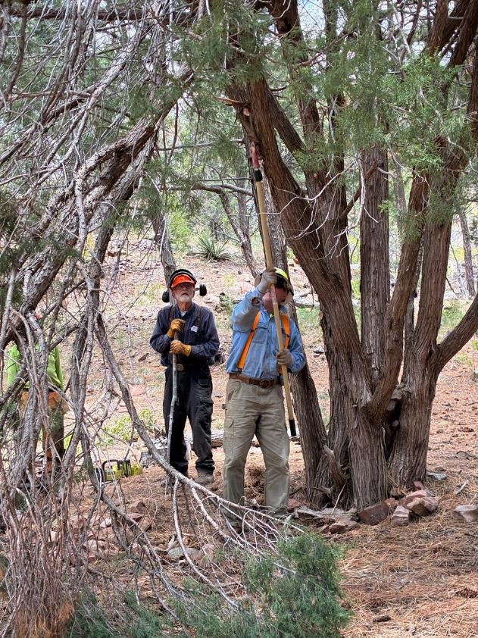
Tim using a pole saw to cut a branch on a juniper with two broken branches.
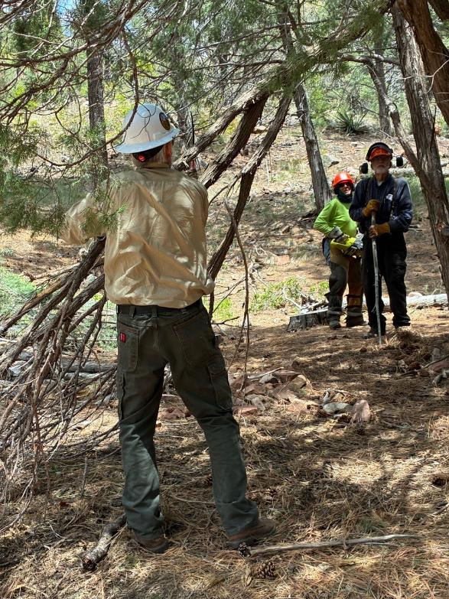
Kent twisting one of the partially broken branches so it can be removed from the juniper.
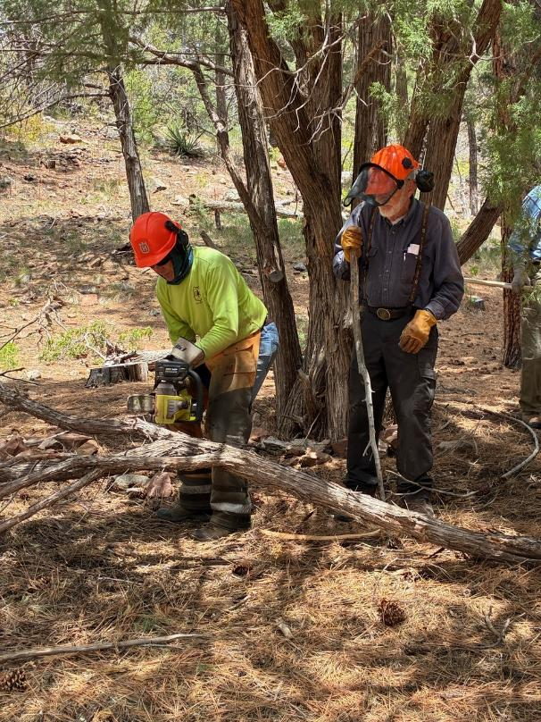
Steve using his electric saw to cut juniper branches.
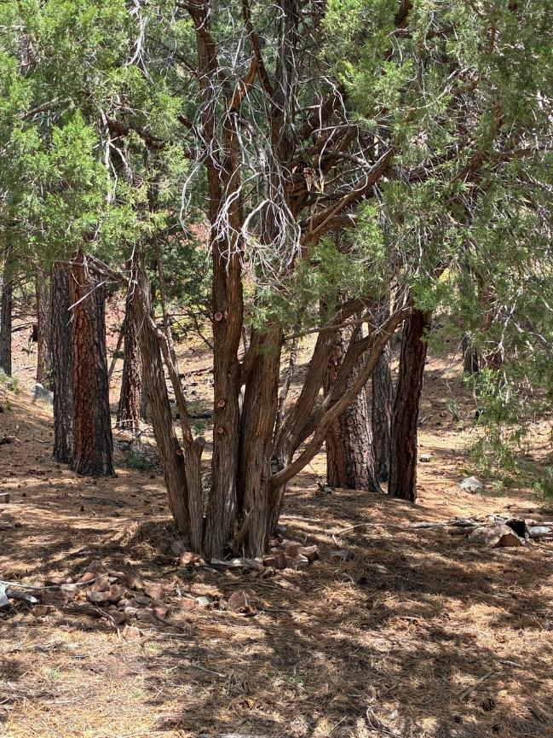
The more attractive juniper after two broken branches were removed.

