Report of Graffiti Tags at La Luz Trailhead Painted Over by Fred Hagstrom on May 13, 2026
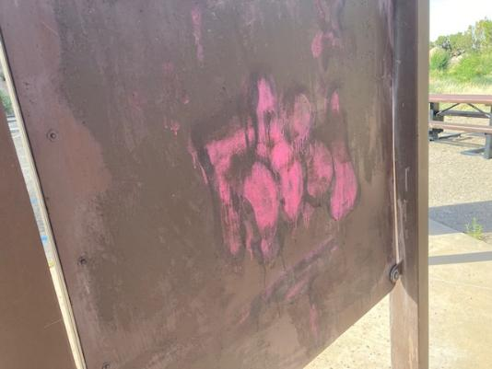
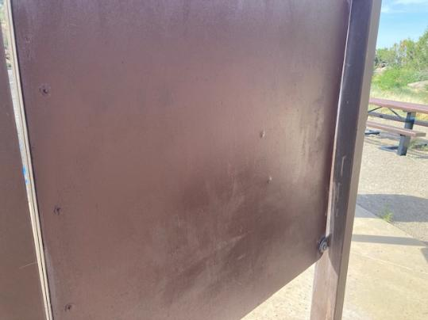
Tag on back of kiosk before and after being painted over. All photos by Fred Hagstrom
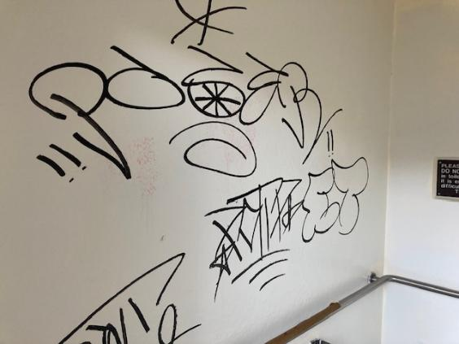
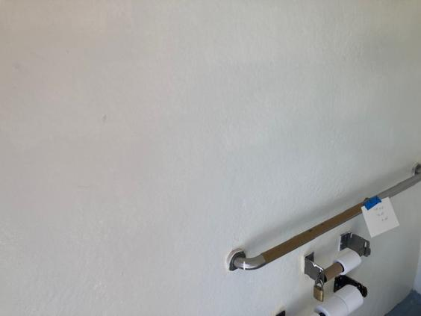
Tag in men’s restroom painted over.
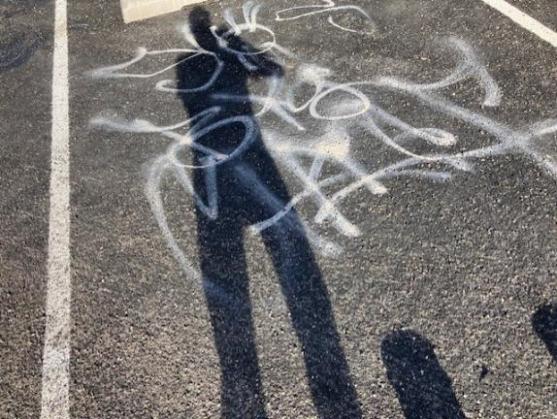
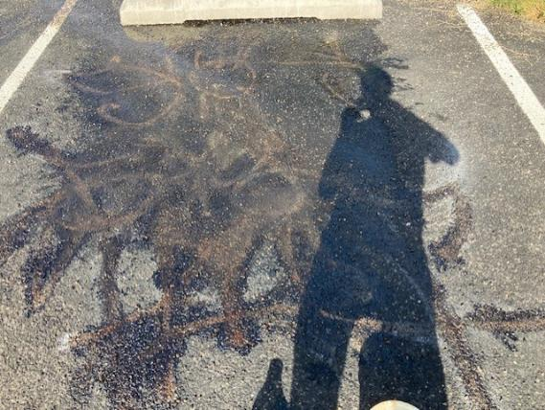
Tag on pavement painted over.

