Thursday, 05/14/26- Pokerchip: Another hot day on Pokerchip for 8 volunteers and Jen and Chris (SRD). We started our hike to the work site to the sound of cicadas buzzing and clicking in the trees- haven’t heard that yet this year. We are working our way down the steep slope so the hike in gets a tiny bit easier each week. Once everyone was situated, we got to work digging trail, removing stumps and big rocks and building some check dams across the old, obliterated trail. The hike out always seems just a bit longer than the hike in! Don and Luis sped by on their bikes leaving us in the dust, literally. We really need rain so keep wishing.

Volunteers: Don Fisher, Eric Russell, Kerry Jones, Claudia Bergsohn, Luis Cuadros,
Eric Messerschmidt, Tony Pachelli and Laura Leon

Pictures- Laura Leon Maps- Luis Cuadros and Bad elf

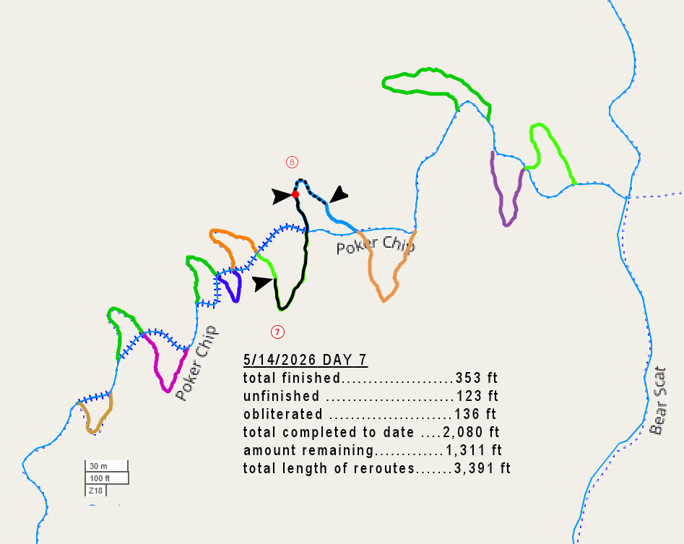

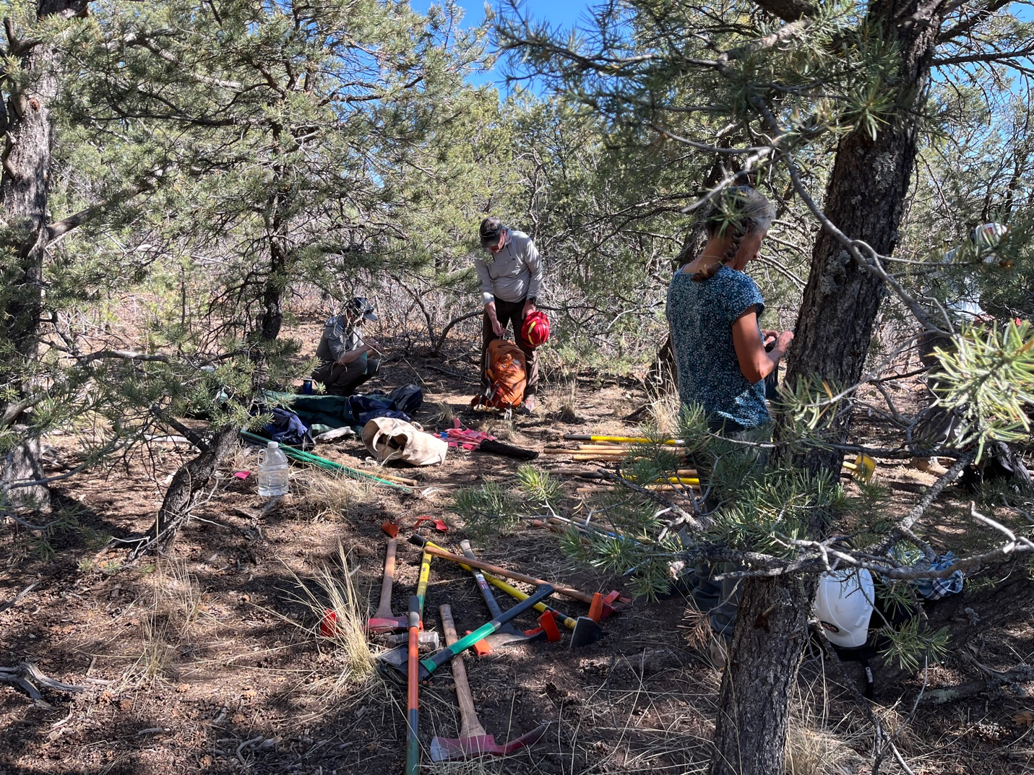

Eric M., Kerry and Claudia at the tool stash getting ready to start work. We grab whatever shade we can.

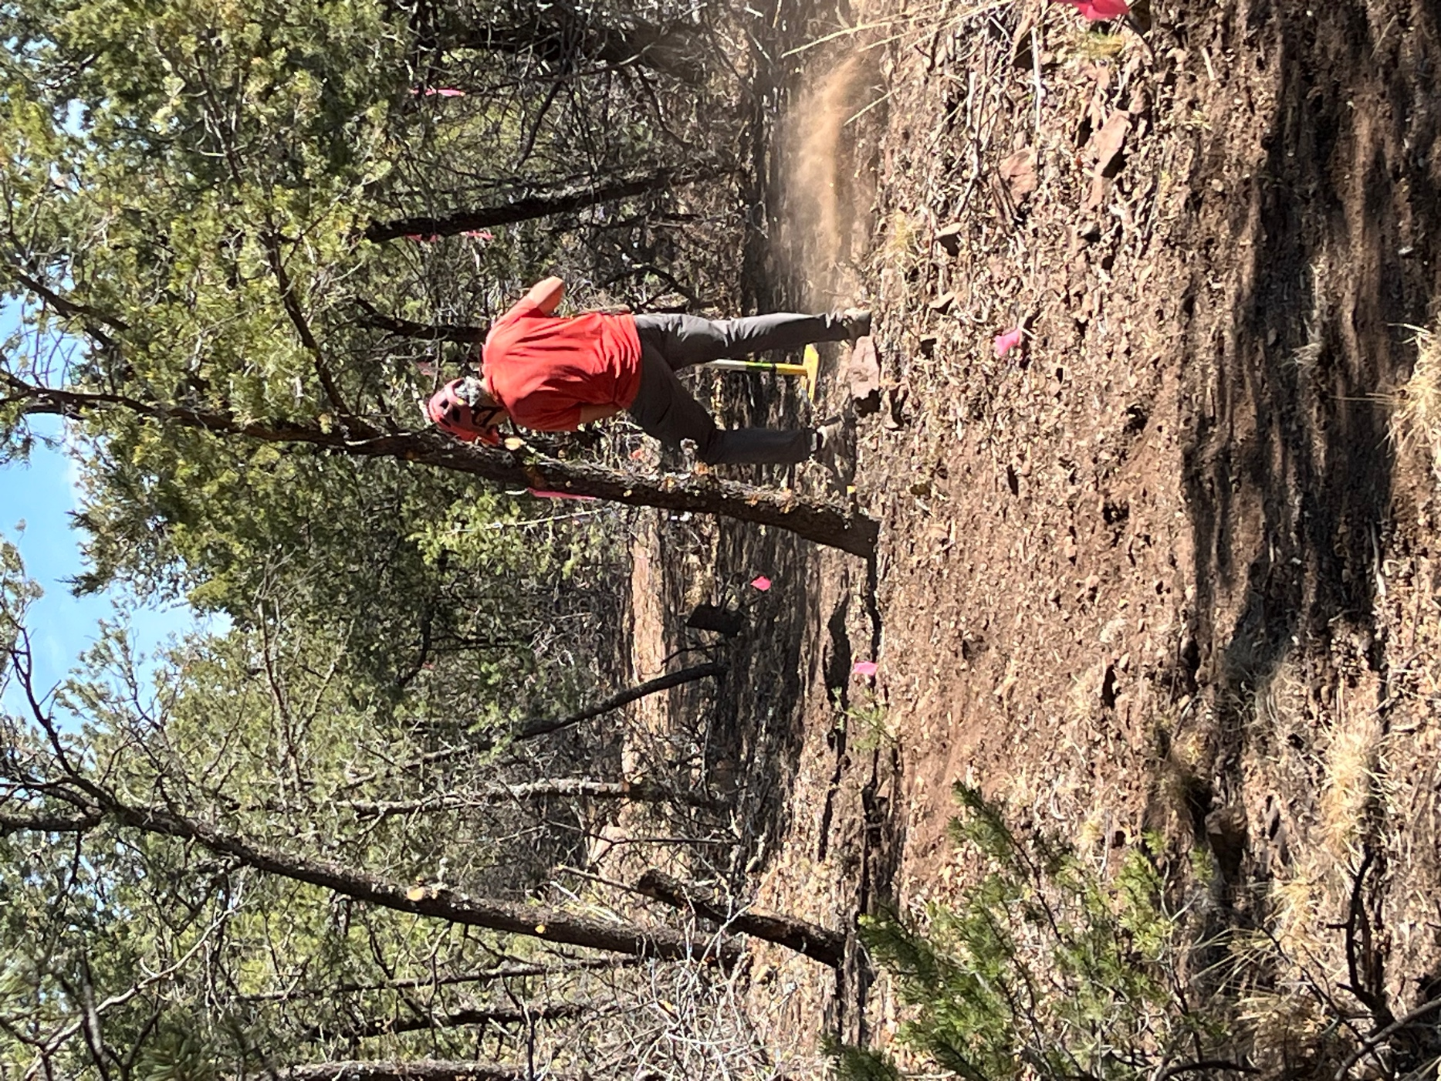

Luis demonstrating how dry and dusty it is.
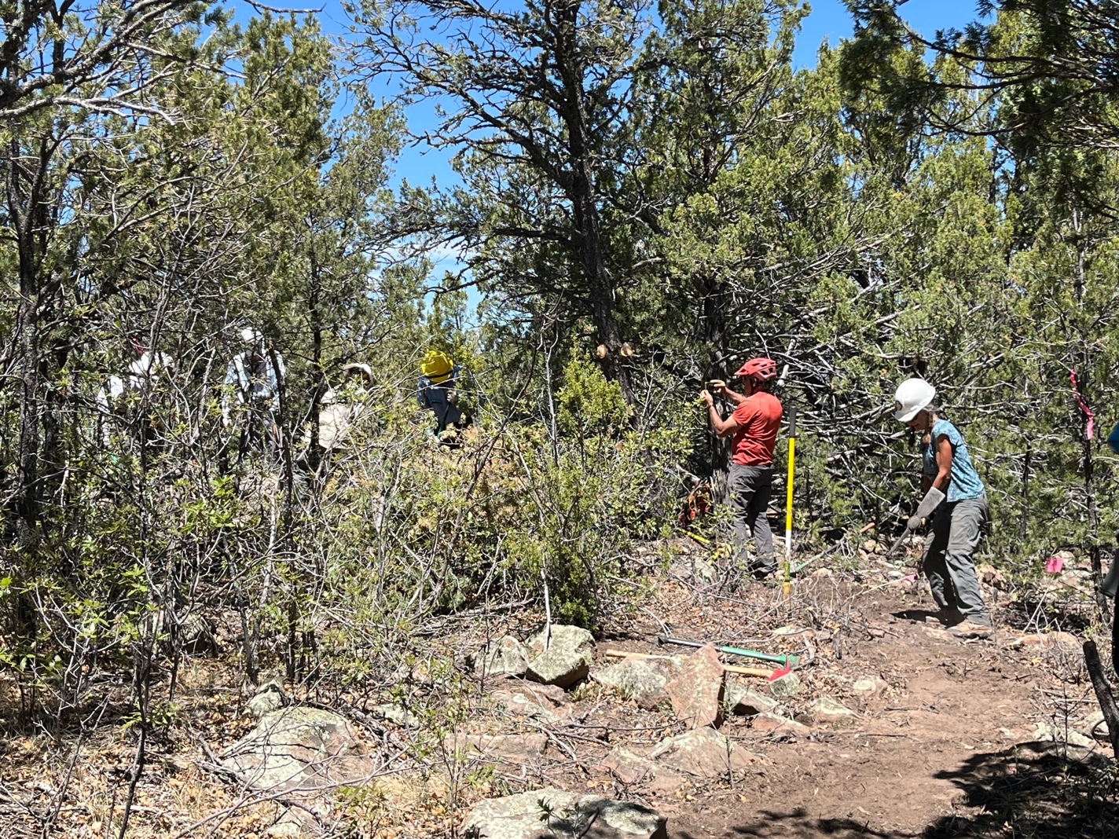

On the curve of the week, a commotion broke out in this Congo line of workers- Chris, Tony, Jen, Eric R., Luis and Claudia. It was a really big rock removal.

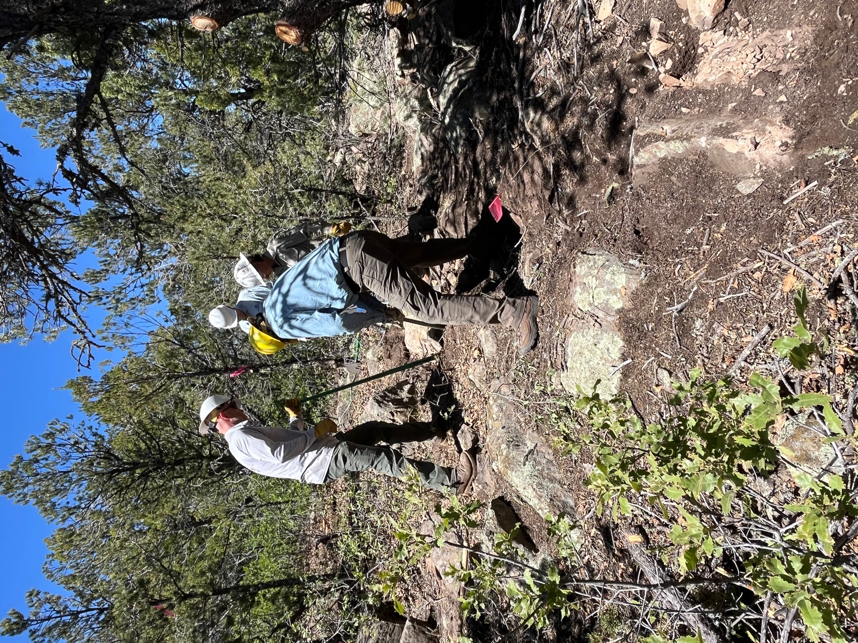

A lot of jimmying to get it loose. Then rocks are dropped underneath it to raise it up a bit.
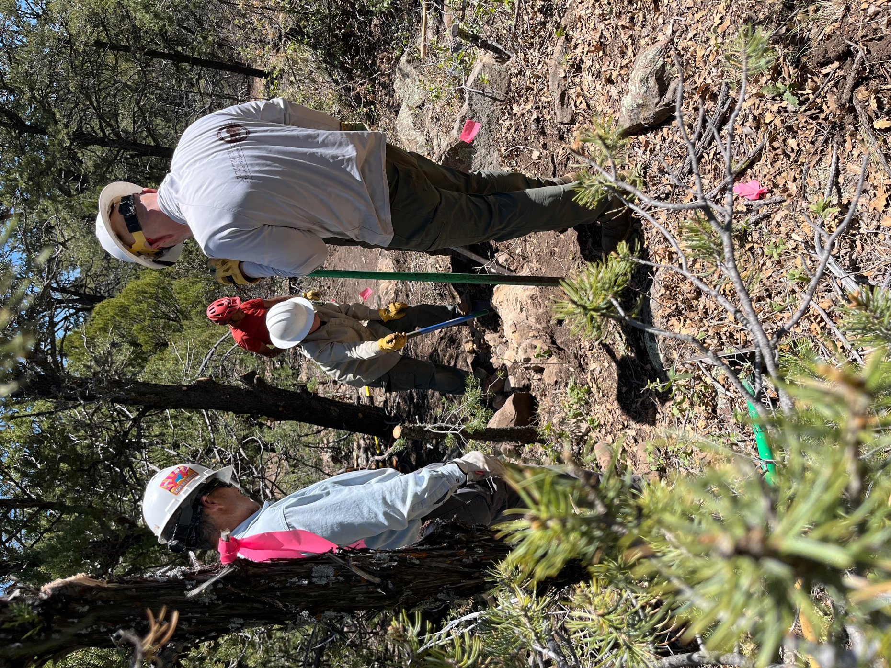

Some more jimmying.
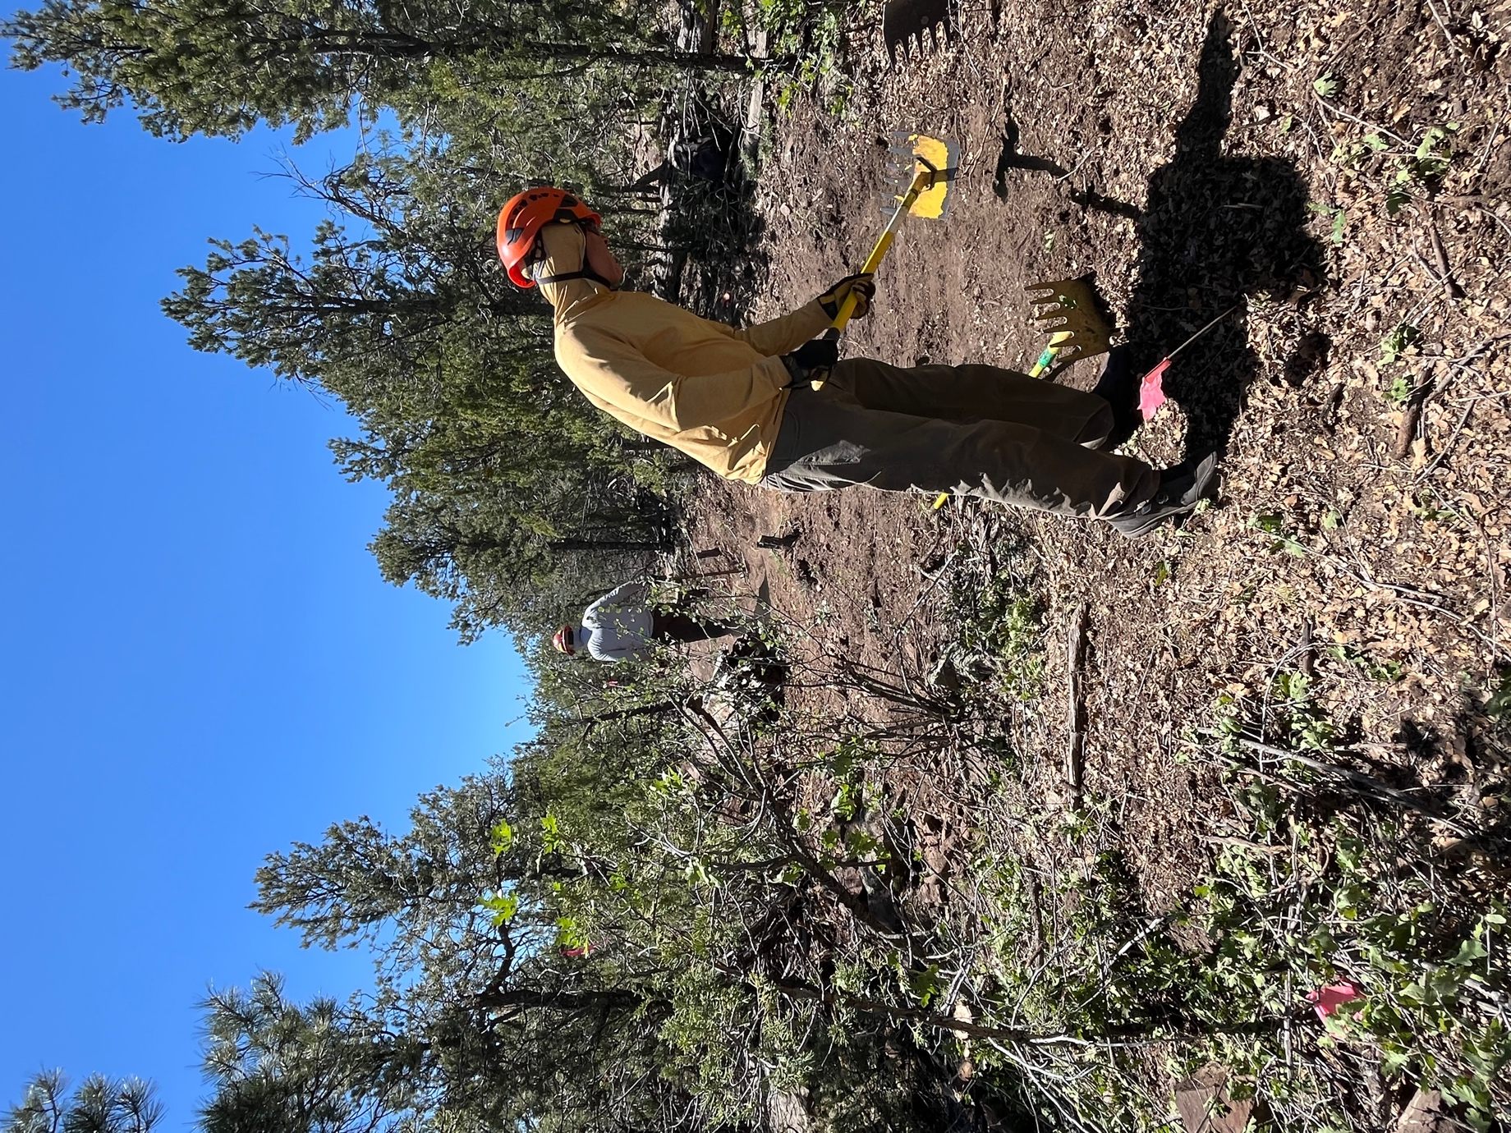

Meanwhile, Kerry and Don keep the digging train moving along.
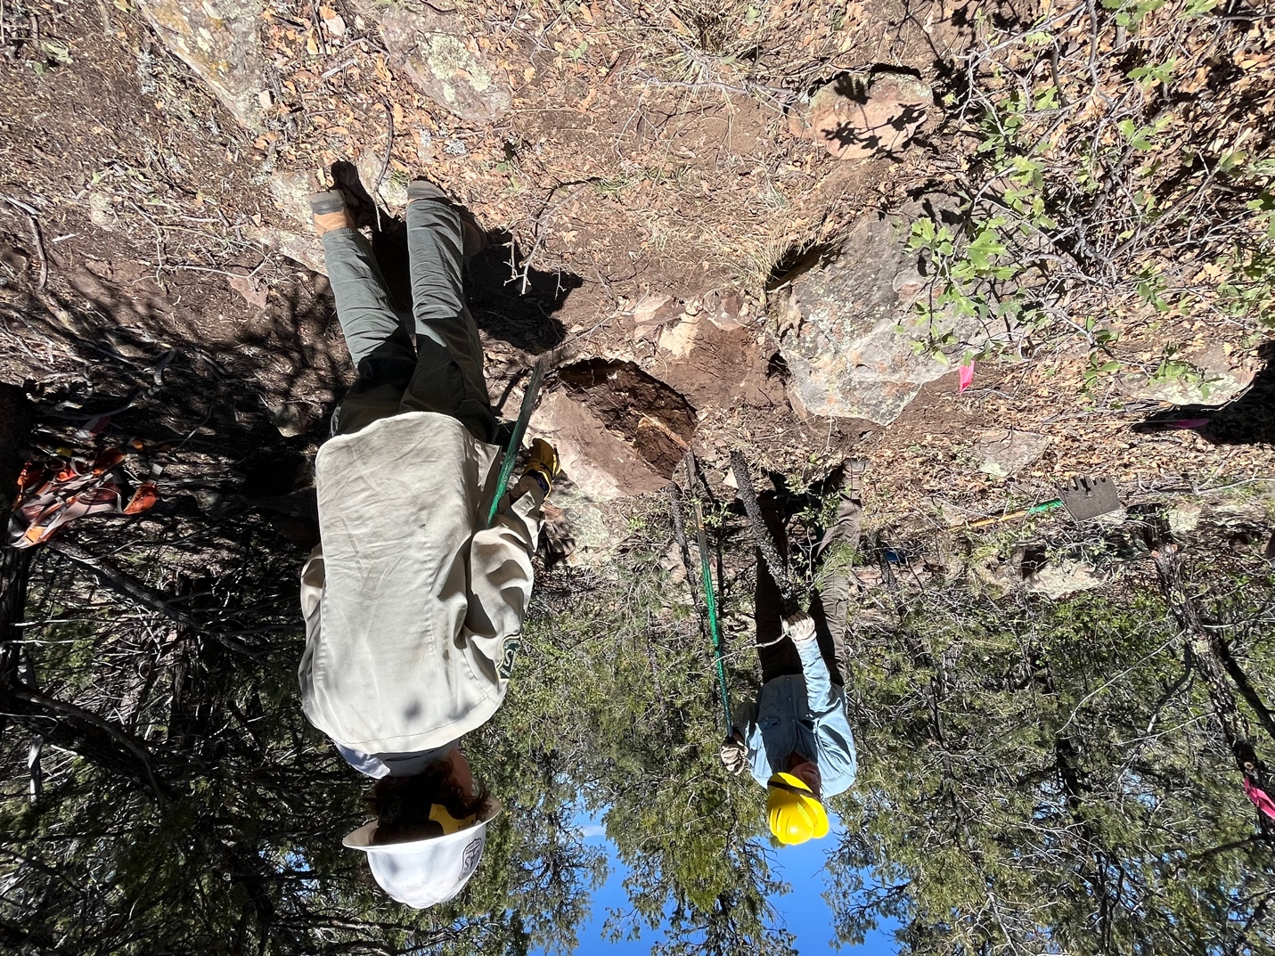

The rock is raised out of the hole and slowly wiggled to the side.

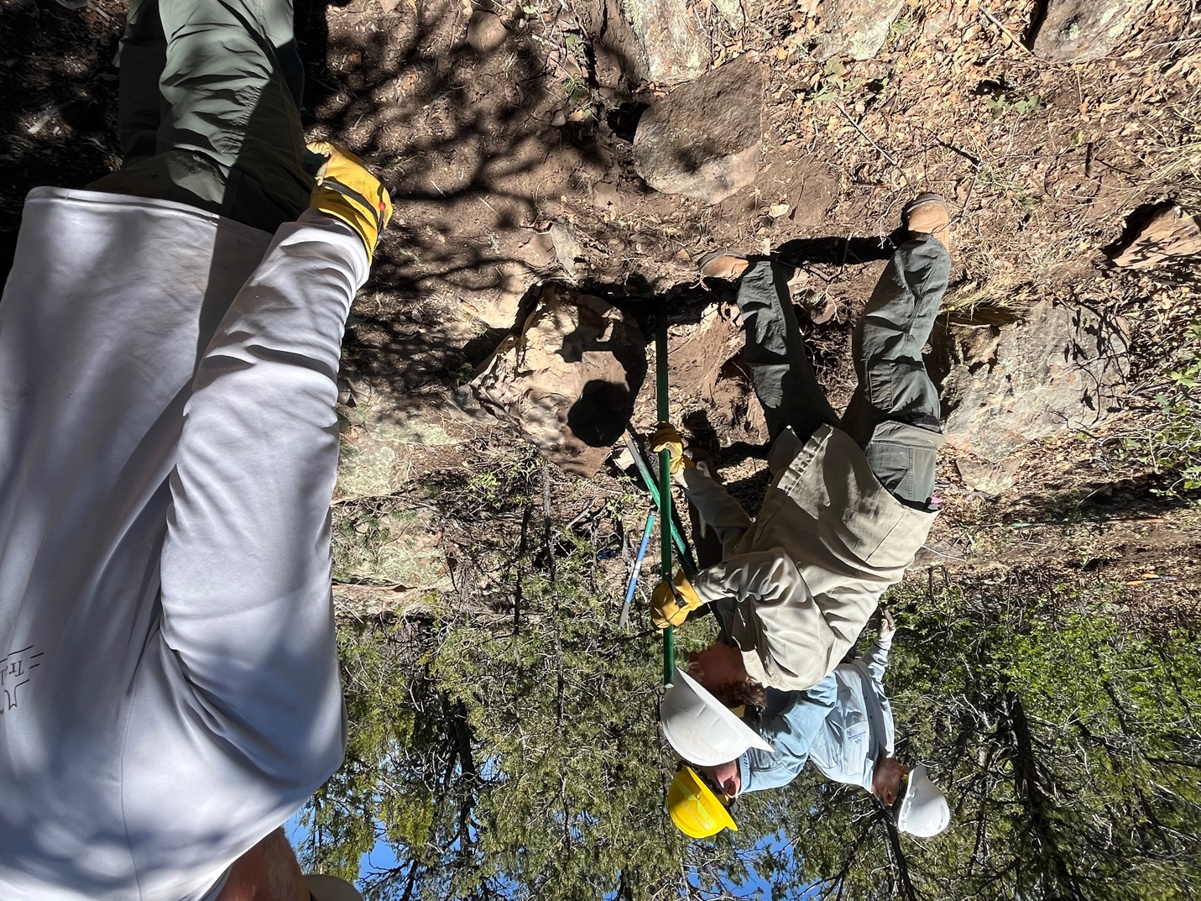

Off the tread line and in its new home. On to the next boulder.

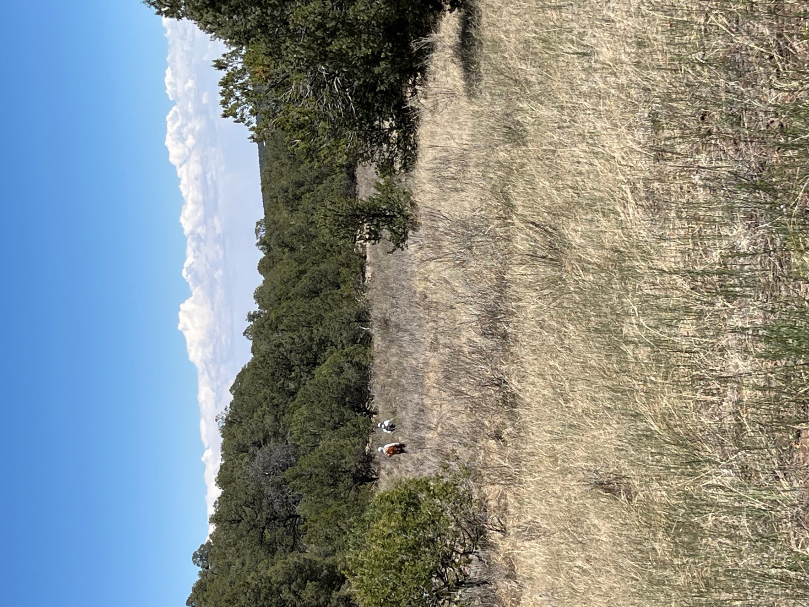

Hiking out, the meadow grass is very dry, the temps were hot and the sun was unrelenting. The clouds off in the distance did at least give us some outflow breezes.

