Report of Project to Pickup Trash and Cut Brush along One Mile of the Crest Highway
Adopted by the Friends of the Sandia Mountains, Friday, May 15, 2026

Sam Beard
On Friday, May 15, eight Friends of the Sandia Mountains volunteers picked up trash on the Crest Highway from Mile Marker 4 to Mile Marker 5. The trash was placed in plastic bags and piled at one place for the NMDOT to collect. A rusty steel guard rail lies along almost the entire length of the adopted segment. Six volunteers cut brush on the highway side of the rail and behind the rail along the upper half of the adopted segment. The objective of the brushing was to prevent the growth of large brush that presents a hazard when drivers do not have adequate sight distances. The brush was cut with chain saws, power brush cutters, and manual loppers. The cut slash is thrown down the mountainside behind the guard rail. Orange cones were placed along the side of the highway to alert the drivers to the presence of the volunteers.
The volunteers picking up trash were Susan Gregory, Cliff Giles, Dan Benton, Betsy Galloway, Karen Grief, Rene Archer, Rav Nicholson, and Ken Nicholson, and the volunteers cutting brush were Don Carnicom, Mike Madden, Sam Beard, Larry Larrichio, Don Carnicom, and Kerry Jones.
Project photos are presented below.
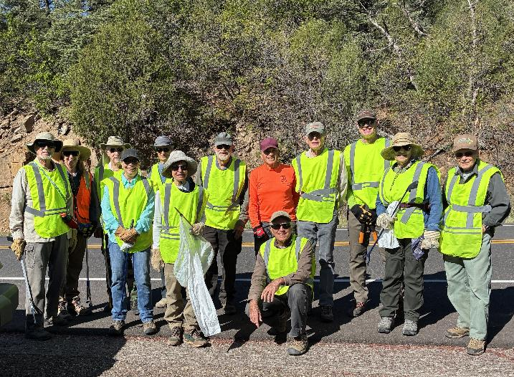
Volunteers who worked on the cleanup and brushing along the one-mile highway segment adopted by FOSM.
L to R: Dan Benton, Betsy Galloway, Ken Nicholson, Rene Archer, Susan Gregory, Rav Nicholson, Sam Beard,
Larry Larrichio, Mike Madden, Sim Cook, Kerry Jones, Karen Grief, Don Carnicom. Photo by Cliff Giles
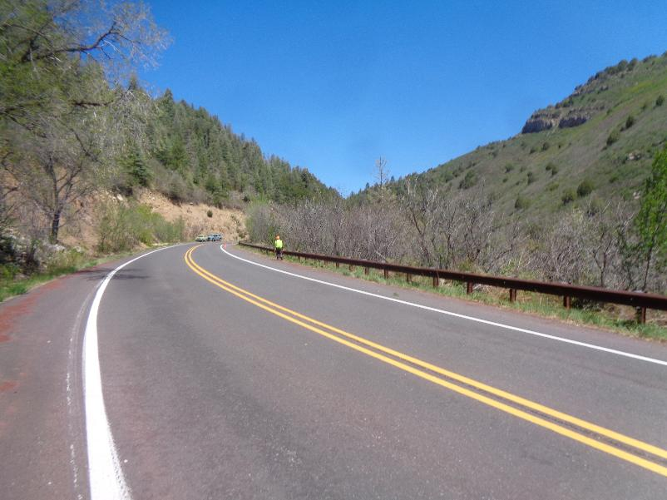
Looking up the highway in the area where brush was cut. Note that all the brush
on both sides of the guard rail has been cut. Photo by Sam Beard

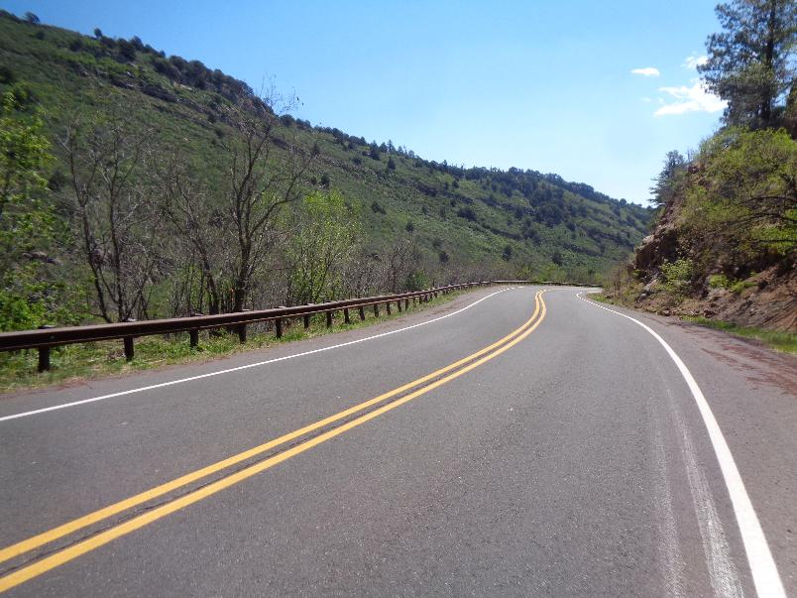
Looking down the highway. Note that volunteers have cut brush on both sides of the guard rail to improve
driver sight disances. Photo by Sam Beard

