Thursday, 05/21/26- Pokerchip: Another sunny day on Pokerchip. Nine volunteers plus Jen and Chris (SRD) plowed through another section of the reroutes, making great progress due to a limited number of stumps and rocks and overall amazing tread digging skill. We always back up and do any finishing work from the week before and then move on ahead. This week we finished all of the remaining parts of reroute 3 and bumped our tools down to the fourth reroute for next week.

Volunteers: Bill Perkins, John McNett, Claudia Bergsohn, Kerry Jones, Jim Houle,
Luis Cuadros, Bruce Hansche, Eric Russell and Laura Leon

Pictures: Laura Leon and Bruce Hansche Map details: Luis Cuadros

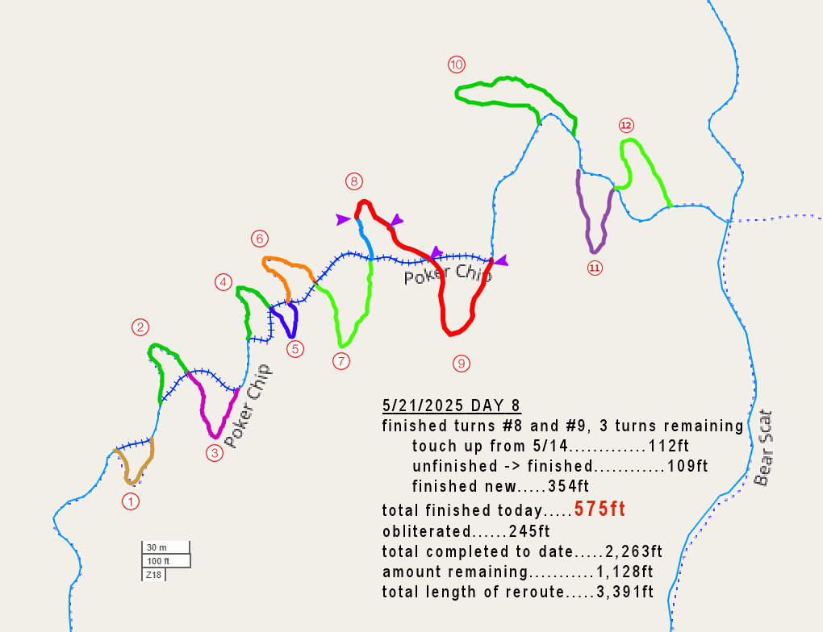

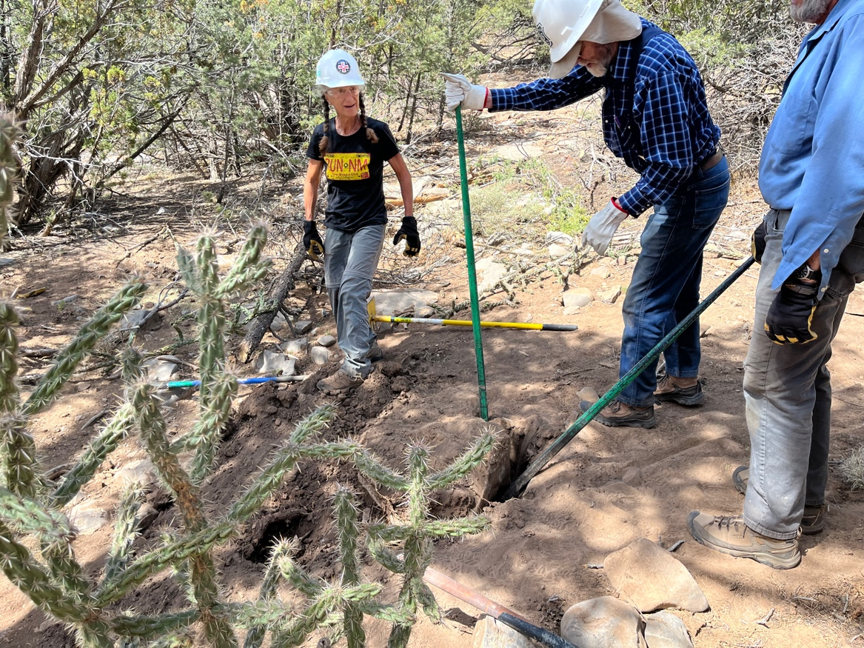

Let’s play “Who can move the biggest rock?”. Last week it was Eric, Jen and Chris. This week it’s Claudia, Bruce and Jim. It really wasn’t in the way but was right next to the old trail that needed some obliteration/water retention work so why not?
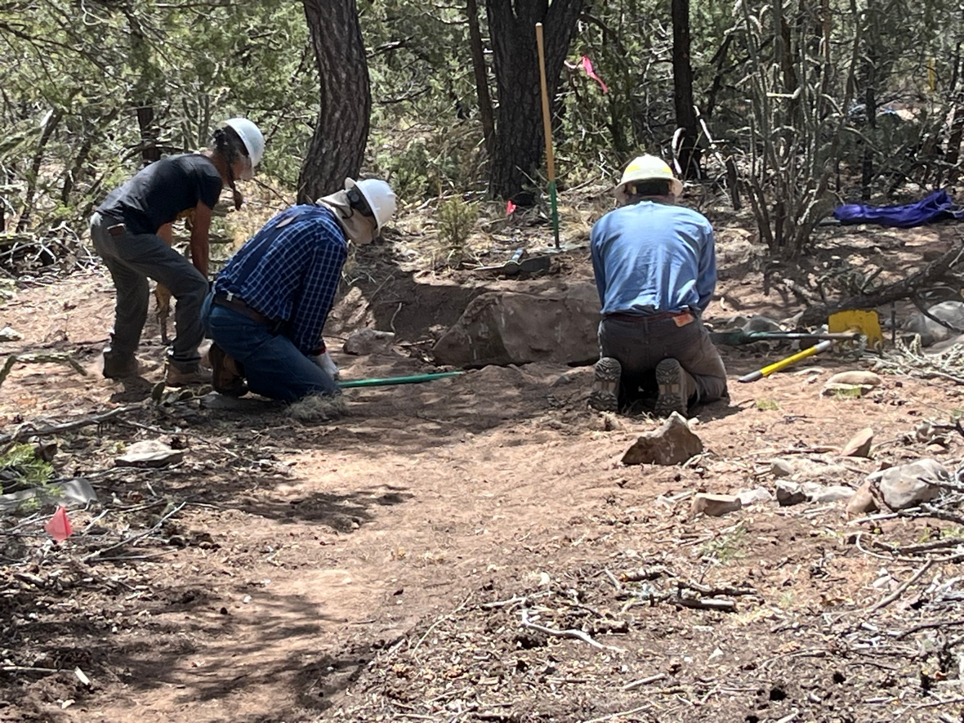
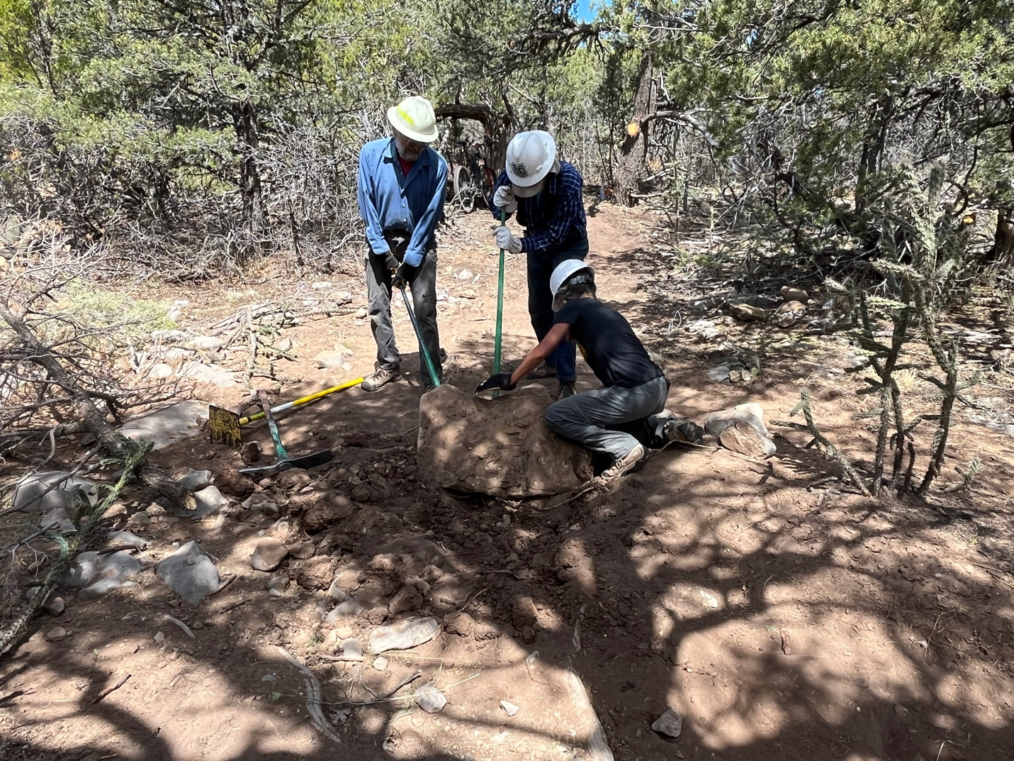
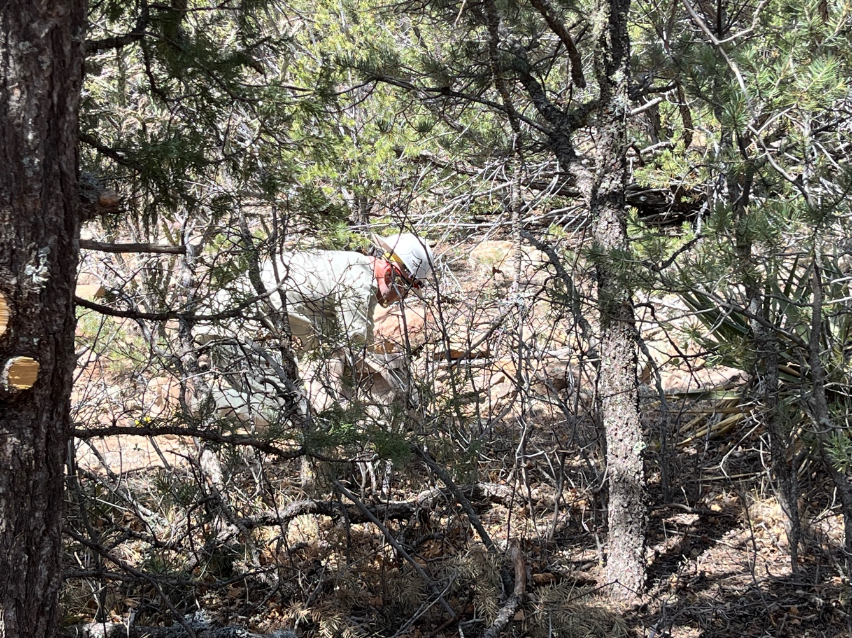

Meanwhile Chris was busy building a check dam on the old trail. A friendly face was keeping an eye on all the activity.

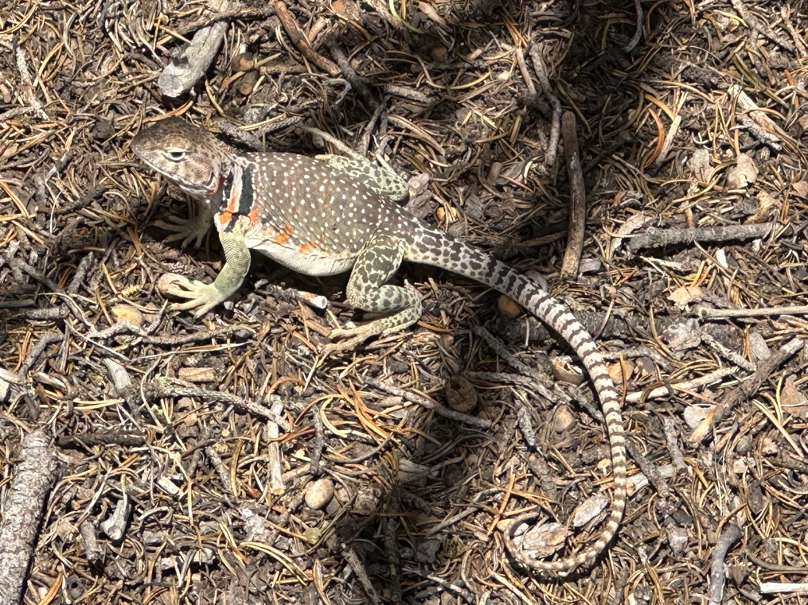
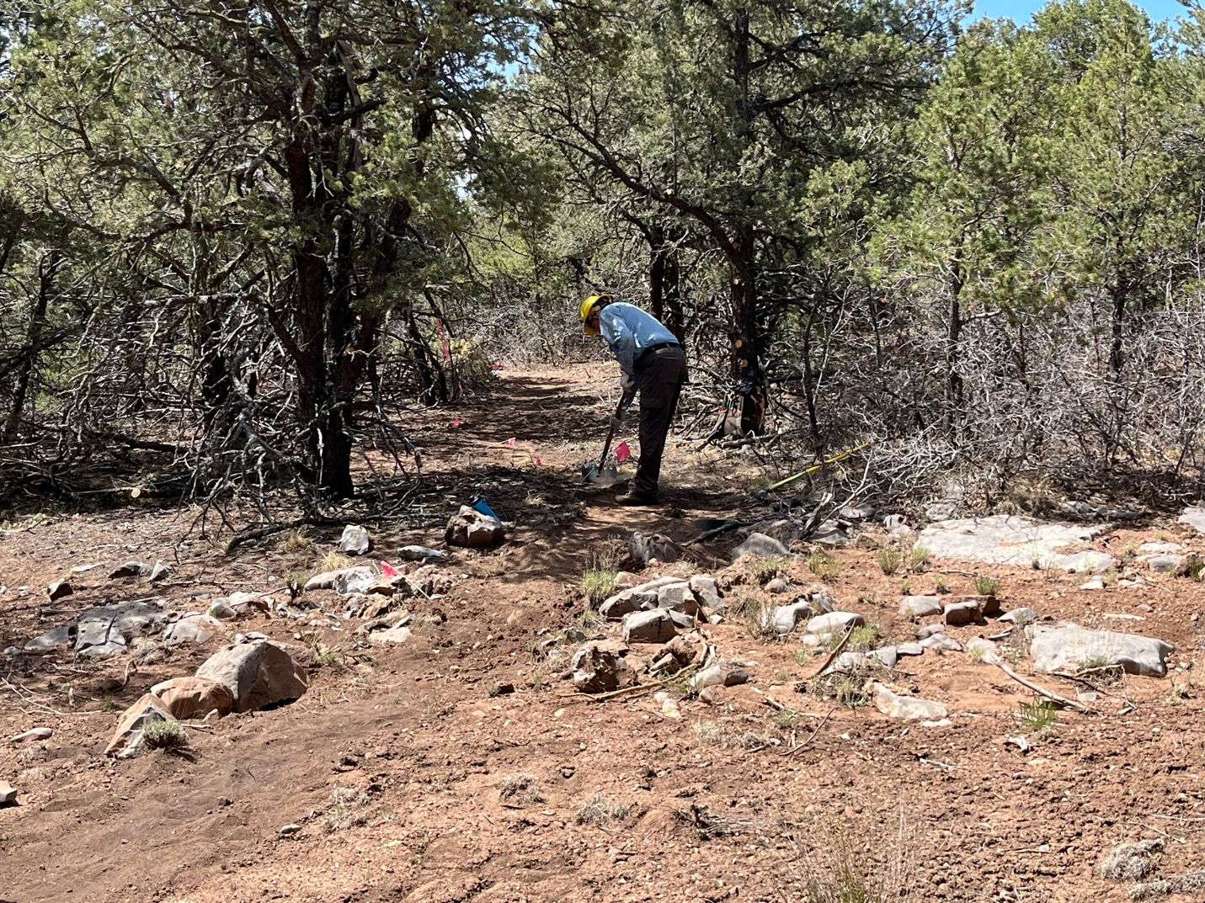

Eric rocketed through a nice, relatively rock and stump free zone, grooving to his tunes.

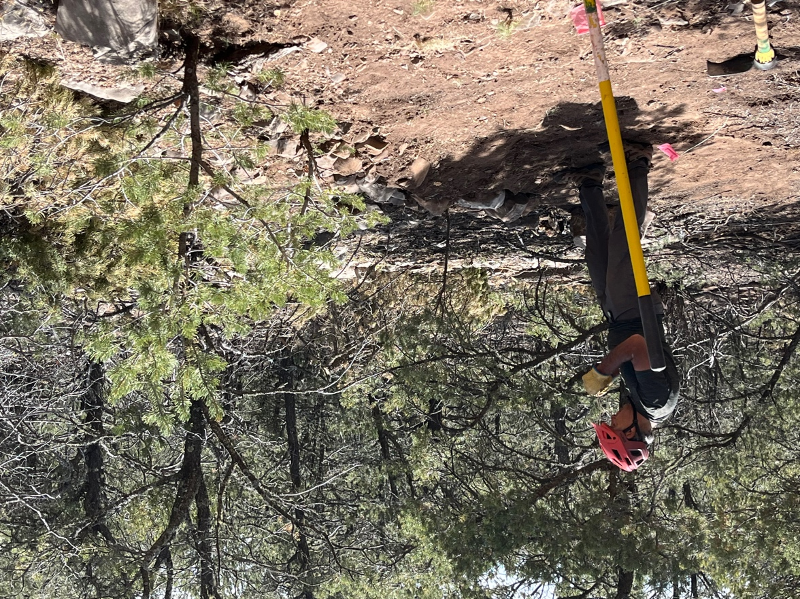

No, he isn’t praying! Luis was building up rocks along the curve of the trail and found some very interesting fossils in the rock.
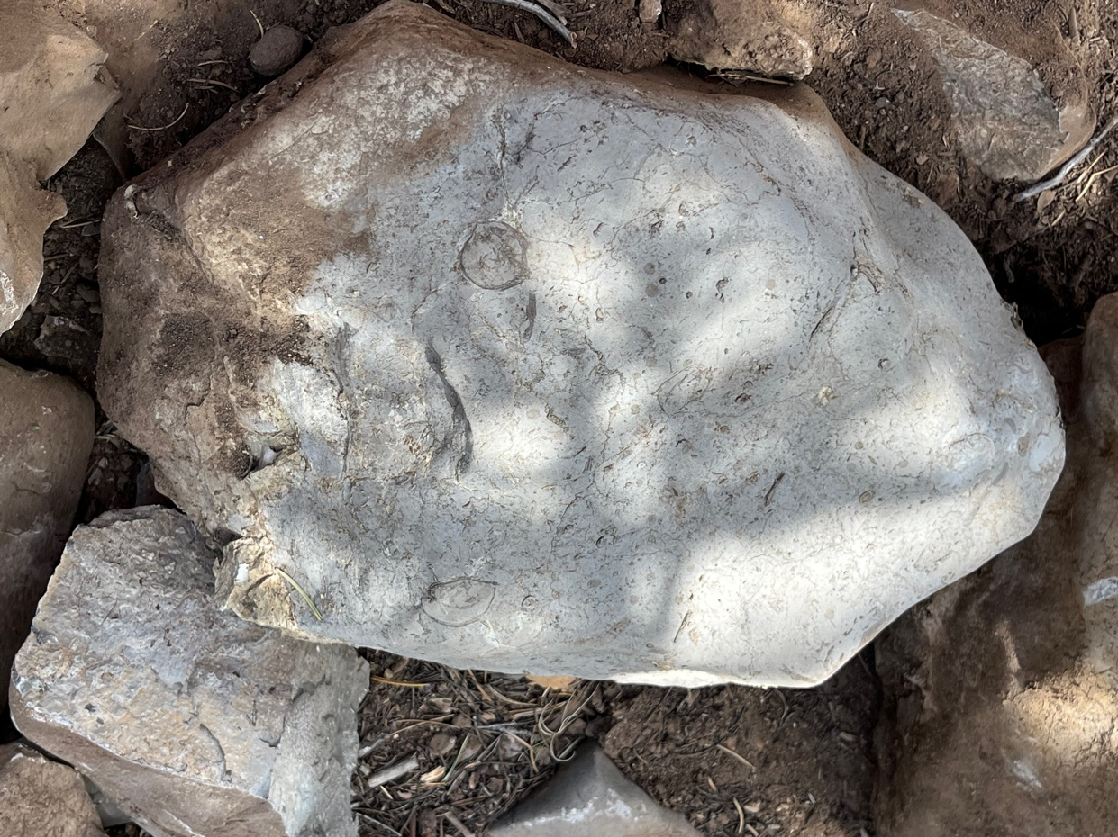
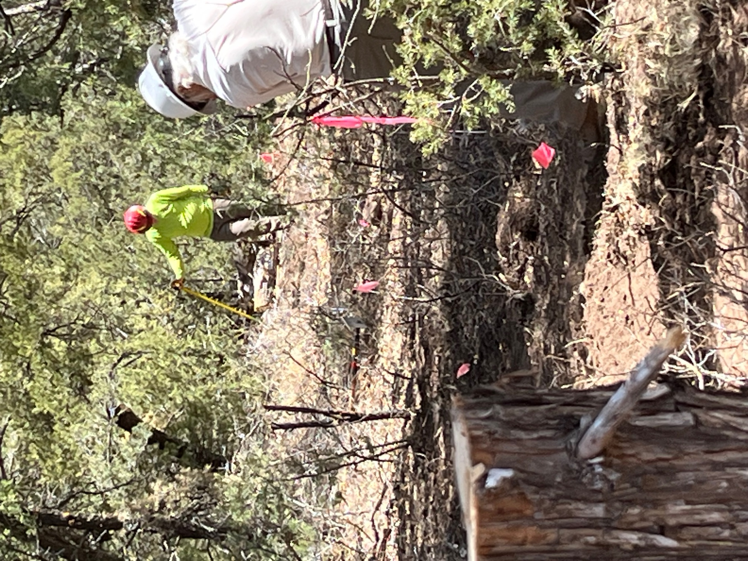

Meanwhile, Kerry and Bill found an area full of stumps and sun and made a go of it. At least it’s not on a slope!
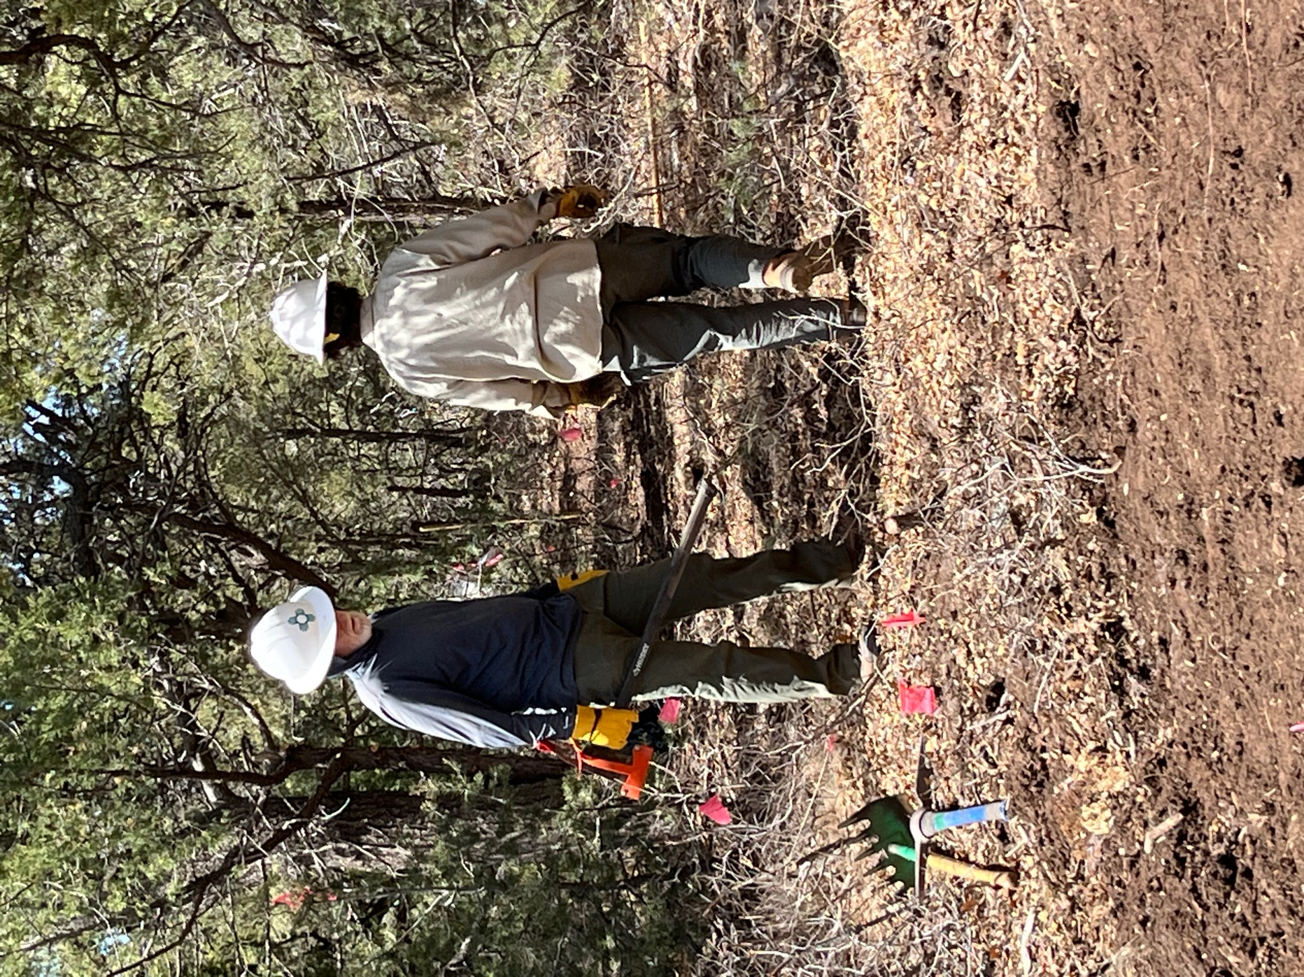

John and Jen debate who will get to work in the shade. Rock, paper, scissors….
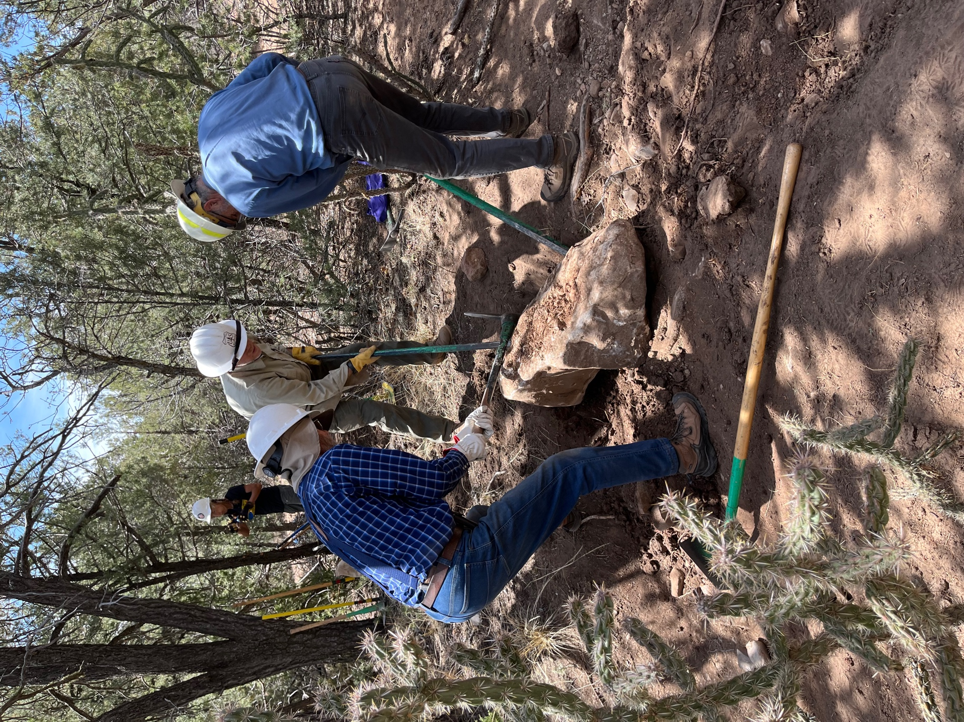

And the rock is out and moved into its new space.
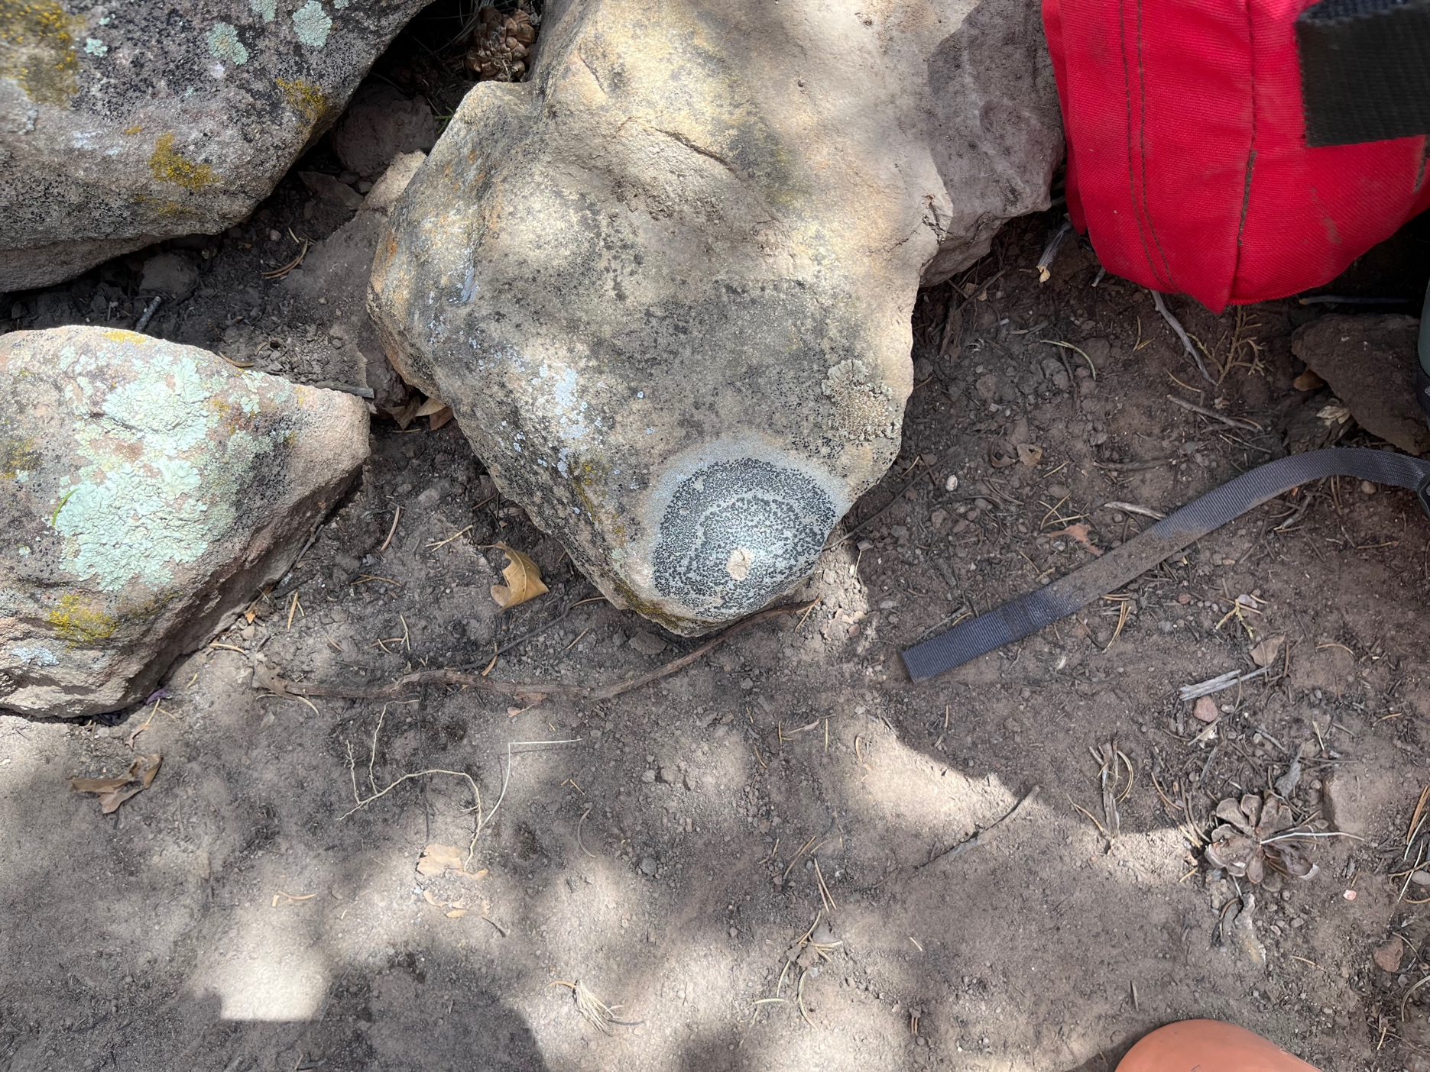

Some interesting fungi.
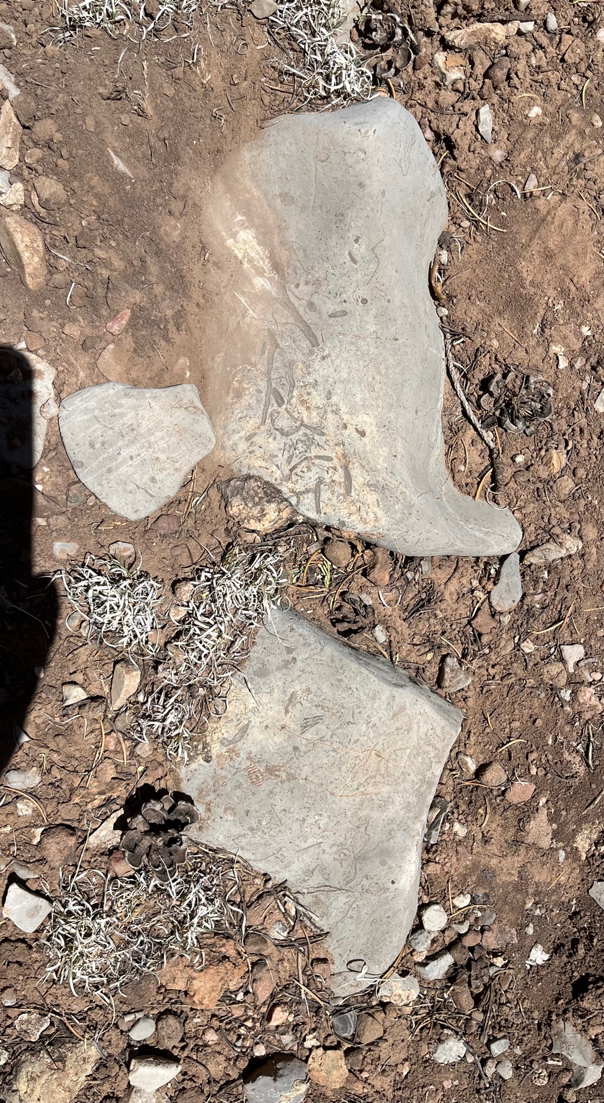

And some more really cool fossils.

